Mobiworld

Computer Science & Engineering /Thakur ShivKumar Shingh Memorial Engineering Collage Ziri/ RGPV/ India

**Introduction**

MOBIWORLD is a website which is manly focuss of Mobile selling and give a best exprience of our coustomer in this website we are selling mobile in cheap rate with good quality. It gives a the whole information of mobile like Company name , Brand Name, Colour, mobile Price, Ram, Storage, Camera etc.

MOBIWORLD mean's buy Mobile including budget, modal ,prices ,company etc. our project is meant to give people a best & truth worthly plate form where they can buy Mobiles of their own choices.

It is an online system through which customers can view available Mobiles, register, view profile and book Mobile. Our project is meant to give people a better and trustworthy platform where they can buy Mobile of their own choice and obviously on our terms and Condition . With the help of internet and computer systems a man from remote area can buy his Mobile from anywhere.

**Abstract**

In our Mobiworld website everyone will be able to take there favorite Mobile according to their budget .With the help of internet and computer today we can buy everything in this word in on click so in this requirement today world our project help it .and today trust is most important in any business growth so we are stablish a trustable business to our client and provide they home delivery of a Mobile.

And most important fact is that we provide the enquiry system in the project that customer easily get information of any Mobile .If the somthing was wrong then customer easily complint it.

* 1. **Motivation:-** There are many motivation for there miner project. It provide the best Mobile in cheapest prices. It saves the precious time of customer by online buying Mobile. our project customer direct interact with us and they get effective price of there product or Mobile .In our website user easily access everything and get there priority and buy or book wonderfull Mobile in just click.
  2. **Objective Of Project :-** There are many objective of this project.
     1. Registration of customer.
     2. This Project become the best market and information source buy a Mobile in India.
     3. This project will provide the facility all buyer and dealer buy Mobile. If anyone want to buy Mobile online,then first he will register in this website and then he can see all the details about the sell used cars including prices, model.
     4. The main objective of this project a buliding a web based application which provide the details of Mobile.
  3. **Application Of Scope :-** There are some application of scope.

1. This website for selling Mobile, it manage Mobile information Mobile_name, Mobile Brand, company ,Mobile price, Ram, Storage, Camera Quality etc.
2. Admin manage the website ,deals with the customer.
3. To allow user can only view the information and also can register to buy a Mobile.
4. It provide the best Mobile on budget.
   1. **Limitation:-** The main Limitation of this website is :-
      1. The registered user can only buy Mobile with same searching criteria like colour, company, Ram , Storage, Camera Quality.
      2. Lack of equality in public access to the internet.
      3. If the visitors can visite the website once then message will not be going in there mobile/email.
      4. We are not taking any identity from the customer.

**Software development life cycle (SDLC) :-** If various activities Require to may software product. Along with the Software Devlopment Life Cycle model is a diagrammatic representation ois diagram representation description of each phase of the SDLC must be given.It is also called as software process model.

# **IncrementalModele:-**

This model is mostly used in software devlopment and this model are useful for devloping best software and Enhancement.

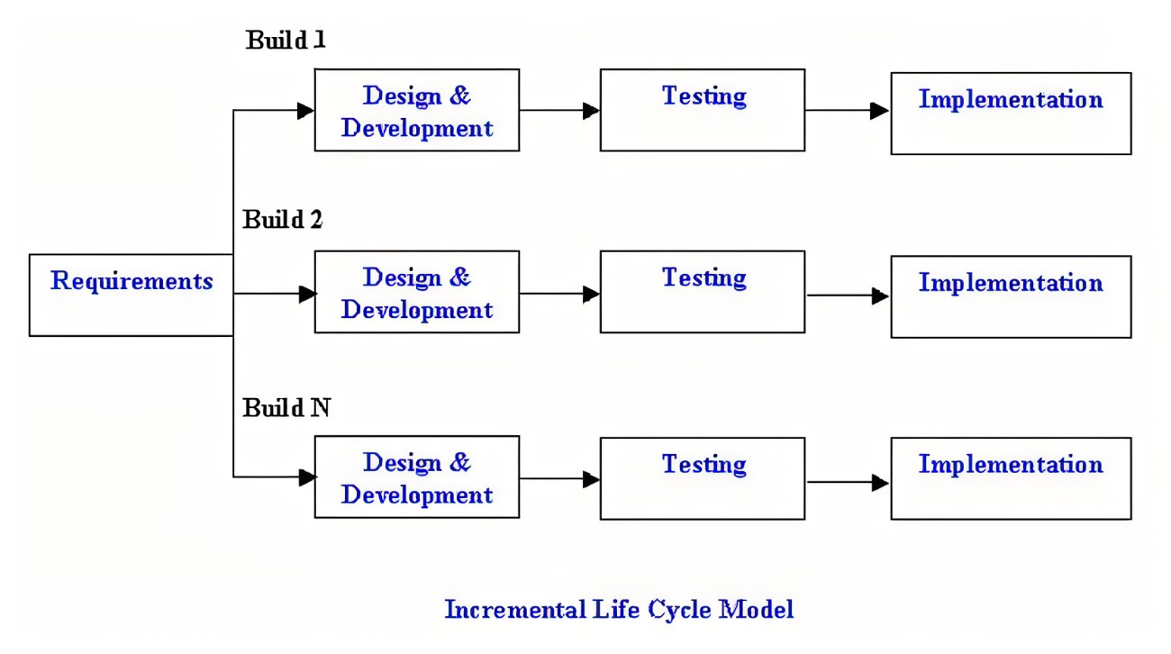

## **phases of incremental model :-**

1. **Requirement analysis:**
2. **Design & Development:**
3. **Testing:**
4. **Implementation:**

**Design:**

**ER- Diagram:-**

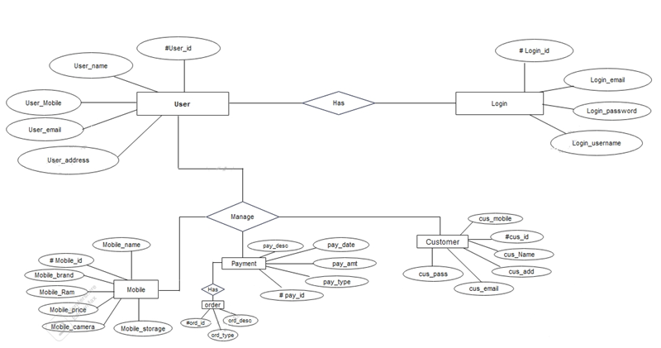

**Fig:ER-Diagram**

**The Symbols that used in ER Diagram:-**

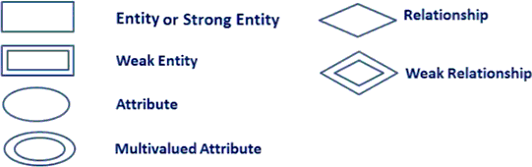

**Data Flow Diagram(DFD):-**

* 1. **0-level DFDM :**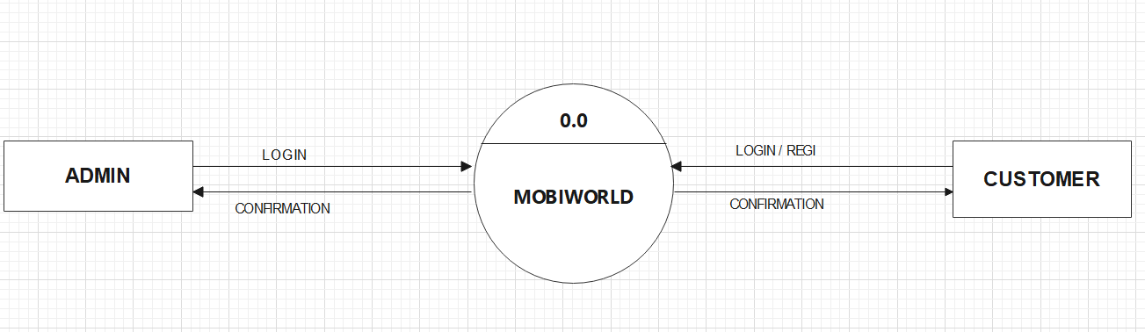

# **Fig 2.3 DFD LEVEL 0 DIAGRAM**

1. **level DFD:-**.

In 1-level DFD level, the system is exposed with more processing details. The process that need to carried out are:-

* + Admin.
  + Enquiry.
  + Bill.

This process provided certain information:-

* + Admin can login & logout.
  + Enquiry for request for enquiry & request is done.
  + Generate a bill& customer pay bill.

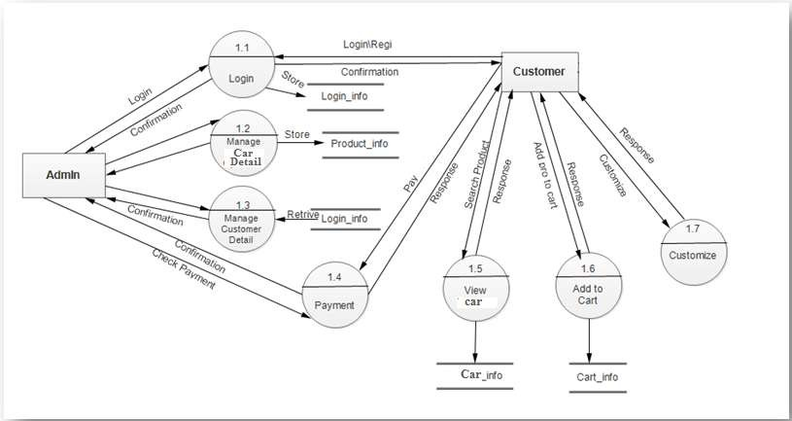

# **Fig 2.4:- DFD**

# **LEVEL 1 DIAGRAM**

**Use Case Diagram:-**

# **Association:**

It identifies an intraction between actor and user.Each association represent a dialog.

# **Extends Relationship :-**

Identifies a reusable test use case that is conditionally intrrupt the execution of another use case by using its functionality.

# **Generalization :-**

identidies an inheritance relationship actor or between use case.

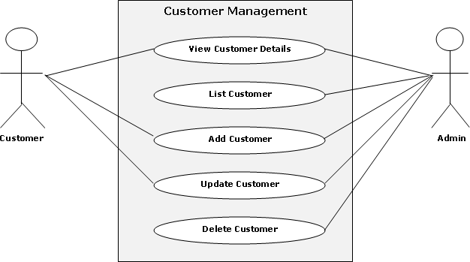

# **Fig 2.5 :- Use case diagram.**

**RESULT:**

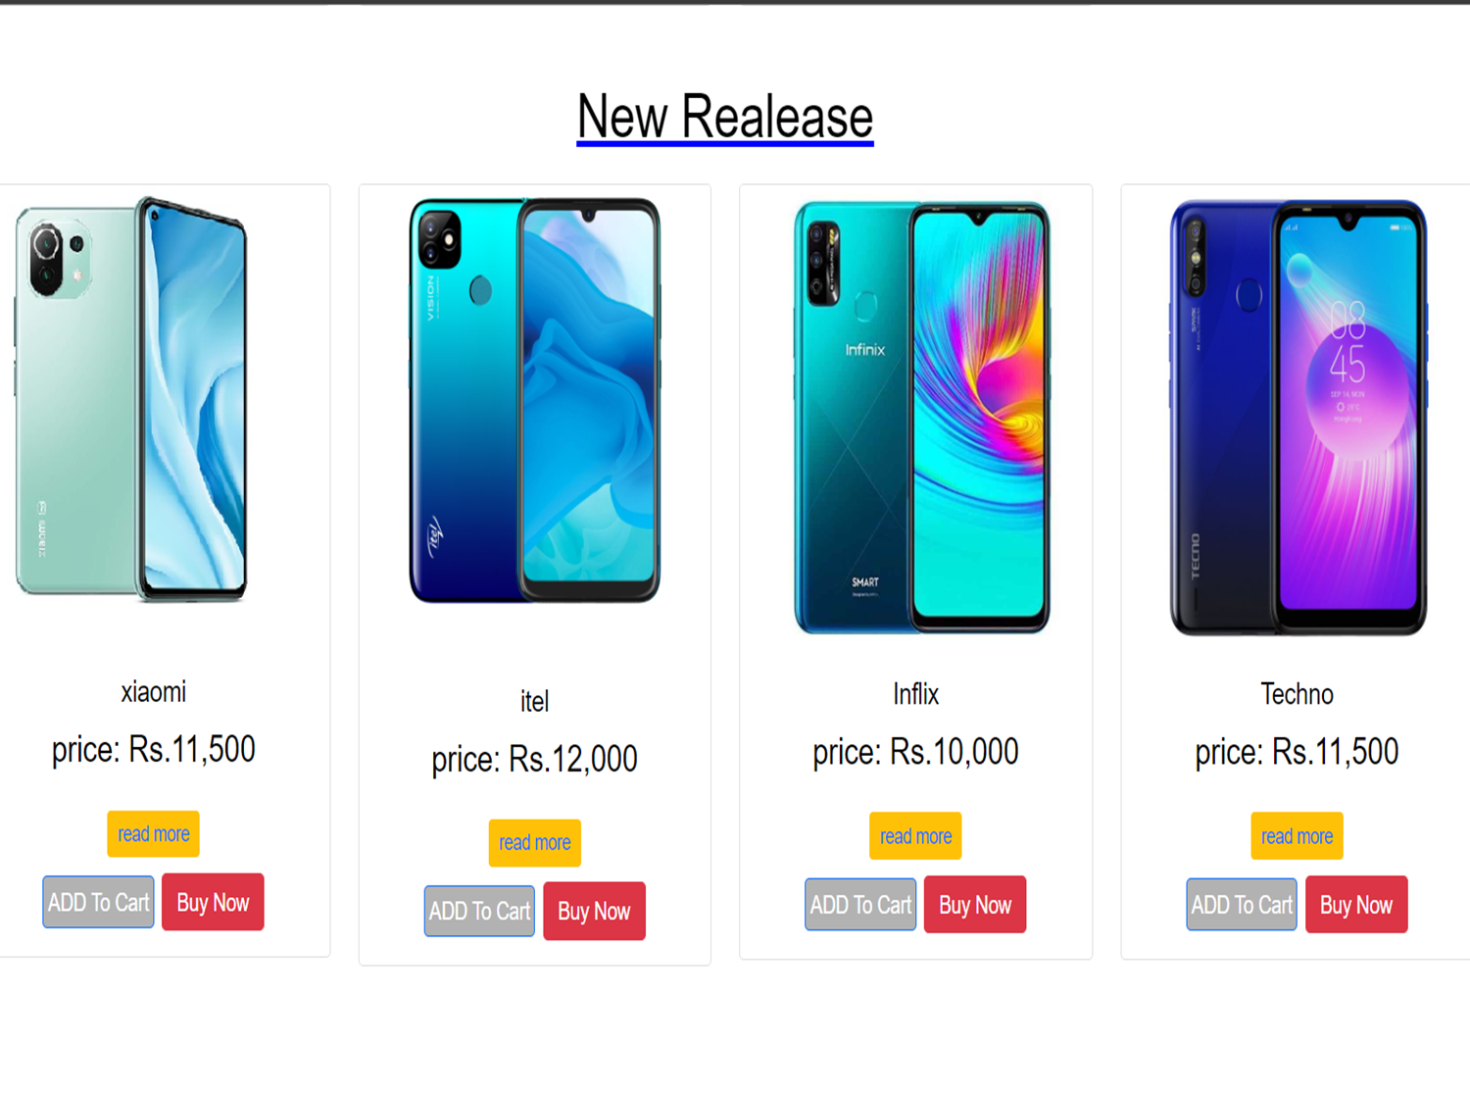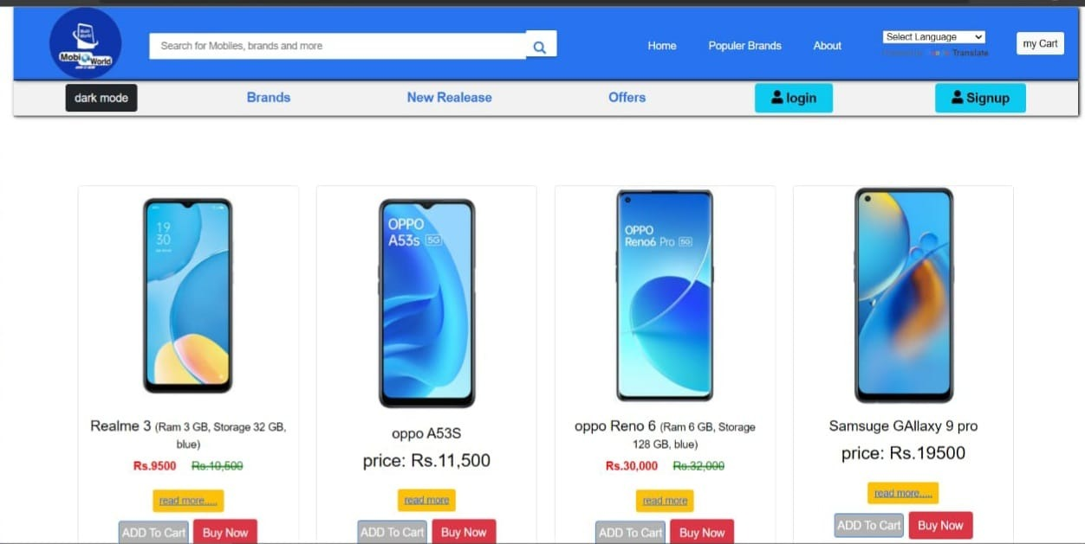**HOME PAGE :-**

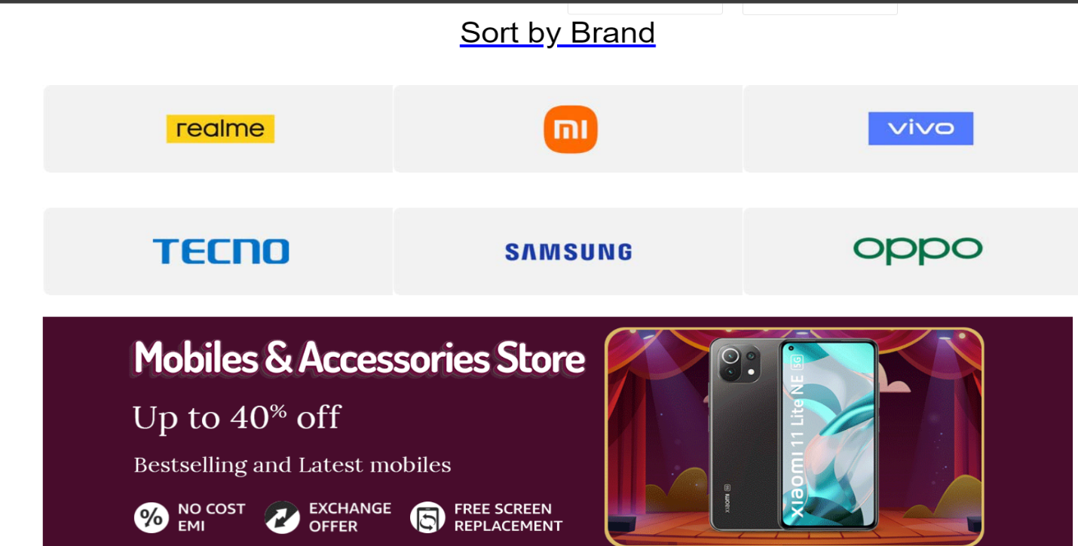**SORT BY BRAND PAGE**

**CONCLUSION**

Using mobiworld website you can save your time .the mobiworld is e-Commarse website that provide you mobile phone .we can say that online shopping is a trending business and mobiworld also support you to find your favorite mobile. Mobiworld website get our desired products and can also gift the same to our close ones

**REFERENCES**

a) Websites

1. [www.w3schools.com](http://www.w3schools.com)

2. [www.geeksforgeeks.com](http://www.geeksforgeeks.com)

3. [www.tutorialspoints.com](http://www.tutorialspoints.com)

4. [www.learnigpoints.com](http://www.learnigpoints.com)

5. [www.tutorialshub.com](http://www.tutorialshub.com)

6. [www.google.com](http://www.google.com)

7. [www.javatpoint.com](http://www.javatpoint.com)

b) Books

1. Software engineering

2. Iwt

3. Ecommerce concepts

4. DBMS







