CREATED TOURS AND TRAVELS WEBSITE

ALTOURS

# Kajal Patil1 Priya Choudhary2 priyanka Lande3

1Dept. of Computer Science & Engg.,1Tha.Shiv Kumar Memorial Engg.College, Burhanpur(M.P.), India.

# ABSTRACT

tourism is one of the fastest growing industries in the tourism industry. People are becoming more interested in events of all kinds. Events can offer social and economic benefits to destinations. Hotel managers can use events to improve the quality of the hotel experience for guests. Our platform offers a wide range of exciting and unique tours to showcase the beauty and culture of our city. From historic landmarks to hidden gems, our knowledgeable guides will take you on an unforgettable journey through the streets and neighborhoods of our vibrant community. Our tours are designed for all types of travelers, whether you're a first-time visitor or a local looking for a fresh perspective. Join us and discover the best that our city has to offer.

# INTRODUCTION

Tourism is an activity of the movement of people that deserves the praise of all human beings. It can further be called activity of movement of people (visitors) .We are thrilled to offer a wide range of exciting and unforgettable travel experiences to destinations all over the world. Our team of expert travel advisors are dedicated to helping you create the perfect itinerary that suits your preferences and budget. With our carefully curated selection of accommodations, transportation options, and activities, we aim to provide you with the ultimate travel experience. Browse our website and discover the endless possibilities that await you. Let's start planning your next adventure today

**Methodology**

**Software Development Life Cycle (SDLC):-**

A software development life cycle (SDLC) model is a conceptual framework describing all activities in a software development project from planning to maintenance. This process is associated with several models, each including a variety of tasks and activities. SDLC provides a series of steps to be followed to design and develop a software product efficiently.

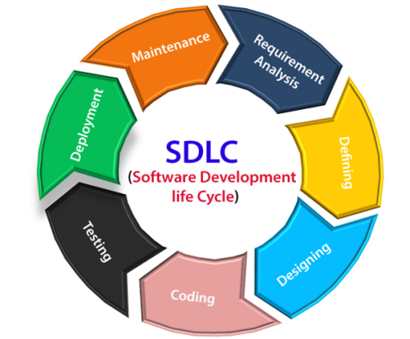

**Type of SDLC:-**

1. Waterfall Model
2. RAD Model
3. Spiral Model
4. Incremental Model
5. Iterative Model
6. Agile Model
7. V-Model

**a)Iterative Model**

In the Iterative model, iterative process starts with a simple implementation of a small set of the software requirements and iteratively enhances the evolving versions until the complete system is implemented and ready to be deployed.

An iterative life cycle model does not attempt to start with a full specification of requirements. Instead, development begins by specifying and implementing just part of the software.



**2.Diagram**

**a) DFD (Data Flow Diagram):-** The data flow diagrams (DFD) depict the information flow and the transforms that are applied on the data as it moves from input to output. The data flow diagrams are used to represent the system at any level of abstraction. The DFD can be partitioned into levels that represent increase in information flow and detailed functionality

**a.1)DFD LEVEL- 0**

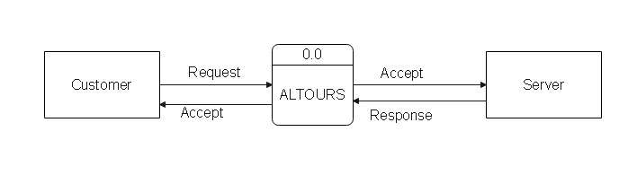

**a.2)DFD LEVEL- 1 :-** 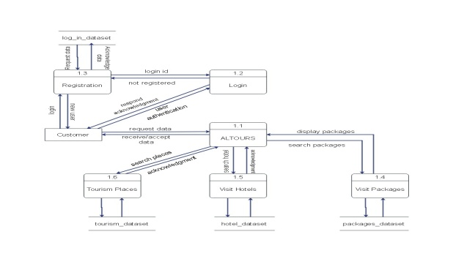

**)DFD LEVEL- 2 :-** In 2-level DFD, a context diagram is decomposed into multiple bubbles/processes.

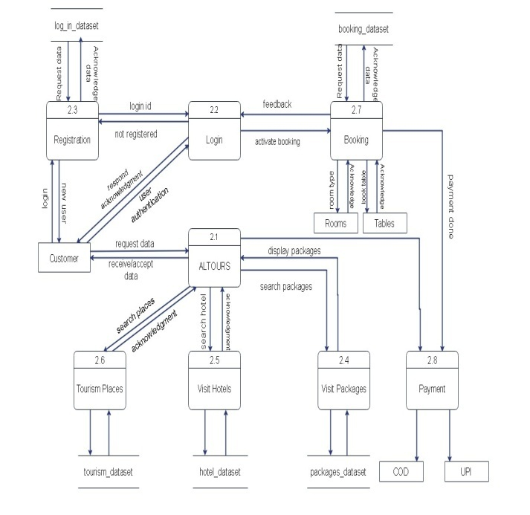

**b)Sequence Diagram** In the sequence diagram how the objects interact with the other objects is shown. There are sequences of events that are represented by a sequence diagram Purpose of a Sequence Diagram

1. To model high-level interaction among active objects within a system.
2. To model interaction among objects inside a collaboration realizing a use case.

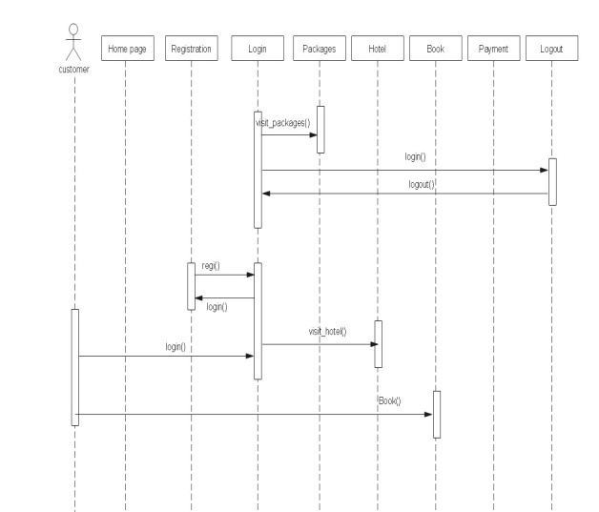

**c)Activity Diagram:-** The activity diagram is a graphical representation of representing the flow of interaction within specific scenarios. It is similar to a flowchart in which various activities that can be performed in the system are represented. This diagram must be read from top to bottom.

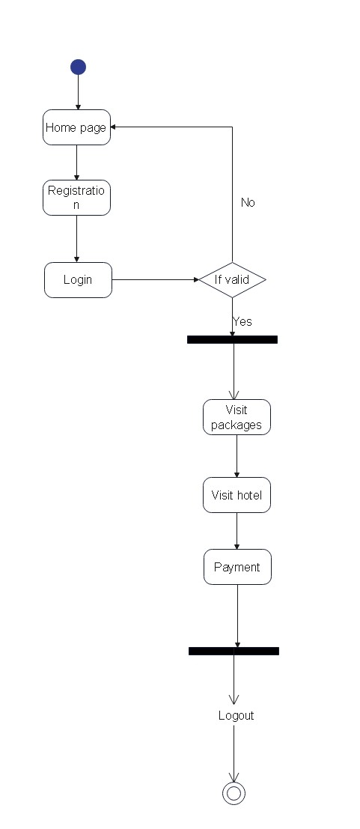

**d)Usecase diagram :-** Use case diagram represent the overall scenario of the system. A scenario is nothing but a sequence of steps describing iteration between a user and a system. Use cases represent the behavior of the system. Typically various functions are represented as use cases.

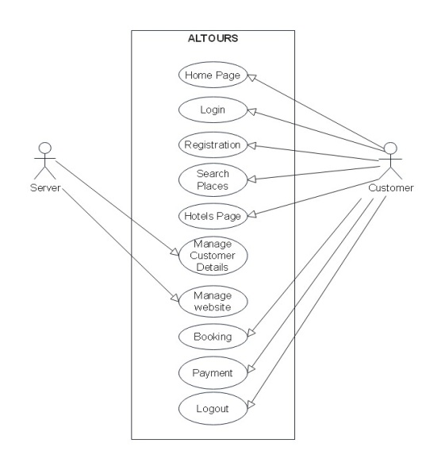**IMPLEMENTATION**

**A. Technologies Used**

Various front-end and back-end technologies are available in this era of digitalization. The technologies used in this project are discussed briefly in the following sections.

**1.Front End Technologies**

***a) HTML***

HTML stands for HyperText Markup Language. It is a markup language used to create and structure the content of a web page. In simpler terms, HTML is used to define the structure and content of web pages, including text, images, videos, and links. HTML uses tags to mark up elements on a page and specifies how they should be displayed in a web browser. With HTML, web designers can create websites that are easy to navigate and accessible to all users, regardless of their device or platform. HTML is the backbone of the World Wide Web, and it provides the foundation for building web pages and web applications.help of different tags available in HTML language.

***b) CSS***

CSS stands for Cascading Style Sheets. It is a stylesheet language used to describe the presentation of a document written in HTML or XML. In simpler terms, CSS is used to style and format the appearance of web pages. It allows web designers to separate the content of a website from its presentation, making it easier to create visually appealing and consistent web pages.

**c)JavaScript**

JavaScript is a high-level programming language that is commonly used to add interactive and dynamic elements to web pages. It is often used in conjunction with HTML and CSS to create interactive user interfaces, web applications, and games. JavaScript can be executed in web browsers or on the server side using Node.js. With JavaScript, web developers can create responsive web pages that can react to user input, update data in real-time, and provide dynamic functionality to users. JavaScript is a versatile language that has a wide range of applications beyond web development, including game development, mobile app development, and server-side programming.

**d)BootStrap**

Bootstrap (Shenoy & Sossou, 2014) is a free and open-source CSS framework directed at responsive, mobile-first front-end web development. It contains CSS and (optionally) JavaScript-based design templates for

typography, forms, buttons, navigation, and other interface components.

**2. Back End Technologie**

**a)Python**

Python is an interpreted, high-level, general-purpose programming language. Created by Guido van Rossum and first released in 1991 (Kuhlman, 2011), Python‟s design philosophy emphasizes code readability with its notable use of significant whitespace. Its language constructs and object-oriented approach aims to help

programmers write clear, logical code for small and large-scale projects.

**RESULTS**

**Home :** This. the home page of Altours.

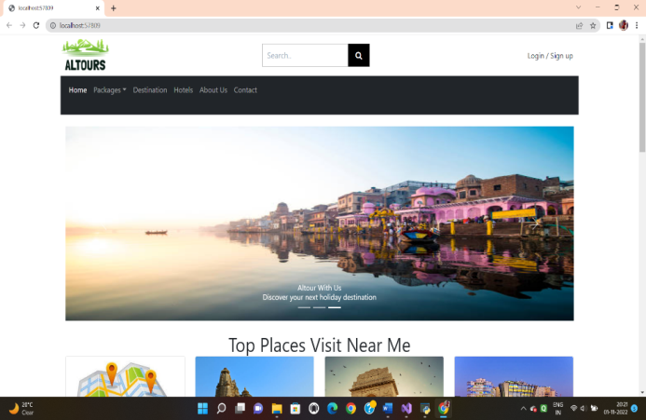

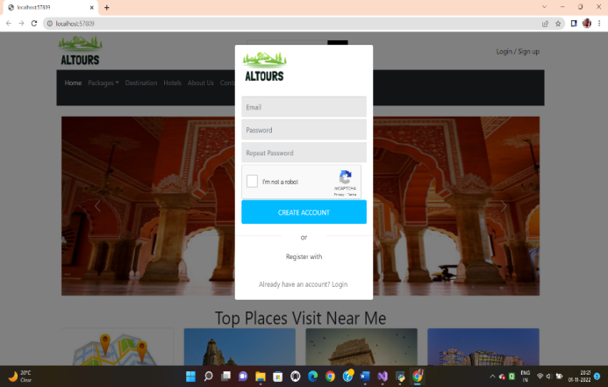

**CONCLUSION**

After analyzing the results obtained, the project developed can be considered satisfiable. It can be concluded that the website will be very helpful to students in their educational life as it

provides all educational resources required in a college or school life. As the project works as an Educational cum Tours and travel Website and thus students can donate or sell their old books too. To conclude, the project is developed using the proper Software Engineering process, following the Iterative Model of SDLC.

**REFERENCES**

**a) Websites**

1. [**www.w3schools.com**](http://www.w3schools.com)
2. [**www.geeksforgeeks.com**](http://www.geeksforgeeks.com)
3. **www.djangoproject.com**
4. [**www.tutorialspoints.com**](http://www.tutorialspoints.com)
5. [**www.learnigpoints.com**](http://www.learnigpoints.com)
6. [**www.tutorialshub.com**](http://www.tutorialshub.com)
7. [**www.pythonconcept.com**](http://www.pythonconcept.com)
8. [**www.google.com**](http://www.google.com)
9. [**www.pythonlean.org**](http://www.pythonlean.org)
10. [**www.javatpoint.com**](http://www.javatpoint.com)

**b) Books**

1. **Software engineering**
2. **Python**
3. **Iwt**
4. **Ecommerce concepts**
5. **DBMS**

**c)Reference Research Paper**

1. Adamya Shyam , Nitin Mukesh A Django Based Educational Resource Sharing Website: Shreic,Volume 64, Issue 1, 2020.
2. Josh JuneauJim BakerVictor NgLeo SotoFrank Wierzbicki,The Definitive Guide To Jython pp 281-325, Web Applications With Django
3. Jian Chou, Lin Chen Hui Ding; Jingxuan Tu, Baowen Xu,A Method of Optimizing Django Based on Greedy Strategy,2013 10th Web Information System and Application Conference