# PLANTO(AGRICULTURE)

# Bhushan Lahase1 Mohit Yadav2

1Dept. of Computer Science & Engg.,1Tha.Shiv Kumar Memorial Engg.College, Burhanpur(M.P.), India.

# ABSTRACT

# Our goal is to provide the latest news, trends, and insights on topics ranging from crop production and livestock management to agricultural technology and sustainability. Whether you're a seasoned farmer or just starting out, our website offers a range of articles, videos, and tutorials to help you stay informed and up-to-date on the latest developments in the industry. allowing us to foster a community of learning and collaboration. Join us and discover the endless possibilities of modern agriculture., the crop, statistical details and new tendencies. The trends of the crops act so that these will be pretty important to the users who access these via the Internet. The main features of the information system includes information retrieval facilities for users from anywhere in the form of obtaining statistical information about fertilizer.

# INTRODUCTION

# Our platform is dedicated to providing the latest news, insights, and resources on agriculture and farming practices. We are passionate about promoting sustainable and efficient farming methods that maximize yields while minimizing the impact on the environment. Whether you're a farmer, a researcher, or just interested in learning more about agriculture, our website offers a wealth of information on topics such as crop management, livestock production, soil health, and agricultural technology. We also provide a forum for industry experts and stakeholders to share their expertise and engage in meaningful discussions on the challenges and opportunities facing the agriculture sector. Join us and be a part of the conversation on the future of agriculture.

# Methodology

**1.SDLC**

The SDLC (Software Development Life Cycle) model is a framework used in software engineering to guide the development process of software applications. It is a structured approach that divides the software development process into distinct phases that must be completed sequentially. The SDLC model typically includes six phases:

1. Requirements gathering and analysis
2. Design
3. Implementation or coding
4. Testing
5. Deployment
6. Maintenance

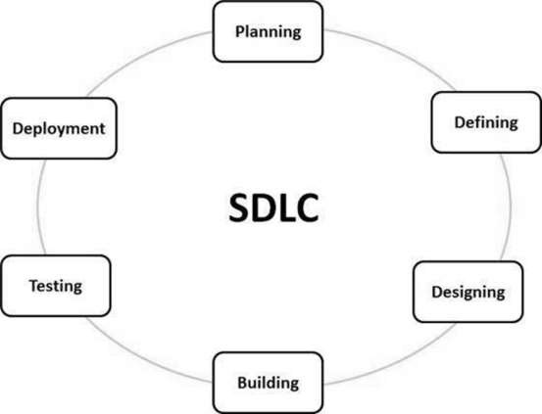

**a)Iterative Model**

In the Iterative model, iterative process starts with a simple implementation of a small set of the software requirements. An iterative life cycle model does not attempt to start with a full specification of requirements.This process is then repeated, producing a new version of the software at the end of each iteration of the model

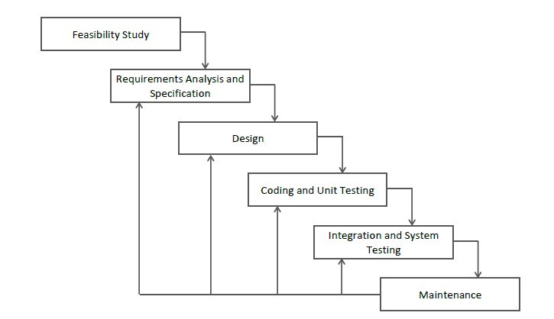

**2.Diagram**

**a) DFD (Data Flow Diagram):-** A Data flow diagram is graphical tool that allows system analysis (and system user) to depict the flow of data in information system

**a.1)DFD LEVEL- 0 :-**

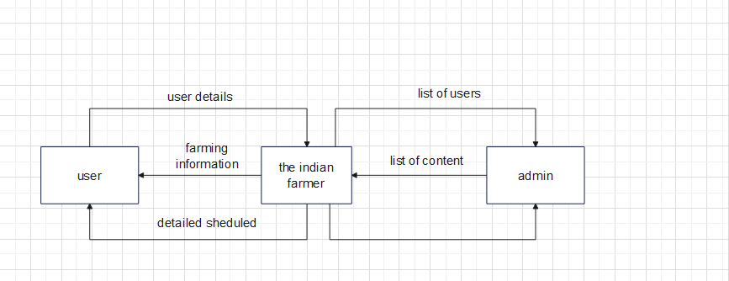

**b)Sequence Diagram** The sequence diagram represents the flow of messages in the system and is also termed as an event diagram. whereas the message flow is represented by a vertical dotted line that extends across the bottom of the page. It incorporates the iterations as well as branching.

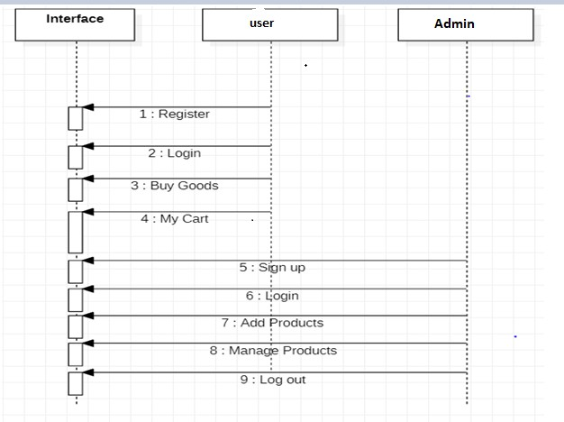

**c)Activity Diagram** The activity diagram helps in envisioning the workflow from one activity to another. 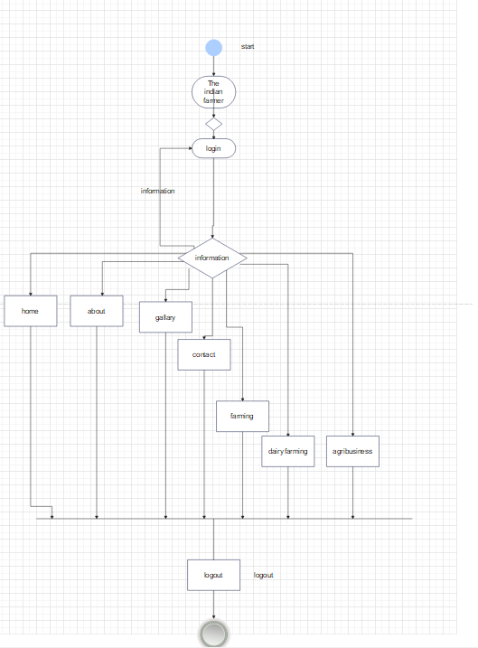

**d)Usecase diagram :-** A use case diagram is used to represent the dynamic behavior of a system. It encapsulates the system's functionality by incorporating use cases, actors, and their relationships. It models the tasks, services, and functions required by a system/subsystem of an application. It depicts the high-level functionality of a system and also tells how the user handles a system.

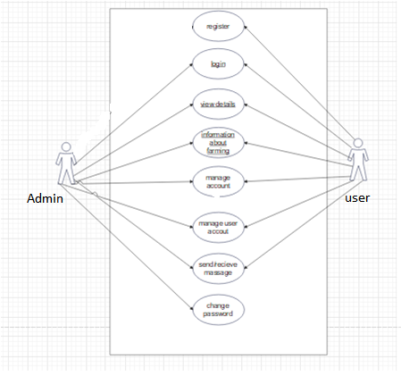

**IMPLEMENTATION**

**1.Front End Technologies**

***a) HTML***

HTML stands for Hypertext Markup Language. It is a markup language used to create and structure content for the web. HTML consists of a series of elements, or tags, that are used to define the structure of a web page, such as headings, paragraphs, lists, images, and links. HTML is the backbone of web development and provides the foundation for creating dynamic and interactive web pages. It allows web developers to create content that is accessible and easy to read for both humans and machines. With HTML, developers can create websites that are responsive and accessible on various devices, from desktop computers to mobile phones and tablets.

***b) CSS***

CSS stands for Cascading Style Sheets, and it is a programming language used for styling web pages. CSS is used to define how HTML elements are displayed on a web page, such as the layout, colors, fonts, and other visual aspects. By separating the presentation style from the content, CSS makes it easier to maintain and update the design of a website. CSS code is written in a separate file or can be embedded within an HTML document, and it uses a set of rules and selectors to target specific HTML elements and apply styles to them. With CSS, web designers can create visually appealing and consistent web pages that are optimized for both desktop and mobile devices.

**c)JavaScript**

JavaScript (JS) is a high level, interpreted programming language. JavaScript has curly-bracket syntax, dynamic typing, prototype-based object-orientation, and first-class functions.

The vast majority of websites use it, and major web browsers have a dedicated JavaScript engine to execute it. JavaScript provides the facility to validate the form on the client-side so data processing will be faster than server-side validation

**d)BootStrap**

Bootstrap (Shenoy & Sossou, 2014) is a free and open-source CSS framework directed at responsive, mobile-first front-end web development. It contains CSS and (optionally) JavaScript-based design templates for

typography, forms, buttons, navigation, and other interface components.

To use bootstrap, we are required to either install in our system or use CDN. CDN is short for content delivery network. A CDN is a system of distributes servers that deliver pages and other web content to a user, based on the geographic locations of the user, the origin of the

webpage and the content delivery server

**RESULTS**

**Home :** This. the home page of Golden India

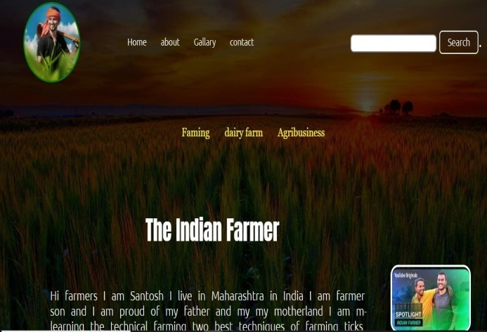

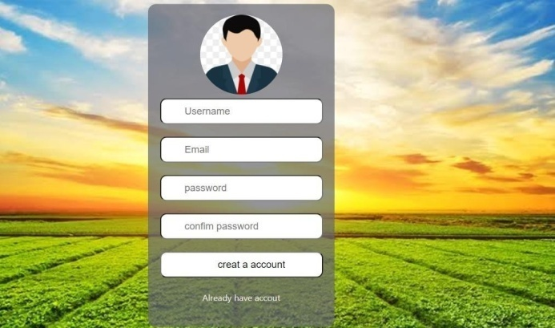

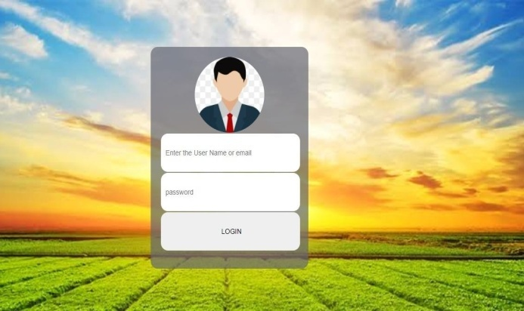

**CONCLUSION**

Our website provides usefull information to farmers .

Our website provide information to the farmers for planting the crop to harvesting.

In conclusion, our agriculture website aims to provide valuable information and resources to farmers, agriculture enthusiasts, and anyone interested in the world of agriculture. We offer a diverse range of articles, videos, and tutorials covering various aspects of farming, including crop cultivation, livestock rearing, irrigation, pest control, and sustainable agriculture practices.

.

**REFERENCES**

**a) Websites**

1. [**www.w3schools.com**](http://www.w3schools.com)
2. [**www.geeksforgeeks.com**](http://www.geeksforgeeks.com)
3. [**www.tutorialspoints.com**](http://www.tutorialspoints.com)
4. [**www.learnigpoints.com**](http://www.learnigpoints.com)
5. [**www.tutorialshub.com**](http://www.tutorialshub.com)
6. [**www.google.com**](http://www.google.com)
7. [**www.phpthonlean.org**](http://www.phpthonlean.org)
8. [**www.javatpoint.com**](http://www.javatpoint.com)

.