CREATED ECOMMERCE WEBSITE

GOLDEN INDIA

# Pramod Patel1 Ganpat Bharwad2 Bhushan Motekar3

1Dept. of Computer Science & Engg.,1Tha.Shiv Kumar Memorial Engg.College, Burhanpur(M.P.), India.

# ABSTRACT

# Our platform is dedicated to providing you with the highest quality, organic milk products that are ethically sourced and sustainably produced. We work with local farmers who prioritize the health and welfare of their animals and the environment. Our milk is free from antibiotics, hormones, and GMOs, ensuring that you get only the purest and healthiest milk possible. Our product range includes whole milk, low-fat milk, flavored milk, and various dairy products, such as cheese, butter, and yogurt. We are committed to providing you with the best products and the best service possible.

# INTRODUCTION

# We are dedicated to providing you with the highest quality organic milk products that are not only delicious but also sustainably produced. Our cows are raised on organic farms that prioritize animal welfare and environmentally responsible farming practices. Our milk is free from antibiotics, hormones, and pesticides, ensuring that you are consuming only the purest and most natural milk possible. Our range of products includes organic milk, butter, cheese, and yogurt, all of which are carefully crafted to deliver the best taste and nutritional value. We believe that food should be both healthy and enjoyable, and we strive to deliver on that promise with our organic milk products. Browse our website to learn more about our products.

**Methodology**

**1.SDLC**

SDLC stands for Software Development Life Cycle, and it is a process used to develop software applications. The SDLC consists of several stages or phases that provide a structured approach to software development, including planning, designing, building, testing, and deployment.

The first phase of the SDLC is planning, where the project goals, scope, requirements, and timelines are defined. This is followed by the design phase, where the software architecture, user interface, and functionality are determined.

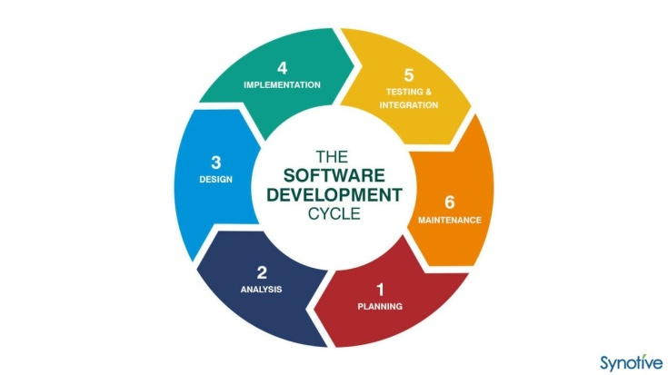

**Type of SDLC:-**

1. Waterfall Model
2. RAD Model
3. Spiral Model
4. Incremental Model
5. Iterative Model
6. Agile Model
7. V-Model

**a)Iterative Model**

The iterative model is a software development process that emphasizes the repetition of a set of activities in order to refine and improve a software system. It is a type of incremental model, which means that development is divided into smaller, more manageable parts or iterations. In the iterative model, the development team begins by defining a subset of the overall requirements and designing and implementing a solution to meet those requirements. The team then tests and evaluates the solution, making changes as necessary. This process is repeated multiple times, with each iteration building upon the previous one, until the complete solution is developed and tested.

The iterative model is often used in agile software development methodologies, which prioritize flexibility, collaboration, and continuous improvement. By breaking development down into smaller iterations, teams can more easily manage complex projects and respond to changing requirements or feedback from stakeholders. The iterative model also allows for testing and feedback to occur throughout the development process, which can result in a more robust and user-friendly final product.

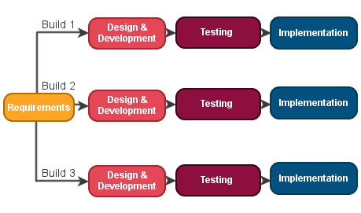

**2.Diagram**

**a) DFD (Data Flow Diagram):-** The data flow diagram are used to represent the system at any level of abstraction information flow. A Data flow diagram is graphical tool that allows system analysis (and system user) to depict the flow of data in information system

**a.1)DFD LEVEL- 0 :-** Level 0 DFDs are also known as context level DFDs.

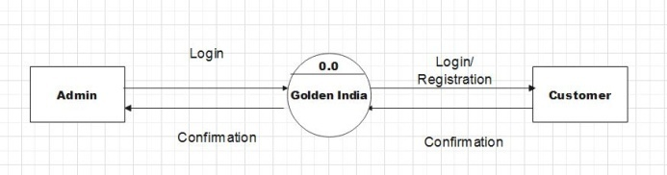

**a.2)DFD LEVEL- 1 :-** In 1-level DFD, a context diagram is decomposed into multiple bubbles/processes. 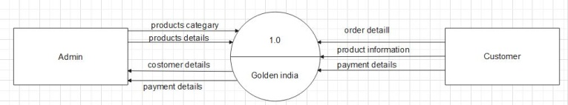

**b)Sequence Diagram** The sequence diagram represents the flow of messages in the system and is also termed as an event diagram. It helps in envisioning several dynamic scenarios. It portrays the communication between any two lifelines as a time-ordered sequence of events, such that these lifelines took part at the run time. In UML, the lifeline is represented by a vertical bar, whereas the message flow is represented by a vertical dotted line that extends across the bottom of the page.

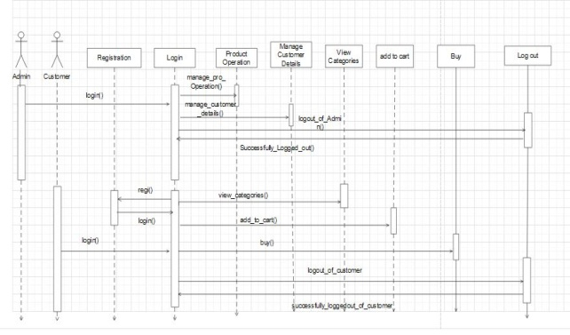

**c)Activity Diagram:-** In UML, the activity diagram is used to demonstrate the flow of control within the system rather than the implementation. It models the concurrent and sequential activities.The activity diagram helps in envisioning the workflow from one activity to another. It put emphasis on the condition of flow and the order in which it occurs. The flow can be sequential, branched, or concurrent, and to deal with such kinds of flows, the activity diagram has come up with a fork, join, etc.It is also termed as an object-oriented flowchart.

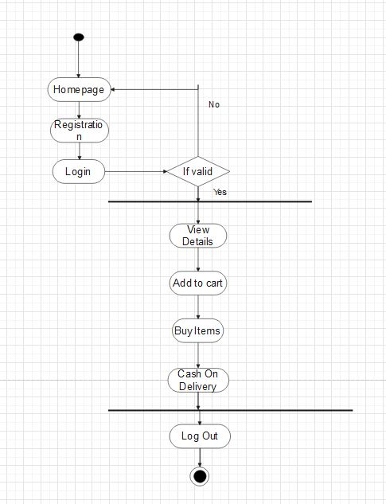

**d)Usecase diagram :-** A use case diagram is used to represent the dynamic behavior of a system. It encapsulates the system's functionality by incorporating use cases, actors, and their relationships. It models the tasks, services, and functions required by a system/subsystem of an application. It depicts the high-level functionality of a system and also tells how the user handles a system.

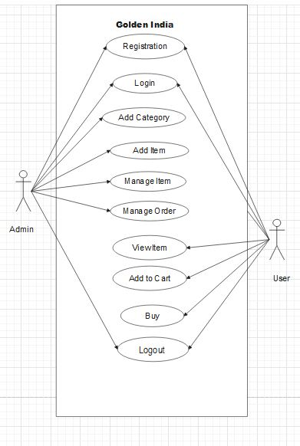

**IMPLEMENTATION**

**1.Front End Technologies**

***a) HTML***

HTML stands for HyperText Markup Language, and it is the standard markup language used to create and structure content on the World Wide Web. It uses a series of tags and attributes to define the structure and presentation of web pages, including text, images, video, and other multimedia elements. HTML is used alongside Cascading Style Sheets (CSS) and JavaScript to create visually appealing and interactive web pages and web applications. HTML documents are interpreted by web browsers, which display the content according to the markup and styles defined in the code. HTML is constantly evolving, with new versions and updates released periodically to accommodate new technologies and web standards.

***b) CSS***

CSS stands for Cascading Style Sheets, and it is a style sheet language used for describing the presentation of markup languages such as HTML and XML. CSS allows web developers to separate the presentation of a document from its content, making it easier to manage and update the visual style of a website or web application. CSS provides a wide range of formatting options, such as colors, fonts, layouts, and animations, which can be applied to specific HTML elements or groups of elements. By using CSS, developers can create complex and sophisticated visual designs without having to write complex HTML code or use inline styles. CSS is a fundamental technology for web development and is supported by all modern web browsers.

**c)JavaScript**

JavaScript is a programming language that is commonly used to create interactive and dynamic effects on websites. It is a high-level, interpreted language that allows developers to add functionality to web pages, create web applications, and build server-side applications using frameworks such as Node.js. JavaScript is supported by all modern web browsers and has a wide range of libraries and tools available for developers to use. Its syntax is similar to other programming languages such as C++ and Java, but it has its own unique features and capabilities that make it a popular choice for web development.

**d)BootStrap**

Bootstrap is a free and open-source front-end web development framework that is used to create responsive, mobile-first websites and web applications. It was developed by Twitter and is now maintained by the Bootstrap team at GitHub. Bootstrap provides a set of CSS, JavaScript, and HTML templates that can be used to create responsive web designs that automatically adjust to different screen sizes and devices. It includes a range of components and tools such as buttons, forms, navigation, typography, and more, which can be customized and extended to meet specific design requirements. Bootstrap is widely used by web developers and designers because it allows them to quickly and easily create modern, mobile-friendly web interfaces.typography, forms, buttons, navigation, and other interface components.

To use bootstrap, we are required to either install in our system or use CDN. CDN is short for content delivery network. A CDN is a system of distributes servers that deliver pages and other web content to a user, based on the geographic locations of the user, the origin of the

webpage and the content delivery server

**2. Back End Technologie**

**a)Python**

It was first released in 1991 by Guido van Rossum and has since become one of the most popular programming languages in the world.

Python's syntax is designed to be easy to read and understand, making it a great choice for beginners who are just learning how to code. It supports multiple programming paradigms, including object-oriented, functional, and procedural programming styles.

modules that can be used to perform many common programming tasks. Additionally, there are numerous third-party libraries available that can be easily installed and used to extend Python's functionality even further.

Python is an open-source language, which means that it is free to use and distribute, and it has a large and active community of developers who contribute to its ongoing development and improvement.

**RESULTS**

**Home :** This. the home page of Golden India

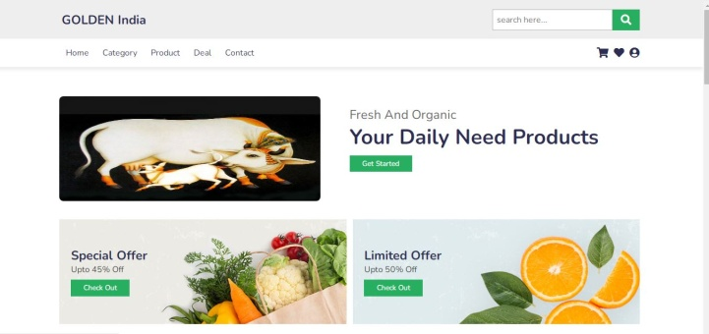

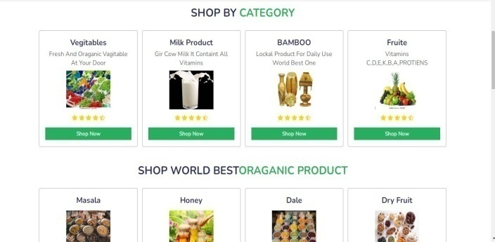

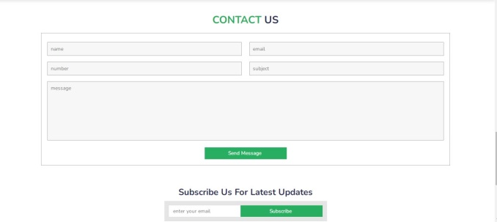

**CONCLUSION**

After analyzing the results obtained, the project developed can be considered satisfiable. It can be concluded that the website will be very helpful to students in their educational life as it

provides all educational resources required in a college or school life. As the project works as an Educational cum E-Commerce Website and thus students can donate or sell their old books too. To conclude, the project is developed using the proper Software Engineering process, following the Iterative Model of SDLC. A Project Control List was created after doing the feasibility study for functionalities as well as non-functional requirements. Then proper schema and tables that were supposed to be required in the development process were made and relationships between each table were drawn. For this ER Diagram was made which has been illustrated in the paper.

**REFERENCES**

**a) Websites**

1. [**www.w3schools.com**](http://www.w3schools.com)
2. [**www.geeksforgeeks.com**](http://www.geeksforgeeks.com)
3. **www.djangoproject.com**
4. [**www.tutorialspoints.com**](http://www.tutorialspoints.com)
5. [**www.learnigpoints.com**](http://www.learnigpoints.com)
6. [**www.tutorialshub.com**](http://www.tutorialshub.com)
7. [**www.pythonconcept.com**](http://www.pythonconcept.com)
8. [**www.google.com**](http://www.google.com)
9. [**www.pythonlean.org**](http://www.pythonlean.org)
10. [**www.javatpoint.com**](http://www.javatpoint.com)

**b) Books**

1. **Software engineering**
2. **Python**
3. **Iwt**
4. **Ecommerce concepts**
5. **DBMS**