Automatic Railway Gate Control System

**Mr. S. Rambabu1, S. Mahesh2, B. Sai3, B.K. Madhu Kumar4, G. K. Ashok5,S.M. Musharaff6**

**Santhiram Engineering College, Nandyal**

2,3,4,5,6 Students at Department of Electronics and Communication and Engineering, Santhiram Engineering College, Nandyal

E-mail: [ramu.luck@srecnandyal.edu.in](mailto:ramu.luck@srecnandyal.edu.in), [19x51a0456@srecnandyal.edu.in](mailto:19x51a0456@srecnandyal.edu.in), [19x51a0471@srecnandyal.edu.in](mailto:19x51a0471@srecnandyal.edu.in), 19x51a0474[@srecnandyal.edu.in](mailto:@srecnandyal.edu.in), [19x51a0413@srecnandyal.edu.in](mailto:19x51a0413@srecnandyal.edu.in), [19x51a0452@srecnandyal.edu.in](mailto:19x51a0452@srecnandyal.edu.in)

***Abstract*** —Human safety is a major goal for railways. Automatic control at the level crossing when the arrival/departure of the train takes place is the intention of the paper. When a train passes through the crossing, the railway gate closes. Two IR sensors are used to detect the arrival and departure of a train.

The opening and closing of the gate will be done with the help of a robot. The status of the gate will be given to the motorman well in advance which will make it safer in the event of an accident. The closing of the gate is indicated by the Buzzers. The system helps in avoiding accidents at level crossing. The hardware is connected to the internet. The system is more cost efficient.

**Keywords *—*** Railway Gate; Level Crossing; nmanned; Microcontroller.

# I. INTRODUCTION

Every day, our lives become more dependent on the digital information technology embedded in our environment. More than 98% of the processors used today are embedded systems, and aren't visible to the customer as 'computers' in the ordinary sense. An Embedded System is a special-purpose system in which the computer is completely encapsulated by or dedicated to the device or system it controls. Unlike a general purpose computer, such as a personal computer, an embedded system performs one or a few pre-defined tasks, usually with very specific requirements. Since the system is dedicated to specific tasks, design engineers can optimize it, reducing the size and cost of the product. Embedded systems are often mass produced, benefiting from economies of scale.

The increasing use of PC hardware is one of the most important developments in high-end embedded systems in recent years. Hardware costs of high-end systems have fallen dramatically as a result of this trend, making possible some projects which weren't done before because of the high cost of non-PC-based embedded hardware.

But the software choices for the embedded PC platform aren't as attractive as the hardware. An embedded system is usually housed on a single microprocessor board with the programs stored in ROM. Virtually all appliances that have a digital interface— watches, microwaves, VCRs, cars— use embedded systems. As the embedded system is a combination of software and hardware. By a valve, you can control the flow of fuel to an engine.

As the embedded system is a combination of software and hardware.

**II. REVIEW OF LITERATURE**

The embedded computer system is versatile in all kinds of enterprises, from the simplification of deliverable products to a reduction in costs in their development and manufacture. Complex systems with rich functionality require special Operating systems that take into account major characteristics of embedded systems. The special computer system is usually less powerful than general-purpose systems.. Sometimes a low power CPU with a limited amount of memory is used in embedded systems. Many embedded systems use very small operating systems; most of these are very limited.Since the embedded system is dedicated to specific tasks, design engineers can optimize it, reducing the size and cost of

the product or increasing the reliability and performance. Some embedded systems are mass-produced, benefiting from economies of scale. Some embedded systems have to operate in extreme conditions such as high temperature and high humidity. However, there are significant differences. It isn't compulsory to have an operating system in every embedded system. For small appliances such as remote control units, air conditioners, toys etc, there is no need for an operating system and you can write only the software specific to that application.

.

# III. METHODOLOGY DETAILING THE ACTIVITIES AND SUBACTIVITIES

Slow response to fire accidents has been solved with the development of a smart fire detection system. The inputs give readings for the system to analyze such as the sensors and the wi-fi module. The inputs are temperature, gas, and flame sensors. The web page displays the readings from the inputs. There are outputs that indicate a fire. When the fire or smoke is released in the shopping malls, schools, theaters, showrooms, industrial areas, and so on. The sensor can detect the fire and smoke and give an alert by using a buzzer and we can also use the blink app wherever you are in the world.

**Block Diagram**

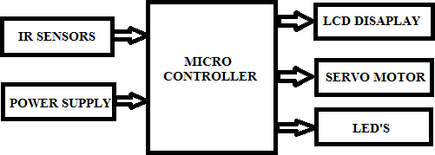

# B. COMPONENT DESCRIPTION AND USED HARDWARE REQUIREMENTS:

The component requirements of hardware and software are given below.

1. An IR sensor is an electronic device that can measure and detect IR radiation. William Herchel accidentally discovered the radiation in 1800.

He noticed that the temperature just beyond the red light was the highest..

1. **BUZZER:**

The buzzer converts audio signals into sound signals. It is usually powered by DC. It is used in many electronic products as a sound device.

1. **Servo Motor:**

A type of motor that rotates with great precision is a servo motor. Normally this type of motor has a control circuit that gives feedback on the current position of the motor shaft, this feedback allows the motor to move with great precision. If you want to change the position of an object, you can use a motor. It is a simple motor that runs through a mechanism. If the motor is powered by a DC power supply, then it's called DC servo motor, and if it's powered by an AC power supply, then it's called AC servo motor. The only thing we will be discussing is the DC motor.

1. **Arudino:**

The ATmega328 is used as a controller in the UNO. The beginners prefer the UNO board for their electronics project. The UNO board is a type of board. The most used board is the Arduino board. The board has 14 digital input/output pins, six of which are analog, one power jack, one reset button, and other components. The components can be used in the project if they are attached to the UNO board. The board can be directly charged by the DC supply or by theusb port.

1. **LED:**

We offer a wide range of traffic signals. The range includes a Pedestrian Stop and Walk and a Led Traffic Signal. The products we offer are used for safety on the roads. These products are demanded by the clients due to their easy installation and great visibility factor.

## IV. RESULT AND DISCUSSION

The proposed model successfully made human safety possible in areas like the railway crossing near rural areas as well as urban areas. The servo motor and senor like IR and Ultrasonic sensors combine to make a system where the object/vehicle/vehicle/trainself is sensed when it passes the gateway and corresponding actions are taken by the motor to open or close the gate, also the buzzer is used to warn the nearby area about the arrival of the train. The sensors are installed before a real range from the gateway so that the time for arrival of train or its departure is enough to take the corresponding decision.

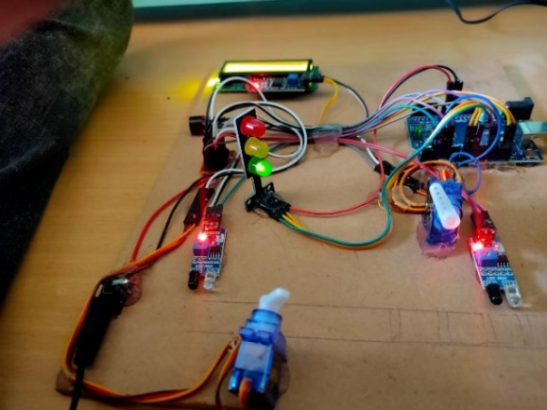

**V. FUTURE SCOPE**

The Automatic Railway Gate Control System is a simple but very useful project, which helps to open and closing the railway gate when detecting the arrival or departure of the train. The information about arrival of the train for opening or closing the door is received from nearby station. Some railway crossings are completely unmanned and many railway accidents occur at these unmanned level crossings.

## VI. REFERENCES

1. Mr.S. Rambabu, P. Aswani,“An automated traffic accident detection and alarm device”, International Journal of Technological Exploration and Learning (IJTEL) Volume 1 Issue 1, August 2012.
2. Mr.S.Rambabu,“High Performance and Low Noise BCD Adder Circuit Design Using Rate Sensing Keeper” ,vol 4,April 2015.
3. Yu, Liyang, Neng Wang, and Xiaoqiao Meng “Real-time forest fire detection with wireless sensor networks,” in Proceedings of international Conference on Wireless Communications, Networking and Mobile Computing, Vol. 2, 2005.
4. Kwon, Oh-Hyun, Sung-Min Cho, and Sun-Myung Hwang, “Design and implementation of fire detection system,” in Proceedings of Advanced Software Engineering and Its Applications, 2008.
5. Mr.S.Rambabu, “Implementing An Efficient Full Adder Using 3T XOR Gate for Low Power Applications”vol 4, Issue 4, April 2014.
6. S. Tanwar, P. Pately, K. Patelz, S. Tyagix, N. Kumar, and M. S. Obaidat, “An Advanced Internet of Thing based Security Alert System for Smart Home”,

IEEE 2017 .