HUMAN ASSISTANT ROBOT

Ms. Anuja Amol Ketkale. Ms.Maya Sarjerao Mane.

Ms. Divya Madhukar Jadhav Ms. Amruta Jivan Mali

Ms.Prachi V.Chendake Ms.Jyoti P.Bhatkande

Ms. Nivedita B.Sathe Ms.Mrunali A. Patil

Electronics and Telecommunication Engineering Department ,

D.K.T.E SOCIETY’S YASWANTRAO CHAVAN POLYTECHNIC, ICHALKARNJI.

# ABSTRACT

This paper presents the design and implementation of a human assistant robot, The human assistant robot is a cutting-edge technology that has been developed to provide support to individuals in their daily lives. This robotic system is designed to perform a range of tasks, such as providing information, assisting with mobility, and completing household chores. The robot is equipped with advanced features, including voice recognition, natural language processing, and machine learning algorithms, enabling it to communicate with humans effectively. The robot is also equipped with sensors and cameras that enable it to perceive and interact with its environment. The human assistant robot has the potential to transform the lives of people with disabilities, the elderly, and those with busy lifestyles by providing them with a reliable and efficient form of support. However, there are ethical considerations that need to be addressed, such as privacy concerns and the potential impact on the job market

# INTRODUCTION

A human assistance robot is a type of robot designed to assist people with daily tasks and activities, such as household chores, mobility assistance, and personal care. These robots are typically equipped with sensors, cameras, and other advanced technologies that enable them to perceive their surroundings and interact with humans in a safe and intuitive way.

Human assistance robots have the potential to revolutionize the way we care for elderly and disabled individuals, as well as improve overall quality of life for people of all ages. By taking on tasks that are physically challenging or time-consuming, these robots can free up time and energy for caregivers and family members, while providing companionship and social interaction for those in need.

As robotics technology continues to advance, human assistance robots are becoming more sophisticated and capable, with features like natural language processing, emotional recognition, and autonomous navigation. With their unique blend of technical capabilities and human-like characteristics, these robots are poised to play an increasingly important role in the future of healthcare, home automation, and personal assistance.

**LITERATURE SURVEY**

## Here are some key findings from recent literature on human assistance robots:

## Impact on elderly and disabled populations: A study published in the Journal of Medical Internet Research found that human assistance robots can significantly improve the quality of life for elderly and disabled individuals, particularly in terms of social support, emotional well-being, and physical function. The study also noted that these robots can help reduce the burden on caregivers and healthcare providers, leading to cost savings and improved efficiency in healthcare delivery.

## Use cases in healthcare: According to a report by Frost & Sullivan, human assistance robots are increasingly being used in healthcare settings to assist with tasks such as medication management, patient monitoring, and rehabilitation. The report notes that these robots can help address staffing shortages and improve patient outcomes, particularly in settings such as hospitals and long-term care facilities.

## Ethical considerations: As human assistance robots become more advanced and capable, there are growing concerns about the ethical implications of their use. A review published in the journal Science and Engineering Ethics explored some of these concerns, such as the potential for robots to replace human caregivers, issues around privacy and data security, and the potential for robots to perpetuate biases and discrimination.

## Technical challenges: Despite their potential benefits, human assistance robots still face a number of technical challenges, particularly around navigation and mobility in complex environments. A study published in the journal Robotics and Autonomous Systems explored some of these challenges and proposed solutions such as using multiple sensors and machine learning algorithms to improve robot performance.

.

**PROJECT OBJECTIVES**

The objective of a project focused on human assistance robots could be to design, develop, and test a robot that can assist individuals with various tasks and activities. More specifically, the project objective could include:

Identifying the needs and requirements of the target population: Before designing a human assistance robot, it is important to understand the needs and preferences of the individuals who will be using it. The project objective could include conducting user research and needs assessment studies to identify the specific tasks and activities that the robot should be able to assist with.

Designing and developing the robot: Once the needs and requirements have been identified, the project objective could include designing and developing the robot. This would involve creating a detailed design specification, selecting appropriate hardware and software components, and programming the robot to perform the desired tasks.

Testing and evaluating the robot: Once the robot has been developed, the project objective could include testing and evaluating its performance. This would involve conducting usability testing, performance testing, and other types of evaluations to ensure that the robot is safe, effective, and user-friendly.

Refining and improving the robot: Based on the results of testing and evaluation, the project objective could include refining and improving the robot. This could involve making changes to the design, hardware, software, or other components of the robot to improve its performance or address any issues that were identified during testing.

**BLOCK DIAGRAM**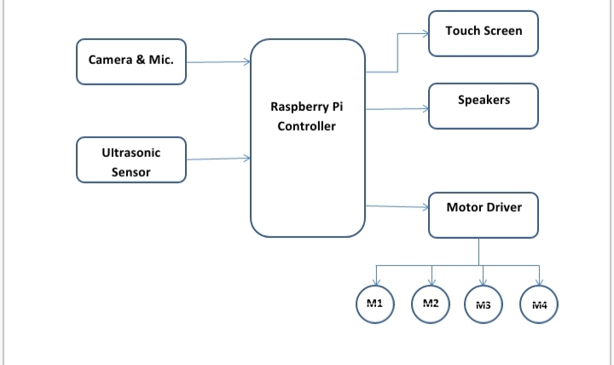

Fig.1: Human Assistant Robot

# MODULE VARIATIONS

There are several module variations that can be incorporated into a human assistance robot, depending on the specific needs and requirements of the target population. Here are some examples:

Mobility module: A mobility module can be added to a human assistance robot to enable it to move around and navigate its environment. This can include components such as wheels, tracks, or legs, as well as sensors and algorithms to help the robot avoid obstacles and navigate complex environments.

Manipulation module: A manipulation module can be added to enable the robot to manipulate objects and perform tasks such as opening doors, picking up objects, and operating appliances. This can include components such as robotic arms, grippers, and sensors to detect and identify objects.

Communication module: A communication module can be added to enable the robot to interact with humans using natural language processing and speech recognition. This can include components such as microphones, speakers, and language models to enable the robot to understand and respond to spoken commands.

Sensory module: A sensory module can be added to enable the robot to perceive its environment using various sensors, such as cameras, lidar, and infrared sensors. This can help the robot navigate its environment, identify objects, and interact with humans in a safe and intuitive way.

Medical module: A medical module can be added to enable the robot to provide medical assistance to individuals, such as monitoring vital signs, dispensing medication, and providing first aid. This can include components such as sensors, drug dispensers, and diagnostic tools.

Entertainment module: An entertainment module can be added to provide companionship and entertainment for individuals. This can include components such as a screen for displaying videos or playing games, a speaker for playing music or audiobooks, and sensors for detecting emotions and adapting its behavior accordingly

.

# WORKING

The working of a human assistance robot can be broken down into several key components:

Perception: The robot must be able to perceive its environment using various sensors, such as cameras, lidar, and infrared sensors. This allows the robot to detect and identify objects, navigate its environment, and interact with humans in a safe and intuitive way.

Planning: Once the robot has perceived its environment, it must be able to plan its actions accordingly. This involves using algorithms and decision-making processes to determine the best course of action for the task at hand.

Manipulation: If the robot needs to manipulate objects, it must be able to do so using a manipulation module, such as a robotic arm or gripper. This allows the robot to perform tasks such as picking up objects, opening doors, and operating appliances.

Communication: To interact with humans, the robot must have a communication module that enables it to understand and respond to spoken commands. This can include natural language processing and speech recognition, as well as text-to-speech and speech-to-text capabilities.

Execution: Once the robot has planned its actions, it must be able to execute them in a safe and effective manner. This can involve using various actuators and motors to move the robot and manipulate objects, as well as monitoring its environment to ensure that it is safe for the robot and any humans nearby.

Learning and adaptation: As the robot interacts with humans and performs tasks, it can learn and adapt to improve its performance over time. This involves using machine learning algorithms to analyze data and adjust its behavior accordingly.

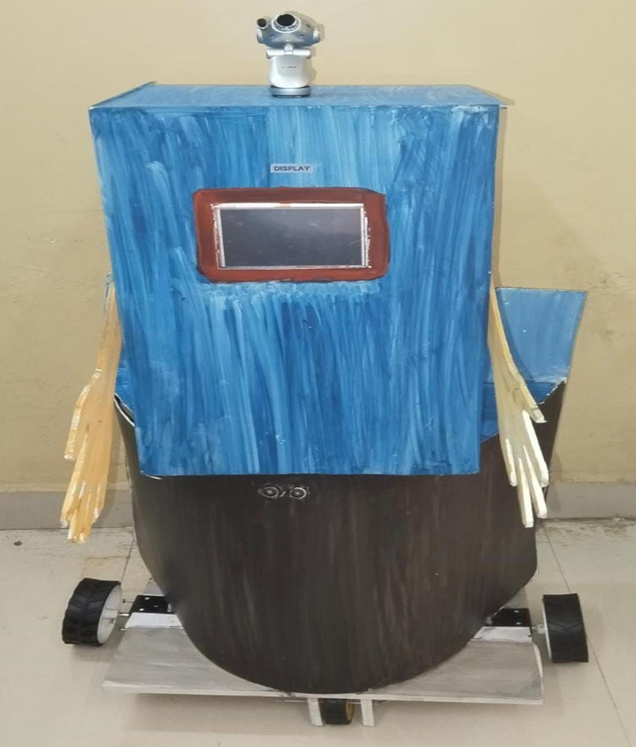.

# CONCLUSION

Human assistance robots have the potential to provide valuable assistance to individuals with various needs and limitations, including elderly and disabled individuals, individuals with chronic illnesses, and individuals who require assistance with daily tasks and activities. These robots can improve the quality of life for individuals by providing companionship, assistance with daily tasks, and medical support.

The development of human assistance robots involves a complex interplay between various modules, including mobility, manipulation, communication, sensory, medical, and entertainment modules. These modules work together to enable the robot to perceive its environment, plan its actions, manipulate objects, communicate with humans, execute tasks, and learn and adapt over time.

There is a growing demand for human assistance robots as the global population ages and the prevalence of chronic illnesses and disabilities increases. However, the development and deployment of these robots must be done with care to ensure that they are safe, reliable, and user-friendly. This includes addressing ethical considerations such as privacy, autonomy, and trust

# REFERENCE

# 1. Anurag Mishra, Pooja Makula , Akshay Kumar, Krit Karan and V. K. Mittal, “A voice-controlled personal assistant robot” Published in: 2015 International Conference on Industrial Instrumentation and Control (ICIC).

# 2. Xianghua Fan, Fuyou Zhang, Haixia Wang and Xiao Lu,“ The system of face detection based on OpenCV” Published in: 2012 24th Chinese Control and Decision Conference (CCDC). Ayu AnggreiniTuasikal, HanifFakhrurroja, CarmadiMachbub “Voice Activation Using Speaker Recognition for Controlling Humanoid Robot” Published in: 2018 IEEE 8th International Conference on System Engineering and Technology (ICSET).

# 3. U Bharath Sai, K Sivanagamani, B Satish,UG Students ”Voice controlled Humanoid Robot with artificial vision” Published in: 2017 International Conference on Trends in Electronics and Informatics (ICEI).

# 4. Renuka SKajale, Soubhik Das and ParitoshMedhekar ”Supervised machine learning in intelligent character recognition of handwritten and printed nameplate” Published in: 2017 International Conference on Advances in Computing, Communication and Control (ICAC3).

# 