**EARLY DETECTION OF FLOOD MONITORING AND ALERTING SYSTEM TO SAVE HUMAN LIVES**

**Dr.Shivnath Chaudhri1, C.Subodh2, M.Lokesh3, B.Saluvappa4,**

**S. Farook5, J.Mani Shankar Rao6**

**1M.Tech, Phd, Department of Computer Science and Engineering,**

**Santhiram Engineering College, Nandyal**

2,3,4,5,6 Students at Department of Electronics and Communication and Engineering, Santhiram Engineering College, Nandyal

E-mail: [shivnath.ece@srecnandyal.edu.in](mailto:shivnath.ece@srecnandyal.edu.in), [19x51a0478@srecnandyal.edu.in](mailto:19x51a0478@srecnandyal.edu.in),

[19x51a0497@srecnandyal.edu.in](mailto:19x51a0497@srecnandyal.edu.in), [19x51a0475@srecnandyal.edu.in](mailto:19x51a0475@srecnandyal.edu.in),

[19x51a04b6@srecnandyal.edu.in](mailto:19x51a04b6@srecnandyal.edu.in), [20x55a0404@srecnandyal.edu.in](mailto:20x55a0404@srecnandyal.edu.in)

**Abstract**

Because of the devastation it causes, flooding has gained international prominence as a natural disaster receiving widespread media coverage across the world. Although floods will continue to occur, their effects on civilization may be mitigated significantly. This research explores the application of Wireless Sensor Networks for early warning in vulnerable flood-prone locations (WSN). In order to identify and monitor floods in real time, the system relies on the placement of sensor nodes in high-risk areas. Individuals are given enough time to prepare for the occurrence of expected floods thanks to real-time monitoring of flood occurrences including flash flooding and run-off water or overflow, protecting them from the aftermath of flood disasters. The effectiveness and precision of the technology were verified by simulating various flood situations.

**INTRODUCTION:**

Because of the devastation it causes, flooding has gained international prominence as a natural disaster receiving widespread media coverage across the world. Although floods will continue to occur, their effects on civilization may be mitigated significantly. This research explores the application of Wireless Sensor Networks for early warning in vulnerable flood-prone locations (WSN). In order to identify and monitor floods in real time, the system relies on the placement of sensor nodes in high-risk areas. Individuals are given enough time to prepare for the occurrence of expected floods thanks to real-time monitoring of flood occurrences including flash flooding and run-off water or overflow, protecting them from the aftermath of flood disasters. The effectiveness and precision of the technology were verified by simulating various flood situations.

**Literature review:**

**Hardware design experiences in ZebraNet**

Research into wireless sensor networks has been sparked by their potentially huge beneficial social effect, and this research is already yielding deployment-ready devices. Hardware platforms for various parts of the design space are diverse as a result of current technological constraints and significantly differing application needs. Moreover, the requirements placed on sensor network hardware vary from those placed on normal integrated circuits due to the inherent energy and reliability restrictions of a system that must run for months at a time without human interaction. In this work, we share what we learned while developing low-level software to manage sensor nodes. In the ZebraNet system we employ GPS technology to capture fine-grained location data in order to follow long term animal movements [14]. The ZebraNet hardware consists of a 900 MHz radio, a low-power GPS chip, 4 Mbits of off-chip flash memory, and a 16-bit TI microcontroller. In this study, we provide our strategies for developing effective power sources for sensor networks, together with ways for controlling the energy intake of individual nodes and the operation of their associated radios, cameras, and other sensors. Finally, we assess the ZebraNet nodes' architecture and propose improvements. Our experiences with this hardware development have implications for both the design and implementation of future sensor nodes.

# Energy-efficient computing for wildlife tracking: Design tradeoffs and early experiences with ZebraNet

Over the past decade, mobile computing and wireless communication have become increasingly important drivers of many new computing applications. The field of wireless sensor networks particularly focuses on applications involving autonomous use of compute, sensing, and wireless communication devices for both scientific and commercial purposes. This paper examines the research decisions and design tradeoffs that arise when applying wireless peer-to-peer networking techniques in a mobile sensor network designed to support wildlife tracking for biology research.TheZebraNet system includes custom tracking collars (nodes) carried by animals under study across a large, wild area; the collars operate as a peer-to-peer network to deliver logged data back to researchers. The collars include global positioning system (GPS), Flash memory, wireless transceivers, and a small CPU; essentially each node is a small, wireless computing device. Since there is no cellular service or broadcast communication covering the region where animals are studied, ad hoc, peer-to-peer routing is needed. Although numerous ad hoc protocols exist, additional challenges arise because the researchers themselves are mobile and thus there is no fixed base station towards which to aim data. Overall, our goal is to use the least energy, storage, and other resources necessary to maintain a reliable system with a very high `data homing' success rate. We plan to deploy a 30-node ZebraNet system at the Mpala Research Centre in central Kenya. More broadly, we believe that the domain-centric protocols and energy tradeoffs presented here for ZebraNet will have general applicability in other wireless and sensor applications.

**A public transport system based sensor network for road surface condition monitoring**

The prosperity and happiness of a nation's citizens depend on a reliable road system. Most third world nations lack adequate road infrastructure. While a lack of resources is mostly to blame for the absence of new road networks and maintenance of existing ones, the poor state of road networks in developing nations is also exacerbated by a lack of a reliable monitoring and reporting system. For example, despite the fact that new roads are being created every day and the existing road network covers the whole country, even the roadways in the nation's capital are not adequately maintained. In this instance, it is clear that there is no system in place for monitoring and reporting. We propose a sensor network for the public transportation system to track the state of the roads. BusNet, the network we're presently developing to track pollutants in the environment, may be expanded to track wear and tear on roads with the use of acceleration sensor boards.

**Existing System:**

Many people's lives were in jeopardy before the advent of modern flood warning systems, and as a result, several people lost their lives. Because of the devastation it causes, flooding has gained international prominence as a natural disaster receiving widespread media coverage across the world. Although floods will continue to occur, their effects on civilization may be mitigated significantly.

hence, we have created an inbuilt technology to safeguard human life in the event of a flood.

**Proposed system:**

Because of the devastation it causes, flooding has gained international prominence as a natural disaster receiving widespread media coverage across the world. Although floods will continue to occur, their effects on civilization may be mitigated significantly. In this work, we examine how Buzzer may be used to provide timely alerts in high-risk flood zones. In order to identify and monitor floods in real time, the system relies on the placement of sensor nodes in high-risk areas. Individuals are given enough time to prepare for the occurrence of expected floods thanks to real-time monitoring of flood occurrences including flash flooding and run-off water or overflow, protecting them from the aftermath of flood disasters. The effectiveness and precision of the technology were verified by simulating various flood situations.

**Methodology:**

The system monitors environmental conditions including humidity, temperature, water level, and flow rate in order to identify a flood. The system is comprised of many sensors that gather data for separate characteristics, all of which are used to track the aforementioned environmental conditions. A DHT11 Digital Temperature Humidity Sensor is included into the system to monitor environmental conditions. It's a high-tech sensor module that can measure both humidity and temperature with remarkable accuracy. A float sensor constantly monitors the water level, changing the state of an electrical circuit by the opening and shutting of dry contacts as the water level rises and falls. Normally, it will be in the closed position, indicating that the circuit is not yet complete and no electricity is flowing through the wires. As the water level falls below a certain threshold, the circuit closes automatically, sending electricity through the circuit and setting off an alert. The water flow is monitored by the system's flow sensor. The water rotor, hall-effect sensor, and plastic valve body make up the water flow sensor. The rotor spins as water passes through it. Its velocity varies with the velocity of the flowing fluid. Furthermore, an HC-SR04 Ultrasonic Range Finder Distance Sensor is a part of the system. The Ultrasonic sensor is based on the SONAR system and measures distance using ultrasonic waves to identify objects' relative positions. The data from all the sensors is processed and stored on an Arduino UNO. Having wifi built into the system allows for easier access to the system and its data through the internet of things.

**Block Diagram**

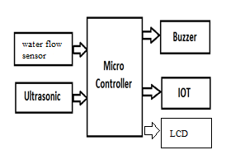

IoT Early Flood Detection & Avoidance System” is an intelligent system which keeps close watch over various natural factors to predict a flood, so we can embrace ourselves for caution, to minimize the damage caused by the flood. Natural disasters like a flood can be devastating leading to property damage and loss of lives. To eliminate or lessen the impacts of the flood, the system uses various natural factors to detect flood. The system has a Wi-Fi connectivity; thus, it’s collected data can be accessed from anywhere quite easily using IoT.

**HARDWARE COMPONENTS:**

1. Node MCU
2. Ultrasonic sensor
3. Water level sensor
4. Buzzer
5. IOT

**Buzzer**

The buzzer consists of an outside case with two pins to attach it to power and ground. Inside is a piezo element, which consists of a central ceramic disc surrounded by a metal (often bronze)vibration disc. Changing the This then causes the surrounding disc to vibrate.

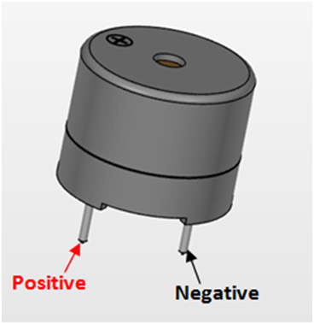

**Water flow sensor:**

Water flow sensor consists of a copper body, a water rotor, and a hall-effect sensor. When water flows through the rotor, rotor rolls, its speed changes with different rate of flow. And the hall-effect sensor outputs the corresponding pulse signal.

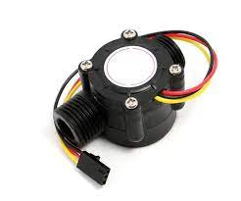

**ultrasonic sensor**

An ultrasonic sensor is an instrument that measures the distance to an object using ultrasonic sound waves. An ultrasonic sensor uses a transducer to send and receive ultrasonic pulses that relay back information about an object's proximity.

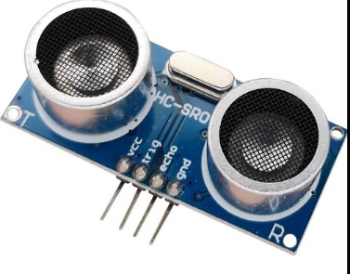

**LCD :**

Depending on how many lines are used for connection to the microcontroller, there are 8-bit and 4-bit LCD modes. The appropriate mode is determined at the beginning of the process in a phase called “initialization”. In the first case, the data are transferred through outputs D0-D7 as it has been already explained. In case of 4-bit LED mode, for the sake of saving valuable I/O pins of the microcontroller, there are only 4 higher bits (D4-D7) used for communication, while other may be left unconnected.

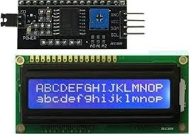

Consequently, each data is sent to LCD in two steps: four higher bits are sent first (that normally would be sent through lines D4-D7), four lower bits are sent afterwards. With the help of initialization, LCD will correctly connect and interpret each data received. Besides, with regards to the fact that data are rarely read from LCD (data mainly are transferred from microcontroller to LCD) one more I/O pin may be saved by simple connecting R/W pin to the Ground. Such saving has its price. EvenEven though message displaying will be normally performed, it will not be possible to read from busy flag since it is not possible to read from display.

**RESULT:**

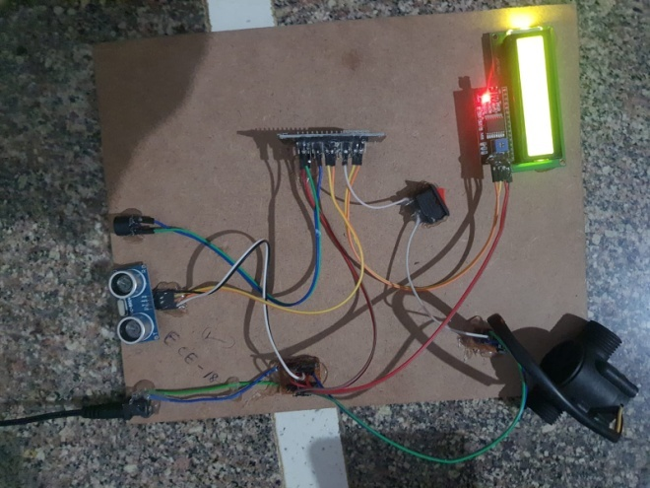

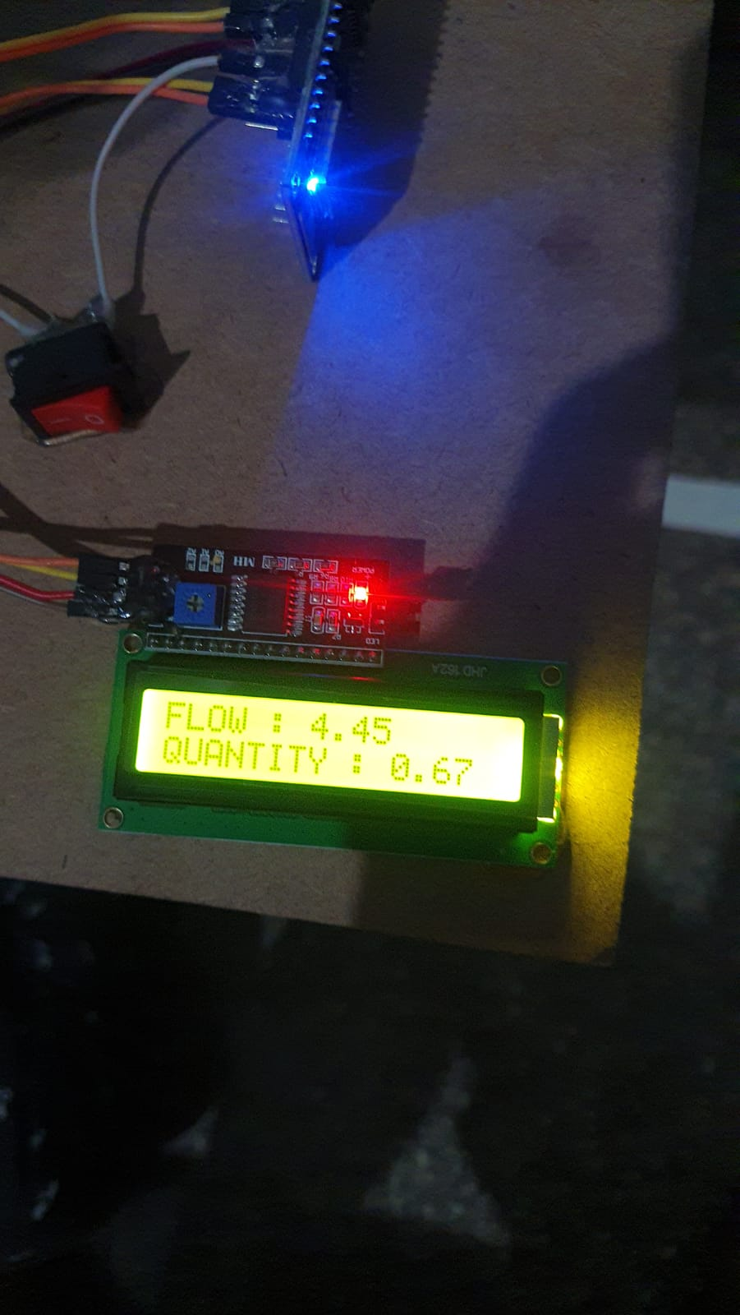

**Conclusion:**

The purpose of this article was to argue that flooding is a natural disaster worthy of international attention due to the devastation it causes to human life and infrastructure. Although floods will continue to occur, their effects on civilization may be mitigated significantly. This research explores the application of Wireless Sensor Networks for early warning in vulnerable flood-prone locations (WSN). In order to identify and monitor floods in real time, the system relies on the placement of sensor nodes in high-risk areas. Individuals are given enough time to prepare for the occurrence of expected floods thanks to real-time monitoring of flood occurrences including flash flooding and run-off water or overflow, protecting them from the aftermath of flood disasters. The effectiveness and precision of the technology were verified by simulating various flood situations.

**Reference:**

[1] CBS News, “Flood clean-up under way in soggy midwest,” CBS News/AP, August 21 2007, online at http://www.cbsnews.com/stories/ 2007/08/21/national/main3188053.shtml.

[2] J. Herskovitz, “Bodies of North Korean flood victims float to south,” Reuters News, August 21 2007, online at http://uk.reuters.com/article/ homepageCrisis/idUKL21191873. CH .242020070821.

[3] United States Geological Survey, “USGS hurricane mitch program,” <http://mitchnts1.cr.usgs.gov/overview.html>.

[4] P. Juang, H. Oki, Y. Wang, M. Martonosi, L. S. Peh, and D. Rubenstein, “c in ASPLOS ’02: Proceedings of the 10th International Conference on Architectural Support for Programming Languages and Operating Systems. New York, NY, USA: ACM Press, 2002, pp. 96–107.

[5] P. Zhang, C. M. Sadler, S. A. Lyon, and M. Martonosi, “Hardware design experiences in ZebraNet,” in SenSys ’04: Proceedings of the 2nd International Conference on Embedded Networked Sensor Systems. New York, NY, USA: ACM Press, 2004, pp. 227–238.

[6] K. D. Zoysa, C. Keppitiyagama, G. P. Seneviratne, and W. W. A. T. Shihan, “A public transport system based sensor network for road surface condition monitoring,” in NSDR ’07: ACM SIGCOMM Workshop on Networked Systems for Developing Regions, August 2007.

[7] R. Guy, B. Greenstein, J. Hicks, R. Kapur, N. Ramanathan, T. Schoellhammer, T. Stathapoulos, K. Weeks, K. Chang, L. Girod, and D. Estrin, “Experiences with the extensible sensing system ESS,” in Proceedings of CENS Technical Report #60. CENS, March 2006.

[8] N. Ramanathan, L. Balzano, D. Estrin, M. Hansen, T. Harmon, J. Jay, W. Kaiser, and G. Sukhatme, “Designing wireless sensor networks as a shared resource for sustainable development,” in ICTD ’06: Proceedings of the International Conference on Information and Communication Technologies and Development, May 2006, pp. 256–265.

[9] J. Panchard, S. Rao, T. Prabhakar, H. Jamadagni, and J.-P. Hubaux, “Common-sense net: Improved water management for resource-poor farmers via sensor networks,” in ICTD ’06: Proceedings of the International Conference on Information and Communication Technologies and Development, May 2006, pp. 22–33.

[10] M. Castillo-Effen, D. H. Quintela, R. Jordan, W. Westhoff, and W. Moreno, “Wireless sensor networks for flash-flood alerting,” in Proceedings of the Fifth IEEE International Caracas Conference on Devices, Circuits and Systems. IEEE, Nov 2004, pp. 142–146. 10

[11] D. Hughes, P. Greenwood, G. Blair, G. Coulson, F. Pappenberger, P. Smith, and K. Beven, “An intelligent and adaptable grid-based flood monitoring and warning system,” in Proceedings of the 5th UK eScience All Hands Meeting, 2006.

[12] ALERT Systems Organization, “Alert history,” http://www.alertsystems. org.

[13] Federal Communications Commission: Public Safety and Homeland Security Bureau, “Emergency alert system,” <http://www.fcc.gov/pshs/eas/>. [14] E. Basha, “Interview with COPECO officials in La Masica, Honduras,” January 2004. [15] G. H. Jørgensen and J. Høst-Madsen, “Development of a flood forecasting system in Bangaldesh,” in Operational Water Management Conference, 1997.