**Leave Management System for ACE**

**Akshay Ghuge1, Sakshi Lambat2, Achal Masram3, Padmashila Supare4, Yash Rathod5, Prof.Achal Kamble6, Mr.Abhishek Kumar7**

1,2,3,4,5 BE student, CSE, Agnihotri College of Engineering Nagthana, Wardha, Maharashtra, India

6Professor, CSE, Agnihotri College of Engineering Nagthana, Wardha, Maharashtra, India

7Principal, CSE, Agnihotri College of Engineering Nagthana, Wardha, Maharashtra, India

**ABSTRACT**

**In the existing Leave Management System, every college follows manual procedure. At the end of each month, administration department calculates leaves of every faculties that why that is time taking process and there are chances of losing data or errors in the leave register.**

**Leave Management System for ACE is a web base system which can be accessed all over the college. This system for managing leaves related information of faculty’s approval of leaves from the principal and head of department. The principal and head of department have permission to verify the leave request of their faculties. After verifying the leave application of faculties, the principal and HOD will give remark like approved and rejected.**

**Keywords:** Faculty, Leave request, Institution, Types of leaves, Updating records, Approval/Rejection of leaves.

1. **INTRODUCTION**

In the existing system paperwork related to leave management, leaves are maintained using the attendance register for faculties. The faculties need to submit their leaves manually to respective HOD which increases paperwork and maintaining the records becomes tedious. The Leave Management System for ACE has been developed to override the problems prevailing in the existing system. Moreover this system is designed for the particular need of the college to perform operations in a smooth and effective manner.

This leave management system for ACE will reduce work as well as possible to avoid errors while entering the data. It also provide error message while entering invalid data and no formal knowledge is needed for the faculties to use this system.

Thus by this all it proves it is user-friendly system. Leave management system, as described above can lead to error free, secure, reliable and fast management system. It can assist the faculty concentrate on their activities rather to concentrate on the record keeping. Thus it will help to college in better utilization of resource.

The main objective of this is to decrease the paperwork and help in easier record maintenance by having a particular centralized database system where leaves and personal information maintained.

1. **METHODOLOGY**

The main purpose of this system is to management of leaves by online. The main concept of this project is to build a website which should be able to allow faculties/users to apply their leaves applications by online.

**2.1 Development Phase**

* Planning: Project selection, Preparation of documents
* Requirement Gathering: Data collections, Survey
* Design: Create system design, Data flow diagram
* Development: Develop the system planned on the design phase
* Testing: Testing of errors

**2.2 Development Tools**

Front-end Technologies:

This project used the following front-end technologies.

* HTML, CSS, JavaScript and BOOTSTRAP

Back-end Technologies:

This project used the following back-end technologies.

* PHP and MySQL

1. **MODELING AND ANALYSIS**

In this project we are going to work on website and this project will help to reduce paperwork and save time in maintaining the leaves in Agnihotri College of Engineering Nagthana, Wardha. The Following are the five modules included in this project:

* Administrator and Principal
* Head of Department (HOD)
* Faculty Model
* Apply Leave Message by Faculty
* Confirm Leave Message by Principal and HOD

3.1 Administrator and Principal

In the Administrator and Principal model, the administrator has already username and password but the principal should be requiring registration first and this principal registration will be done by the administrator. After registration the principal will get username and password to login into the system after that he will add Head of Departments (HOD) of all branch, departments and leaves types. The principal can check how much leave applications are pending in my dashboard then he will take action on that applications and will send a confirmation email to the HOD and Faculty/applicant.

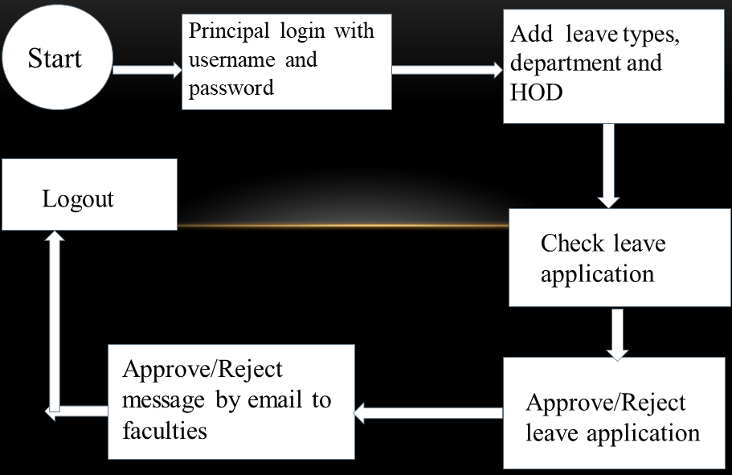

Fig.1: Data Flow Diagram for Administrator and Principal

3.2 Head of Department (HOD)

In the Head of Departments (HOD) model, the HOD should be requiring registration first and this HOD registration will be done by the Principal of the college. After registration the HOD will get username and password to login into the system after that he will login in the system using that username and password then HOD can add faculties of particular departments and manage faculty profile. The HOD can check how much leave applications are pending in my dashboard then he will take action on that applications and will send a confirmation email to the Faculty/applicant.

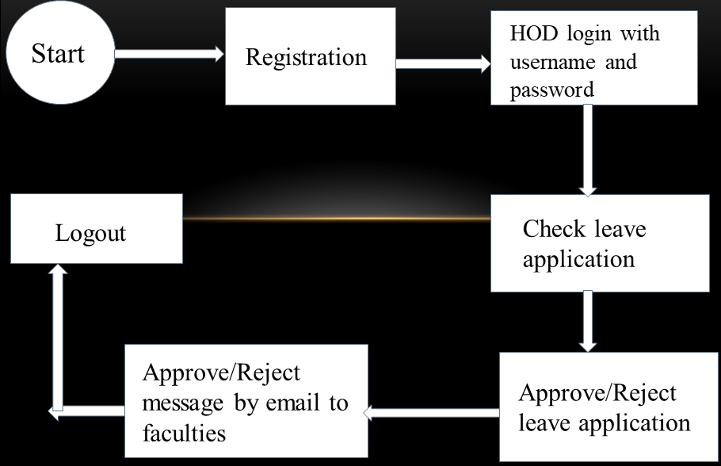

Fig.2: Data Flow Diagram for Head of Department

3.3 Faculty Model

In the Faculty model, the faculty should be requiring registration first and this faculty registration will be done by the HOD of particular departments. After registration the faculty will get username and password to login into the system after that he will login in the system using that username and password then faculty can manage theirs profile, check leaves types, check leaves format then faculty can apply for leaves request after that they will send a apply email to the HOD and Principal. The faculty can check leave applications status in his dashboard.

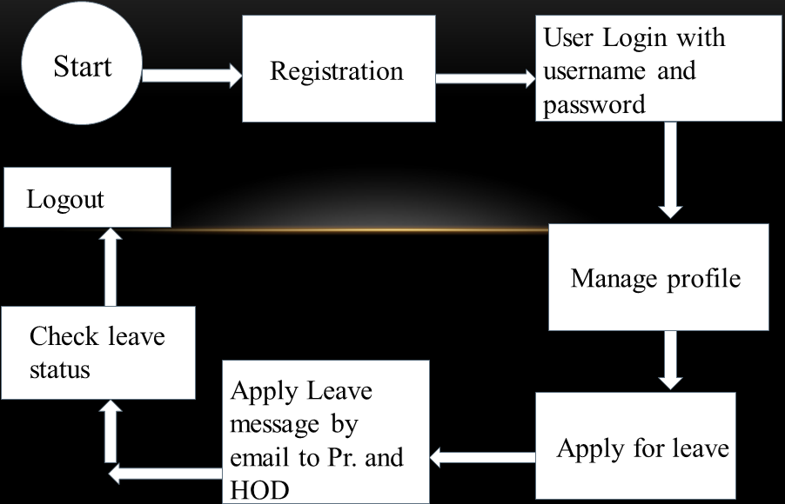

Fig.3: Data Flow Diagram for Faculty

3.4 Apply Leave Message by Faculty

In Apply Leave Message model, when the faculty will apply for the leaves request then he will send an email message to the

HOD of particular departments and the principal of college using apply leave email form. In the form there are some fields

including the name of the faculty, branch of the faculty, email of HOD and faculty, subject, write a message for HOD and

the principal and also he will upload leaves proof with this email form.

Apply Leave Message form is below:

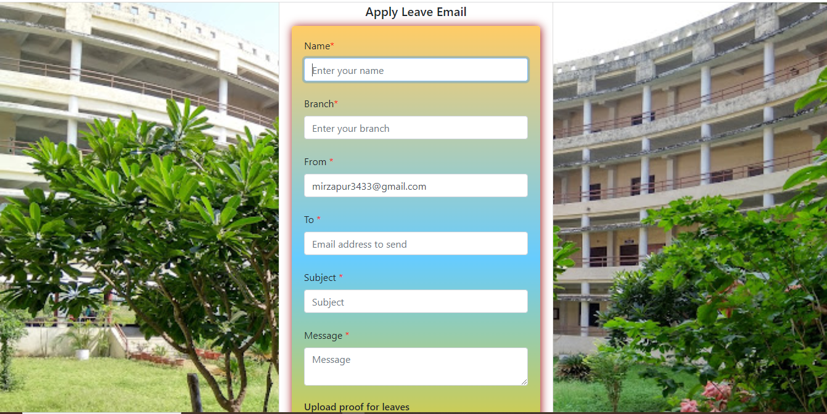

Fig.4: Apply Leave Email Page

3.5 Confirm Leave Message by Principal and HOD

In Confirm Leave Message model, when the faculty will apply for the leaves request then he will send an email message to the HOD of particular departments and the principal of college using above apply leave email form but there is one another email form for the HOD and principal that is Confirm Leave Email form. In the confirm leave form there are some field including email of HOD/ Principal and faculty, subject, write a message for faculty and the one more benefits of this form the faculty can also use this confirm leave email form for message to the HOD and Principal.

Confirm Leave Message form is below:

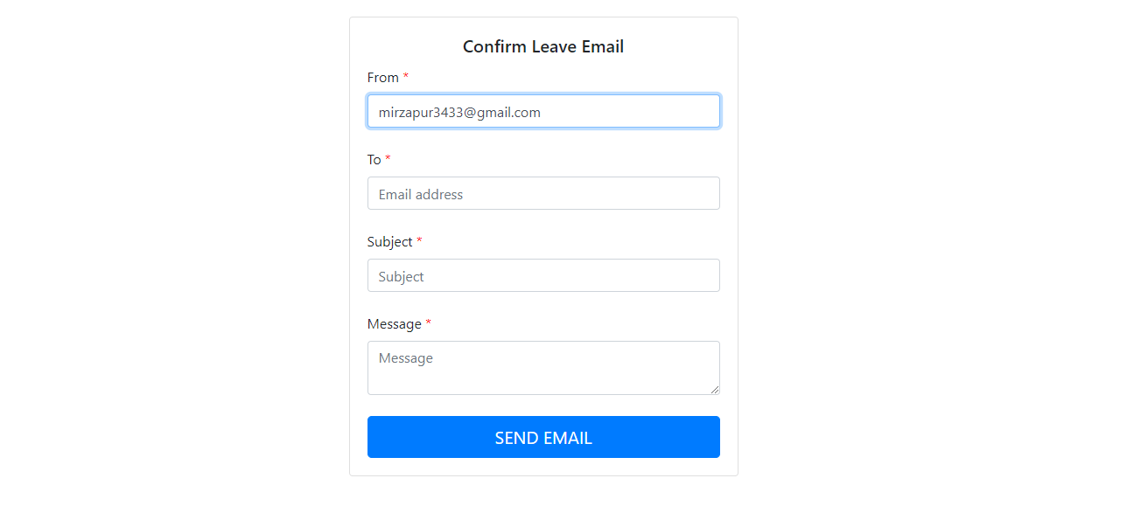

Fig.5: Confirm Leave Email Page

1. **RESULTS AND DISCUSSION**

The login form/home page is the first graphical user interface displayed when the Leave Management System for ACE is launch figure: 6 show the login form/home page of the Leave Management System for ACE. The Faculty, HOD, Principal and the administrator can login using this home page and they have to enter accurate username & password to login into the system

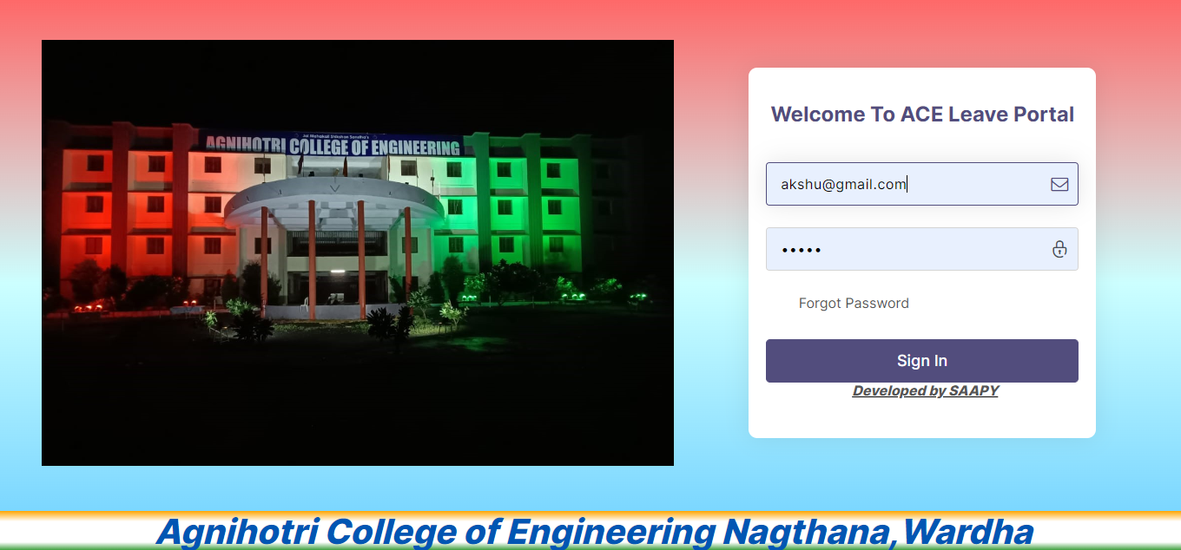

Fig.6: Home Page of Leave Management System for ACE

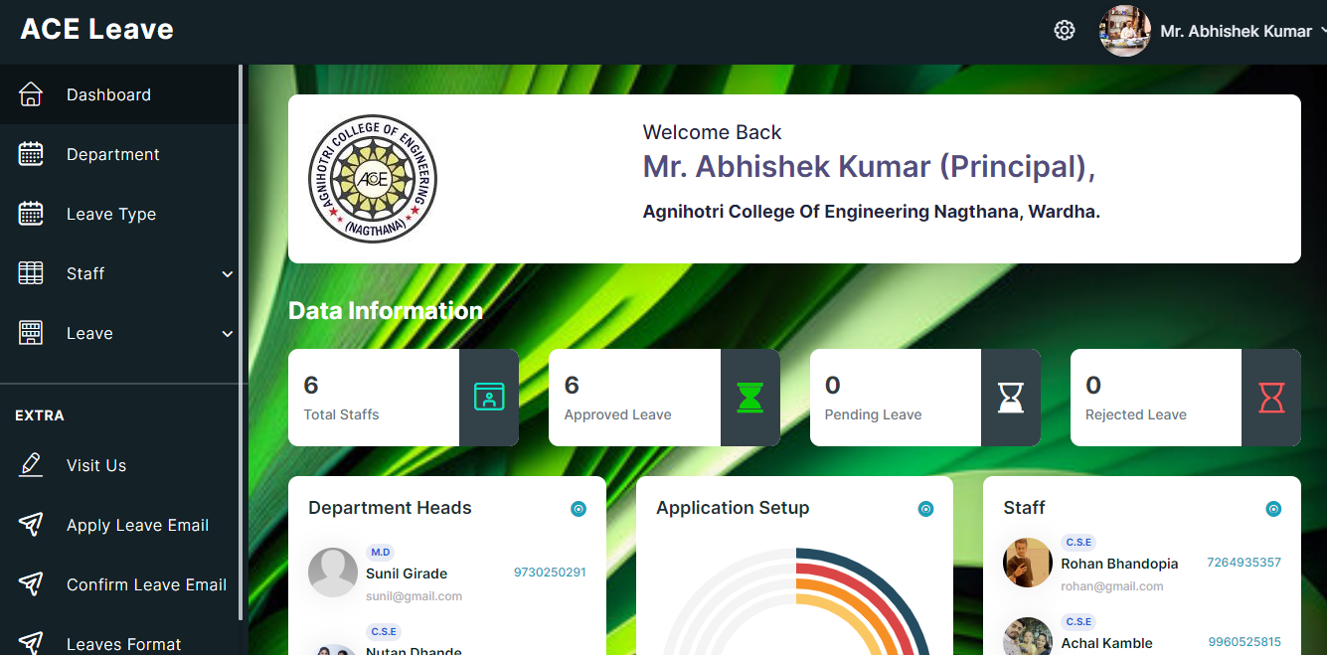

Fig.7: Principal Page of Leave Management System for ACE

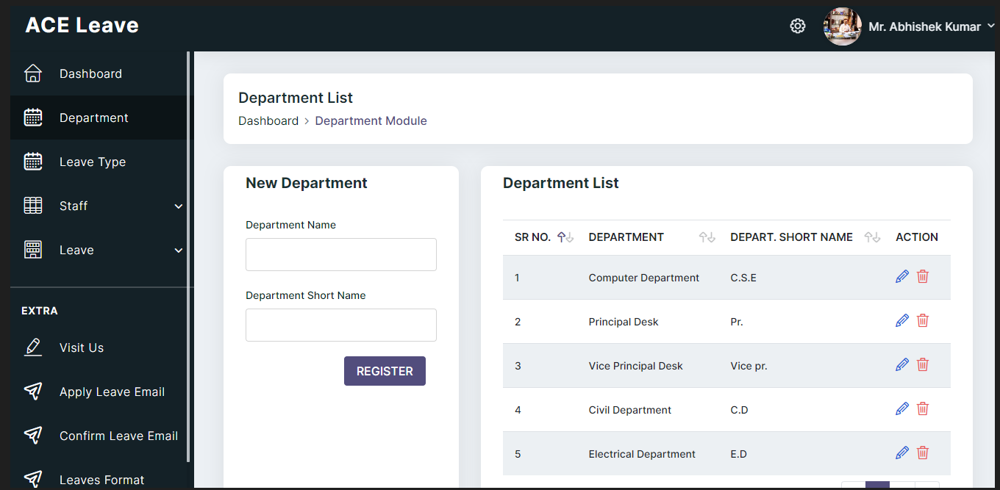

Fig.8: Creating Departments of Leave Management System for ACE by Principal

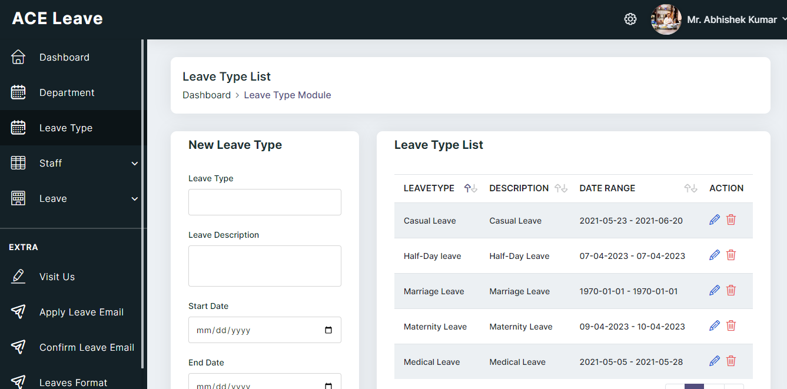

Fig.9: Creating Leave Types of Leave Management System for ACE by Principal

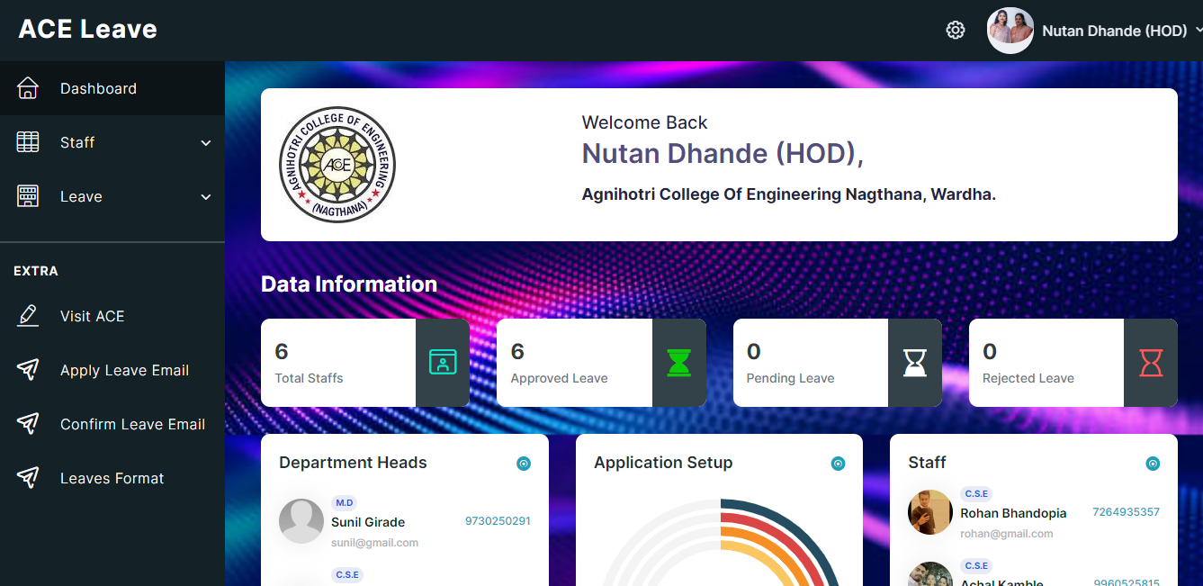

Fig.10: Head of Department Page of Leave Management System for ACE

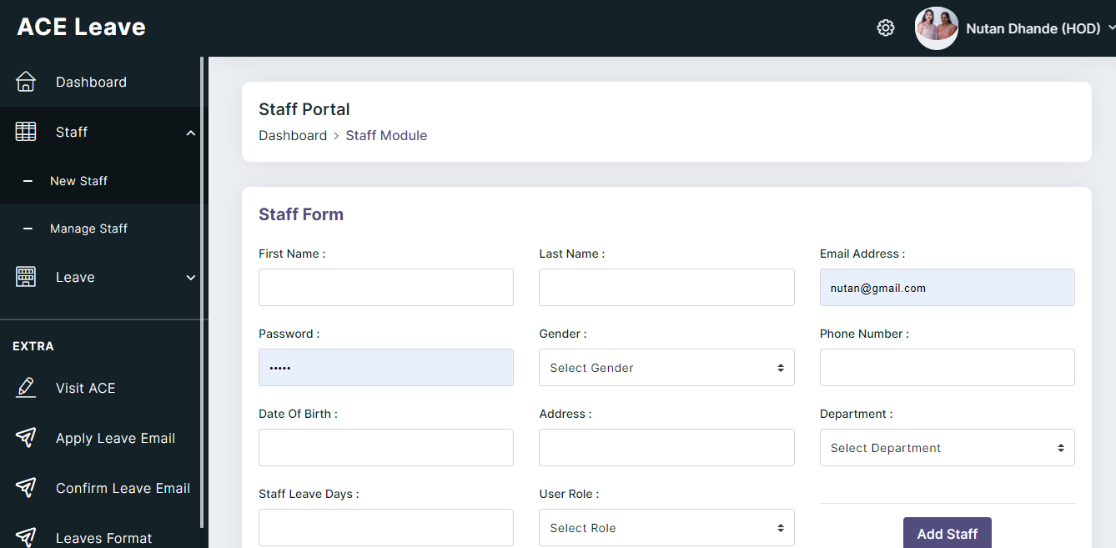

Fig.11: Creating Faculty of Leave Management System for ACE by Principal

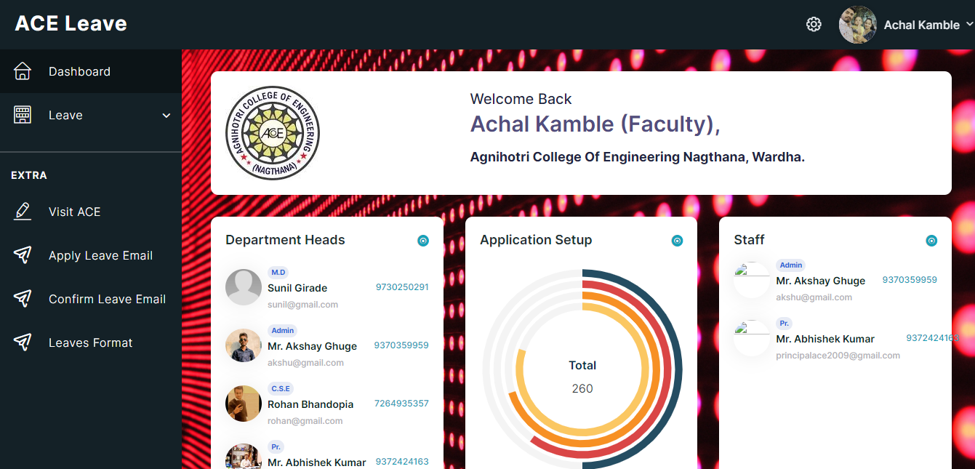

Fig.12: Faculty Page of Leave Management System for ACE

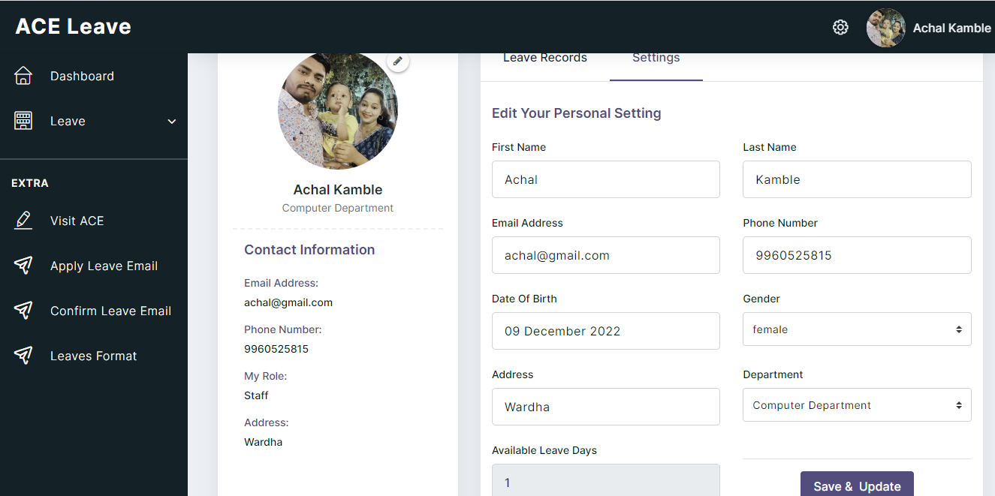

Fig.13: Profile Updating of Leave Management System for ACE by Faculty

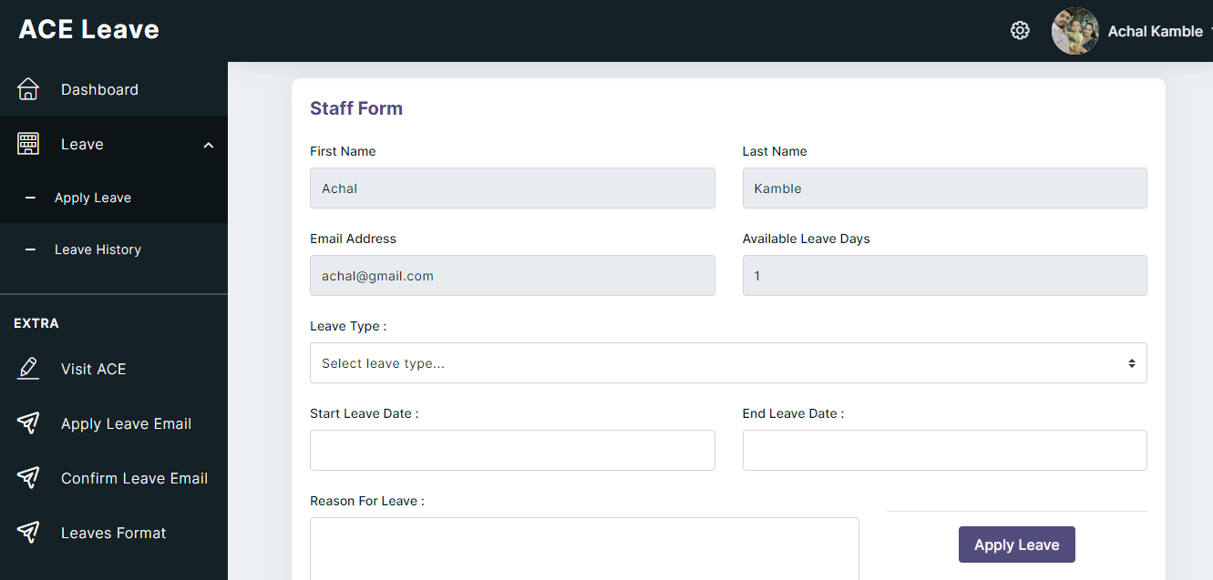

Fig.14: Leave Request of Leave Management System for ACE by Faculty

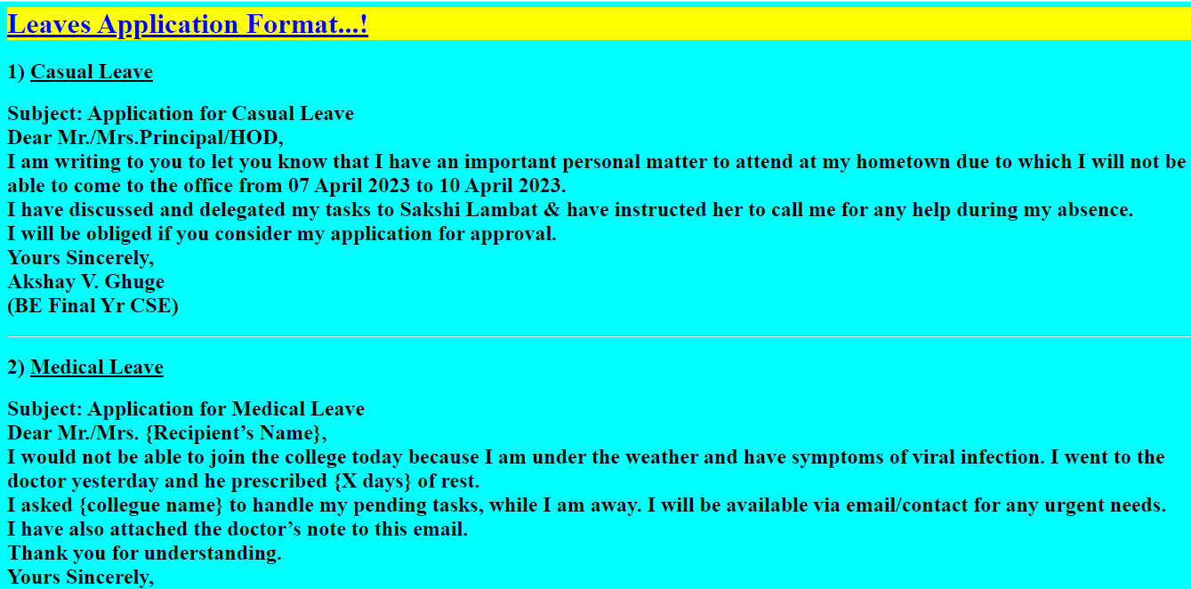

Fig.15: Leaves Format of Leave Management System for ACE

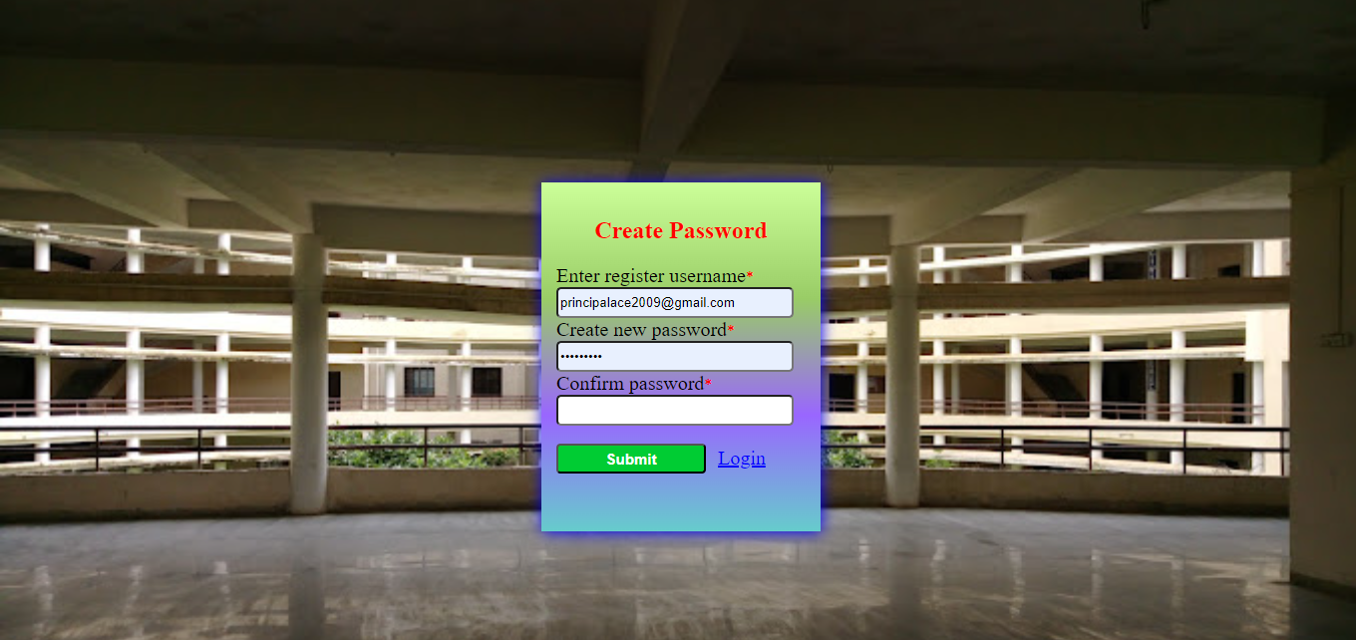

Fig.16: Reset Password Page of Leave Management System for ACE

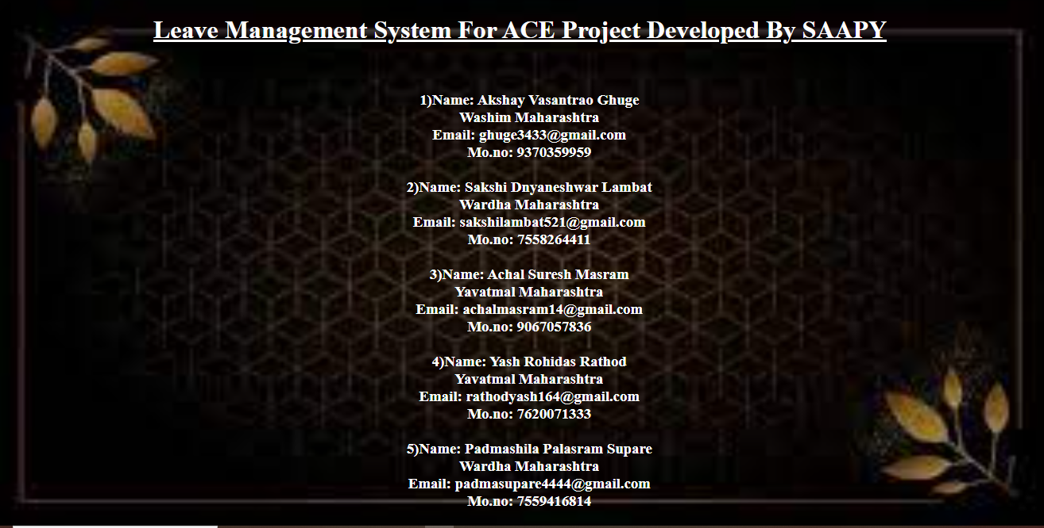

Fig.17: Developers Information Page of Leave Management System for ACE

1. **CONCLUSION**

This system provides facility to conduct leave management system by online. The development of leave management system carried out to reduce stress of paper based method in managing attendance. The project will implement using PHP programming language and MySQL server database and it starts with a login interface which contains faculties, principal and HOD login.

**ACKNOWLEDGEMENTS**

We would like take the opportunity to express our sincere thanks to our guide Prof. Achal Kamble, Assistant Professor, Department of Computer Science & Engineering, Agnihotri College of Engineering Nagthana, Wardha for invaluable support

And guidance throughout our project work. .

We are thankful to Prof. Nutan Dhande , HOD, Department of Computer Science & Engineering, Agnihotri College of Engineering Nagthana, Wardha, for providing advice and valuable guidance.

We are thankful to all our family members whose constant support and encouragement in every aspect helped us to complete our project.

1. **REFERENCES**
2. Adamu A, “Employee Leave Management System”, FUDMA Journal of Science (FJS), val.4, June-2020, pp.86-91.
3. Nameera Choudhary, Aynas Khalfe, Yaman Khan, Mukhtar Ansari, “Leave Management System for AIKTC”, International Research Journal of Engineering and Technology (IRJET), volume:07, Issue:03, Mar 2020.
4. Rajan Deshmukh, Saurav Avhad, Adarsh Maid, Abid Dhankwala, “Leave Management System”, Journal of Emerging Technologies and Innovative Research (JETIR) Volume 9, Issue 4, April 2022.
5. S Selvi, Manas Rath, N K Sinha, S P Singh**,** “ HR e-Leave Tour Management System at RDCIS” in 2014 Sail International Conference on Information Technology (SICIT).
6. Hridita A**.** proposed the “Employee Leave Management System” in 2018 An Intenship Report on Meltlife (IRM).
7. Pandore Yogesh Bandopant ,"E-Notifier: Transport Information Services in Colleges and Exploring Mobile Notification Journal of Advanced Research in Computer and Communication Engineering Vol.5, Issue 4",[April 2016]
8. Sai Ba Oo*, Nang Hlaing Myat Oo, Suparat Chainan, arpha Thongniam, Waralak Chongdarakul , School of Information and Technology, Mae Fah Luang University, "Cloud-based web application with NFC for employee attendance management system, [June 2018]
9. Chugh, R. (2014). Role of Human Resource Information System in Educational Organization. Journal of Advanced Management Science.
10. Rushitha, E., Preethi, G., Harshita, N.M., Manisha, R.R. and Veena, M. (2019). Android Leave Management System. International Research Journal of Computer Science.
11. Mishal, R., Prity, S., Prachir C. and Arhant, C. (2017). Employee Leave Management System. International Journal of Advance Research and Innovative Ideas in Education.
12. Stephen, B.U. and Chukwudebe, G.A., Dike, D.O. and Chukwuchewa, N. (2018). Improved Leave Schedulling Algorithm for Improved Service Delivery in Nigeria University System. Nigerian Journal of Technology.
13. Kanchev, Kancho D., (2006.) Development and presentation of an information system.
14. Wilson, (2002). Key Concepts in Information and Knowledge Management. Retrieved from: [www.tlu.ee](http://www.tlu.ee)
15. Maltoni D, D. Maio, A. Jain, S. Prabhaker. (2003). Handbook of Fingerprint Recognition”, Springer, New York, Pp 13-20.
16. Unati, A., Swaminarayan, P. (2014). Development of a Student Attendance Management System Using RFID and Face Recognition: A Review. Vol. 2. ISSN: 2321-7782.
17. Newman-Ford, L.E., Fitzgibbon, K., Llyod, S. & Thomas, S.L. (2008). A Large-Scale Investigation into the Relationship between Attendance and Attainment: A Study Using an Innovative, Electronic Attendance Monitoring System, Studies in Higher Education.
18. Mweemba Simaanya. (2014). Employee Management System.