**ABSTRACT**

**SMART HOME AUTOMATION BY USING INTELLIGENT ELECTRICITY DISPATCH**

Dr. S. N. Chaudhri1Ph.D, S. Ganesh Goud2, K. Jaya Chandra3, K. Azur Hussain4, S. Prasanna Kumar5

Assistant Professor1, B. Tech scholors2,3,4,5

Department of Electronics and Communication Engineering1,2,3,4,5

Santhiram Engineering College, Nandyal (Dist)1,2,3,4,5

Andhra Pradesh, India.

The iiot (IoT) refers to the networked devices, software, and services that allow for joystick of devices and software via computer, mobile phone, or other internet-connected device, as well as the control of gadgets and applications via code and algorithm frameworks for use in ai technologies. Connecting our tools, material, and products to a Wi-Fi or Ethernet network allows us to manage them remotely using mobile apps or online interfaces in the event that we need to develop complex systems utilising python algorithms. That's a very basic explanation of what the Internet of Things is. The Internet of Things (IoT) has far-reaching applications beyond the realm of the "smart home," where it is used primarily to control lighting and other household appliances. It can also be used as a network security or a factory system, for instance, to unlock or unlock the main building door, run fully automatic industrial machinery, or manage network and telephone connections. Nevertheless, more may be accomplished with the help of Internet of Things technologies. Light fixtures may be found in abundance in large buildings such as factories and government buildings. Some workers leave work without first turning them off. Having the security guard use the smart device by Blynk app to manage the building's lighting is proposed as a strategy to reduce energy consumption in this study. With a certain wiring setup, the lights may be operated both by switches located throughout the building and the Blynk app. This study introduces a basic smart home prototype, or a cheap and simple method of controlling loads through a Wi-Fi network.

**Introduction:**

Each equipment in an IOT network is given its own unique IP address, which can be used by anybody to identify that device on the web. Machines, both adc, are given their own UIDs and the capacity to communicate with one another via a network without any need for human or human-machine mediation. Initial implementations might be thought of as a "Net of Systems." The number of "things" or gadgets that are linked to the World Wide Web is expected to skyrocket, according to research. Because of this interconnection, a new network has emerged, dubbed the "Internet of Things" (IoT). The advent of Beta and Wi-Fi, among other wireless management contexts, has given previously incompatible gadgets the ability to communicate with one another thanks to recent technological advancements. To save money and make the Arduino board capable of functioning independently, you may use a WIFI shield to turn it into a Mini web server. To allow the Arduino to interact with the net, the Wi-Fi shield must be connected to a wireless network or wireless hotspot. As a result, we develop an internet-based automated home for controlling and monitoring our electronics remotely. As wireless technology develops, new connection protocols like GSM, WIFI, and BT become available. Every single one of these links was designed for a certain purpose and comes with its own set of requirements. WIFI is chosen because it has the most desirable characteristics among the four most common wireless connections used in HAD projects. WI-FI may be included into the design because to its extensive possibilities. The vast majority of today's notebooks and smartphones also include an integrated wireless LAN card. The overall system price will be lowered as a result.

**Literature review:**

The dispatch model was associated with various power structures, like cooling, heating, electrical energy, response on any desired request. This model was composed of an orderly manner prototype. Similarly, the structure had many substructures, like calculation of risk factors, the response, which was demanded, power plants that existed virtually, knowing the situation conditions and optimization. In this dispatch model, every sub-structure interacted with one another to get the desired results. With the help of this case study clearly, we could get the improved and integrated renewable power from response which was demanded. This paper is about the smart home problem, regarding the power dispatched the system. The technique used here was to convert domestic loads into 3 major groups on the basis of controllability. These three groups were the divided generation model, a small-scale wind rotatory engine, and the photovoltaic structure in the aimed model. Minimal time, which is allotted to every load, can be extracted from the prescribed load power control strategy. From the proposed algorithm performance of the battery is also improved. Apart from the above-mentioned advantage, another advantage of demanded power is that the loss and expense of transmission are decreased. Results from the proposed model meet the requirements of demanded requirements, and the overall performance of the model increases. In [5], the aim of the technique was to quantitate the performance of household demanded forecast by the impact of integrated electric power measurement. State of the art is used for the measurement purpose, as a tool of the forecast. The tool used the integrated data, got from sensors in an automated home or smart home, to valuate home level demanded forecasting. Results are based on three main categories. Category one contains performance relation of prediction based on machine learning with a continuous prediction. The next category was the advancement of prediction around (4 to 33 %). This percentage is got by a relation of prediction depending on integrated data acquired from smart, automated home sensors along with persistence and smart-meter benchmarks. Last category was analyzing sensitivity according to time resolution information. This research was about the problem of a smart home regarding energy management.

**EXISTING SYSTEM:**

The lighting control circuits have traditionally been accessed by males, or the work has been done via a Wireless device like a joystick in past initiatives. Due to our occasional lapses in judgement, the monthly electricity bill often rises when we forget to turn off lights and fans. We developed a new method, known as Cellular Smartthings, to counteract this issue.

**PROPOSED SYSTEM:**

The framework of the suggested method for building an autonomous home system is shown here. The computer hardware and software components of this system work together to create this system. We have addressed the issue of power usage head-on in our suggested model. The recommended answer for most electric power consumption issues is the Electrical Manager for home automation. This suggested system utilises three distinct automated methods: those found on the internet, in mobile applications, and in the user's immediate vicinity. The Arduino Uno and several modules for sensors, relays, and relays have been used in this implementation of the concept. We are doing our research on four specific appliances—a light bulb, a fan, an air conditioner, and an electric heater—that are being operated in one of three ways: locally, through the web, or via an app. Specifically, the sensor readings are read by an Arduino Uno, which is then programmed to respond with a signal that triggers the relay module the switches to either interrupt or reset the line. The Microcontroller, relay, and NodeMCU form the circuit that controls home appliances through the web and mobile app. Depending on the situation, one may use the app or website, submit a request to turn off or on the device, and then have the server carry out the predetermined action. For example, if a person is positioned in a room, both the light will turn on because a sensor has detected that presence, and the light will turn on as a result, according to the local system's conditions; however, if that person does not desire the light to turn on, he or she will turn it off via an app or web page. As the online and app case is more pressing, the lights will remain off. There are three subsections below (labelled A, B, and C) that go into detail on these methods. Our approach is functional in the two primary cases (normal and emergency) described. Assuming a typical condition, the electricity dispatcher model allows for three distinct methods of regulating smart home equipment..

**Methodology:**

The Esp32 Wi-Fi module was integrated inside sugar cube relays for remote or wireless device control in this project. This project makes use of hotspot settings, in which a hotspot channel is established for the purpose of connecting ESP8266 to other devices. Next, the other gadgets may connect once we set up the proper Address, which is created by that of the "Arduino.ide" programme. The ESP module mechanism is stable, hence the IP remains constant [5]. To protect against the potential harm caused by the back EMF produced by the relay's coil, diodes are included into the circuitry of sugar cube relay configurations. Coils were employed to maintain a steady charge in the coil.

The Arduino IDE, as the software is more often known, features a code editor, a message board, a text terminal, a toolbar with frequently used buttons, and a selection of menus. It communicates with and uploads programmes to Arduino and Genuino boards. Microcontrollers (IDE) code is known as sketches. Files with the.ino extension contain these draughts, which are depicted in Figure 6. Text may be copied, pasted, searched, and replaced using the blogger's National Conference of Communication devices and Advance Computing capabilities. The error messages and feedback throughout the saving and exporting processes are displayed in the message box. The console presents the entire messages and other results produced by the Arduino (IDE). The board + serial port settings may be seen in the lower right corner of the screen. A number of useful functions, including programme verification and upload, sketch creation, opening, and saving, and accessing the serial monitor, are all accessible via buttons on the toolbar.

**BLOCK DIAGRAM**

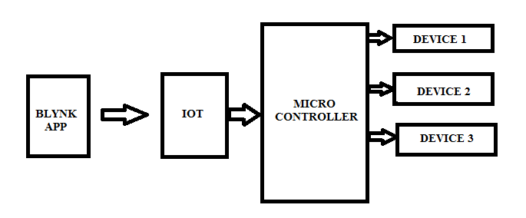

**LOCAL AUTOMATION:**

To begin, we have local robots. The suggested system would intelligently respond to the current environment and make selections based on the collected data from the sensors. The microcontroller will be wired to a variety of sensors, and in response to certain conditions, will trigger the operation of various electrical devices. The hardware for this method is a D6T mems heat sensor, a relay unit, some switches, and an Arduino. D6T sensor can be put to calculate warmth and identify human presence. These computations are helpful for switching goods based on specific conditions, such as turning on devices (e.g., lights) when a person enters a room and turning off devices (e.g., air conditioning and electric heating) when the room temperature reaches a certain threshold. If a human is detected in a room and the temperature rises over the setpoint (normal temperature of room), fans and air conditioners will activate; if the temperature drops below the setpoint, heaters will do the same. But, if no one is in the area at that point, the electronics will power off by themselves.

**WEB-BASED AUTOMATION:**

Blog automation has been the second way for intelligent device control. If a user wants to turn on or just off goods of any location, all they have to do is browse web sites and send control to the http module. The hardware component, a microcontroller, will be connected to a server where web pages will be hosted. Devices like Arduino Shields, Relays, Switching, Electric Appliances, internet Server, and a Cellphone are all examples of technology. With the use of server-hosted websites, users may remotely operate appliances by issuing on/off requests. A schematic representation of web-based automation is presented in Figure 2.

**Hardware components required:**

**Node MCU:**

A poor inviting IoT platform, NodeMCU is available for download. [4] [5] Both the ESP-12 unit and the software that runs on Esp8266' Micro controller Wi-Fi SoC were initially supplied. [6] [7] With subsequent updates, compatibility for the ESP32 32-bit Soc was included.

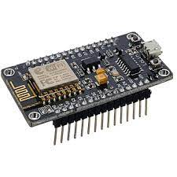

**Relay module:**

A authority switch is an electromagnet-controlled electrical switch. A separate, low-power transmission from a node mcu activates the magnets. When switched on, the magnets exerts a pulling force that can open or shut the circuit.

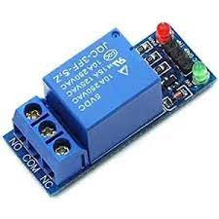

**AC devices:**

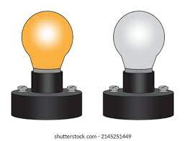

**DC fan:**

Fans that run on direct current (DC) are powered by an external cause that is then transformed by the fan's transformer. After receiving the fuel, the inverter changes it into dc current, or electricity that flows just in one direction. This ultimately results in less energy being consumed.

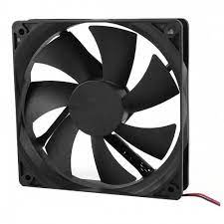

**RESULT:**

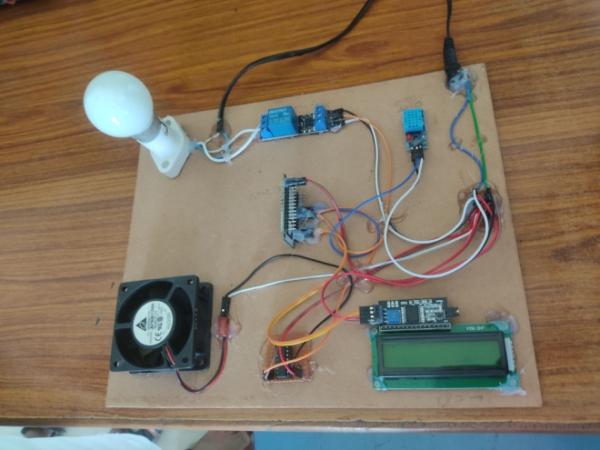

**CONCLUSION:**

The above may be deduced from an examination of all data collected during trials of the Online of Factors NodeMCU ESP6288 chip in a smart home:

1)With the help of numerous software and hardware features, a smart house with an Internet of Everything (IoT) oriented NodeMCU Serial communication Module may be created and configured into a connected house system that is managed first by Blynk android mobile application.

2) This NodeMCU ESP8266 Component is based on the Internet of Items (IoT) and may be used in a Smart Home to manage many electronic functions. These include but are not limited to lights, fans, temperature monitoring, and alarms.

**REFERENCES**

1) Arduino Temperature Sensor Using LM35. Groups of Electronics Hobbyist, Roboticist. We Developed Electronics Project Tutorials Make Open for Everyone.

2) BOHORA, Bharat; MAHARJAN, Sunil; SHRESTHA, Bibek Raj. IoT Based Smart Home Using Blynk Framework. Zerone Scholar, [S.l.], v. 1, n. 1, p. 26-30, dec. 2016. ISSN 2542- 2774. google scholar.

3) DC-DC Step Down Converter Power Supply Provides Regulated 5VDC Output with Range Input of 10-32VDC, Model GTD21088L-1505-T2.

4) Home Automation Using Internet of Thing 2016 IEEE 7th Annual Ubiquitous Computing, Electronics & Mobile Communication Conference (UEMCON) Published: 2016. Google Scholar.

5) Internet of Things in Home Automation and Energy Efficient Smart Home Technologies Simon G. M. Koo Department of Computer Engineering, Santa Clara University, CA 95053, USA

6) Low Cost Implementation of Smart Home Automation Ravi Kishore Kodali Department of Electronics and Communication Engineering National Institute of Technology, Warangal , 506004 India

7) Mobile based home automation using Internet of Things (IoT) 2015 International Conference on Control, Instrumentation, Communication and Computational Technologies (ICCICCT) Published: 2015

8) NodeMCU Features and Pinout. A Brief Tutorial on the Introduction to NodeMCU V3. \

9) Yoyosteven in Circuits Microcontrollers. NODEMCU 1.0 (ESP8266) CONTROLLED RELAY USING BLYNK (OVER THE WEB).

10) 5V 4-Channel Relay Interface Board, Standard Interface that can be Controlled Directly by Microcontroller.