**Abstract:**

**AN IOT BASED SMART E-FUEL STATION USING ESP 32**

Dr. Y. Mallikarjuna Rao1 M.tech, Ph.D ,B.Surendra2, K. Govardhan3, A. Madhava reddy4,

B. Mallikarjuna5, P. Sayyed Basha6, Associate Professor1, B. Tech scholors2,3,4,5,6

Department of Electronics and Communication Engineering1,2,3,4,5,6

Santhiram Engineering College, Nandyal (dist)1,2,3,4,5,6

Andhra Pradesh, India.

The increased need for Internet of Things and cloud services is directly correlated to the rapid technological development in these areas. These now, most gas stations are still usually operated, a process that is both time-consuming and labor-intensive. Providing first-rate service at a gas station located in a remote place is time-consuming and expensive. The suggested idea is the key to fixing all these issues. In this work, we propose the creation and execution of an Internet of Things (IoT)-based smart e-fuel station that can assess gasoline levels, transfer that data to a cloud server, and automatically deduct the quantity

delivered from a subscriber card through RFID technology. Admins only have access

to this cloud server. Whenever the main station detects that a facility's fuel level is dangerously low, it will ship emergency supplies to replenish the tank. These days, it seems like every process is being automated.

**Introduction:**

Internet shopping and trading, financial reporting, tax filing, automated gasoline pumps, and the medical industry are just a few examples of the ways in which telecommunications and the internet have advanced in recent years [1-2]. In reality, there is cause for alarm over the use of the internet at the automated gas station, wherever all data is entered digitally. We may still be on this planet, but if fuel pumps [3-5] leak gasoline or any oil, there will be an explosion, and fuel thieves may cause a catastrophe.

The suggested paper work defines the IoT as a network of interconnected devices used to control the systems and services that ensure our standard of living. Because the server is distantly located, employees would need to use a web-based computer service to get their work done. Most cloud storage solutions rely on a single data centre, to which a user provides access over the internet. With the use of numerous electrical devices, components, and circuits, we designed a system to computerise the fuel bunks for the people who use this product. The main components of this project are a microchip and a frequency identification (RFID)/Wi-Fi card; the processor performs the active tasks, while the RFID/Wi-Fi card provides the necessary connectivity. Gas may be instantly refilled at an automatic gas station pump. Each RFID/Wi-Fi card is linked to a bank account that has been pre-loaded with a fixed sum of money, and users may just utilize the service if they possess the appropriate card. Customer access to this service is strictly limited to those in possession of an RFID or Wi-Fi card. It's an example of a self-service setup. At the moment of issuing, the correct amount of the remaining balance is withdrawn from in the Bar codes card or the time and date of the transaction are recorded. Authentic details on sales and quality control are provided.

**Literature survey:**

Here, we report the results of a comprehensive literature study that was conducted in order to achieve the goals that had been set for the work that had been done. This study investigates the automation of retail outlets using an Internet of Things-based commerce automation and notification system created by S. V. Sagar et al. The technology notifies the retail outlet dealer once an hour on inventory and sales. One of the site's biggest problems is that consumers are getting less gas for the same price.

Staff members are human, too; they might become sidetracked during customer interactions and end up refuelling by resetting the dispenser's tip. Researchers Punit Yadav et al. [2] set out to design and implement a "smart fuel station," one that would measure gasoline levels at the terminal and relay that data to a remote location. As the supply gets low, more fuel is sent to the tap. Layered IoT framework and its component parts were described by Matharu et al. [3].

This work also allowed for the development of a safe infrastructure for the Internet of Things. The prospective implications of IoT technology were discussed at the conclusion of this research, and they ranged across connected vehicles and smart homes to e-health care including green agricultural development.  
The research conducted by Jadhav et al. [4] makes use of a gadget that may be placed in a plane's gas tank to prevent fuel theft and misrepresentation to customers. The gasoline tank surface hosts the ultrasonic range finder, which is set to emit two pulses over such a 10-microsecond interval. The ultrasonic rangefinder calculates a value based on the time it takes to receive these pulses.

**Existing system:**

Formerly, catastrophes and damage were commonplace at gas stations because of a lack of safety features like fire alarms and smoke detection, which were required to fill the tanks.

**Proposed system:**

The suggested system details the production and administration of a smarter fuel. The layout is meant to be easier to use thanks to the usage of an integrated multimedia technology.

To convert data from analogue to digital mode, it employs an AC-based data acquisition system relying on a cpu. Even though a practical vehicle's on-board computers are located all throughout the car, a process or a system is used to enable the installation of an ESP32 microcontroller-based fuel-dispensing technology.

Vehicle detection identification (AVI) is used in this project, and the client will provide all relevant information by scanning an RFID or Wi-Fi id.

**METHODOLOGY:**

The app's primary function is to authenticate the user while also keeping tabs on whether the tank valve is open or closed in response to the user's demand. Info servers utilise IoT (Internet of Everything) technologies and cloud services to send data to other servers, either manually or automatically, across the internet [6-9]. After the information is saved, it may be retrieved over the internet.

The suggested paper work defines the IoT as a network of interconnected devices used to control the systems and services that ensure our standard of living. Because the server is distantly located, employees would need to use a web-based computer service to get their work done. Most cloud storage solutions rely on a single data centre, to which a user gains access over the internet. With the use of numerous electrical devices, components, and circuits, we created an approach to fully automate the fuel bunks for the people who use this product. The main components of this project are a microcontroller and a radio-frequency ID (RFID)/Wi-Fi adapter; the microcontroller performs the active tasks, while the RFID/Wi-Fi card provides the necessary connectivity. Gas may be instantly refilled at an automatic gas station pump. The Bar codes card is linked to a bank account that has been pre-loaded with a fixed sum of money, and users may only use the service if they possess the appropriate card. Customer access to this service is strictly limited to those in possession of an RFID or Wi-Fi card. It's an example of a self-service setup. At the moment of dispensing, the precise amount of the remaining balance is withdrawn out of the Iclass card and the time and date of the transaction are recorded. Authentic details on sales and quality control are provided.

**BLOCK DIAGRAM:**

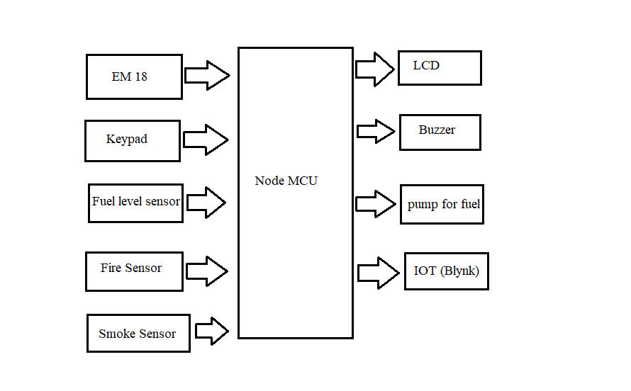

**HARDWARE REQUIREMENTS:**

**EM 18 Reader:**

Radio frequency identification, also referred to as or RFID, is a system that detects the location of RFID tags through the use of radio waves.

RFID readers may be used to detect the presence of people, objects, and other things in the same way as Bar code readers can.

Unlike radio frequency identification (RFID), which just requires bringing tags within range of readers, scanner technology involves the barcode to be kept in direct visual contact with the reader. Also, unlike RFID, barcodes can become degraded and unreadable.

There are several uses for RFID, including an attendance monitoring system in which each employee has their own RFID tag.

RFID is widely utilised by businesses to grant access only to verified personnel.

The use of a tag (with an id) is also useful in automated toll collecting systems on highways and for keeping track of cargo.

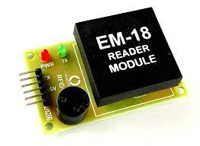

**4x4 keypad:**

We just need one general-purpose input/output (GPIO) pin to connect a single button to the microcontroller. Nevertheless, it may use up the entire microcontroller's Digital pins if we wish to interface a large number of buttons, such as nine, twelve, sixteen, etc.

The usage of a matrix keypad can free up Input pins on the microcontroller. Simply said, a diagonal keypad is a keypad with rows and columns of keys.

For instance, if we wish to connect 16 key to the controller, we'll need 16 Gpios; but, if we're employing a matrix four wheel keypad, we'll just need 8 GPIO pins.



**4x4 Keypad Matrix Structure**

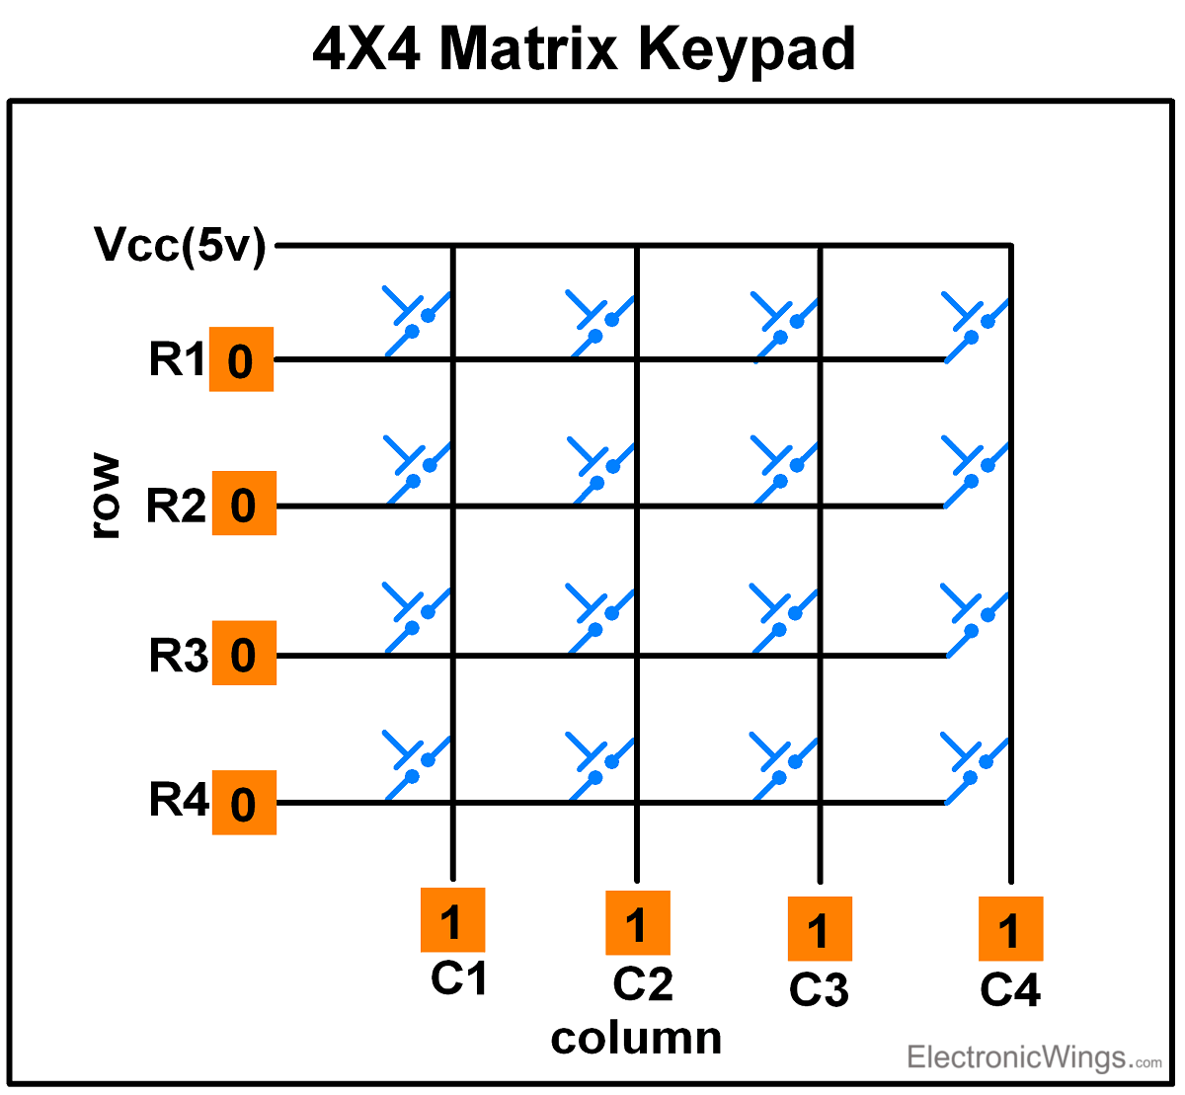

4x4 Keypad Pinout

The columns and rows make up the matrix layout of the keyboards. The columns and rows make intimate contact if a key is pushed. If not, then rows and columns don't have any significance.

**Liquid level sensor:**

Let's keep reading to find out more about this fascinating device, the liquid level sensor, whose construction is based on a very simple design. The sensor for measuring the level of a liquid is one of the most common types of sensor. This sensor is widely used and may be seen in devices such as the water level indicator. Practical applications for water-level sensors abound.

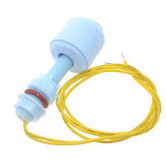

**Fire sensor:**

Flame sensors are the most sensitive type of light detectors. That's why fire alarms make use of this current sensor. This detector is able to pick up on flames with an incident light wavelength between 760 nm and 1100 nm. Because of its sensitivity to heat, this sensor is readily destroyed by even moderately hot conditions. As a result, this sensor may be set at a predetermined distance from the fire. With a 100cm separation, our detection angle for a light will be 600 degrees. This sensor may provide either an analogue or digital signal as its output. Wildland robots employ these devices in applications like a flame detector.

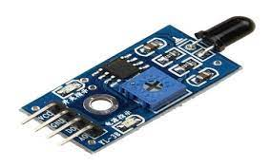

**Smoke sensor:**

An electronic device designed to detect smoke as an early warning of fire is called a smoking detector. Smoke detectors have plastic housings that are normally a disc form, measuring around 150 mm (6 in) in size and 25 centimeters (1 in) in thickness, however this varies depending on the brand. There are two main ways to detect smoke: visually (photoelectrically) and physically (ionization). Both sensing techniques can be used in detectors. Alarms with a high degree of sensitivity are capable of helping dissuade people from smoking in restricted locations and to catch them if they do. All too often, appliances in large office and factory buildings are not linked to a centralised fire alarm system.

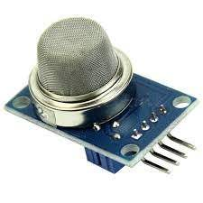

**Buzzer:**

An audible signalling device, a buzzer or beeper[1] can be hydraulic, electric, or capacitive (piezo for short). Buzzers and beepers are commonly used for a wide variety of purposes, including but not limited to alarms, clocks, trains, and confirming user actions such clicking or typing.

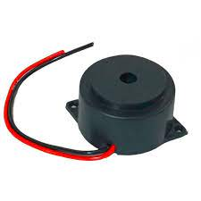

**Pump for fuel:**

Droplets (liquids, gases, or slurries) can be pushed about by mechanical action using a pump, which generally transforms electricity into hydraulic energy.

Physical pumps have a broad variety of uses, including pulling water from wells, filtration in aquariums and ponds, fuel injection in automobiles, petroleum and natural gas transport, and the operation of chillers and other HVAC components. Artificial limb and penile prostheses, in particular, rely on pumps for biological pathways during drug development and production.

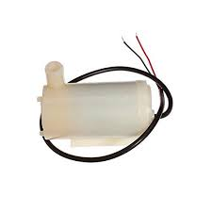

**Result:**

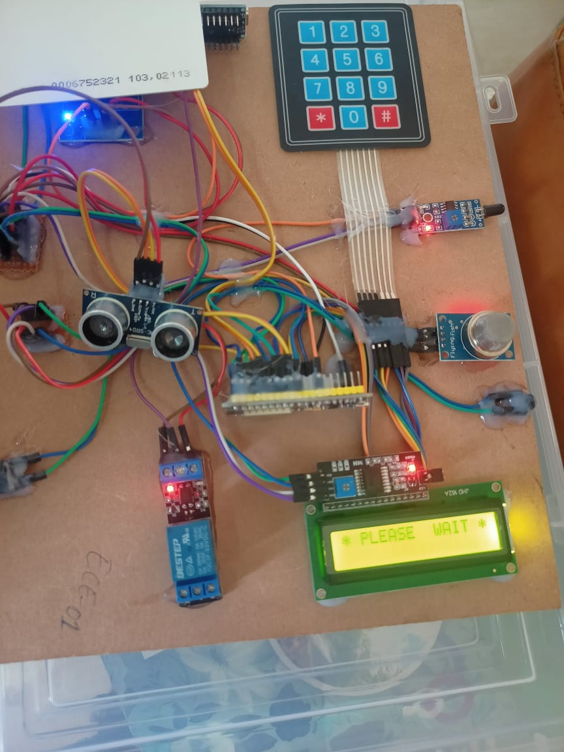

**Conclusion:**

Using an Internet of Things–based smart fuel station system, we were able to complete our primary aim, which will aid in modernising the typical gas station by reducing the need for human labour and financial investment and facilitating cashless transactions. The system may be upgraded in the future by adding a bill generator, hardness tester, and touch display to provide a user-friendly interface. Customers may load money onto their prepaid cards at any time, and they can use that card to buy gas at any gas station that participates in the system. Bill printers, density checkers, and touch screens can be added to the system in the future to provide a more intuitive interface. This means that the suggested Smart e-fuel station incorporates data analysis, operational computation, data collecting, and data visualisations. The suggested model is built on a free and open-source platform, making it both affordable and useful for Internet of Things (IoT) projects.

**Reference:**

[1] Y.Mallikarjuna Rao et. al, “Adaptive Leaf Abnormality Segmentation and Improved Plant Disease Classification by Tuned LSTM with RNN”, Concurrancy and Computation – Practice and Experience, **Wiley– SCIE.**

[2] Y.Mallikarjuna Rao et. al, “A Model Precdictive Goertzel Algorithm based active islanding detection for grid integrated photovoltaic systems”, Microprocessors and Microsystems, Vol.95, 2022, **Elseveir, – SCIE**

[3] Y.Mallikarjuna Rao, M.V.Subramanyam and K. Satyaprasad, “QoS based mobility management algorithms for wireless mesh networks”, Journal of scientific and industrial research, volume. 77, pp. 203-207, 2018. **(Impact factor – 0.534, SCI Indexed)**

[4] Y.Mallikarjuna Rao, M.V.Subramanyam and K. Satyaprasad, “Cluster based mobility management algorithms for wireless mesh networks”, International Journal of Communication systems **(Wiley)**, Vol. 31, no.11, pp.1-14, 2018. **(Impact factor – 1.717, SCI Indexed)**

[5] Y.Mallikarjuna Rao, M.V.Subramanyam and K. Satyaprasad, “Cluster based hybrid routing protocol for wireless mesh networks”, Wireless personal communications – An international journal **(Springer),** Vol. 103, no.4, pp. 3009-3023, 2018. **(Impact factor – 1.2, SCI Indexed)**

[6] Y.Mallikarjuna Rao, M.V.Subramanyam and K. Satyaprasad, “Multi layer routing protocol for mobility management in wireless mesh networks”, Twelfth International Conference on Communication Networks, 19-21 August 2016, VTU, Bangalore, **Proceedia computer science- journal (Elsevier), 2016. (Scopus Indexed)**

[7] Y.Mallikarjuna Rao, M.V.Subramanyam and K. Satyaprasad, “An efficient resource management algorithms for mobility management in wireless mesh networks”, IEEE Conference on energy, communication, data analytics and soft computing, SKR Engineering College, Chennai, 2017. **(Scopus Indexed)**

[8] Y.Mallikarjuna Rao et.al., “A Review on Beamforming Approaches for Speech Enhancement”, International Journal of Control and Automation, volume. 13, No. 4, pp. 590-595, 2020. **(Scopus Indexed)**

[9] Y.Mallikarjuna Rao, M.V.Subramanyam and K. Satyaprasad, “An enhanced mobility management algorithms for wireless mesh networks”, International Conference on advances in engineering management and sciences, Santhiram Engineering College, Nandyal, 16-17 July 2017.

[10] Y.Mallikarjuna Rao,M.V.Subramanyam and K. Satyaprasad, “Performance analysis of energy aware QoS enabled routing protocol for wireless mesh networks”, International journal of smart grid and green communications, **Inderscience publishers.** (**Accepted for publication- UGC approved Journal**).

[11] S. V. Sagar, G. R. Kumar, L. X. T. Xavier, S. Sivakumar and R. B. Durai, "SISFAT: Smart irrigation system with flood avoidance technique," 2017 Third International Conference on Science Technology Engineering & Management (ICONSTEM), Chennai, 2018.

[12] P. Gupta, S. Patodiya, D. Singh, J. Chhabra and A. Shukla, "IoT based smart petrol pump," 2016 Fourth International Conference on Parallel, Distributed and Grid Computing (PDGC), Waknaghat, 2016, pp. 28-32, doi: 10.1109/PDGC.2016.7913168.

[13] G. S. Matharu, P. Upadhyay, L. Chaudhary, "The Internet of Things: challenges and security Issues”, IEEE, pp. 54-59, 2014.

[14] Aniket H Jadhav, Ranjan S Pawar, Priyanka M Pathare, Kishori D Pawar, Prafulla Patil “Multi- Automized Fuel Pump with User Security", International Journal of Scientific & Technology Research Volume 3, issue 5, May 2014.

[15] Priyanka A Gaikwad, Shubangi S Wanare, Pallavi S Sanone, Prathibha kBahekar, “Automation in Petrol Bunk Using RFID and GSM. (2017).

[16] Sahana S Rao, V Siddeshwara Prasad, “Centralized automation of petrol bunk management and safety using RFID and GSM Technology”.(2017)Control system with GSM technology”, American journal of Engineering.

[17] R. N. Rao and B. Sridhar, "IoT based smart crop-field monitoring and automation irrigation system," 2017 2nd International Conference on Inventive Systems and Control (ICISC) 2017.

[18] P. K. Dutta, K. Mallikarjuna and A. Satish, "Sensor based solar tracker system using electronic circuits for moisture detection and auto-irrigation," 2017 IEEE International Conference on Power, Control, Signals and Instrumentation Engineering (ICPCSI), 2017.

[19] H. Purandare, N. Ketkar, S. Pansare, P. Padhye and A. Ghotkar, "Analysis of post-harvest losses: An Internet of Things and machine learning approach," 2016 International Conference on Automatic Control and Dynamic Optimization Techniques (ICACDOT) 2016 .

[20] D. R. Bolla, D. R. Rajesh, Shivashankar, M. Abhiram, B. K. C.S. and M. K. B. V., "An Innovative Smart Railway Platform Assist in Domestic Railway Stations," 2018 3rd IEEE International Conference on Recent Trends in Electronics, Information & Communication Technology (RTEICT), Bangalore, India, 2018, pp. 2608-2612, doi: 10.1109/RTEICT42901.2018.9012272.

[21] D. R. Bolla and Shivashankar, "An efficient protocol for reducing channel interference and access delay in CRNs," 2017 2nd IEEE International Conference on Recent Trends in Electronics, Information & Communication Technology (RTEICT), Bangalore, 2017, pp. 2247-2251, doi: 10.1109/RTEICT.2017.8257000.

[22] M. Penna, J. J. Jijesh, D. R. Bolla, M. S. Pramod and P. Satyasrikanth, "Reconfiguring CPLD to perform operations based on sequence detection condition," 2016 IEEE International Conference on Recent Trends in Electronics, Information & Communication Technology (RTEICT), Bangalore, 2016, pp. 554- 558, doi: 10.1109/RTEICT.2016.7807883.