A Review Paper on Spy Robo

# Maruti B. Limkar,

*Assistant Professor,*

*Department of Electronics Engineering, Terna Engineering College, Nerul, Maharashtra, India*

# Arti Chawrasia, Vivek Bade, Asjad Adhikari, Vijay Sal

*UG Student, Department of Electronics Engineering, Terna Engineering College, Nerul, Maharashtra,India*.

***ABSTRACT:***

*The main aim of this project development for mobile operated spy robot using Arduino Uno microcontroller. In this spy robot, the camera was mound to operate the vehicle, which acquires and sends video to mobile. The movement of vehicles is controlled by a microcontroller and camera.*

*Our idea is to make a robot to tackle the hostage situation & the worst conditions which cannot be handled by a human being. The hostage humans are moved out from direct exposure to potentially dangerous situations. The robotic system can perform many security and surveillance functions moreeffectively than humans.*

**KEYWORDS:** ESP 32, Atmega 328PArduino Nano, L298 Motor Driver, Camouflage, Robot

# INTRODUCTION:

In this project, we will deliberate how to control robot controlled using Bluetooth

module through an android mobile phone. A new version of wireless & bluetooth controlled vehicle is proposed for spying purposes. This robot supposes a movable spy robot with wireless system.

The spy robot is made up of an IP camera, DC motors, servo motors for camera rotation, solar cells instead of the regular lithium rechargeable ion batteries, and four movable wheels.

Smart phone camera is used as an IP camera to capture livestreaming video surrounding the robot and that information will be appeared in user's smart phone GUI window.

One of the basic features of military robots in operations is that they are not completely automatic. They are actually controlled remotely by human beings.

The robots or unmanned machines as they are termed can be any moving object or a flying airplane fitted with all necessary equipment like sensors, LIDARS (Laser-based Communication RADARS), cameras, etc. Their operations can vary from disposing of bombs to surveying enemy territories.

# LITERATURE REVIEW:

1. This system is developed in order to reduce the number of human victims in terrorist attack like 26/11. This problem can be overcome by designing a spy robot which involves wireless camera in order to examine rivals easily when it is required. These robots can secretly enter into the enemy's area and send us the information through wireless camera. For over half a century robotics has been a key for advanced manufacturing.
2. The main objective behind developing this robot is for surveillance of human activities in the field region in order to reduce infiltration from the enemy side. The robot consists of camera which can transmit video of the field in order to prevent any damage loss to human life. The robot consists of metal detector and gas detector for the prevention of damage of field.
3. The main aim and objective of this project is to deal with the security issues such as combating of the terrorists activities by tracking their locations and launch pads and reducing soldier's efforts and involvement in the mission. This can be achieved by the RF BASED spy robot which consists of a night vision wireless camera.The robot consists of night vision camera which is wireless and it can record real time videos and footages even in dark and these footages are displayed on our mobile screen which is connected through Wi-Fi via MI-app spy.
4. On aiming to increase the safety because by using this robot we can know their activities by keeping some safe distance from the enemy, the flexibility of attacking will be increased because we can know their activities and there will be a laser that will lock the position of the enemy and guides the missal, this is also contain the metal detector that will helpful in detecting the land mains which will lead to death, and control of this robot will be very easily done because it is controlled wirelessly and by connecting to Bluetooth of any android mobile. We have done this project for our army to detect the land mains safely and for the safety of our soldiers and to attack them without keeping our army soldiers life on the line.
5. This system presents the wireless bomb disposal robot which will help to improve the defense of our nation from terrorist, suicide bombers and other such activities. The bomb detectors and disposal system work only with the presence of experts. But this way of analyzing takes more time and makes the risk to the life of experts. The Wireless Bomb Disposal Robot uses the control application, at the user end to control the robot remotely using Wireless technology. The bomb technician controls the robot using this application at the control site. The Robot consists of a Base, a Robotic Arm, RPI, and a camera on it. We have used DC motors for the moving robot and the gripper of the robotic arm.
6. An intelligent robot is used to reduce the humanloss during the war in defence. It alerts the soldiers about the threat from rivals. This project presents a smart surveillance robot for military application by using Xbee to communicate with wide range of areas. Microcontrollers are the heart of the robot. Advanced software and hardware applications are used. The mini spy robot with a CCD camera plays a vital role. Along with camera it has Gas sensors, Bomb detection and diffusion kit and a voice controller.

# AIM AND OBJECTIVES:

* + To ensure the safety and security of a Military Personnel. The robot will serve as an appropriate machine for the defense sector to reduce the loss of human life and will also prevent illegal activities.
  + To make India independent in terms of defence capability.

# WORKING:

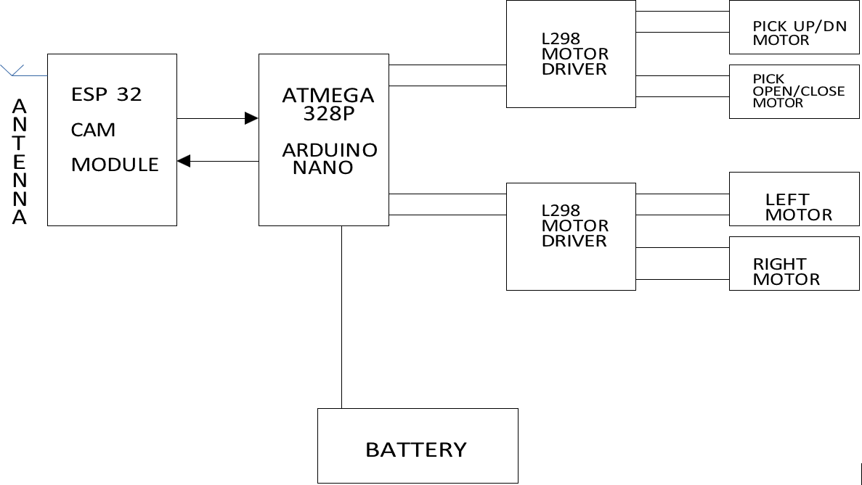

There are some spying robots which are controlled by remotes, spying robot also have a camera in it and it also transmits video material or information to the mediation group or spying group. The size of these types of robots are usually suitably small so can travel more efficiently. The task that we have to perform, we have moveable military mediator or spying robot which will be controlled by remote, we have used L298 motor driver as well as Arduino nano. These type of robots which should be handle in a secret manner it have camera which will also controlled by remote, batteries, an antenna. We have used motor’s to control the robot and whole system through remote. In our robot we have also used ESP 32 camera (charged couple device), it is used to latch all information or data to the robot. On our remote controlled we have used mobile to watch the direction of user. If the robot have to travel in dark areas or in night we have set up a LED light on the ESP 32 camera with all the lightning circuitry. Wi-fi module are also used in this robot for receiving and transmitting the signals from remote to agent robot, so the user can control the robots speed, turning of robot basically whole control over the robot. To have good control over speed and turning we have used brushed DC motors with its motor driver l2989 in our military agent robot.

# CONCLUSION:

* Through this project we aim to develop an military spy robot which will monitor and track enemy location, ensuring safety and security of human being and our military personal and even improved our defense industry.
* All these operations will be performed by using Arduino uno, robot circuit, guile suit which will camouflage object , dc motors and wireless camera.
* All the data collected will be captured as well as it will be recorded for future use.

# REFERENCES:

1."Design and Implementation of Spy Robot" Shubham Kalvankar, Kunal Nagarkoti, Bhushan Narkhede,Shubham Patil

International Journal of Innovative Research in Computer and Communication Engineering

e-ISSN: 2320-9801, p-ISSN: 2320-9798 [www.ijircce.com](http://www.ijircce.com/) Impact Factor: 7.488 2."Spy Robot for Military Application Using Wi-Fi Module" Anita Jadhav, Prachi Jadhav, Pooja Magdum, Kiran N. Patil

Advancement of Signal Processing and its Applications Volume 1 Issue 1

1. "Military Spying Robot" Sarmad Hameed, Muhammad Hamza Khan, Naqi Jafri, Adeel Azfar Khan, Muhammad Bilal Taak

International Journal of Innovative Technology and Exploring Engineering (IJITEE)

ISSN: 2278-3075,Volume-8, Issue-7C2, May 2019

1. "Military Spying & Bomb Diffusing Robot with Night vision " Richa Parmar, Akash Malik, Attarwala Shahnawaz , Barot Parth

International Research Journal of Engineering and Technology (IRJET) e-ISSN: 2395 -0056

Volume: 04 Issue: 03 | Mar -2017 [www.irjet.net](http://www.irjet.net/) p-ISSN: 2395-0072