# CV GENERATOR

# Ritesh Balange1 Rudraksh Jagnani2 Sidharth Mahajan3

1Dept. of Computer Science & Engg.,1Tha.Shiv Kumar Memorial Engg.College, Burhanpur(M.P.), India.

# ABSTRACT

# Online cv generator website is provide facility to build new cv and edit,delete .A number of technologies are involved in gathering the data, storing it, and showing it on the Resume Building website. In this project, we have used database management with sqlite3 at the back-end for storing and fetching information, and HTML on the front-end.

# INTRODUCTION

# Candidates do not need to invest additional time in planning and creating a polished CV. They can instantly enter their information into the website, and a resume will be generated for them. After entering their information, users will receive a well-structured resume that they may download in PDF format if necessary. The "ONLINE RESUME BUILDER" project is a web-based application designed for organizing information, such as educational, personal.

# HISTORY

# In 2003 by Lawrence, Django was designed and developed and released to the open public under BSD license in 2005.Currently, Django Software Foundation takes care of maintenance and new releases .

# Django is widely accepted and used by various well-known sites such as:

# Spotify

# Youtube

# Dropbox

# Pinterest

# NASA

**Methodology**

**1.SDLC**

Software Development Life Cycle (SDLC) is a process used by the software industry to design, develop and test high quality softwares. The SDLC aims to produce a high-quality software that meets or exceeds customer expectations, reaches completion within times and cost estimates

.

SDLC is a process followed for a software project, within a software organization. It consists of a detailed plan describing how to develop, maintain, replace and alter or enhance specific software. The life cycle defines a methodology for improving the

quality of software and the overall development process..

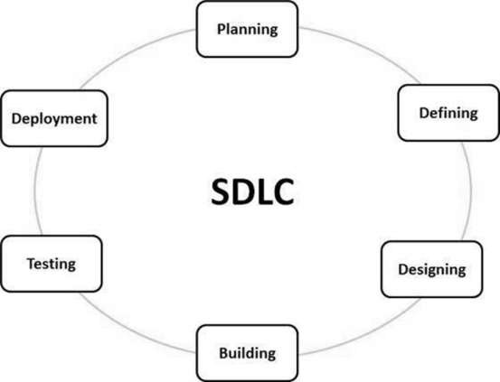

**Type of SDLC:-**

1. Waterfall Model
2. RAD Model
3. Spiral Model
4. Incremental Model
5. Iterative Model
6. Agile Model
7. V-Model

**a) Waterfall Model**

The Waterfall Model was the first Process Model to be introduced. It is also referred to as a linear-sequential life cycle model. It is very simple to understand and use. In a waterfall model, each phase must be completed before the next phase can begin and there is no overlapping in the phases.The waterfall Model illustrates the software development process in a linear sequential flow. This means that any phase in the development process begins only if the previous phase is complete. In this waterfall model, the phases do not overlap.

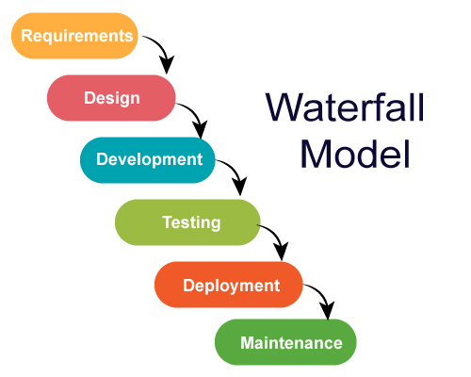

**2.Diagram**

**a) DFD (Data Flow Diagram):-** The data flow diagrams (DFD) depict the information flow and the transforms that are applied on the data as it moves from to output. The data flow diagram are used to represent the system at any level of abstraction information flow. A Data flow diagram is graphical tool that allows system analysis (and system user) to depict the flow of data in information system

**a.1)DFD LEVEL- 0 :-** Highest abstraction level DFD is known as Level 0 DFD, which depicts the entire information system as one diagram concealing all the underlying details. Level 0 DFDs are also known as context level DFDs.

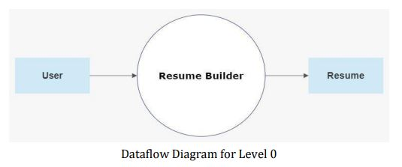

**a.2)DFD LEVEL- 1 :-** In 1-level DFD, a context diagram is decomposed into multiple bubbles/processes. In this level, we highlight the main objectives of the system and breakdown the high-level process of 0-level DFD into subprocesses.

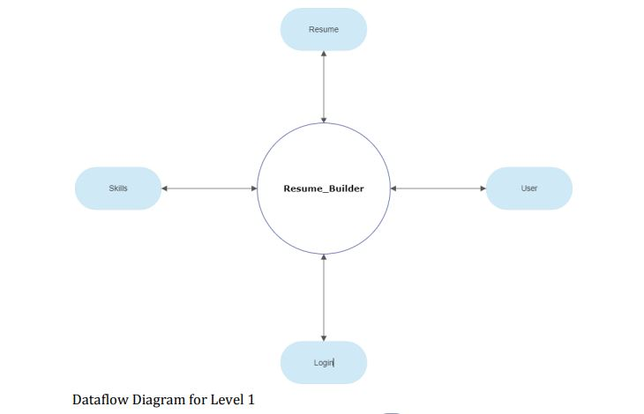

**b)Sequence Diagram** The sequence diagram represents the flow of messages in the system and is also termed as an event diagram. It helps in envisioning several dynamic scenarios. It portrays the communication between any two lifelines as a time-ordered sequence of events, such that these lifelines took part at the run time. In UML, the lifeline is represented by a vertical bar, whereas the message flow is represented by a vertical dotted line that extends across the bottom of the page. It incorporates the iterations as well as branching.

## Purpose of a Sequence Diagram

1. To model high-level interaction among active objects within a system.
2. To model interaction among objects inside a collaboration realizing a use case.

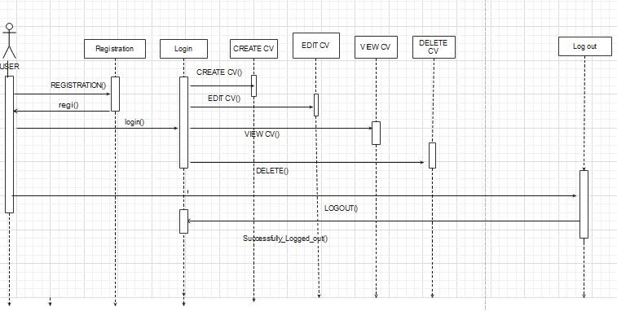

**c)Activity Diagram:-** In UML, the activity diagram is used to demonstrate the flow of control within the system rather than the implementation. It models the concurrent and sequential activities.The activity diagram helps in envisioning the workflow from one activity to another. It put emphasis on the condition of flow and the order in which it occurs. The flow can be sequential, branched, or concurrent, and to deal with such kinds of flows, the activity diagram has come up with a fork, join, etc.It is also termed as an object-oriented flowchart.

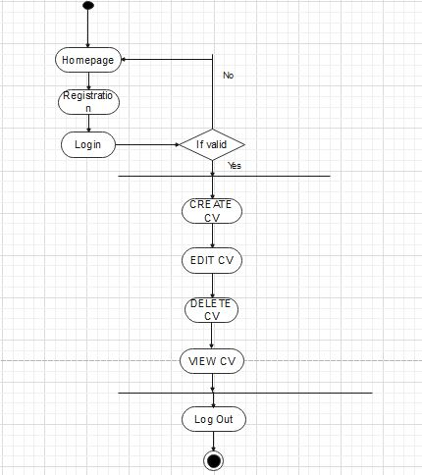

**d)Usecase diagram :-** A use case diagram is used to represent the dynamic behavior of a system. It encapsulates the system's functionality by incorporating use cases, actors, and their relationships. It models the tasks, services, and functions required by a system/subsystem of an application. It depicts the high-level functionality of a system and also tells how the user handles a system.

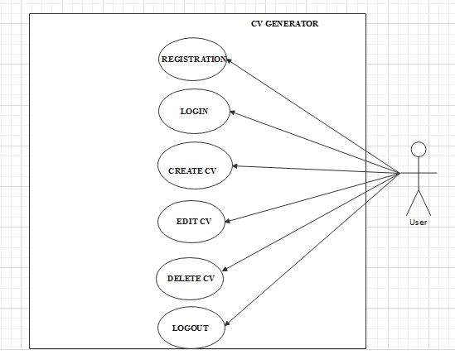

**IMPLEMENTATION**

**A. Technologies Used**

Various front-end and back-end technologies are available in this era of digitalization. The technologies used in this project are discussed briefly in the following sections.

**1.Front End Technologies**

***a) HTML***

It stands for Hypertext Markup Language, and it is the most widely used language to write Web Pages. Hypertext refers to the way in which Web pages (HTML documents) are linked together. Thus, the link available on a webpage is called Hypertext. As its name suggests, HTML is a Markup Language which means you use HTML to simply "mark-up" a text document with tags that tell a Web browser how to structure it to display (Musciano & Kennedy,1996). Originally, HTML was developed with the intent of defining the structure of documents like headings, paragraphs, lists, and so forth to facilitate the sharing of scientific information between researchers. Now, HTML is being widely used to format web pages with the help of different tags available in HTML language.

***b) CSS***

CSS (Powell, 2010) stands for Cascading Style Sheets. CSS describes how HTML elements are to be displayed on the screen, paper, or in other media. CSS saves a lot of work. It can control the layout of multiple web pages all at once.

**c)JavaScript/JQuery**

JavaScript (JS) is a high level, interpreted programming language. JavaScript has curly-bracket syntax, dynamic typing, prototype-based object-orientation, and first-class functions.

Alongside HTML and CSS, JavaScript is one of the core technologies of the World Wide Web (Flanagan, 2006). JavaScript enables interactive web pages and is an essential part of web applications. The vast majority of websites use it, and major web browsers have a dedicated JavaScript engine to execute it. JavaScript provides the facility to validate the form on the client-side so data processing will be faster than server-side validation

**d)BootStrap**

Bootstrap (Shenoy & Sossou, 2014) is a free and open-source CSS framework directed at responsive, mobile-first front-end web development. It contains CSS and (optionally) JavaScript-based design templates for

typography, forms, buttons, navigation, and other interface components.

To use bootstrap, we are required to either install in our system or use CDN. CDN is short for content delivery network. A CDN is a system of distributes servers that deliver pages and other web content to a user, based on the geographic locations of the user, the origin of the

webpage and the content delivery server

**2. Back End Technologie**

**a)Python**

Python is an interpreted, high-level, general-purpose programming language. Created by Guido van Rossum and first released in 1991 (Kuhlman, 2011), Python‟s design philosophy emphasizes code readability with its notable use of significant whitespace. Its language constructs and object-oriented approach aims to help

programmers write clear, logical code for small and large-scale projects. In this website, python is used as backend language to code database part and all functionalities that the website can perform. The version of Python used in this

development is Python 3.6.

# b) Django

## To know the MVT Structure of Django firstly we need to know what is MVT structure. The full form of MVT is Model View Template. MVT Structure has three parts

## 1. Model

## 2. View

## 3. Template.

## Model: This part of the MVC structure acts as a medium for storing data from the user into the database. This is responsible for handling the logical part of the web application as well as how the data is stored in the database .

## Views: This is a user interface. It is responsible for displaying data from databases and storing information provided by the user. In Django views are not the same as they are in basic MVC structure. Controller: This part in MVC is responsible for the whole logic and workings behind the web application. When a user raises an HTTP request, the controller receives the request and sends back the appropriate response.

## Hence Django implements a different kind of MVT architecture.

## Django-Architecture-2.png

## User Manual

**a)Software Requirements:**

• Browser: Internet Explorer or Mozilla Firefox or Opera

• IDE : VS Code Studio

• Language : Python

• Other Tech **:** HTML, CSS and JavaScript

• Operating system: Any Windows version/ MAC

**b)Hardware Requirements:**

• Processor: Intel Pentium IV or above

• Ram: 1GB or more

• Hard Disk: 40 GB or more

**c)Step to Run Project :**

**Step 1**:- Firstly start your laptop/pc .

**Step 2**:- Now install python setup for coding of python language .

**Step 3**:- After that install vs code .

**Step 4**:- In vs code terminal write pip install django for installing django .

**Step 5**:- In vs code we write coding for project . to run the project select brouser google chrome . Open one of the browser enter your url <http://127:0:0:1:9898> .

**RESULTS**

**Home :** This. the home page of Golden India

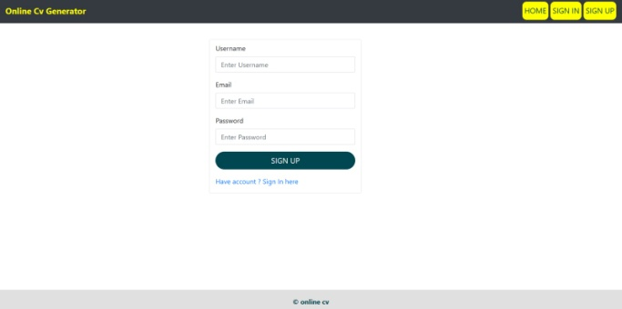

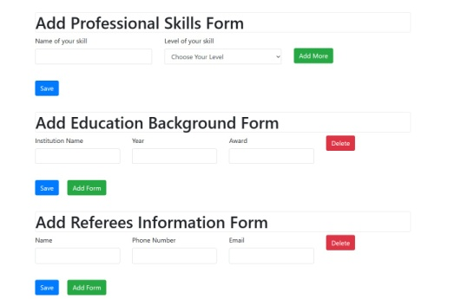

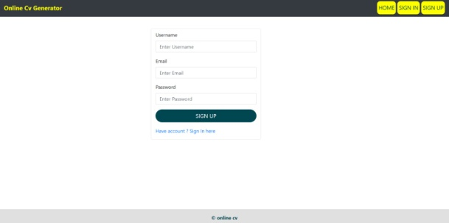

**CONCLUSION**

The Resume Builder Application is a web-based application that may be used to construct a resume by both novice and experienced users. Users can construct a resume in a standard manner using the Resume Builder Application. It also encourages open-source developers to develop open-source goods.

**REFERENCES**

**a) Websites**

1. [**www.w3schools.com**](http://www.w3schools.com)
2. [**www.geeksforgeeks.com**](http://www.geeksforgeeks.com)
3. **www.djangoproject.com**
4. [**www.tutorialspoints.com**](http://www.tutorialspoints.com)
5. [**www.learnigpoints.com**](http://www.learnigpoints.com)
6. [**www.tutorialshub.com**](http://www.tutorialshub.com)
7. [**www.pythonconcept.com**](http://www.pythonconcept.com)
8. [**www.google.com**](http://www.google.com)
9. [**www.pythonlean.org**](http://www.pythonlean.org)
10. [**www.javatpoint.com**](http://www.javatpoint.com)

**b) Books**

1. **Software engineering**
2. **Python**
3. **Iwt**
4. **Ecommerce concepts**
5. **DBMS**

**c)Reference Research Paper**

1. Adamya Shyam , Nitin Mukesh A Django Based Educational Resource Sharing Website: Shreic,Volume 64, Issue 1, 2020.
2. Josh JuneauJim BakerVictor NgLeo SotoFrank Wierzbicki,The Definitive Guide To Jython pp 281-325, Web Applications With Django
3. Jian Chou, Lin Chen Hui Ding; Jingxuan Tu, Baowen Xu,A Method of Optimizing Django Based on Greedy Strategy,2013 10th Web Information System and Application Conference
4. Arnold Rosenbloom,A Simple MVC Framework for Web Development Course,the 23rd Western Canadian Conference

.