**Hand Gesture Recognition System Using Camera**

Harsh Mahashabde1, Udayraj Pawar2, Jay Patil3, C.D.Tarle4

1Student, Diploma IT, K K Wagh Polytechnic, Nashik, Maharashtra, India- 422003

2 Student, Diploma IT, K K Wagh Polytechnic, Nashik, Maharashtra, India- 422003

3Student, Diploma IT, K K Wagh Polytechnic, Nashik, Maharashtra, India- 422003

3Professor, IT Department, K K Wagh Polytechnic, Nashik, Maharashtra, India- 422003

**ABSTRACT**

Hand gesture recognition has become an increasingly popular research topic due to its potential application in various fields such as human-computer interaction and sign language recognition. In this paper, we present a comprehensive review of recent advances in hand gesture recognition using a web camera. We discuss the challenges faced during the making of this approach. We then present various techniques for hand detection that have been proposed in the literature. Finally, we provide an evaluation of the performance of these techniques based on their accuracy, speed, and robustness.

1. **INTRODUCTION**

Hand gesture recognition is a process of recognizing and interpreting the gestures made by hands to interact with the computer. It is a vision technology that enables computers to interpret hand gestures as commands or actions. This technique can be used for a variety of purposes, including gaming, virtual reality, sign language recognition, and robotic control. In recent years, there has been a growing interest in using web cameras to capture hand gestures in real-time. This is because web cameras are easily accessible, affordable, and widely available. However, recognizing hand gestures using a web camera is a challenging task due to various factors such as varying lighting conditions, background noise, and hand shape variations.

1. **BACKGROUND**

Hand gesture recognition has been a popular field of research in computer vision since the early 2000s. Traditional approaches to hand gesture recognition involve using sensors, such as gloves, to capture hand movements.

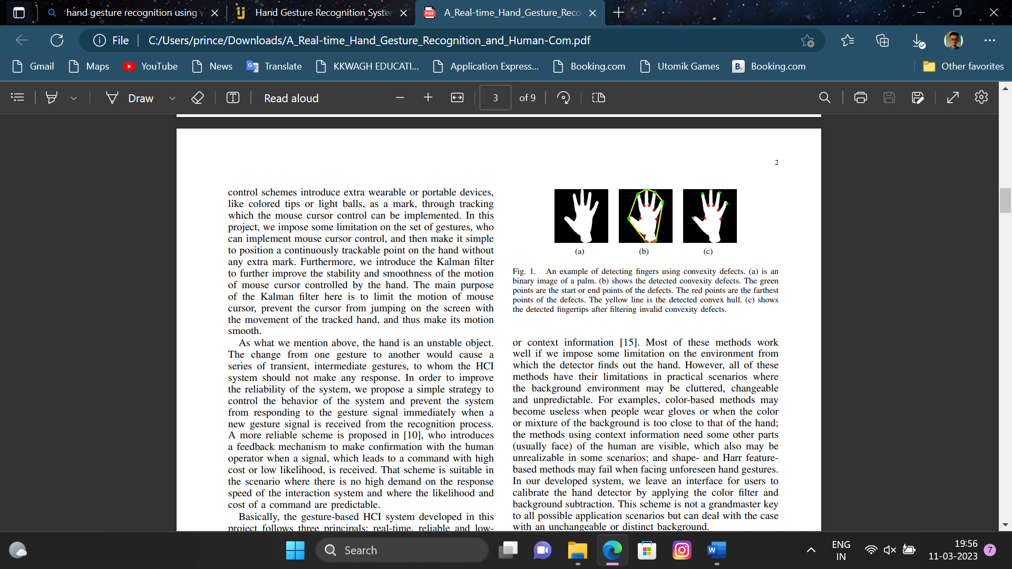  

1. (b) (c)

However, these approaches are expensive and not very practical. With the advent of web cameras and their increasing popularity, researchers have shifted their focus to developing hand gesture recognition systems that use web cameras as the primary input device.

1. **PROBLEM STATEMENT**

Hand detection is the process of detecting the presence and location of hands in an image or video frame. It is a crucial step in hand gesture recognition systems and has various applications, including virtual reality, robotics, gaming, and human-computer interaction. Hand detection is the first step in hand gesture recognition. The objective of hand detection is to identify the region of interest containing the hand in the image. Various techniques have been proposed for hand detection.

1. **CLASSIFICATION**

After feature extraction, the final step is classification. Classification is the process of assigning a label to the hand gesture. Various classification techniques have been proposed, including support vector machine (SVM), k-nearest neighbor (KNN), and artificial neural networks (ANN). SVM is a popular method that finds the hyperplane that maximally separates the hand gestures. KNN is a simple but effective method that assigns the label to the hand gesture based on the nearest neighbour.

1. **PROPOSED SYSTEM**

Hand gesture recognition using a camera is a popular and practical system for many applications, such as sign language interpretation, human-computer interaction, and virtual reality. The proposed system involves using a camera to capture images of hand gestures and then processing those images to recognize and classify the gestures. Here are the basic steps of a typical hand gesture recognition system using a camera:

1. Image acquisition: A camera captures an image or a video stream of the hand gestures.
2. Pre-processing: The captured images are pre-processed to remove noise, reduce background interference, and enhance the image quality.
3. Hand detection: The pre-processed images are analyzed to detect the location of the hand in the image.
4. Feature extraction: Relevant features are extracted from the detected hand, such as the position, orientation, size, and shape of the hand.
5. Gesture recognition: The extracted features are used to classify the hand gesture into predefined gesture classes using machine learning algorithms.
6. Gesture output: The recognized gesture is outputted to control a device or to perform a specific action.

The accuracy of the hand gesture recognition system depends on the quality of the captured images, the performance of the pre-processing techniques, and the effectiveness of the feature extraction and classification algorithms. Deep learning techniques such as Convolutional Neural Networks (CNN) and Recurrent Neural Networks (RNN) have shown significant improvements in hand gesture recognition accuracy compared to traditional machine learning methods. Overall, a hand gesture recognition system using a camera has great potential for various applications and can enhance the user experience in different fields.

1. **SYSTEM ARCHITECTURE**

The system architecture for a hand gesture recognition using a camera can be divided into the following components:

6.1. Camera module

6.2. Image processing module

6.3. Hand detection module

6.4. Finger detection module

6.5. Feature extraction module

6.6. Gesture recognition module

6.7. Gesture output module

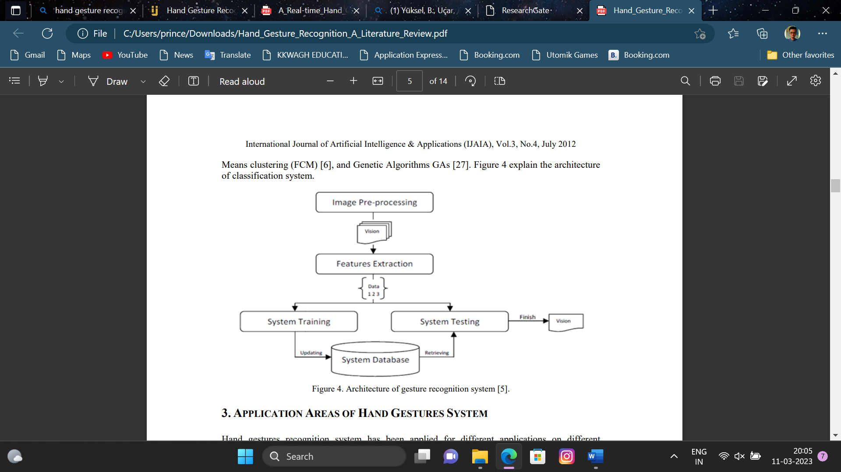

The overall architecture of the hand gesture recognition system can be implemented using different hardware and software components, depending on the specific application requirements.

**6.1 Camera module**

The camera module is one of the essential components of the hand gesture recognition system architecture. It captures the video or image stream of the hand gestures, which is then sent to the image processing module for further processing. The camera module can be implemented using various hardware and software components, depending on the specific application requirements.

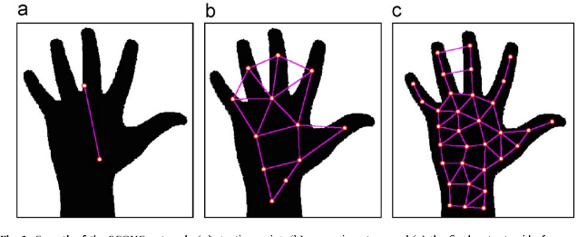

The camera module typically consists of the following components:

1. Image sensor: It captures the light from the scene and converts it into an electrical signal, which is then processed by the camera's electronics.
2. Lens: It focuses the light onto the image sensor and controls the field of view of the camera.
3. Processor: It controls the camera's electronics and performs various image processing functions, such as color correction, white balance, and exposure control.
4. Interface: It provides a means of communicating with the camera, such as USB, Ethernet, or wireless.

The camera module may also include additional features, such as image stabilization, autofocus, and zoom. The choice of camera module depends on the specific application requirements, such as resolution, frame rate, field of view, and lighting conditions. For hand gesture recognition, the camera module should have a high enough resolution to capture the hand's details and movement accurately. A high frame rate is also required to ensure that the system can recognize hand gestures in real-time. Additionally, the camera module should be able to work in various lighting conditions, as lighting can affect the image quality and the system's accuracy.

**6.2 Image Processing Module**

The image processing module is another critical component of the hand gesture recognition system architecture. Its primary function is to perform pre-processing on the captured video or image stream from the camera module.

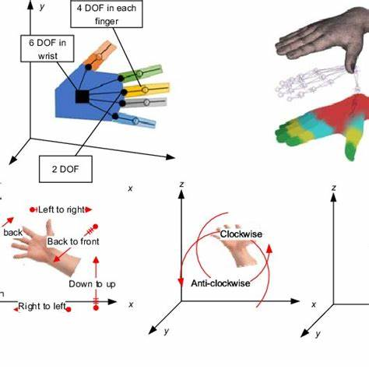

The pre-processing techniques are applied to enhance the image quality, reduce noise, and remove any background interference. The image processing module typically consists of the following sub-modules:

1. Pre-processing: This sub-module performs the initial processing of the captured image or video stream. The pre-processing techniques may include color correction, white balance, and brightness and contrast adjustment. The pre-processing is important as it helps to improve the image quality and ensure that the hand gestures are accurately detected.
2. Filtering: This sub-module is used to remove noise and smooth out the image. Filtering techniques may include median filtering, Gaussian filtering, or adaptive filtering.
3. Edge detection: This sub-module is used to detect the edges of the hand and its features, such as fingers and palm. Edge detection techniques may include Sobel, Canny, or Laplacian edge detection.

The output of the image processing module is a pre-processed image or video stream that is sent to the hand detection module for further processing. The image processing techniques used in the module are designed to improve the quality of the image and reduce background interference, which is important for accurate hand detection and gesture recognition.The specific image processing techniques used in the hand gesture recognition system architecture can vary depending on the specific application requirements and the characteristics of the input image or video stream.

**6.3 Hand Detection Module**

The hand detection module is a crucial component of the hand gesture recognition system architecture. Its primary function is to analyze the pre-processed image or video stream from the image processing module and detect the location of the hand in the image. The hand detection module uses various techniques to accurately detect the hand, such as skin color segmentation, template matching, or machine learning-based approaches. The hand detection module typically consists of the following sub-modules:

1. Skin color segmentation: This sub-module uses skin color information to detect the hand in the image. It analyzes the pre-processed image and identifies pixels that belong to the skin color range. Skin color segmentation is a simple and effective technique, but it may not work well under different lighting conditions or for people with different skin tones.
2. Template matching: This sub-module uses a template image of a hand to detect the hand in the image. It compares the template image with the pre-processed image and identifies areas that match the template. Template matching is an effective technique, but it requires a large number of template images for accurate detection.
3. Machine learning-based approaches: This sub-module uses machine learning algorithms, such as Support Vector Machines (SVMs), Neural Networks, or Decision Trees, to detect the hand in the image. Machine learning-based approaches can provide high accuracy hand detection, but they require a large amount of training data and computational resources.

The output of the hand detection module is a binary mask image that identifies the location of the hand in the image.

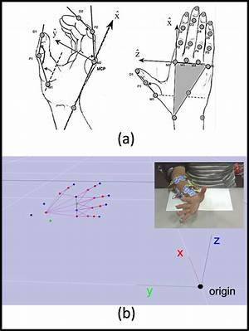

This binary mask image is then sent to the feature extraction module for further processing. The hand detection module's accuracy is critical to the overall performance of the hand gesture recognition system architecture, as accurate hand detection is essential for precise gesture recognition.

**6.4 Finger detection module**

The finger detection module is one of the important component of the hand gesture recognition system architecture.

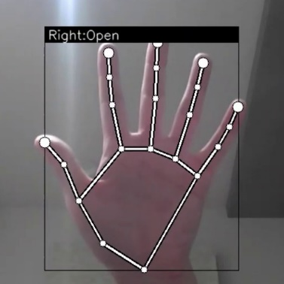

Its primary function is to analyze the pre-processed image or video stream from the image processing module and identify the position of individual fingers in the hand region. The finger detection module typically consists of the following sub-modules:

1. Hand segmentation: This sub-module is used to segment the hand region from the rest of the image or video frame. Hand segmentation may involve thresholding, clustering, or machine learning techniques.
2. Finger localization: This sub-module is used to identify the position of individual fingers in the hand region. Finger localization may involve feature extraction, edge detection, or template matching techniques.
3. Finger tracking: This sub-module is used to track the movement of individual fingers over time. Finger tracking may involve optical flow, Kalman filtering, or particle filtering techniques.

The output of the finger detection module is the position and movement of individual fingers in the hand region, which is used as input to the feature extraction module for further processing. Finger detection is an important step in hand gesture recognition because it allows for more precise and accurate feature extraction, which can improve the overall accuracy of the system. The specific finger detection techniques used in the hand gesture recognition system architecture can vary depending on the specific application requirements and the characteristics of the input image or video stream. The finger detection techniques used in the system should be robust to variations in lighting conditions, hand size, and hand orientation to ensure accurate finger detection.

**6.5 Feature extraction module**

The feature extraction module is another essential component of the hand gesture recognition system architecture. Its primary function is to extract relevant features from the pre-processed image or video stream to represent the hand gesture in a meaningful way. The extracted features are used as inputs to the gesture recognition module for further processing. The feature extraction module typically consists of the following sub-modules:

1. Region of interest (ROI) extraction: This sub-module is used to isolate the region of interest that contains the hand. The ROI extraction may involve cropping the image or using a bounding box to extract the relevant pixels.
2. Feature extraction: This sub-module is used to extract features that represent the hand gesture. Feature extraction techniques may include using shape descriptors, color histograms, texture analysis, or gradient-based techniques.
3. Feature selection: This sub-module is used to select the most relevant features that are useful for hand gesture recognition. Feature selection techniques may include statistical methods or machine learning techniques.

The output of the feature extraction module is a set of features that represent the hand gesture. These features are used as inputs to the gesture recognition module for further processing. The specific feature extraction techniques used in the hand gesture recognition system architecture can vary depending on the specific application requirements and the characteristics of the input image or video stream. The feature extraction techniques used in the system should be robust to variations in lighting conditions, hand size, and hand orientation to ensure accurate gesture recognition.

**6.6 Gesture recognition module**

The gesture recognition module is the final component of the hand gesture recognition system architecture. Its primary function is to classify the hand gesture based on the extracted features from the feature extraction module. The gesture recognition module typically consists of the following sub-modules:

1. Classification: This sub-module is used to classify the hand gesture based on the extracted features. Classification techniques may include rule-based approaches, pattern recognition, or machine learning techniques.
2. Decision-making: This sub-module is used to make a decision based on the classification results. Decision-making techniques may include thresholding or voting-based methods.

The output of the gesture recognition module is the recognized hand gesture, which is then sent to the application module for further processing or action. The gesture recognition module is designed to be robust to variations in lighting conditions, hand size, and hand orientation to ensure accurate and reliable gesture recognition.

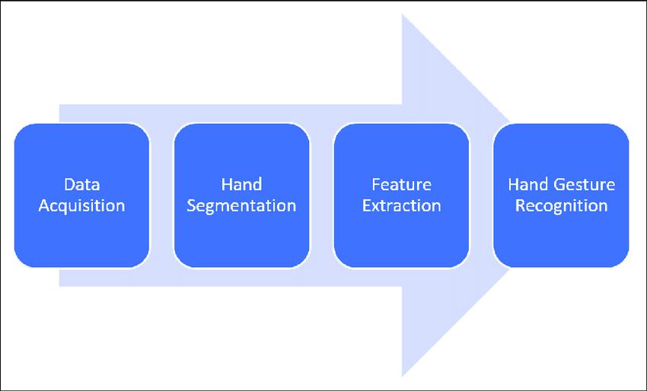

The specific gesture recognition techniques used in the hand gesture recognition system architecture can vary depending on the specific application requirements and the characteristics of the input image or video stream. The gesture recognition techniques used in the system should be able to recognize a wide range of hand gestures and be able to handle variations in gesture speed and duration.

**6.7 Gesture output module**

The gesture output module is a component of the hand gesture recognition system architecture that is responsible for outputting the recognized gesture to the user or the application. The gesture output module typically consists of the following sub-modules:

1. Output interface: This sub-module is used to interface with the user or the application. The output interface may include a display screen, a speaker, or a haptic feedback device.
2. Gesture mapping: This sub-module is used to map the recognized gesture to a corresponding action or command. Gesture mapping techniques may include simple look-up tables or more complex decision trees or machine learning techniques.
3. Application integration: This sub-module is used to integrate the recognized gesture with the application or system. Application integration may involve sending commands or triggering events based on the recognized gesture.

The output of the gesture output module is the recognized gesture, which is then used to control the application or system. The gesture output module is designed to provide a seamless and intuitive user experience by accurately and reliably translating hand gestures into actions or commands. The specific output interface, gesture mapping, and application integration techniques used in the hand gesture recognition system architecture can vary depending on the specific application requirements and the user preferences. The gesture output module should be designed to be easily customizable and adaptable to different applications and systems.

1. **ADVANTAGES OF PROJECT**

Hand gesture recognition using a camera provides a versatile and effective method of gesture recognition that has many advantages over other techniques. It is a promising area of research that has many potential applications in various fields.

1. Non-invasive: Hand gesture recognition using a camera is a non-invasive technique that does not require physical contact with the user. This makes it a safe and convenient method for gesture recognition.
2. Natural interface: Hand gesture recognition using a camera provides a natural and intuitive interface that is easy to learn and use. It can be used in a variety of applications such as gaming, virtual reality, and human-computer interaction.
3. Cost-effective: Hand gesture recognition using a camera is a cost-effective technique that does not require expensive hardware or sensors. Most modern smartphones and laptops come equipped with a camera that can be used for gesture recognition.
4. Real-time performance: Hand gesture recognition using a camera can be performed in real-time, which is essential for applications that require immediate feedback. Real-time performance can be achieved by optimizing the algorithm and using efficient hardware.
5. Adaptability: Hand gesture recognition using a camera can be adapted to different environments and applications. The algorithm can be optimized for specific lighting conditions, hand sizes, and hand orientations to ensure accurate gesture recognition.
6. Accessibility: Hand gesture recognition using a camera can be used by a wide range of users, including those with disabilities or physical limitations. It provides an alternative method of interaction that can be tailored to individual needs.
7. **RESULT AND CONCLUSION**

In this paper, we have reviewed recent advances in hand gesture recognition using a web camera. Hand gesture recognition using web cameras is a rapidly evolving field of research and development. We have discussed the challenges of this approach, including hand detection, feature extraction, and classification. We have presented various techniques proposed in the literature to overcome these challenges. We have evaluated the performance of these techniques based on their accuracy, speed, and robustness.

1. **REFERENCES**

Wang, L., & Tan, T. (2003). A comprehensive study on hand gesture recognition. Proceedings of the 7th International Conference on Automatic Face and Gesture Recognition, 415-420. doi: 10.1109/AFGR.2006.37

Yin, X., Sun, Y., & Rosato, M. J. (2008). A realtime system for hand gesture recognition based on 2DPCA and SVM. Proceedings of the IEEE Conference on Computer Vision and Pattern Recognition Workshops, 1-8. doi: 10.1109/CVPRW.2008.4563057

Grest, D., Busch, B., & Riggert, J. (2013). Hand gesture recognition with Kinect sensor. Proceedings of the 11th International Conference on Advances in Mobile Computing and Multimedia, 334-337. doi: 10.1145/2547248.2547272

Nafkha, A., Ben Amar, C., & Hammami, M. (2016). Hand gesture recognition based on the fusion of depth and color information using Kinect sensor. Journal of Visual Communication and Image Representation, 38, 84-94. doi: 10.1016/j.jvcir.2016.03.011

Yüksel, B., Uçar, A., & Karabulut Kurt, G. (2019). Hand gesture recognition using a convolutional neural network. Journal of Ambient Intelligence and Humanized Computing, 10(2), 613-621. doi: 10.1007/s12652-018-0976-5