**“Code! T (Realtime Code Editor)”**

1. **Author name: Apeksha Choudhary**

Student, Department of Computer Science Thakur Shivkumar Singh Memorial Engineering College, Burhanpur, Madhya Pradesh, India

Mobile no.: 6263460801

E-mail: apekshachoudhary4301@gmail.com

1. **Author name:** **Pratiksha Patil**

Student, Department of Computer Science Thakur Shivkumar Singh Memorial Engineering College, Burhanpur, Madhya Pradesh, India

Mobile no.: 8959309365

E-mail: pratikshapatil2304@gmail.com

**Guide name: Prof. Jinal Patel**

Assistant professor, Department of Computer Science Thakur Shivkumar Singh Memorial Engineering College, Burhanpur, Madhya Pradesh, India

# ABSTRACT

Real-time code editor refers to the concept that a group of geographically separated users can work on the same files at the same time. In the past, when users wanted to share a file, they sent the entire copy via email or an internal communication channel. When another user wants to edit a file, the user downloads a copy and edits it locally and sends the edited copy to the affected group through a communication channel. During this process there may be another user who is working on the previous copy and has now received the new copy, the user must manually determine the changes made by the previous user and fix any collisions, then redo the modified copy submit. This process is slow and time consuming. Code! T solves this problem by allowing multiple users to access and make changes to a file so other users can see the changes immediately. Nowadays they have become quite famous due to the obvious benefits of pair programming. Pair programming allows two or more programmers to work together on the same program. This increases productivity, improves code quality, and helps solve problems more easily (more intelligence per problem). We developed the platform, the Collaborative Code Editor, a real-time online code editor to make development easier for the couple. It is a web-based application that allows multiple users to view and edit code files simultaneously in a distributed environment. We designed features to ensure seamless editing between users.

# INTRODUCTION

It is a collaborative code editor that is a real-time online code editor to improve pair programming. This increases productivity,

improves code quality, and helps solve problems more easily (more intelligence per problem). It is a web-based application that allows multiple users to view and edit code files simultaneously in a distributed environment. Code! T solves this problem by allowing multiple users to access and make changes to a file, allowing other users to see the changes immediately. Nowadays they have become quite famous due to the obvious benefits of pair programming. Pair programming allows two or more programmers to work together on the same program. This increases productivity, improves code quality, and helps solve problems more easily (more intelligence per problem). We developed the platform, the Collaborative Code Editor, a real-time online code editor to make development easier for the couple.

# EXPLANATION

Before creating a website, you need to go through various processes related to it. Many processes combine into a model that every developer uses to maintain the development cycle for any type of application.

**SDLC** (Software Life Cycle Model) consists of many phases, from requirements gathering to design, coding, testing, implementation, and maintenance. There are also many models available to choose based on your needs and budget.

**Iterative Model**: -

With the iterative model, the iterative process begins with the simple implementation of a small set of software requirements and iteratively improves on successive releases until the entire system is deployed and operational. The iterative life cycle model does not start with a complete requirements specification. This process is then repeated, creating a new software version at the end of each **model** **iteration.**

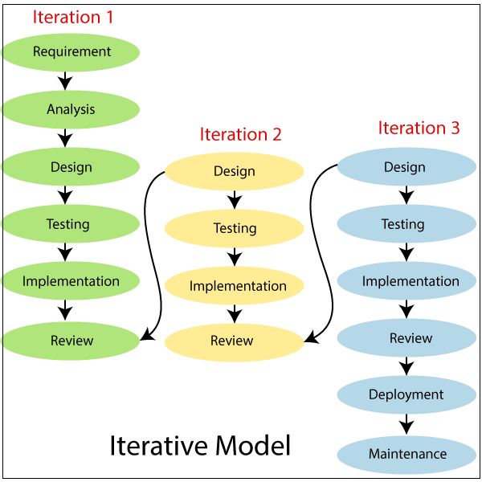

**Fig 1.1 Iterative Model**

# Objective of Project

The objectives of the project are as follows:

• The overall quality of the system must be good and smooth for users.

• User programs are protected in the editor.

• If necessary, security checks are carried out.

“Code! T (Realtime Code Editor)”, while creating our Editor we have gone through multiple phases, at first, we have tried to find the problem which is existing among various groups of peoples. After that we figured out that due to unavailability of single platform for the trade, we decided to create the website which must be accessible to all over the world on desktop, laptops, mobile or any other devices which have internet connection.

Putting focuses on the designing perspective we have created a Editor rather than choosing a mobile application, website easily loads on the user’s devices without consuming memory. We have designed our website in such manner that it is compatible to almost all devices including the laptops of different brands, mobile phone, tablets and many more.

# Home Page|

It includes the short description of the different categories. It is home page of website where the user visits first and generate their room Id and join the room.

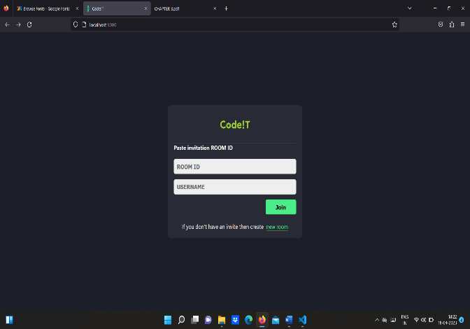

# Editor page|

This page is maintained for maintaining the track of users who have visited on our Editor, using their name, email-id, DOB, and password they can register them.

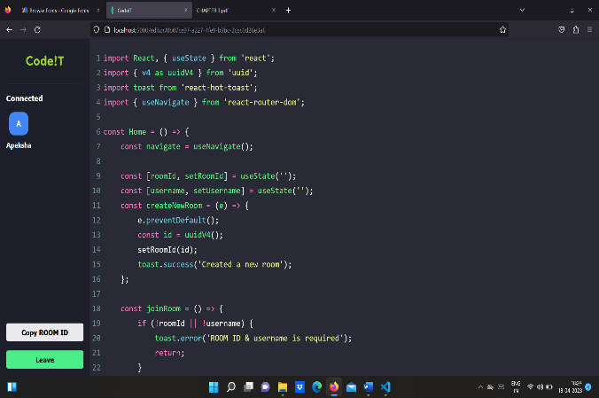

It is editor page of website where the user enter on this page after joining the room. Here the user will able to write their code easily and if in any case, user need another user for help then he/she can copy the room Id and will share that id to user. By using that id another user can join the same room. The explanation of that room will discuss in the next figure. The user does not need a specific application to navigate the site, only a browser and a rented Internet connection. this is the most commonly used format for convenience.

The technology we used in our project including frontend and backend is HTML, CSS, JS, PHP, NodeJS, React, MongoDB to make our website responsive so it can easily interface with other devices, languages, java JSP, servlets and my -sql as data store is compatible backend, we used my-sql to store the database.

# FUTURE SCOPE

Future work on the project would include moving from stateful to stateless, implementing a global cache, and using the Redis publishing subsystem to notify sockets on other servers of code change events. We can integrate version control into the application. Branching functionality to create a branch at any time, which would create a new sub-session with a snapshot of the current document. User authentication and chat/calling capabilities can also be added to provide them with better user experience and security.

# CONCLUSION

Code!T is a web application that helps programmers to create and see the result of the executed source code by terminal, collaborate in real-time with other programmers by chat or invite to join the same project and manage the project such as import, export, shared projects. Code!T supports C, C ++, and Java programming languages. Code! T has the main functions: it provides a workspace for building, running, and building source code, real-time collaboration, chatting and building terminals.

# ACKNOWLEDGEMENT

We wish to express our deepest gratitude to our project guide **Prof. Jinal Patel** and **HOD Vikas Kumar Yadav** for their continuous support in the completion of this project which led us to be inspired and motivated with their guidance at all times, providing with the best facilities for completion of our work. Also, we are thankful the support of the lab technicians and the departmental help provided by them.

# REFRENCES

[1] “A.A. Puntambekar” Software engineering & project management, 2013, Technical Publication.

[2] Database Systems: The Complete Book, Hector Garcia-Molina, Jeff Ullman and Jennifer Widom, June 9, 2008-Second edition.

[3] www.javapoints.com

[4] www.stackoverflow.com

[5] HTML and CSS: Design and Build Websites, November 2011

[6] Software Engineering, Tenth Edition, By Pearson Paperback-May 2017

[7] www.tutorialspoint.com

[8] Fundamentals of Software Engineering Paperback 0- Import, October 2002.