**DROWSINESS DETECTION SYSTEM USING HAAR CASCADE CNN**

**Subashree S1, Visalachi V2, Wamika Yogini J3, Malaiarasan S4**

1Department of Computer Science and Engineering, Francis Xavier Engineering College, Tirunelveli, Tamilnadu, India

2 Department of Computer Science and Engineering, Francis Xavier Engineering College, Tirunelveli, Tamilnadu, India

3 Department of Computer Science and Engineering, Francis Xavier Engineering College, Tirunelveli, Tamilnadu, India

**ABSTRACT**

In order to forecast a driver's state of mind and emotions and to deliver information that will increase road safety, machine learning techniques have been applied. It uses artificial intelligence in some way. Bio-indicators, a driver's conduct while driving, and facial expressions can all be used to gauge a driver's health. We provide an exhaustive review of recent efforts on driver sleepiness detection and alert systems in this paper. We also discuss the machine learning algorithm, HAAR-based cascade classifier, and OpenCV that are employed to assess the state of the driver. Finally, we list the difficulties the current systems and present the corresponding research opportunities. Due to their distinctive driving characteristics, humans have different driving methods, knowledge, and attitudes. Several research projects have investigated the issue of identifying abnormal driving behavior by using computer vision techniques to examine the driver's frontal face and vehicle dynamics. Yet, complex driver behavior aspects cannot be captured by standard approaches. However, since the development of deep learning architectures, a lot of research has been done on employing neural network algorithms to assess and identify driver drowsiness.

**Keywords:** Face Detection, Cascade CNN, Drowsiness Detection, Open CV, Artificial Intelligence

1. **INTRODUCTION**

Transportation infrastructure is crucial to human activities in daily life. Road accidents may happen to anybody at any moment for a variety of causes, but most of the time, the driver's inattention is to blame. Lack of rest and sleep, which results in fatigue on lengthy flights, are the primary causes of sleepiness. These elements will induce a decrease in driver vigilance, which will result in dangerous circumstances and an increase in the likelihood of accidents. Due to this rationale, most accidents occur annually all over the world [1]. In our technologically evolved age, new technologies might be crucial in offering a solution to this issue. According to the National Sleep Foundation USA's data study, driving sleepiness issues result in 100,000 accidents each year. In fact, research on analysis demonstrates that being up for 18 hours results in tiredness R. Kabilan, R. Ravi, G. Rajakumar, S. Esther Leethiya Rani, and V. C. Mini Minar (2015) suggested using histogram intersection methods to assess how closely two distributions generated from the LVP's spatial histograms resemble one another and identify the facial image [2]. Fortunately, today's technology, such as wearable devices for key parameter detection or distributed pressure sensors, can solve these issues According to B. Suvitha and R. Ravi (2021) an automated flaw detection and classification method can guarantee better tile quality during the manufacturing process as well as higher production rates. [3]. The driver sleepiness detection system in automotive vehicles is the main topic of this study. A. Agnes, M. Bala Santhiya, V. K. Supriya Banu, and R. Ravi (2021) their idea refers to two frames. The computer vision technique known as OpenCV helps with image processing and other motion prediction systems [4]. A.Deepika, K.Raja Sundari, and R.Ravi (2014) suggested that the output pixel's value should fall inside the range of its neighbours. Degraded mages can be effectively repaired using these filters. As a result, these filters work well for concepts like picture deconstruction and restoration [5]. According to B. Suvitha and R. Ravi (2021) estimation for medical picture cryptosystems provides preferred productivity over conventional methods [6]. The behaviour of the driver may be seen in a variety of circumstances, including wearing eyeglasses and a dark interior. The suggested system will continually scan the driver's retina, sending all observed signals to a microcontroller. With the use of driver drowsiness detection technology [7], accidents can be avoided and drivers' lives can be saved while they are about to nod off. In this study, computer vision is used to identify drowsy driving. The device has a detection time of more than two seconds for the presence of sleepiness. When improper behaviour is identified, the driver is warned by alerts, and the parking lights come on to stop the car, reducing accidents caused by driver inattention. The approach that is required in the current situation determines sleepiness based on the geometric characteristics of the lips and eyes. It is based on the notion of image processing. The technology offers a non-intrusive method. Moreover, this approach suggests using yawning as a criterion to identify tiredness. A number of face traits were recognised in order to determine a driver's condition[8]. Python libraries were used to investigate them. These characteristics included yawning frequency, ECD, per closure, head orientations, and eye closure rate.

1. **LITERATURE SURVEY**

It has been a long-standing objective to offer effective driver sleepiness detection. This section's main goal is to summarise the methods, reasoning, applications, and measuring measures of earlier scholars. The initial method was based on the observation of driving habits, vehicle attributes, and driving styles. Success rate for accuracy was 86%. Data from sensors is gathered in the second method. These sensors were mostly used to monitor people. Information regarding brain activity is derived from this data. Moreover, there are indications that relate to driver fatigue. This strategy makes more sense intellectually. With this method, Mardi et all Success accuracy was greater than 90% [10] But this strategy had a significant drawback. It is not at all practicable for the driver to equip himself with that many sensors in order to follow it. Another strategy was to measure the time between yawns and eye closed. Wavelet Network Algorithm, to detect dynamic drowsiness system. Event detection based on 3-D information, for relevant regions of the face are identified and used for further analysis [11]. The driving performance deteriorates with increased drowsiness with resulting crashes constituting morel vehicle accidents based to focused on the analysis of blinks and head movements.

1. **RELATED WORK**

The survey that is conducted comprises the most recent developments and research on the subject of our project. It is an endeavour to comprehend the work that has gone into this area of research and to identify the areas where our project-development efforts should be concentrated. The existing sleepiness detection systems for facial landmark identification, blink detection, and yawn detection have been the subject of this literature review. From titled “The detection of drowsiness using a driver monitoring system”. In this study, scientists combined several types of sensors with a driver monitoring system (DMS) to identify tiredness. They have also gathered information in the form of signals from various sensors located on other vehicles. The collected findings demonstrate that the models were successful in classifying the amount of sleepiness into three categories: low, moderate, and severe. Yet even though the model could distinguish between moderate and severe levels, it was ineffective. The model failed to distinguish between moderate and severe sleepiness, which is one of the paper's weaknesses. The tiny sample size that was employed in this work is another drawback. titled “Driver Drowsiness Detection System Using Computer Vision”. The purpose of the study is to analyse human eye blinks using a recent facial landmark recognition and to apply E.A.R. (eye aspect ratio) for simple, quick, and accurate blink detection. The system's ability to dependably and precisely estimate the degree of eye opening indicated that it was effective in detecting driver sleepiness. Since facial landmark detection only incurs a very little performance penalty, this warning system can be employed in real-time. Because a fixed blink time is assumed despite the fact that everyone's blink duration varies, this work has certain drawbacks. EAR is calculated using two-dimensional data, which cannot take into account out-of-plane head position, and the model solely uses the eyes to determine sleepiness. titled “Drowsiness Detection Based on Eye Closure and Yawning Detection”. In this study, Haar -cascade classifiers are used to follow a driver's eye and lip movements. This will make it easier to spot eye closure and frequent yawning. If the driver is already dozing off, the device will also sound an alarm. As a consequence, the system accurately recognises faces and necessary facial traits in 85% of situations. After the face's feature identification is successful, the algorithm quickly detects tiredness. The paper's shortcoming is the observation that the system's accuracy declines under poor illumination.

1. **Methodology**

In this work, the eye and lip movements of a driver are tracked using Haar-cascade classifiers. This will make it simpler to identify frequent eye closure and yawning. The gadget will also sound an alarm if the driver is already nodding asleep. As a result, in 85% of circumstances, the system correctly recognises faces and required facial features. The algorithm instantly recognises fatigue after successfully identifying the features of the face. The fact that the system's accuracy decreases under dim lighting is the paper's flaw.

**4.1 HAAR Training**

The OpenCV library has a wide range of features for face and feature detection, including eyes, mouth, sunglasses, and more. It is possible to train classifiers using some of these functions. The face detection procedure may be taught to the classifiers. Training for HAAR is what this is. Object. Here, a cascade function is trained using a variety of pictures, both good and bad. Each feature is a single value that is produced by deducting the total of the pixels under different sections of the pictures [3]. For each characteristic, a distinct set of pixels are used for extraction. The needed process will not benefit from all of the retrieved attributes. The essential characteristics are extracted using the Cascade method. The training photos are applied with each and every feature. For each characteristic that divides photos into positive and negative categories, the optimum threshold is found. The least prone to mistake features are chosen. Each characteristic is initially given equal weight. The weights are adjusted as the procedure goes on in accordance with the results to increase precision. The final classifier is the weighted average of the weak classifiers

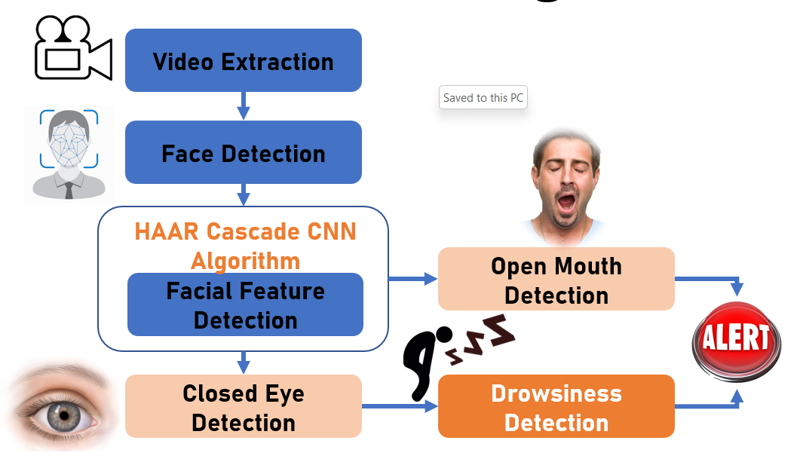

**Figure 1:** Flow of drossiness detection

1. **PROPOSED SYSTEM**

**5.1 HAAR Training**

In order to fulfil these criteria, it is necessary to gather the necessary hardware and software materials. The main design idea of Driver Drowsiness Detection is to take a picture with the camera and roughly estimate the status of the drivers using data processing. Arduino, a camera, and load cell sensors are all utilised for this project along with Python machine learning. OpenCV and Haar Cascade algorithms, as well as OPENCV packages, are utilised for face and eye identification.

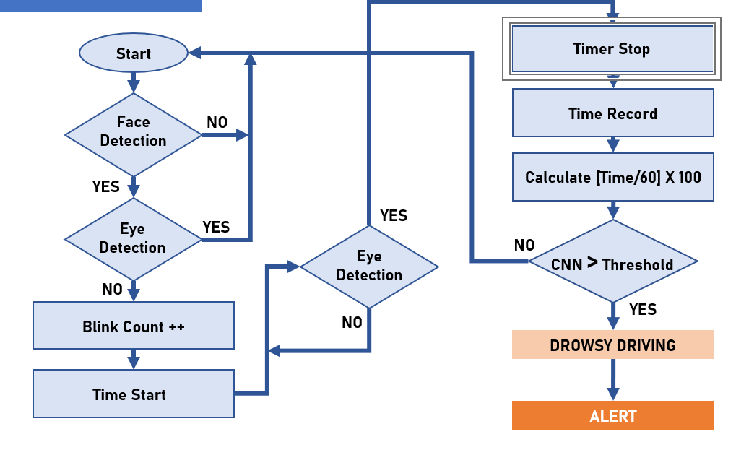

**Figure 2:** Flowchart

**5.2 Face Detection**

Hardware and software are needed for Driver Drowsiness Detection, including sensors to measure hand pressure and communicate results to Arduino, cameras to identify faces and eyes, and software to calculate the blink rate of the eyes. Many techniques are used in this endeavour, and these are described in this paper.

**5.3 Eye Detection**

The next step is to evaluate a driver's level of tiredness using the rate at which their eyes are blinking after taking their picture and doing pre-processing. Every frame, values are computed, and variations in blink rate are checked against the threshold value. HOG, which is helpful for face identification and gives an accurate eye detection rate, is utilised to successfully identify the rate at which eyes blink.

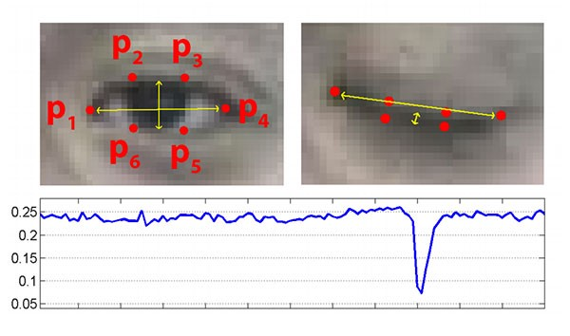

**Figure 3:** Ratio of eye blink

**5.4 Dataset**

The data set is gathered from a live video feed of the car's drivers. The live camera records user characteristics, and real-time eye tracking data is recorded and used as decision-making input. For confirming user data, the shape predictor landmark is employed.

1. **CONCLUSION**

Driver's drowsiness and fatigue nature can be detected by using Drowsy care system. The system consists of a camera and alarm fastened inside the vehicle and mounted in front of the driver. The driver's facial expressions are captured on camera so that the tiredness may be seen. The camera's continuous video frames and the training data sets will be compared. The collection of different photographs with open and closed right and left eyes, together with images of the mouth yawning, make up the training data sets. An alert will sound if the camera's continuously recorded video frames and the pictures in the training data sets match. Using the datasets, we suggest a new method for determining if a driver is not fatigued based on the eyes and yawn deduction. The HAAR cascade CNN algorithm is used to create and propose the new algorithm, dubbed Drowsy Care System, which tracks the driver's eyes and lips.

1. **REFERENCES**
2. Y. S. S. E. Viswapriya, Singamsetti Balabalaji, “A machine-learningapproach for driver-drowsiness detection based on eye-state,”INTERNATIONAL JOURNAL OF ENGINEERING RESEARCH & TECHNOLOGY (IJERT), vol. 10, April 2021
3. R. Kabilan, R. Ravi, G. Rajakumar, S. Esther Leethiya Rani and V. C Mini Minar, “A combined face recognition approach based on LPD and LVP”, ARPN Journal of Engineering and Applied Sciences, vol. 10, no. 6, pp. 2577-2581, 2015
4. B.Suvitha, and R. Ravi, “A survey on various surface defect detection techniques”, International Journal On Engineering Technology and Sciences, vol.8, no.9, pp. 25-28 2021.
5. A. Agnes, M. Bala Santhiya, V. K. Supriya Banu, and R. Ravi (2021) their idea refers to two frames. The computer vision technique known as OpenCV helps with image processing and other motion prediction systems [100].
6. A.Deepika, K.Raja Sundari, and R.Ravi, “Image Decomposition and Restoration for Blurred Images Using Filtering Techniques”, International Journal of Advanced Research in Computer Engineering & Technology, vol. 3, no. 3, pp. 631-635, 2014.
7. B.Suvitha, and R. Ravi, “Securing a biometric medical images using lightweight encryption”, International Journal On Engineering Technology and Sciences, vol. 8, no.9, pp. 23-25, 2021.
8. Z. He, Z. Cai, and J. Yu, ‘‘Latent-data privacy preserving with customized data utility for social network data,’’ IEEE Trans. Veh. Technol., vol. 67, no. 1, pp. 665–673, Jan. 2020
9. S. S. E. Viswapriya, Singamsetti Balabalaji, “A machine-learningapproach for driver-drowsiness detection based on eye-state,”INTERNATIONAL JOURNAL OF ENGINEERING RESEARCH & TECHNOLOGY (IJERT), vol. 10, April 2021
10. M. M. Hasan, C. N. Watling, and G. S. Larue, “Physiological signal based drowsiness detection using machine learning: Singular and hybridsignal approaches,” Journal of Safety Research, 2021
11. D. K. D. K.Mirunalini, “Drowsiness detection using deep neural network,” Turkish Journal of Computer and Mathematics Education, Vol. 12, no. 9, pp. 317–326, 2021
12. H. U. R. Siddiqui, A. A. Saleem, R. Brown, B. Bademci, E. Lee,F. Rustam, and S. Dudley, “Non-invasive driver drowsiness detection system,” Sensors, vol. 21, no. 14, 2021