**“Rang Tarng Resort Website”**

1. **Author name: Devesh Ugave**

Student, Department of Computer Science Thakur Shivkumar Singh Memorial Engineering College, Burhanpur, Madhya Pradesh, India

E-mail: deveshugave[@gmail.com](mailto:patilnikam813@gmail.com)

1. **Author name: Prathmesh Pandit**

Student, Department of Computer Science Thakur Shivkumar Singh Memorial Engineering College, Burhanpur, Madhya Pradesh, India

E-mail: [prathmesh18102001@gmail.com](mailto:prathmesh18102001@gmail.com)

**3. Author name: Ritik Mahajan**

Student, Department of Computer Science Thakur Shivkumar Singh Memorial Engineering College, Burhanpur, Madhya Pradesh, India

E-mail: [ritikmahajan7777@gmail.com](mailto:ritikmahajan7777@gmail.com)

Guide name: **Prof. Akshay Dalal**

Assistant professor, Department of Computer Science Thakur Shivkumar Singh Memorial Engineering College, Burhanpur, Madhya Pradesh, India

# ABSTRACT

Rang Tarng Resort website is an online booking site for wedding venues, wedding ceremonies, and more. You can easily book rooms, halls, lawns and more. This website helps people who are not at the resort and cannot come to the resort to visit and book their rooms or halls so they can book their rooms and halls on this site and those who are already at the resort live and want something to eat or other things, they can also order their stuff and many other facilities from , like someone wants to book a room for a event or business meeting and confirm whether the room is the best or not, so do the following do a video conference with the manager and check if all the arrangements are in place or not and if a tourist wants to stay at the resort so they can browse the Rang Tarng Resort website and book rooms can.

# INTRODUCTION

This is Rang Tarng Resort website where all facilities like lawns, rooms, halls, lawns, water park and many other things are available. On this website you can book rooms or lawns and enjoy them with or without family. All things about the station are mentioned on this page, if you cannot visit the station, no problem, you can get all the details and galleries of this station on this page. Rang Trang Resort is the best and cheapest resort in this resort, all facilities are available. This website is more helpful for people who are out of resort and want to fulfill a function or stay in our resort so people can book rooms online through this website and before booking they can see our gallery how this resort looks like when they do feel that it is the most beautiful and biggest resort and not more expensive, they can book rooms and stay in this resort.

# EXPLANATION

Before creating a website, you need to go through various processes related to it. Many processes come together to form a model that each developer uses to keep the cycle going that builds each type of application.

**SDLC** (Software Life Cycle Model) consists of many phases, from requirements gathering to design, coding, testing, implementation, and maintenance. There are also many models available to choose based on your needs and budget.

**Iterative Model**: -

The iterative model process begins with a simple implementation of a subset of software requirements and iteratively improves evolutionary versions until the system is fully implemented. With each iteration, the design changes and new functionalities are added.

**Benefits** - Iterative Model

¬ Rapid generation of working software early in the software lifecycle.

¬ Greater flexibility, less costly scope, and requirement changes.

¬ Easier testing and debugging with fewer iterations.

**Objective of Project**

The goals of the project are:

• Manage all information related to customer reservations, payments, and other details.

• The purpose of the project is to build an application that will reduce people's stress, what the station is, whether it is good or not, you can easily see it on this page.

The main purpose of this project is that we can help people find the best things for wedding and vacation stays, picnics, and many other things so that they have no problem finding all these things in one place. site is for.

Rang Tarng Resort **website,** while creating our website we have gone through multiple phases, at first, we have tried to find the problem which is existing among various groups of peoples. After that we figured out that due to unavailability of single platform for the trade, we decided to create the website which must be accessible to all over the world on desktop, laptops, mobile or any other devices which have internet connection.

Putting focuses on the designing perspective we have created a website rather than choosing a mobile application, website easily loads on the user’s devices without consuming memory. We have designed our website in such manner that it is compatible to almost all devices including the laptops of different brands, mobile phone, tablets and many more.

The multiple pages in our website are home page, category page, trending cloths page, sign in and login page.

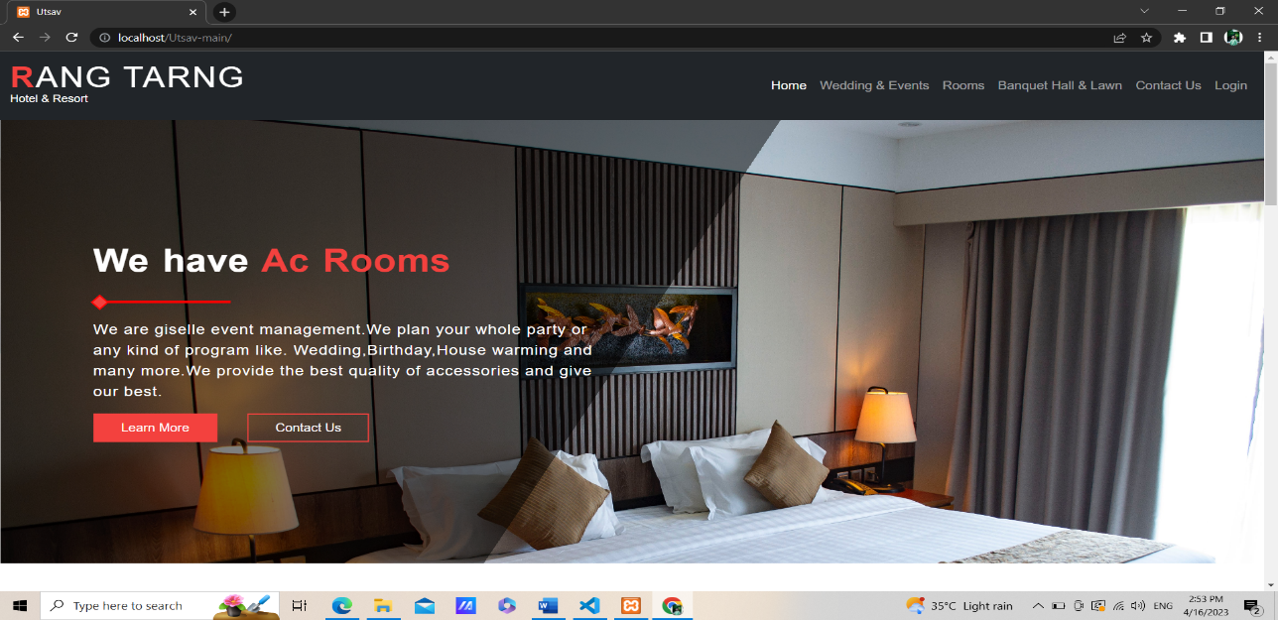**Home Page|**

It includes the short description of the different categories of renting including with the button of the sign in, login page, trending trade and category.

**Sign Up page|**

This page is maintained for maintaining the track of users who have visited on our website, using their name, email-id, DOB, and password they can register their account on Rang Tarng Resort **website.**

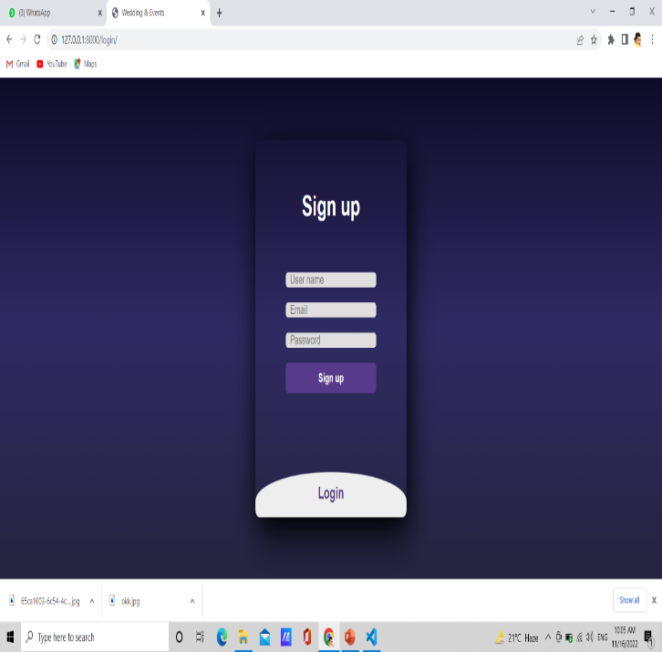

**Login page|**

This page will allow registered user to access on the system by using the email-id and password they can login to the system. We have kept an option of forgot password if a user forgot their password, then by using their email- id they will get their password.

**Category page|**

It will contain multiple categories and by clicking on them user can see a wide variety of cloths available in that kind of category, but for viewing the Rang Tarng Resort **website** present in different category user first have to login on website.

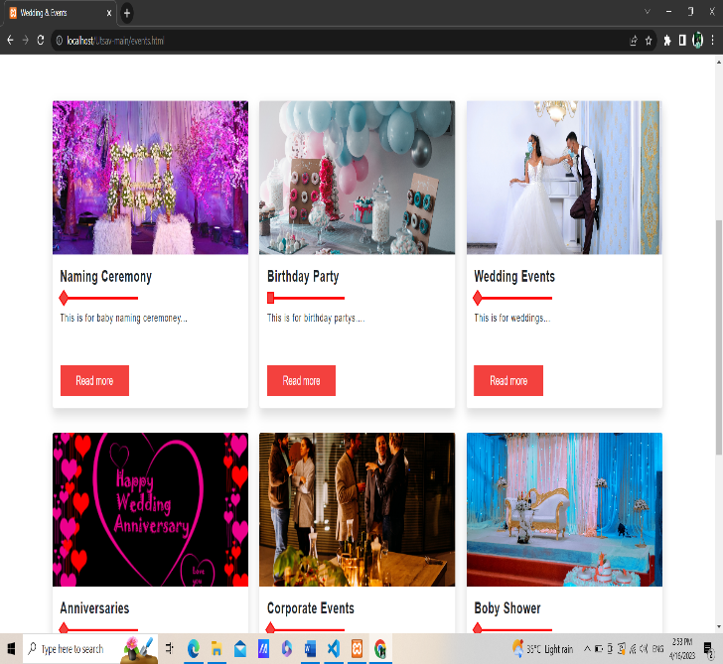

The user does not need a specific application to navigate the site, only a browser and a rented Internet connection. this is the most commonly used format for convenience. The technology we used in our project including frontend and backend is HTML, CSS, JS, PHP to make our website responsive so it can easily interface with other devices, languages, java JSP, servlets and my -sql as data store is compatible backend, we used my-sql to store the database.

**FUTURE SCOPE**

* We will add all locations of all our stations.
* We will add a live mode so users can watch all live events.

**CONCLUSION**

Our project Finally, let us discuss how to invest in the project as a whole with the idea of ​​creating for the company. One of the objectives of this chapter was to recognize that projects are unique and carry a different level of risk than the company as a whole. In terms of value, it all depends on how much cash you can generate. After the introduction of cash flow calculation tools, the concept of capital budgeting was introduced.

.**ACKNOWLEDGEMENT**

We wish to express our deepest gratitude to our project guide **Prof. Akshay Dalal** and **HOD Vikas K Yadav** for their continuous support in the completion of this project which led us to be inspired and motivated with their guidance at all times, providing with the best facilities for completion of our work. Also, we are thankful the support of the lab technicians and the departmental help provided by them.

# REFRENCES

1. [www.w3school.com](http://www.w3school.com/)
2. [www.scribd.com](http://www.scribd.com/)
3. [www.google.com](http://www.google.com/)
4. [www.wikipedia.com](http://www.wikipedia.com/)
5. [www.youtube.com](http://www.youtube.com/)
6. PHP API Documentation Online @ <https://docs.oracle.com/en/xamp/mysql/11/> (php).
7. [www.geeksforgeeks.com](http://www.geeksforgeeks.com/)
8. www.phpprojects.com
9. [www.tutorialspoints.com](http://www.tutorialspoints.com/)