An Arduino Based Automated Vehicle Accident Detection and Messaging system

**Mr. S. Rambabu1, K. Mahesh2, M. Dilip kumar3, K. Sai kumar4, E. Mahith5, M.Chinna Sai Dastagiri Reddy6**

**1Assistant Professor, Department of Computer Science and Engineering,**

**Santhiram Engineering College, Nandyal**

2,3,4,5,6 Students at Department of Electronics and Communication and Engineering, Santhiram Engineering College, Nandyal

E-mail: [ramababu.ece@srecnandyal.edu.in](mailto:ramababu.ece@srecnandyal.edu.in), [19x51a0490@srecnandyal.edu.in](mailto:19x51a0490@srecnandyal.edu.in), [19x51a0495@srecnandyal.edu.in](mailto:19x51a0495@srecnandyal.edu.in), [20X55A0405@srecnandyal.edu.in](mailto:20X55A0405@srecnandyal.edu.in), [19x51a0481@srecnandyal.edu.in](mailto:19x51a0481@srecnandyal.edu.in), [19x51a0493@srecnandyal.edu.in](mailto:19x51a0493@srecnandyal.edu.in)

***Abstract*** —Arduino Based Vehicle Accident Alert System using GPS, GSM and Accelerometer. Accelerometer detects the sudden change in the axes of vehicle and GSM module send the alert message on your Mobile Phone with the location of the accident. The advancing technology has made our day to day lives easier. Since every coin has two sides similarly technology has its benefits as well as its disadvantages. The rise in technology has increased the rate of road accidents which causes huge loss of life. The poor emergency facilities available in our country just add to this problem. Our project is going to provide a solution to this problem.. Numerous passing is caused because of absence of crisis administrations. Along these lines, in this undertaking we intend to give crisis administrations to the individual who meet with a mishap as quickly as time permits. At the point when a vehicle meets with a mishap, promptly the accelerometer sends varieties to the Arduino and subsequently the Arduino sends the alarm message through the area which is distinguished by IOT to recently spared crisis contacts. This paper points in giving crisis benefits as quickly as time permits for future extension, we include numerous applications like liquor recognition and rest discovery and so forth.

**Keywords *—*** *GSM, GPS, Arduino, sensor, MEMS. .*

# I. INTRODUCTION

In the twentieth century, the number of vehicles exponentially increases due to growth in the automobile industry. As the number of vehicles increases, the accident also increases. The reason of most of the road accidents are heterogeneous traffic and lack of traffic separation. According to World Health Organization (WHO), India is the leading country in the road accident deaths. In India, 13 million peoples were dead in road accident in the year of 2014-15. These statistics are reported accidental records but there are numbers of accident, which are unreported. Hence, the numbers of actual accident are more than the statistic of World Health Organization (WHO).

The existing system mostly focuses on the safety of the passenger but not on the immediate help after accident. India has earned the dubious distinction of having a greater number of fatalities due to road accident in the world. Road safety is emerging as a major social concern around the world especially in India. The system implemented by us aims at automatically detecting an accident and alerting the nearest hospital or medical services about the exact location of the accident. This system sends the basic information to the medical rescue team within a few seconds of an accident. This device can detect accidents and sends an alert message to rescue teams in significantly less time which will help in saving the lives of the people. The alert message contains the geographical coordinates, time and angle in which the accident has occurred. When an accident occurs, it is detected with help of a sensor which activates the device, the sensor gives its output to the microcontroller. The microcontroller sends the alert.

We have used GPS and GSM module for our project. GPS (Global Positioning System) is a satellite navigation system used to determine the ground position of an object. It is a global navigation satellite system that provides geo location and time information to a GPS receiver anywhere on or near the Earth. Here GPS is used for both tracking and navigation. This enables a base station to keep track of the vehicles and navigation system helps the driver to reach the destination.

GSM is an open, digital cellular technology used for transmitting mobile voice and data services. The GSM system is the most widely used cellular technology in use in the world today. It has been a particularly successful cellular phone technology for a variety of reasons including the ability to roam worldwide with the certainty of being able to operate on GSM networks. It is also highly economic and less expensive.

**II. REVIEW OF LITERATURE**

In countries where the economic status is poor, it becomes crucial for those concerned with developmental policies to adopt appropriate strategies which will ensure that every single unit of money available is used to develop the country in those fields to facilitate a conductive environment for economic development. Road traffic accidents have been recognized as one of the adverse elements which contribute to the suffocation of economic growth in the developing countries, due to the high cost related to them, hence causing social and economic concern. So, Traffic safety is an important key and plays an integral role in sustainable transportation development. Now days, the main negative impacts of modern road transportation systems are injuries and deaths in road accidents. The success of traffic safety and highway improvement programs hinges on the analysis of accurate and reliable traffic accident data. This study discusses the present state of traffic accident information on NH 47 .

Gandhipuram to Avinashi and NH-209 from

Gandhipuram to Annur, Coimbatore District. It shall also discuss the Identification of high rate accident Locations by using GIS Software and safety deficient areas on the highway. Remedial measures and provisions for traffic safety are suggested for reducing the risk of accidents in black spots.

Citation classics offer an outlook on those papers that have attracted great and historical interest by a research community and that could be also considered the basis of the research field. A new approach, which is called H-Classics, has been developed to identify such highly cited papers. It is based on the H-index and is sensitive to both the own characteristics of the corresponding research discipline and its evolution.

The present study provides a useful insight into the development of intelligent transport systems research fields revealing those scientific actors (authors, countries, and institutions) that have made the biggest research contribution to its development.

# III. METHODOLOGY DETAILING THE ACTIVITIES AND SUBACTIVITIES

In this era of large professional growth everybody is busy with their lives. People, especially in urban areas have to move from one place to another any time of the day with much of speed. Due to this reason and sometimes due to in efficient people in the driving seats road accidents are quite common thing that can happen. Road accidents can snuff out a life if the victim is not given proper medical attention at proper time.

So, in this project we have planned to design a

system that can detect road accident and identify the location through GPS. After that, through GSM interface this will be notified to the nearest emergency care unit so that the victim can get immediate medical attention.

# A. STEP BY STEP ACTIVITY

First of all, a driver takes a driver seat. The system checks if the driver has worn the seat belt or not. If not, it displays a message, “Wear seat belt”. If the driver wears the seat belt, the engine starts and gives message “Happy Journey”. While moving if it detects a vehicle or any other objects it will decreases the vehicle speed, even though the accident occurred then vibration sensor will activate the GPS to locate accident area. If there is no affect to anyone then the person involved in accident has to press the safety switch. In this case no SMS will send to emergency care centre. If no one is pressed the safety switch within 40s then GSM will send the location and persons heart beat status to the emergency care centre and optional mobile number stating that ACCIDENT OCCURRED. In addition to that it will send a message to emergency care centre when the vehicle is flipped or detects the fire.

START

Initialize The System Successfully

calibrate accelerometer and check

connectivity and r

esponse of

GPS

and

GSM

modules

Accident

Occurs

?

Send Message To Specified Mobile Number

As Well As Location Via Google Maps

END

observe for any accident via adxl335

accelerometer

**Fig 1: flow chart of the operation**

# B. COMPONENT DESCRIPTION AND USED SOFTWARES

The component requirements of hardware and software are given below.

1. **ARDUINO UNO**: The Arduino UNO is an open-source microcontroller board based on the Microchip ATmega328P microcontroller and developed by Arduino.cc. The board is equipped with sets of digital and analog input/output (I/O) pins that may be interfaced to various expansion boards (shields) and other circuits. The board has 14 Digital pins, 6 Analog pins, and programmable with the Arduino IDE (Integrated Development Environment) via a type B USB cable. It can be powered by a USB cable or by an external 9 volt battery, though it accepts voltages between 7 and 20 volts. It is also similar to the Arduino Nano and Leonardo.
2. **GPS Module:** GPS stands for Global Positioning System and is used to detect the latitude and longitude of any location on the earth, with the exact UTC time.GPS module is used in our project to track the location of the accident. This device receives the coordinates from the satellite for each and every second, with time and date. In our project, we have used GPS module SKG13BL, which is a Ultra High Sensitivity and Low Power GPS Receiver Module
3. **GSM MODULE**: GSM/GPRS module is used to establish communication between a computer and a GSM-GPRS system. Global System for Mobile communication (GSM) is an architecture used for mobile communication in most of the countries. **(iv) 16*2 LCD DISPLAY:** LCD stands for liquid crystal display. Character and graphical LCD’s are most common among hobbyist and diy electronic circuit/project makers. Since their interface serial/parallel pins are defined so it’s easy to interface them with many microcontrollers. They are used to show status of the product or provide interface for inputting or selecting some process. Character LCD come in many sizes 8x1, 8x2, 10x2, 16x1, 16x2, 16x4, 20x2, 20x4, 24x2, 30x2, 32x2, 40x2 etc. We have used 16x2 LCD for our project.

**(v)** **ADXL335 ACCELEROMETER:** An accelerometer is an electromechanical device that will measure acceleration force. It shows acceleration, only due to cause of gravity i.e. g force.

ARDUINO

UNO

ADXL

335

GPS

Modul

e

G

SM

Modul

e

LCD Display

**Figure 2: Hardware connection of all the components**

## IV. RESULT AND DISCUSSION

After all the components are connected properly, the system is put into a moving car. If accident occurs, the acceleration due to the collision occurred is sensed by the ADXL335 Accelerometer and its x, y and z-axis ADC output pins are directly connected to Arduino ADC pin A1, A2, and A3.

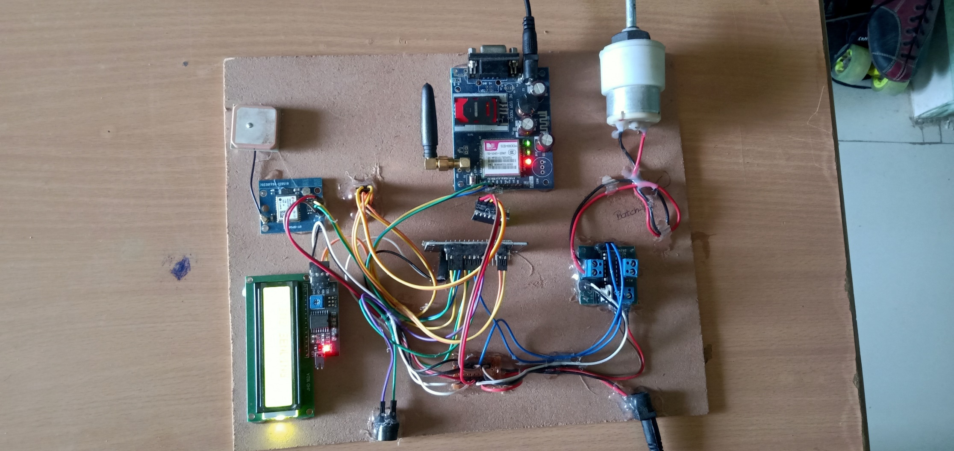

**Figure 3: ARDUINI UNO R3 Development board**

After successful compiling and uploading the program on Arduino IDE, the system is initialized successfully, the accelerometer is calibrated and the x,y and z samples of the vehicle are displayed on the serial monitor.

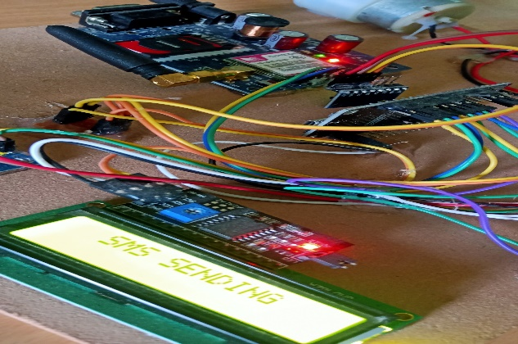

**Figure 4: The successful initialization of the system is displayed in the LCD**

After receiving GPS signal, the latitude and longitude of the current position of the vehicle is displayed, also the speed is displayed in knots.

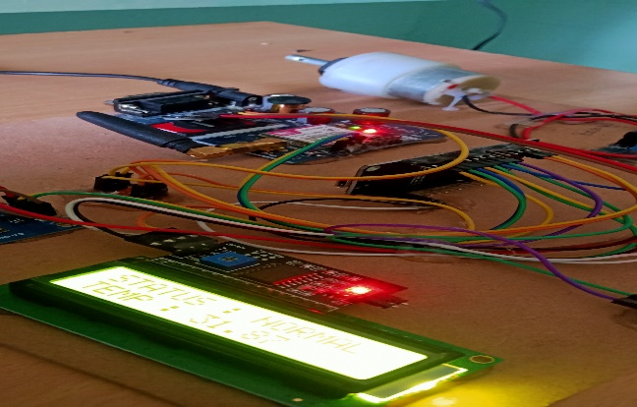

**Figure 5: After receiving GPS signal, the latitude and longitude of the current position of the vehicle is displayed.** When the accelerometer is shaken abnormally, i.e., in case of an accident when there is an abrupt change of axis, SMS is sent to the mobile number mentioned in the code and the latitude and longitude is also sent in the form of Google maps. The message is received in the specified mobile number along with the specific location.

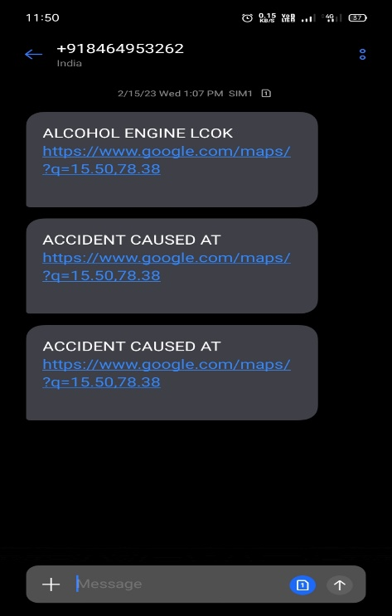

**Figure 6: message received by the specified phone number**

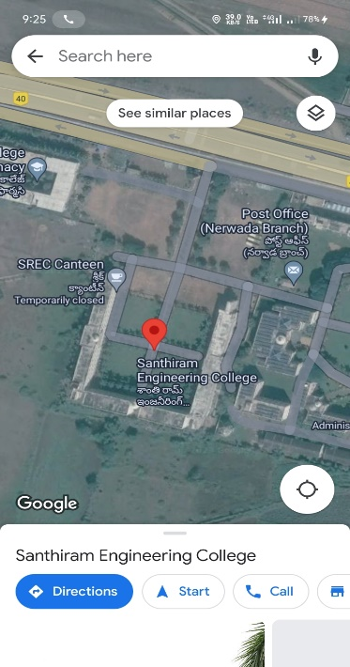

**Figure 7: Location of the accident sent via Google Map.**

**V. CONCLUTION**

Vehicle tracking system makes better fleet management and which in turn brings large profits. Better scheduling or route planning can enable us to handle larger loads within a particular time. Vehicle tracking both in case of personal as well as business purpose improves safety and security, communication medium, performance monitoring and increases productivity. So, in the coming years it is going to play a major role in our day to day living. The main motto of the accident alert and detection project is to decrease the chances of losing life in such accidents which we can’t stop from occurring. Whenever accident is alerted the paramedics can reach the particular location to increase the chances of life. This vehicle tracking and accident alert feature may play a more important role in day to day life in the future.

However, in some places where there is no provision of GSM networks it is difficult for communication.

## VI. REFERENCES

1. Mr.S. Rambabu, P. Aswani,“An automated traffic accident detection and alarm device”, International Journal of Technological Exploration and Learning (IJTEL) Volume 1 Issue 1, August 2012.
2. Mr.k. Kishore, Mr.S. Rambabu “High performances and lownnoise BCD adder circuit design using Rate Sensing Keeper.
3. Ms. Sarika , B. AlekyaHimabindhu, “Embedded system for intelligent ambulance and traffic control management International Journal of Computer and Electronics research”,Volume 2, Issue 2, April 2013.
4. Fengyuan Jia Hongyan Wang ,“A New Type of Automatic Alarming Device to Rescue Accident Injured in Time”,September 2014.
5. G. Sowmya, Mr.S. Rambabu, “ Design of Area And Power Efficient arithmetic and Logic unit.
6. T. Nagamani, Poornesh, Tarun Varma, Harsha ,“Automatic Vehicle Accident Detection and Messaging system using GPS and GSM Modems”, International Journal of Scientific & Engineering Research, Volume 4, Issue 8, August-2013 ISSN 2229-5518.
7. Tanaya Achalkar, Shrinath Panmand, Saurabh Naik,

Dilip Patil, Rachna Sonkumwar *"An Efficient*

*Approach for Accident Detection System"* International Journal of Engineering Trends and Technology 67.4 (2019): 4-7.