“Swift Bank Management System”

## **Author name: Chaitali Patil**

Student, Department of Computer Science Thakur Shivkumar Singh Memorial Engineering College, Burhanpur, Madhya Pradesh, India

Contact: 9685711493

E-mail: [1304chaitalipatil@gmail.com](mailto:1304chaitalipatil@gmail.com)

## **Author name: Tejal Mahajan**

Student, Department of Computer Science Thakur Shivkumar Singh Memorial Engineering College, Burhanpur, Madhya Pradesh, India

Contact : 7987755697

E-mail: [tejalmahajan17@gmail.com](mailto:tejalmahajan17@gmail.com)

## **Author name: Bhawna More**

Student, Department of Computer Science Thakur Shivkumar Singh Memorial Engineering College, Burhanpur, Madhya Pradesh, India

Contact: 9511622803

E-mail: [bhawnamore12@gmail.com](mailto:bhawnamore12@gmail.com)

## **Guide name: Prof. Pragati Lokhande**

Assistant professor, Department of Computer Science Thakur Shivkumar Singh Memorial Engineering College, Burhanpur, Madhya Pradesh, India

E-mail: [pslokhande13@gmail.com](mailto:pslokhande13@gmail.com)

# ABSTRACT

We have a project named bank management system my bank name is swift bank we have tried to work on all bank related information in this project we have put some important features in it like debit, credit, open new account, transfer Worked on features etc. It is important that we have given employee login and manager login but if employee login is already there then manager cannot login or if manager is login then employee cannot login basically what we have done Only one user will be able to login in a system, in this the manager's job is that he will manage all the data, will keep the employee to manage the customer's data and will also manage all the data of the employee and all the information of the bank.

**INTRODUCTION**

we have a project named bank management

system my bank name is swift bank we have tried to work on all bank related information in this project we have put some important features in it like debit, credit, open new account, transfer Worked on features etc. It is important that we have given employee login and manager login but if employee login is already there then manager cannot login or if manager is login, then employee cannot login basically what we have done Only one user will be able to login in a system, in this the manager's job is that he will manage all the data, will keep the employee to manage the customer's data and will also manage all the data of the employee and all the information of the bank. Will keep how many customers are there in the bank and how much total money is there in the bank and how many new accounts have been opened, who has withdrawn how much money, who has deposited how much money, who has transferred how much money. Who will manage how much money is debited .and credited, he will also employ all the work,

in this we have also put validation that you will not be able to open an account on zero

rupees, there should be at least 200 rupees.

**EXPLANATION**

We will see how we designed our Swift Bank software, first, we have designed the home page, in which two buttons have been given, Employee Login and Manager Login, and there is the option of home page, here we have also given contact form and maps. In the form, we can see the details in the filled database and in the footer, we have given an option by which we can subscribe to the email, after that we will see the important work of the software, that if the employee is already logged in, then the manager is not logged in. Can do and manager login then employee cannot login so basically what we have done is only one can login on a system then we login if we do wrong entry then login will not happen if we login employee then one Dashboard open, we can add customer, debit, credit, debit in this dashboard now we go to manager login it also works in the same way manager can add any customer or employee can delete and can delete any the manager can view and print the list of both the customer and the employee. I have features like the analytics page. You can see how many customers and employees are there in the bank, and how much money is there, and how many You can see the list of man and woman and it also tells how much transaction happens in a week and that is all that happens in us software.

**ITERATIVE MODEL: -**

The iterative process model is a software lifecycle (SDLC) approach in where initial development work is performed based on 1087 well-defined prerequisites and 1087 more functionality is added to this 1087 base software through iterations until the final 1087 system is complete. The iterative life cycle model does not attempt to start with a complete specification of requirements. This SDLC approach is not intended to produce a complete specification plan. Instead, the iterative development model is a method by which breaks down any large software development project into smaller pieces. It is specifically designed to start with the absolute minimum requirements of a and iteratively build just a portion of a program. Next, the prototype is checked again for additional requirements, and then the rest of the planning, requirements analysis, implementation, and maintenance is done. This helps to anticipate and mitigate the risks of requirements.

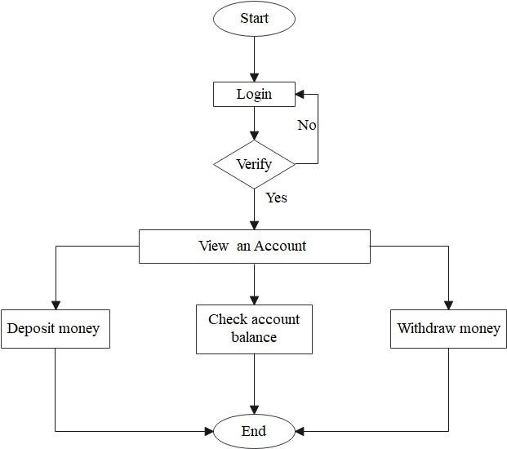

**Objective of Project**

There are many definitions of bank management. In general, bank management refers to the process of managing the Bank’s statutory activity. Bank management is characterized by the specific object of management - financial relations connected with banking activities and other relations, also connected with implementation of management functions in banking. The main objective of bank management is to build organic and optimal system of interaction between the elements of banking mechanism with a view to profit. Successful optimization of the "profitability-risk" ratio in a bank lending operation is largely determined by the use of effective methods of bank management. Ability to take reasonable risk is one of the elements of entrepreneurship culture in general and banking culture in particular.

**Home Page**

There are two login buttons in the home page of our software, one employee and the other manager, both can login from here and there is also an option and at the bottom of the home page, we have also given a subscribe option and have to enter in Contact Us and There is also a map. This type is the home page of our software.

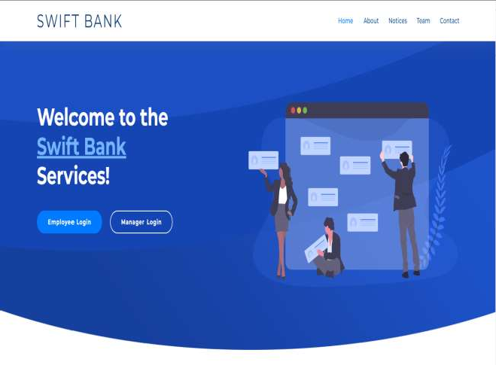

**EMPLOYEE Login Page: -**

There are two login pages in our software, one of them is employee login, only when the employee

logins, only further work will be done, we can enter our data, in the login, we have kept the option of email id and password and have also given a robot captcha.

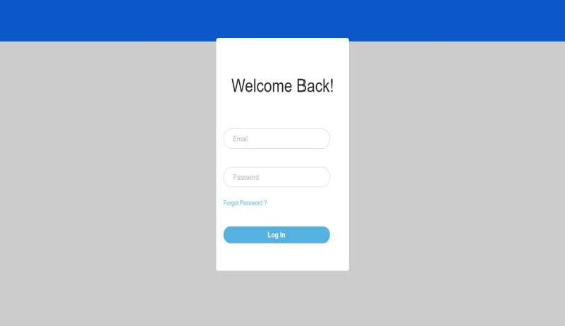

### **Manager Login Page:**

We have two login pages in the software, the second login page is manager login. This login is similar to employee's login. Till manager does not follow the process of login, no further work will be done. There is also an option to login if you do not click on the captcha after data entry.

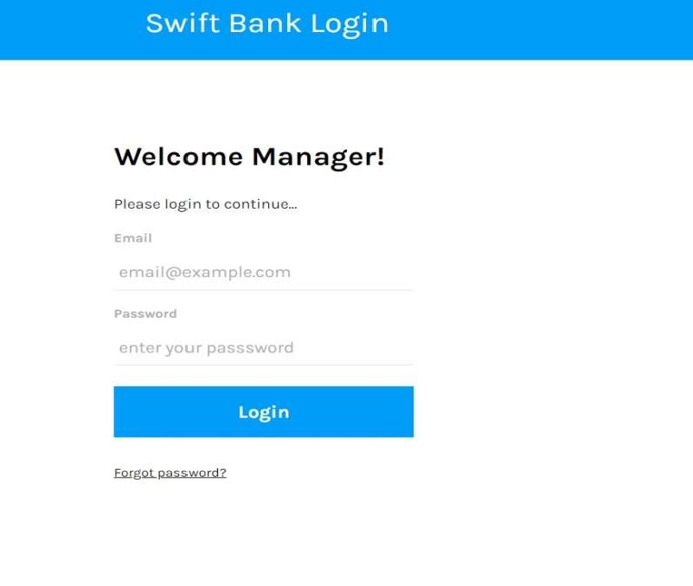

## **ADVANTAGES & DISADVANTAGES**

We can manage information both side employee or manager. Manager can manage all employee, customer, and bank data and aceess it. Manager can add, delete, update details of customer or employee. Employee can manage a customer account. Employee can manage fund withdraw, debit and transfer Banks have been in existence since human society started the Manager can manage customer and employee data, can add, and remove employee in employee detail, can find employee details by account number and can-do debit, transfer business of trade. Around 000 BC, the merchants in India gave grain loans to farmers and traders to aid them in business. In the Greece & Roman empires, temples fund and credit etc.

**FUTURE SCOPE: -** In future we can increase high security like fingerprint or face lock. In future we can manage a pie chart like a-

# A money transfer system will be added.

# The system allows the member to verify their bank account and/or change account options.

# Chat online with many users of the service.

**CONCLIUSION: -** A bank is a financial institution which accepts deposits, pays interest on pre-defined rates, clears checks, makes loans, and often acts as an intermediary in financial transactions. It also provides other financial services to its manager can manage customer and employee data, can add and remove employee in employee detail, can find employee details by account number and can-do debit, transfer fund and credit etc. There are many options in the employee's customer details such as the employee can add and remove customers, customers. Project Scope Management is not difficult to implement; however, it does require effort, time, and patience. It is worth the investment because proper Scope Management will help you specify a clear scope and deliver the project with minimal overruns. Project management will remain debit, credit, transfer funds and find their details by searching the account number. crucial in the future as organic actions seek to efficiently deliver projects on time and within budget. With the increasing complexity of projects, project management provides a structured approach to planning, executing, and monitoring projects. ensuring their success and maximizing.

REFERENCES

[1] JAVA tpoint.

[2]“ManojSarwate” Software engineering and project management,2019,Technical Publication,

senior professor SSI Digital.

[3]www.w3school.com

[4 ]www.codeschool.com

[5]www.codeacademic.com

[6]www.bestitutorial.com

[7]www.sourcecodeonline.com

[8]www.wilsonnandasaba.com

[9]www.SSISchool.com

[10]www.tutorials point.com