**Women Safety App**

**Mr. Ayush Pramesh Tadvi1, Mr. Suyash Pandit Borade2,**

**Mr. Akshay Ramdas Bendkoli3, Mr.Aniket Pravin Kadam4,Ms.S.A. Lavangale5**

1,2,3,4 Student, Information Technology, Sandip Foundation’s Sandip Politechnic, Nashik, Maharashtra, India

5 Professor, Information Technology, Sandip Foundation’s Sandip Polytechnic, Nashik, Maharashtra, India

**ABSTRACT**

In today’s world, people using smart phones have increased rapidly and hence, a smart phone can be used efficiently for personal security or various other protection purposes. The heinous incident that outraged the entire nation have waken us to go for the safety issues and we have developed a new app to provide security systems to women via their phones. This proposed application for the Women Safety has two modules app can share the location for guardian , second user can search nearby police station This project is an android application where we have to install in the mobile and if we find some dangerous signs at anytime we have to just open the application in our mobile and a template will be displayed as safe or unsafe if we choose unsafe the message (template) will be sent to our favorite contacts with the location where we are present. The unique feature of this application is to send the message to the registered contacts continuously for every five minutes until the “stop” button in the application is clicked. Continuous location tracking information via SMS helps to find the location of the victim quickly and can be rescued safely.

Keywords –Heinous ; Outraged ; Victim.

1. **INTRODUCTION**

In today’s fast moving world, Women Security is an issue of growing concern. We have read about many unfortunate incidents happening with women and the rate is increasing. Women these days are working women and the globalization has made us aware of gender equality. Earlier the women were restricted only to the household chores. With the changing scenario, women are competing with men in all fields. We can see women going to great success levels in all fields, may it be corporate, scientific, education, business or any other field. Safety of women matters a lot whether at home, outside the home or working place. Last few crimes against women especially the case in Delhi was very dread and fearful. Because of such crimes, women safety has become a major topic. According to the statistics, it is found that every two out of three women have suffered trauma in the last year. According to the survey of women, it is found that women are losing their confidence because of such incidents. By the survey of Delhi government’s Women and Child Development Department, around 80% of the women in national capital have fear regarding their safety. Women are harassed not only in the night or evening but also in the day time at their home, working places, or other places like street, club, etc. It is found through the survey that the reason of safety concern is the lack of gender-friendly environment and improper functional infrastructure such as consumption of alcohol and drugs in open area, lack of adequate lighting, safe public toilets, sidewalks, lack of effective police service, lack of properly working helpline numbers, etc. A huge percentage of women have no faith that police can curb such harassment cases. There is an urgent need to understand and solve this problem of women safety so that they can also grow equally like men in their own country

1. **METHODOLOGY**

The Methodology behind our app is that we are focusing on building an effective, fast, and reliant application to make the women of India feel safe and empowered. Our application will act as a 24/7 active help and companion for women so that they don’t ever feel that they are alone in the middle of a crisis situation. It will unite and enable the citizens of India and the police to work toward a common problem. This app will act as eyes and ears for the police and help them in prevent

This is a privacy security app having troop of features; GPS tracking, emergency & important contact numbers, directions to safe locations, pins displaying danger zone area and a Safety Score. It drives in advance of exemplary women safety apps, and presents a vast range of features, so that, they will help to practically plan and can give a counter attack to those spots in the locality. When a person is moving to a new locality that is unknown to her and if she needs to know the safe areas, then this app will be much helpful, providing the user, a map based view of the locality along with its safety score.

1. **MODELING AND ANALYSIS**

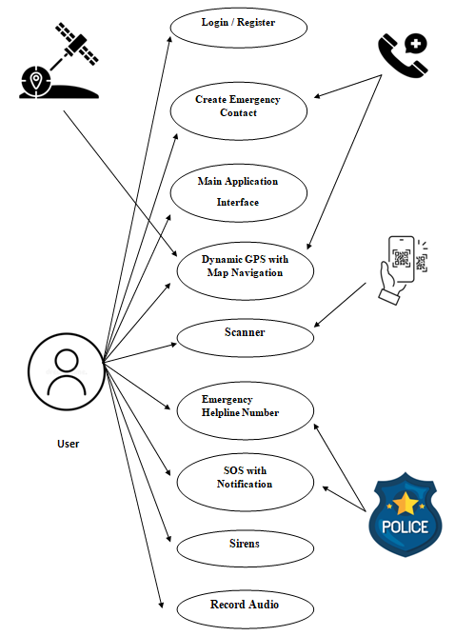

**Figure 1**: Use Case Diagram of Women Safety App

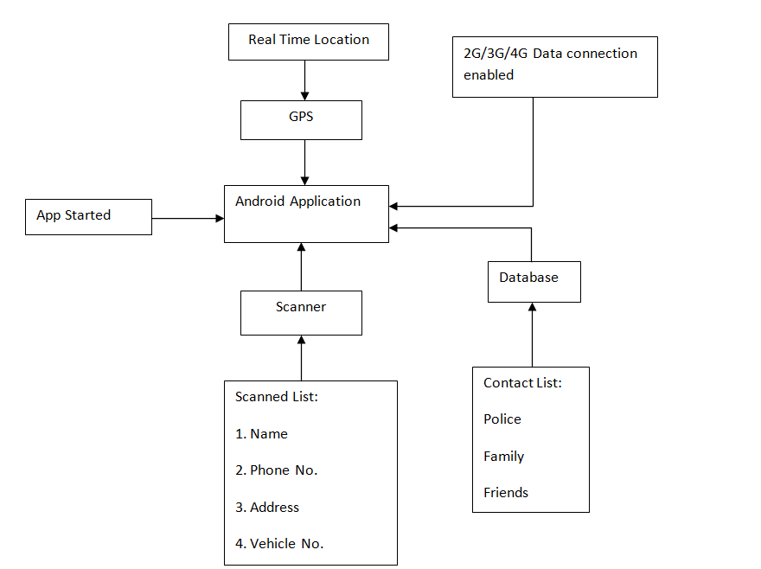

**Figure 2:** Architecture diagram of Women Safety app.

1. **RESULTS AND DISCUSSION**

This android application is useful when the user is in some problem or needs any help. When the user opens this application, can see a registration of user. When user creates the profile then the main activity of application will be visible.we have added many features like Add Contact, Video Recording, Emergency Helpline, Sirens, Recording Audio and scanner

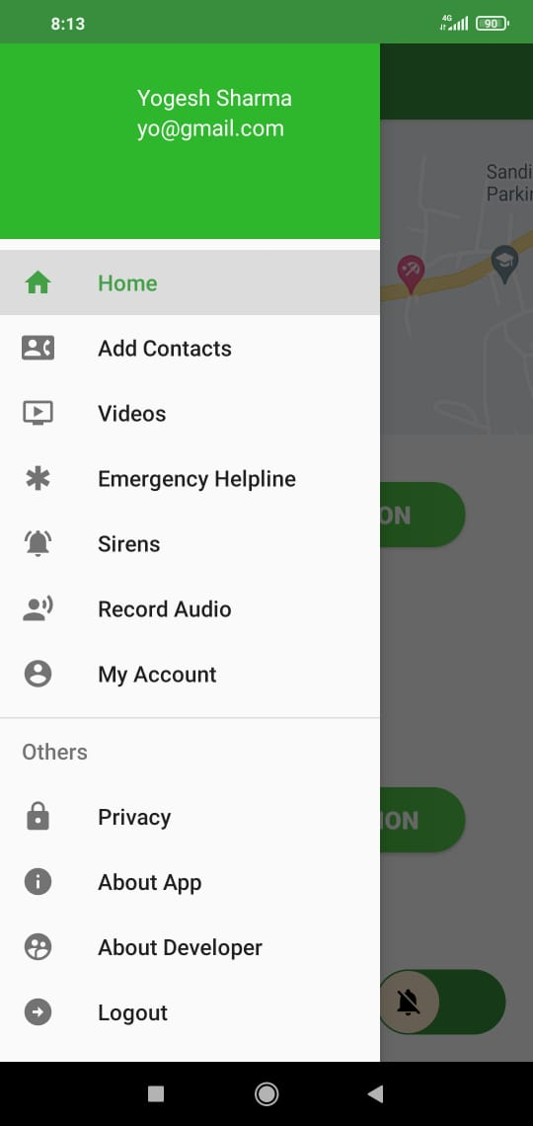

**Figure 1** : Features Of Women Safety App

First feature of the application is SOS. It sends an alert message to emergency contact containing the GPS location of the user every thirty seconds it sends a predefined message to the pre-register contact with the URL of their location

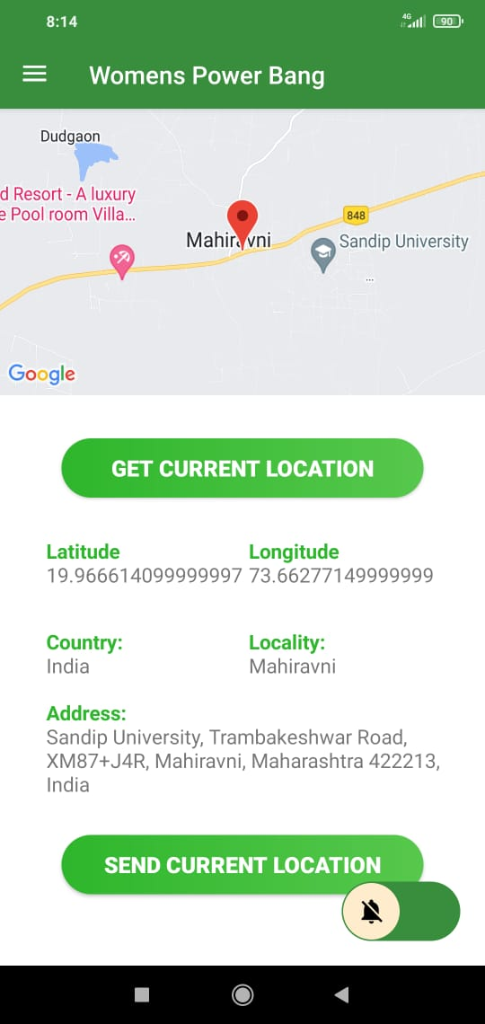

**Figure 2**: Dynamic GPS with Navigation

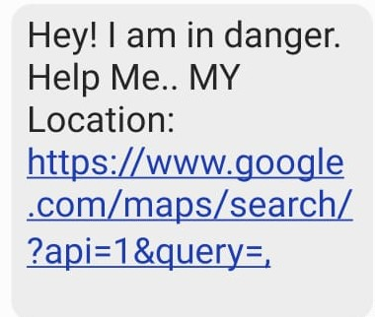

**Figure 3** : SOS with Notification

Second feature of the application is Siren. In these modules there are two buttons i.e. “start” to start the siren and “stop” to stop the siren. When we click on “start” then a siren which sounds like a loud police siren will start . This can alert the nearby people of the situation and in some cases may deter the assailant from proceeding with his malicious intentions.

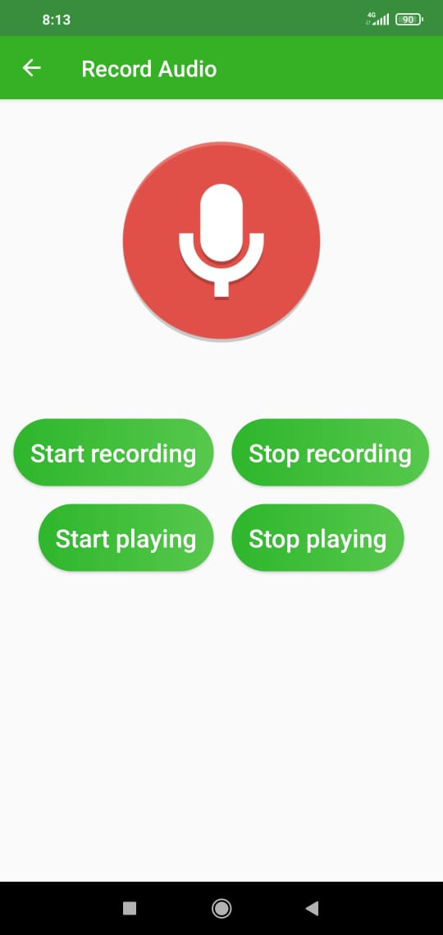

**Figure 4** : Record Audio

Third feature of the application is Voice Recording. In these we have provided the four buttons to start the recording, to stop the recording, after stopping the recording we can play the saved recording and the last one is to stop playing the saved recording. Here, the Recording function will record the surrounding sounds which can be used by the victim in case of a police investigation as evidence.

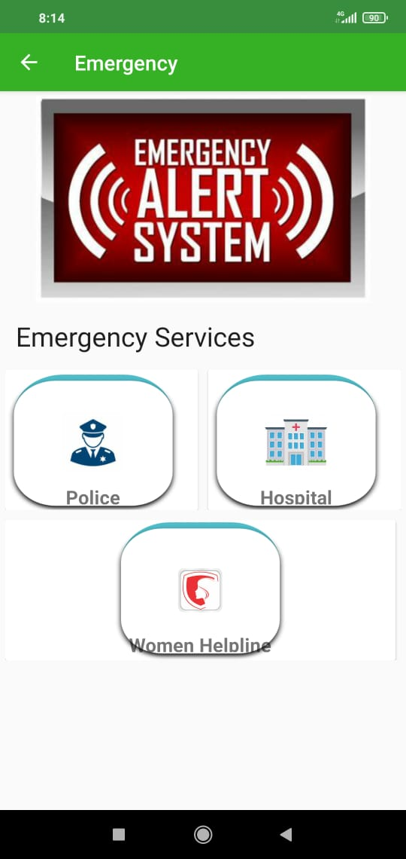

**Figure 5**: Emergency Alert System

Fourth feature of the application is Helpline Numbers. In these we have provided the helpline numbers of Ambulance, Police, Fire Brigade and Women Safety Department. After single click on any of the helpline numbers which are provided in these module, the call will be sent and the victim will get the help which is required.

Fifth feature of our application is Scanner for example whenever you are travelling you can scan the QR and you will have Driver’s name, phone no., Address, Vehicle’s no and can be saved in your mobile

1. **CONCLUSION**

This is the “Android Application for women security system” which is very useful application mainly for girl’s safety. When we feel that we are in emergency situation, for example travelling alone in the Auto/Cab at night time we can use this application. So that by shaking phone three times we can send our location to our family members and to any police stations. So, once we shook phone three times it instantly sends updated locations messages to all authorized persons and we can stop the crime that will be conducted. So, this application is having both safety and security which needs the engineering code of conduct which is essential in the today’s world this mobile application is helpful in future when any problem arises in travelling or any kind of situations.

1. **REFERENCES**

* <https://www.researchgate.net/publication/360162359_Women_Safety_App>
* http://en.wikipedia.org/wiki/android.
* Android Programming Tutorials by Code with Harry https :/ / www.youtube.com / c / Code With Harry.
* JavatPoint: <https://www.javatpoint.com>
* Piyush Bhanushali et al, “Women Safety Android App”, International Research Journal of Engineering and Technology (IRJET), 2018.
* Mona Chaware et al, “Smart Safety Gadgets for Women: A Survey”, Journal of University of Shanghai for Science and Technology, 2020.
* Ravi Sekhar Yarrabothu and Bramarambika Thota, “ABHAYA: AN ANDROID APP FOR THE SAFETY OF WOMEN”, 2015 Annual IEEE India Conference (INDICON), 2015.
* Ms. Priyanka Y. Gonde and Mr. P.B. Ghewarli, “REVIEW PAPER ON WOMEN SAFETY SYSTEM”, International Research Journal of Engineering and Technology (IRJET), 2021.