AGRICULTURE THAT MAKES USE OF THE IOT

B. NageswaraRao1,S.ZakeerHussain2,G.AnilKumar3,K.BalaKumar4,K.CharanKumarReddy5,S.Mahammed6 1Assistant Professor, Dept. of EEE, Santhiram Engineering College, Nandyal, A.P., India. 2,3,4,5,6UG Student, Dept. of EEE, Santhiram Engineering College, Nandyal, A.P., India.

[nageswararao.eee@srecnandyal.edu.in](mailto:nageswararao.eee@srecnandyal.edu.in), [20x55a0235@srecnandyal.edu.in](mailto:20x55a0235@srecnandyal.edu.in)

# ABSTRACT

**The widespread adoption of IOT technology has resulted in revolutionary changes across all walks of the average person’s life. The Internet of Things, or IOT, is a system where devices create their own network topology. Intelligent Smart Farming Internet of Things(IOT) based devices are changing the game in agriculture by improving yields, cutting costs, and maximizing efficiency.The purpose of this report is to propose an Internet of Things(IOT) based Smart Farming System that will help farmers get live data (Temperatures, Soil Moisture) for efficient environment monitoring there by boosting both yield and product quality. This report proposes an IOT based Smart Farming System that utilities Arduino technology combined with various sensors and Wi-Fi module to generate a live data feed that can be accessed online via Thingsspeak.com. The proposed product has been tried and tested in real agricultural fields, yielding data feed accuracy rates of 98% or higher.**

**Keywords: NodeMCU, Sensors and Pump Motors.**

# INTRODUCTION

Agriculture is essential to the survival of the human race because it provides the majority of the world's food supplies and other raw materials. It also gives people a lot of opportunities to get jobs. Unfortunately, many farmers still use the traditional methods of

farming, which results in low yielding of crops and fruits. However, wherever automation had been implemented and human labour had been replaced with automatic machineries, yield had improved.

# LITERATURE SURVEY

1. **Automated Farming Through the Internet Of things:**

Agriculture 4.0, also known as "smart farming," "precision agriculture," and "agricultural precision," is the practise of incorporating cutting-edge technologies into conventional farming practises. The objective is to boost productivity, improve quality control, and cut costs. As a result of the rising costs of conventional farming and the need to comply with stricter environmental regulations, the adoption of Smart technologies in Irish agriculture was inevitable. It is estimated that the value of the global Smart Agriculture Solution Market was around US $10.2 Billion in 2016, with a subsequent increase to a peak of US $38.1 Billion by the end of 2024. Due to the rising popularity of high-tech farming tools like agricultural drones, precision seeding systems, auto-steering, automatic feeding systems, and fruit-picking robots, conventional agri-businesses are beginning to invest in such "smart agriculture" innovations. More time and energy could be devoted to less lucrative activities like farm maintenance and environmental practises with the help of cutting-edge agri-tech. The health and work-life balance of agricultural workers can

benefit from the elimination of backbreaking labour and monotonous tasks.

# The Use of IOT in Smart Farming

In contrast to other industries, agriculture is more slow to adopt new technologies and is generally more conservative about their use. Plants have been raised in controlled conditions for a long time, especially in countries with extreme climatic conditions (very cold or very hot). Hot houses, another name for greenhouses, are commonly used in colder climates because they provide a managed growing environment for plants that would not thrive outside. This includes intelligent decision- making for smart irrigation with smart control based on accurate real-interval field data. Similarly, it has sensors for measuring soil moisture, water level, and pressure, and all of these processes will be monitored via a cloud- based computer system connected to the internet. Data can be completely updated at a faster rate than is possible with other wireless computing. Methodology implementation based on a preexisting architecture and a set of domain- independent software tools (generic enablers) developed for use in fi-ware initiatives. Operations are used to verify several novel ideas for the agriculture sector of a nation's service marketplace, including the systems' variability in response to network failures. The results of the calculation process sanction the adoption of such a system and the needs of farmers to have access to cultured services at reasonable price during the planning and implementation phases as method have been estimated by end user.

# EXISTING SYSTEM

As the world's population rises, fewer resources and arable land become available, and climate change makes the future more uncertain, ensuring enough food to feed everyone becomes a top priority for every country. Due to these issues, the agricultural sector is transitioning to

"smart agriculture," which makes use of IoT and big data solutions to boost operational efficiency and productivity. Wireless sensor networks, cognitive radio ad hoc networks, cloud computing, big data, and end-user applications are just some of the cutting-edge technologies and solutions that make up the IoT. This research provides an overview of available Internet of Things (IoT) solutions and shows how they can be implemented in the smart agriculture industry. To that end, we review the architecture (IoT devices, communication technologies, big data storage, and processing), applications, and research timeline of IoT-enabled smart agriculture ecosystems and discuss their vision. We also highlight the open questions and difficulties associated with IoT application in smart agriculture and talk about the current trends and opportunities in this field. The results of this research should serve as important guidelines for the development and dissemination of Internet of Things (IoT) solutions that enhance agricultural output and quality while also easing the shift towards a future sustainable environment based on an agroecological framework.

# PROPOSED SYSTEM

This sensor is used in smart agriculture to measure soil temperature and moisture, which improves crop yields and reduces water use. In order to keep an eye on crops and pinpoint problem areas, we use sensors, unmanned aerial vehicles, and satellites. In addition to measuring things like crop health, humidity, rainfall, temperature, and more, crop monitoring systems record everything.

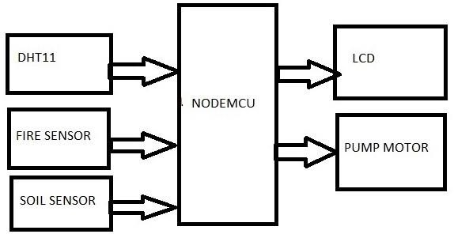

# FUNCTIONAL BLOCKS OF PROPOSED SYSTEM

**LIQUID CRYSTAL DISPLAY (LCD):**

LCD stands for Liquid Crystal Display. LCD is finding wide spread use replacing LEDs (seven segment LEDs or other multi segment LEDs) because of the following reasons:

* + The declining prices of LCDs.
  + The ability to display numbers, characters and graphics. This is in

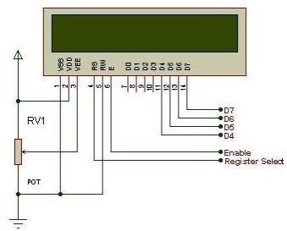

contrast to LEDs, which are limited to numbers and a few characters. Incorporation of a refreshing controller into the LCD, thereby

* + relieving the CPU of the task of refreshing the LCD. In contrast, the LED must be refreshed by the CPU to keep displaying the data.
  + Ease of programming for characters and graphics.

These components are “specialized” for being used with the microcontrollers, which means that they cannot be activated by standard IC circuits. They are used for writing different messages on a miniature LCD.

A model described here is for its low price and great possibilities most frequently used in practice. It is based on the HD44780 microcontroller (Hitachi) and can display

messages in two lines with 16 characters each. It displays all the alphabets, Greek letters, punctuation marks, mathematical symbols etc. In addition, it is possible to display symbols that user makes up on its own. Automatic message on display (shift left and right), appearance of the pointer, backlight etc. are considered as useful characteristics.

# ESP8266 NodeMCU Pinout:

The ESP8266 NodeMCU has total 30 pins that interface it to the outside world. The connections are as follows:

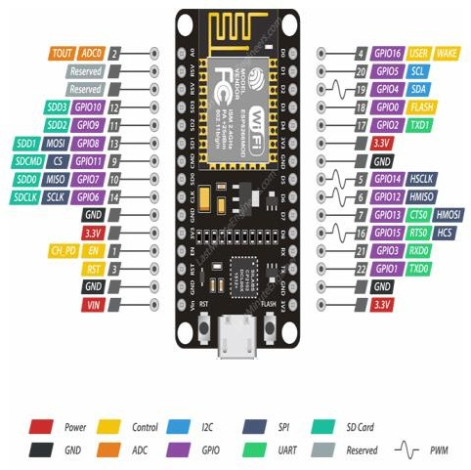

**Power Pins** There are four power pins viz. one VIN pin & three 3.3V pins. The VIN pin can be used to directly supply the ESP8266 and its peripherals, if you have a regulated 5V voltage source. The 3.3V pins are the output of an on- board voltage regulator. These pins can be used to supply power to external components.

**GND** is a ground pin of ESP8266 NodeMCU development board.

**I2C Pins** are used to hook up all sorts of I2C sensors and peripherals in your project. Both I2C Master and I2C Slave are supported. I2C interface functionality can be realized programmatically, and the clock frequency is 100 kHz at a maximum. It should be noted that I2C clock frequency

should be higher than the slowest clock frequency of the slave device.

**GPIO Pins** ESP8266 NodeMCU has 17 GPIO

pins which can be assigned to various functions such as I2C, I2S, UART, PWM, IR Remote Control, LED Light and Button programmatically. Each digital enabled GPIO can be configured to internal pull-up or pull-down, or set to high impedance. When configured as an input, it can also be set to edge-trigger or level-trigger to generate CPU interrupts.

**DHT11 Specifications:**

* Operating Voltage: 3.5V to 5.5V
* Operating current: 0.3mA (measuring) 60uA (standby).
* Output: Serial data
* Temperature Range: 0°C to 50°C
* Humidity Range: 20% to 90%
* Resolution: Temperature and Humidity both are 16-bit
* 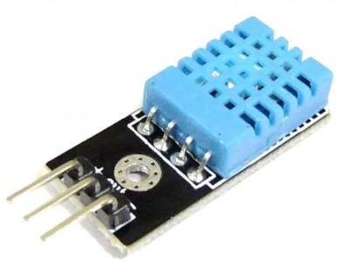Accuracy: ±1°C and ±1%

**SOIL SENSOR:**

Soil moisture sensors measure the water content in the soil and can be used to estimate the amount of stored water in the soil horizon. Soil moisture sensors do not measure water in the soil directly. Instead, they measure changes in some other soil property that is related to water content in a predictable way. Each sensor manufacturer

uses different technologies to measure soil moisture content; for a detailed explanation of all the different types, we recommend reading about the various technologies. For a soil sensor to work, no matter the type, it must make contact with the soil. The highest accuracy will be obtained when the soil sensor is entirely surrounded by the soil, with no gaps between the probe and the soil.

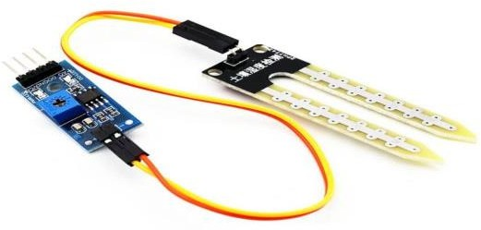

# PUMP MOTOR:

Maintaining continuous production and avoiding dry run operation is critical in any pump application. One simple, cost-effective way to ensure reliable operation is by installing [pump](https://www.levelsensorsolutions.com/float-level-sensors) [float level sensors.](https://www.levelsensorsolutions.com/float-level-sensors) Water level sensors monitor fluid levels inside your pump and send feedback to a controller or the pump, causing it automatically start or stop operation based on the level.

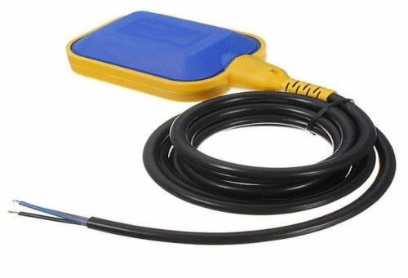

# VI. HARDWARE EXPERIMENTAL RESULTS: CONCLUSION:

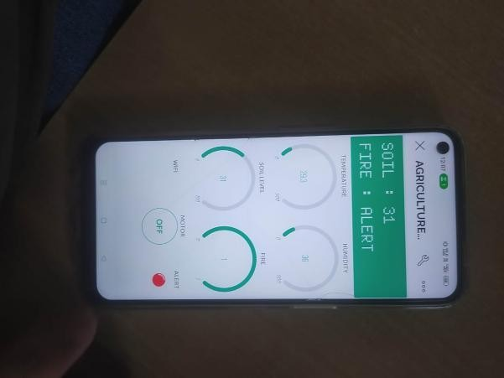IOT based SMART FARMING

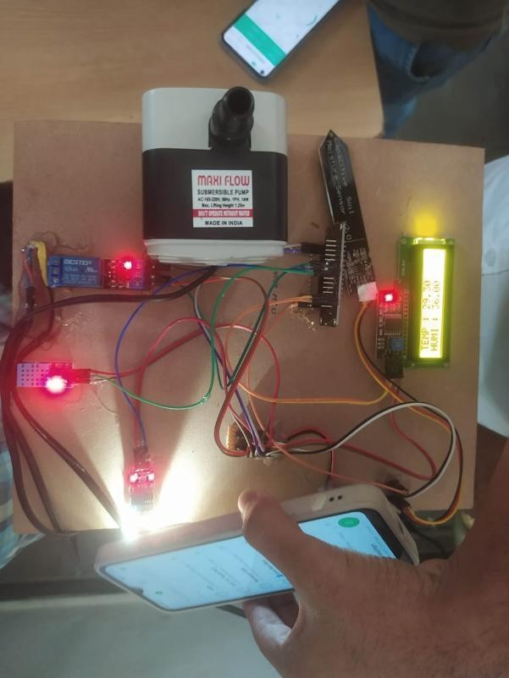SYSTEM for Live Monitoring of Temperature and Soil Moisture has been proposed using Arduino and Cloud Computing. The System has high efficiency and accuracy in fetching the live data of temperature and soil moisture. The IoT based smart farming System being proposed via this report will assist farmers in increasing the agriculture yield and take efficient care of food production as the System will always provide helping hand to farmers for getting accurate live feed of environmental temperature and soil moisture with more than 99% accurate results.

# REFERENCE:

* 1. 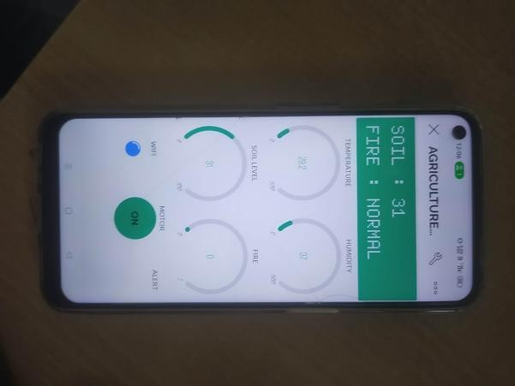M. Yerri Veeresh, Dr.V.Nagabhaskar Reddy, Dr.R.Kiranmayi, Modeling and Analysis of Time Response Parameters of a PMSM-Based Electric Vehicle with PI and PID Controllers, in Engineering, Technology & Applied Science Research (ETASR), ISSN: 2241-4487, Vol. 12, Issue. 6, December 2022, PP.No. 9737-9741.
  2. 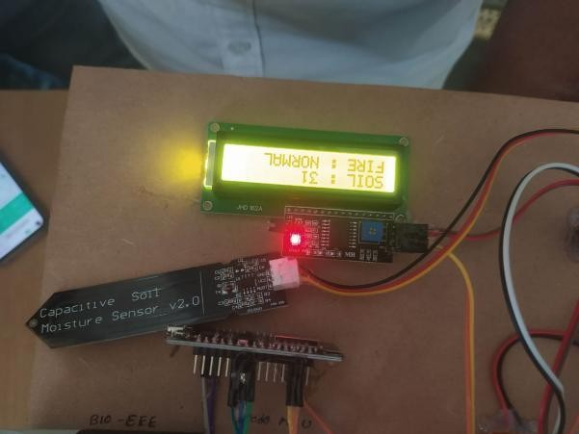M. Yerri Veeresh, Dr.V.Nagabhaskar Reddy, Dr. R. Kiranmayi, Range Estimation of Battery Electric Vehicle by Mathematical Modelling of Battery’s Depth of Discharge, in International Journal of Engineering and Advanced Technology (IJEAT), ISSN: 2249- 8958, Vol. 8, Issue. 6, August 2019, PP.No. 3987-3992.
  3. Dr. M. V. Subramanyam et al ‘Multiple Sensor Data Fusion Based Top-Down Embedded System for Automatic Plant Pot WateringJournal of Algebraic Statistics, e- ISSN: 1309-3452, Marmara University Istanbul University, Istanbul, Vol. 13, No. 1, PP: 884 – 891,2022, No.3.
  4. Research & Technology (IJERT), ISSN: 2278-0181, Volume 2, Issue 9, September 2013, Pg.no: 1835-1843.
  5. B. NAGESWARA RAO, “Design and control of space vector PWM technique with fuzzy controller based multilevel inverter for an open winding induction motor” (IJEAT) Scopus International Journal of Engineering and Advanced Technology (IJEAT) ISSN: 2249 – 8958, Volume-9 Issue-2, December, 2019.
  6. B. NAGESWARA RAO, “Simulation of an Induction Motor Driven by a Modular Multilevel Cascade Inverter without Speed Sensor with Fuzzy controller” (IJARTET) ISSN 2394-3777 (Print) ISSN 2394-3785 International Journal of Advanced Research Trends in Engineering and Technology (IJARTET) Vol. 4, Special Issue 2, January 2017.
  7. J. Sofia Priya darshani &, Dr. M.V. Subramanyam Emperor Penguin Optimized User Association Scheme for MMWAVE Wireless Communication’ Wireless Personal Communications**.** An International Journal, ISSN 0929-6212.
  8. V. Jyothi, Dr. M. V. Subramanyam “Design and Implementation of Solar Energy Monitoring System using LoRa for Solar Power Plants’, International Journal on Advanced Science & Technology, Vol. 29, No. 03, (2020), pp.12757 –12763, Aug-2020.
  9. V. Jyothi, Dr. M. V. Subramanyam “ An Enhanced technique to improve the Network Lifetime of Cognitive Sensor Networks ’, International Journal of Wireless Personal Communications’ pp. 12757 – 12763, May- 2021.
  10. V. Jyothi, Dr. M. V. Subramanyam “An energy efficient fuzzy clustering-based congestion control algorithm for cognitive

radio sensor networks’, Wireless Networksl.Oct-2022.

* 1. Saraswati, B. Alekya himabindu, Dr. M.

V. Subramanyam “Multiple Sensor Data Fusion Based Top-Down Embedded System for Automatic Plant Pot Watering” JOURNAL OF ALGEBRAIC STATISTICS Volume 13, No. 1, 2022, p. 884 – 891.

* 1. B. NAGESWARA RA0, Adaptive Control Techniques Integrated to Grid Connected RES with Harmonic Filter Capabilities. International Journal of Engineering Trends and Technology (IJETT) Volume 69 Issue 2, 201-206, February2021, ISSN:2231/doi:10.14445/22315381/IJETT- V69I2P228© 2021 Seventh Sense Research Group® Scopus.
  2. V. Ramanjaneyulu, "DTMF Based Irrigation Water Pump Control System" in International Journal of Research Available at https://edupediapublications.org/journals p- ISSN: 2348-6848 e-ISSN: 2348-795X Volume 05 Issue 12 April 2018.