Weather App

**Shivam Kushwah1, Aayush Gupta2, Premlal Bhaskar3**

Computer Science & Engineering /Thakur ShivKumar Shingh Memorial Engineering Collage Ziri/ RGPV/ India

**Abstract**

ABSTRACT This Research paper studies about a python based web framework known as Django. It is an open source framework which follows the basic Model View Template structure with some modifications which are explained inside the paper and it also help us to know why we use Django over other web frameworks that are available in the industry and how we can install it on our system and create a basic project using this framework following this our paper also studies about the different modules that are available to us this also helps us understand the MVT structure of this framework very briefly. When we go deep inside the paper we also get to know how we can create apps inside the framework and add them to our main project and how we can create form inside views how it interacts with databases and how it performs operations on databases how it make easy making dynamic websites and making task easy by centralizing access to the apps. Basically this paper covers everything required for a person or a student to get started with the django framework and learn the basics to create some simple projects related to the Django web framework and make learning interactive and easy even for a lame person.

# **Introduction**

Weather App is a web application . My project is show weather condition like temperature , rain , wind etc of cities My project is work globally any of the cities that means we have show any city temperature in the world . So with one weather solutions, its users can get weather reports by getting information directly from satellite and radar via proper communication medium. Its user’s friendly tools are so simple to use, that even a child can handle it and get information on particular geographical area. Its calculations and details are so accurate, that you can even check and match it from news channel. Weather App is developed in python and it’s frontend is made in html and css. In this project I used pyhon’s Django framework and , for user interface use html and css . I used weather api to fetch weather data from the server . Weather App project is a web based application through which you will able to get all the reports related to weather forecasting of any locations. Its geographical locator which will be received through your browser setting and server configuration will automatically identify the location and able to present its weather details such as temperature, direction of wind, rains, humidity etc. To change the location you will just have to select the options provided below to get its details.

**II. Methodology**

**2.1 Software Development Lifecycle**

Software Development Life Cycle (SDLC) is a process used by the software industry to design, develop and test high quality softwares. The SDLC aims to produce a high-quality software that meets or exceeds customer expectations, reaches completion within times and cost estimates.

* SDLC is the acronym of Software Development Life Cycle.
* It is also called as Software Development Process.
* SDLC is a framework defining tasks performed at each step in the software development process.
* ISO/IEC 12207 is an international standard for software life-cycle processes. It aims to be the standard that defines all the tasks required for developing and maintaining software

SDLC is a process followed for a software project, within a software organization. It consists of a detailed plan describing how to develop, maintain, replace and alter or enhance specific software. The life cycle defines a methodology for improving the quality of software and the overall development process..

The diagram showing phases of SDLC are as follow :-

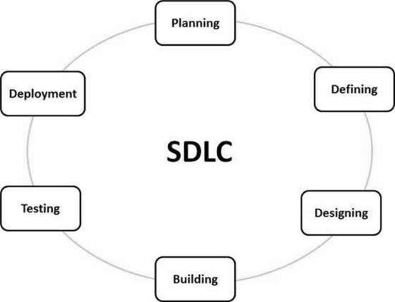

**Fig.1 : Software Development Life Cycle**

**Type of SDLC:-**

1. Waterfall Model
2. RAD Model
3. Spiral Model
4. Incremental Model
5. Iterative Model
6. Agile Model
7. V-Model

Here for us project we use the iterative model because this model is iterative and linear sequential in nature , So, our website should be iterative in nature because website can be update many times.

**Iterative Model**

In the Iterative model, iterative process starts with a simple implementation of a small set of the software requirements and iteratively enhances the evolving versions until the complete system is implemented and ready to be deployed.

**Requirement Phase :-** Software development is one of the important phase and in iteration development this phase is repeated iteratively as the full specification of the software is divided into the smaller requirement chunks and developed.

**Design Phase :-** After the iteration requirement is gathered then we need to implement the design phase. Effective design is decided to implement the requirement out of many alternatives.

**Implement or Development Phase :-** The design that has been decided will be implemented by the developer with decided coding and metrics standard. The developer needs to implement a unit test at each stage of the development while developing the code.

**Testing :-** Once the code has been implemented then this testing phase is implemented to identify any defects that are present in the code and if present then they need to be reported back to the developers.

**DFD LEVEL :- 0**

* **Level 0** - Highest abstraction level DFD is known as Level 0 DFD, which depicts the entire information system as one diagram concealing all the underlying details. Level 0 DFDs are also known as context level DFDs.

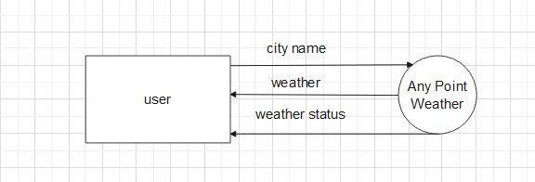

**Fig:- DFD level 0**

**1-level DFD**

In 1-level DFD, a context diagram is decomposed into multiple bubbles/processes. In this level, we highlight the main objectives of the system and breakdown the high-level process of 0-level DFD into subprocesses.

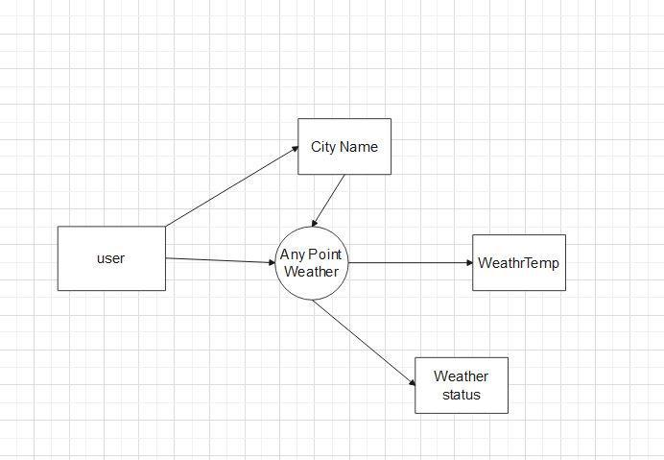

**Fig:-level 1 DFD**

**2.3.3 Sequence Diagram**

The sequence diagram represents the flow of messages in the system and is also termed as an event diagram. It helps in envisioning several dynamic scenarios. It portrays the communication between any two lifelines as a time-ordered sequence of events, such that these lifelines took part at the run time. In UML, the lifeline is represented by a vertical bar, whereas the message flow is represented by a vertical dotted line that extends across the bottom of the page. It incorporates the iterations as well as branching.

Purpose of a Sequence Diagram

1. To model high-level interaction among active objects within a system.
2. To model interaction among objects inside a collaboration realizing a use case.
3. It either models generic interactions or some certain instances of interaction.

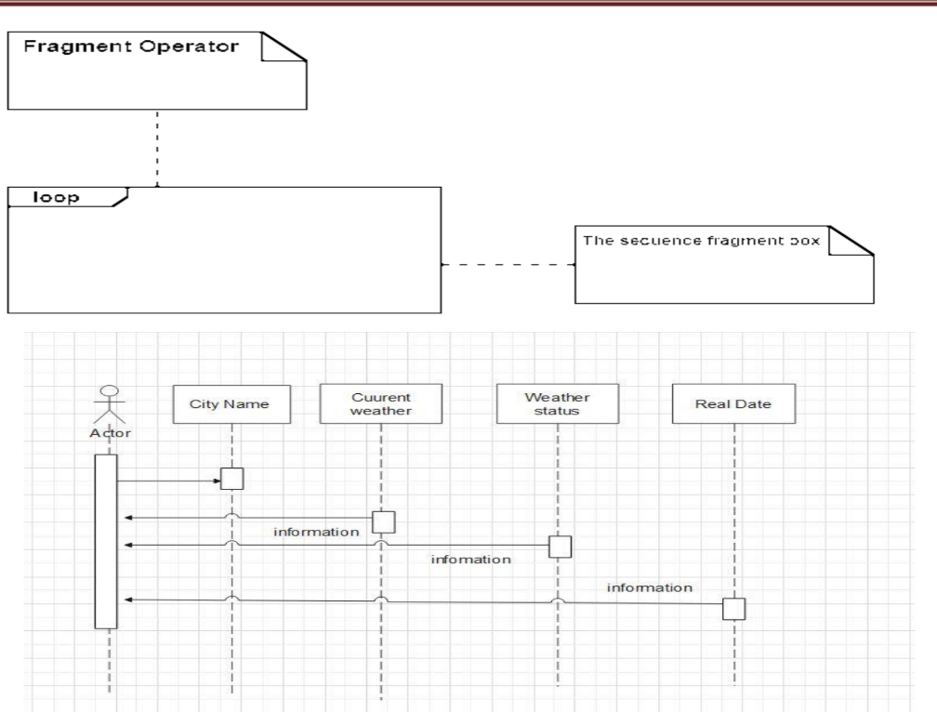

**Fig:- sequence diagram**

**2.4 Requirment & Analysis**

[Software requirement](https://www.geeksforgeeks.org/software-engineering-classification-of-software-requirements/) means requirement that is needed by software to increase quality of [software product.](https://www.geeksforgeeks.org/software-engineering-software-product/) These requirements are generally a type of expectation of user from software product that is important and need to be fulfilled by software. Analysis means to examine something in an organized and specific manner to know complete details about it. Therefore, **Software requirement analysis** simply means complete study, analyzing, describing software requirements so that requirements that are genuine and needed can be fulfilled to solve problem. There are several activities involved in analyzing Software requirements. Some of them are given below :

1. **Problem Recognition :**The main aim of requirement analysis is to fully understand main objective of requirement that includes why it is needed, does it add value to product, will it be beneficial, does it increase quality of the project, does it will have any other effect. All these points are fully recognized in problem recognition so that requirements that are essential can be fulfilled to solve business problems.
2. **Evaluation and Synthesis :**

Evaluation means judgment about something whether it is worth or not and synthesis means to create or form something. Here are some tasks are given that is important in the evaluation and synthesis of software requirement :

* + To define all functions of software that necessary.
  + To define all data objects that are present externally and are easily observable.
  + To evaluate that flow of data is worth or not.
  + To fully understand overall behavior of system that means overall working of system.
  + To identify and discover constraints that are designed.

1. **Modeling :**

After complete gathering of information from above tasks, functional and behavioral models are established after checking function and behavior of system using a domain model that also known as the conceptual model.

1. **Specification :**

The [**software requirement specification (SRS)**](https://www.geeksforgeeks.org/software-requirement-specification-srs-format/) which means to specify the requirement whether it is functional or non-functional should be developed.

1. **Review :**

After developing the SRS, it must be reviewed to check whether it can be improved or not and must be refined to make it better and increase the quality.

**RESULTS**

**4.1 Home Page .**

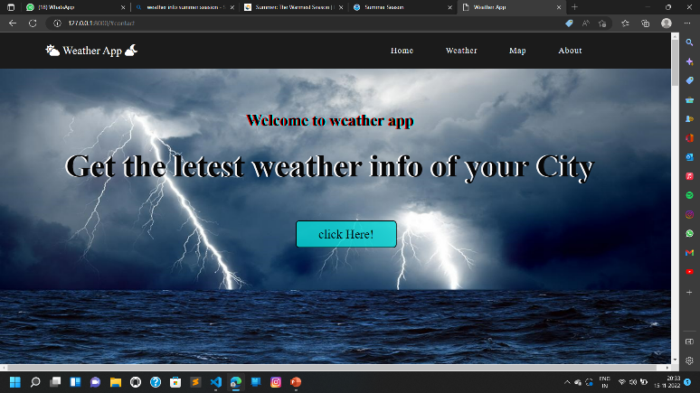

**Main Page:-**

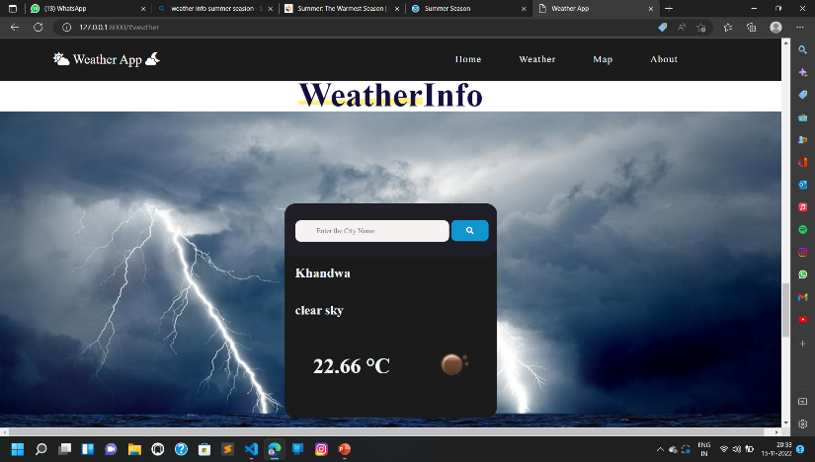

**User Manual**

**5.1 Software Requirements:**

* + Browser: Internet Explorer or Mozilla Firefox etc.
  + IDE : VS Code Studio.
  + Language : Python.
  + Other Tech **:** HTML, CSS and JavaScript.
  + API : openweather.com
  + Operating system: Any Windows version/ MAC

**5.2 Hardware Requirements:**

* + Processor: Intel Pentium IV or above
* Ram: 1GB or more
* Hard Disk: 40 GB or more

**5.3 Step to Run Project :**

**Step 1**:- Firstly start your laptop/pc .

**Step 2**:- Now install python setup for coding of python language .

**Step 3**:- After that install vs code .

**Step 4**:- In vs code terminal write pip install django for installing django .

**Step 5**:- In vs code we write coding for project . to run the project select brouser google chrome . Open one of the browser enter your url <http://127:0:0:1:9898>.

**6.1 CONCLUSION**

Everyone is aware of Internet these days and it is the only way to propagate our information. The data and maintain and format the data requested by the authority. Also to formatted the text to embed into World Wide Web. The data is about to change all the time so we will update it all the time possible. The web sites are going to the future of get information.

A website is a collection of Web pages, images, videos and other digital assets that is hosted on one or several Web server, usually accessible via the Internet, cell phone or a LAN. The es of websites can usually be accessed from a common root URL called the homepage, and usually reside on the same physical server. The URLs of the pages organize them into a hierarchy, although the hyperlinks between them control how the reader perceives the overall structure and how the traffic flows between the different parts of the sites. A website requires attractive design and proper arrangement of links and images, which enables a browser to easily interpret and access the properties of the site. Hence it provides the browser with adequate information and functionality about the organization, community, network. The website has been developed for our college in an effort to make it as attractive and dynamic as possible. Compared to the existing site a database has been added to our project. The working of the project is as follows: The first page provides several links. The Home page contains several information about the site like city weather, forecast, atmosphere etc. The weather news and the corner display the latest developments, announcements and events associated with the weather activities

**6.2 Future Scope**

* **Weather News:-** It gives the all wild area weather news and forecast because this website is an only search weather in globally city name.
* **Wind Flow:-** This website provides the facility to user to wind speed and others services to help our area weather information.
* **Vileges :-** This website is an search weather as globally city to work to make an advance website to search weather any vileges.

• **Satellite Connectivity**:- Our website can fach data to api but future Apart from

weather,algorithms can be used to scan satellite images to automatically derive plant count and production estimates.