**IoT Based Smart Security and Home**

K. Pedda Obulesu1, G. Sai Ganesh2, A. Tejeswara Reddy3, S. Bharath Reddy4, S. Deepak Kumar5, N. Sai Akhil6

1 Asst. Prof., SREC, Nandyal

2,3,4,5,6 UG students, SREC, Nandyal

obulesh.ece@srecnandyal.edu.in

**Abstract:**

Radio-frequency identifier (RFID) is a well-known technique that has been around since the 1970s; it was first put to use tracking train cars. It is now widely utilised for a wide range of applications across the globe. As hacking becomes increasingly widespread, RFID's use for security reasons is a welcome solution. Since the RFID tag contains the specific information, a replacement tag with the same knowledge cannot be read because its radio wave does not match the original tag's. Thus, RFID locking systems are very secure and safe. Nonetheless, this should not be taken to imply that there are no drawbacks.

**INTRODUCTION:**

There has been a steady increase in crime across India, but it spiked following the COVID-19 outbreak. It's because plenty of folks were laid off and went bad as a result. It's important to take additional safety measures. As RFID has been around for over than 50 years, it has shown itself to be a trustworthy and dependable technology, making it the ideal choice for this application.

RFID may be utilised in the real world for a variety of purposes, such as an additional layer of protection at the entrances of homes, workplaces, hotels, etc. It may also be utilised for entryways and exits that only a carefully chosen few people are allowed to use. It also works effectively as a supplementary safety precaution for lockers.

RFID chips may come in a variety of formats, including cards, tags, and lanyards, to best suit the needs of each individual user. In addition, the RFID chip may be placed in our body, albeit the process of insertion is now highly debated. This makes it convenient for users to always have the RFID tag with them, since such card can be stored in a wallet and the key clip may be linked to a set of keys. The major drawback of the RFID tag is that it may be lost or stolen in the same way that our keys or wallets can. If an RFID tag is required to access a closed door and the name is misplaced, the only option is to resort to more drastic means, such as breaking the lock. If the RFID tag is lost, the individual may still get entry to the door or locker by entering a password into the reader's touchpad.

**Literature survey:**

**Raspberry Pi as a Platform for the Internet of Things Projects: Experiences and Lessons**

The internet of objects (IoT) is a new computer paradigm that might also soon need a broader range of abilities from IT specialists. In response to these needs, several CS programmes are including material related to the Internet of Things (IoT) into their current curriculum. This article discusses the authors' practise of introducing Internet of Things (IoT) projects into a dedicated Hardware Coursework. Educators interested in incorporating Internet of Things (IoT) content into their curricula may find our analysis of numerous viable hardware platforms, examples of student projects built on Raspberry Pi with various sensors, and discussion of several lessons learned to be helpful.

# IoT based Smart Home design using power and security management

Using a Nvidia geforce GALILEO 2ND generation arduino boards, this article details the planning and execution of a Multimode fiber Smart Home sophisticated system for monitoring electrical energy use based on real-time tracking of gadgets in the home. The suggested system allows for remote control and monitoring of electrical items and switches via the use of real-time surveillance and voice control, all without the need for an Android-based software. It employs a number of sensors to do things like track devices in real time and keep your home safe. It may be monitored and managed from anywhere with Internet or Intranet access and an Android device. The project's proposed outcome has multiple goals, including lowering homeowners' monthly electricity costs, improving home security by allowing users to remotely turn on and off electronics with the touch of a button or the sound of their voice, and conserving limited natural resources by lowering the consumption of electricity.

# IoT based smart security and home automation system

The term "Internet of Things" (IoT) refers to the notion of digitally linking and keeping tabs on physical items in the physical world from afar. This idea can be properly implemented in our home to make it more advanced, secure, and automated. The goal of this Internet of Things project is to create a wireless home surveillance system that is both smart and secure, sending notifications to the owner through the Internet in the event of a break-in and optionally sounding an alarm. Moreover, the same sensor collection may be used for home automation. This system has an advantage over others of its sort since the user may check the status and get notifications from the wifi-linked microcontroller-managed system on his mobile from anywhere, regardless of whether or not his device is linked to the web. The present prototype makes use of the TI-CC3200 Launchpad board, which is equipped with a developed online and an onboard Wi-Fi shield, allowing for complete administration and control of all electrical appliances inside the house.

**Iot based monitoring an control system for home automation**

The project offers an effective implementation of IoT (Internet of Things), which may be used to keep tabs on and manage domestic appliances remotely through the Internet. The portable devices are the interface to the home automation system. Low power communication protocols like Zigbee, Wi-Fi, etc., allow them to talk to a home automation network through an Internet gateway. The goal of this project is to allow users to command various household appliances from their smartphones via the use of a Wi-Fi network and a Raspberry Pi server. Here, the user interacts with the system in real time through a web interface while lighting, fans, and locks in the house are managed from a central location. Protection against fire accidents is further bolstered by the system's capacity to detect smoke and send a warning message and picture to a user's smartphone if one is detected. The server will connect to hardware relay circuits that manage the household appliances. Device selection is made possible by interaction with a server. User acceptance of a certain gadget is determined by interaction with a server. The server talks to the appropriate relays. The embedded system board can control and run the appliances locally even if the internet connection or server are unavailable. In doing so, we provide a scalable and reasonably priced solution for automating your home.

**Methodology:**

RFID is used as a method of access control in IoT and RFID-based security systems. The RFID tag must be swiped so at RFID reader by the person holding it. The RFID reader picks up the tag's individual number. The Rfid tag then communicates with the mcu to provide the ID data.

The microcontroller is set up to check whether the swiped card's ID number matches one in the database of valid cards. When the mcu detects an invalid card number, it activates the buzzer. The microcontroller checks the payment details and releases the gate's lock if it's a great fit.

As part of the project, a DC motor is wired in to act as a demonstration gate. An LCD screen may also be linked to the system to display helpful information like "Please present your card," "you are approved," and "you are not permitted."

The IOT module is also linked to the microcontroller. The Internet of All Things (IoT) is the network of "things" that enables physical objects to communicate and share data via the use of embedded electronics, networked computing, and software. There is no need for human intervention in these systems. Several sectors, including healthcare, energy, transportation, etc., make use of IoT technologies.

When a card is swiped over an RFID reader, information about the card gets transmitted to an Internet of Things (IoT) website. The website receives the RFID account number and a timestamp. This may be used to keep tabs on all the customers that have visited your store, bank, etc.

The Internet of Things (IoT) module is optional for this project's execution. The Arduino Uno isn't the only microcontroller option.

**Existing system:**

The use of a smartphone, with Arduino uno, and Bluetooth technologies for home automation creates a safe and inexpensive solution. [2] R.Piyare and M.Tazil suggest a Bluetooth-based home control system. A personal computer or mobile phone acts as the system's receiver. As a real-time system, it can communicate quickly, is highly secure, and doesn't break the bank. The typical range of a Bluetooth network is just ten metres. One of the biggest drawbacks of a Bluetooth-based home automation system is that the iphone will lose control over the appliances if it is out of range.

**Proposed system:**

In this article, we will explore a potential method for The primary objective of this project is to employ an RFID to offer strong home safety and security measures, including the simple operation of home appliances. The EM 18 Audience software, via which the user controls his home appliances, may be made more convenient in the future by adding support for RFID cards. Other methods of authentication, such as retinal and fingerprint scanning, are also on the horizon. The security system may be made more reliable by applying image processing.

**Block diagram:**

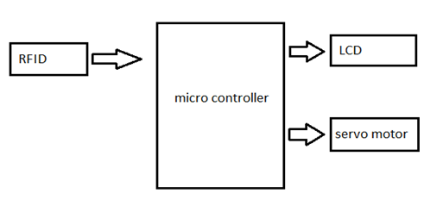

**Hardware requirement:**

1. Micro controller
2. RFID
3. Servo motor
4. LCD

**Software:**

1. Arduino UNO
2. Embedded C, C++

**HARDWARE COMPONENTS REQUIRED:**

**RFID:**

Module for RFID Reader (EM-18) It employs radio frequency waves to verify and classify various items. An RFID tag is used, and information is sent directly and instantly between the two devices. Vccgnd, Light emitting, data0, data1, Transmitter(tx), and a select pin are all present (sel). The device's UART protocol enables direct connection between the transmitter and receiver pins of a microcontroller. The RFID reader module is equipped with an RF signal generator for broadcasting signals to the tag and a receiver/signal detector for picking up signals broadcast by the tag. High-frequency electromagnetic field waves are generated by a Radio Frequency (RF) module and an antenna in a Reader.

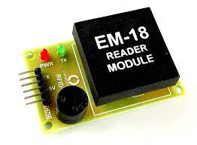

**Servo Motor:**

A cortico motor is a mechanical device with precise rotational control, used for example, in a robotic arm.

A servo motor is a DC motor equipped with a negative feedback system that can detect and correct for errors. The angular velocity and motor location may be precisely controlled in this way. Sometimes, ac motors are the best option.

The shaft's motion and ultimate position are controlled in a closed loop using negative feedback.

Unlike standard AC/DC motors, it is not designed for continuous spinning.

It may rotate between zero and one hundred and eighty degrees.



**RESULT:**

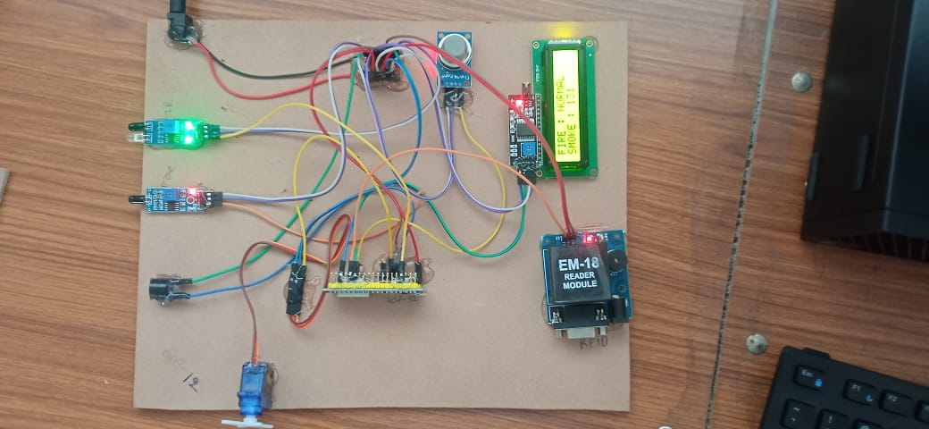

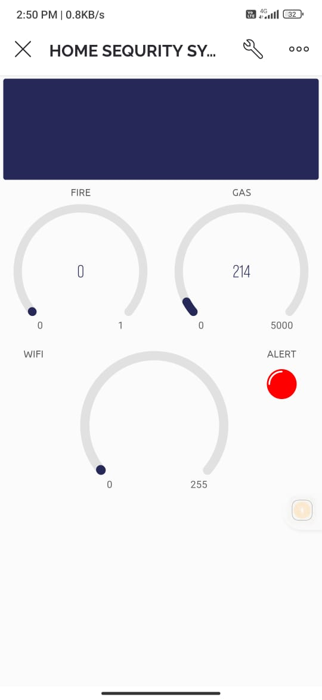

**Conclusion:**

The primary objective of the project is to employ an RFID to offer strong home safety and security safeguards, including the simple operation of home appliances. The EM 18 Reader software, via which the user controls his home appliances, may be made more convenient in the future by adding support for RFID cards. Other methods of authentication, such as retinal and fingerprint scanning, are also on the horizon. To make the security system more reliable, we may use image processing. In order to tell the difference between a real intruder and a false alert, this system would consult a trusted face database.

**Reference:**

[1] Ravi Kishore Kodali, Vishal Jain, Suvadeep Bose and Lakshmi Boppana, "IoT Based Smart Security and Home Automation System"

[2] Jasmeet Chhabra,Punit Gupta," IoT based Smart Home Design using Power and Security Management"

[3] Stan Kurkovsky, Chad Williams," Raspberry Pi as a Platform for the Internet of Things Projects: Experiences and Lessons ",2017 .

[4] VamsikrishnaPatchava, Hari BabuKandala,P Ravi Babu,"A Smart Home Automation technique with Raspberry Pi using IoT",2015.

[5] B. R. Pavithra, D., “Iot based monitoring an control system for home automation,” 2015.

[6] Al-Ali, A.R. ; Dept. of Comput. Eng., American Univ., United Arab Emirates ; AL-Rousan, M., "Java-based home automation system"2004.

[7] Stefan Marksteiner, Víctor Juan Exposito Jimenez, Heribert Valiant, Herwig Zeiner, " Internet of Things Business Models, Users, and Networks", 2017 .

[8] S. Tanwar, P. Patel, K. Patel, S. Tyagi, N. Kumar, M. S. Obaidat, "An advance Internet of Things based Security Alert System for Smart Home