A Project report on

**“IOT Based Smart Medical Wheelchair”**

Submitted in partial fulfilment of the requirements for the degree of

**Bachelor of Technology**

**In**

**Mechanical Engineering**

Submitted by

**Mr. Vinay Shankar Lohar (20112073)**

**Mr.Pushkaraj Arun Ambade(20112079)**

**Mr. Akash Dasrao Surywanshi(20112087)**

**Mr.Amit Bharat Patel (20112088)**

**Mr.Sachin Sanjay Pawar (20112095)**

Under guidance of

**Mr. A.R. Mane**



**DEPARTMENT OF MECHANICAL ENGINEERING**

**ANNASAHEB DANGE COLLEGE OF ENGINEERING AND TECHNOLOGY, ASHTA.**

**2022-23**

**C E R T I F I C A T E**

This is to certify that the project report entitled **“IOT Based Smart Medical Wheelchair”** submitted by

Lohar Vinay Shankar(20112073)

Ambade Pushkaraj Arun(20112079)

Suryawanshi Akash Dasrao(20112087)

Patel Amit Bharat(20112088)

Pawar Sachin Sanjay(20112095)

as the record of the project work carried out by them, is accepted as the Project Phase-1Reportin partial fulfilment of the requirements for the award of degree of Bachelor of Technology in Mechanical Engineering from Annasaheb Dange College of Engineering, Ashta, during the academic year 2022- 2023.

Place: Ashta

Date:

|  |  |  |
| --- | --- | --- |
| Mr. A.R. Mane  PROJECT GUIDE |  | Prof. M. M. Jadhav  HEAD OF DEPARTMENT |

Prof. V. S. Patil

DIRECTOR

ADCET, ASHTA

**ABSTRACT**

Everyone wants to be independent, but especially people who must use wheelchairs their entire lives. This "Smart Wheelchair" project offers its users specific assistance. Since technology has increased our level of independence, a wheelchair patient no longer needs to be dependent on anyone to take care of him or her. The "Inbuilt Health Monitoring Facility" of this product is self-contained. Even in an emergency situation, this structure can help users get through difficult situations. We finish with our outlook on the direction of research into smart wheelchairs and how to best assist those who have certain types of disability.

**INDEX**

|  |  |  |  |  |
| --- | --- | --- | --- | --- |
|  |  |  | List of Figures | i |
|  |  |  | List of Tables | ii |
|  |  |  | Symbols and Notations | iii |
|  |  |  | Synopsis approved copy | iv |
| **1** |  |  | **Introduction** | **1** |
|  | 1.1 |  | Background | 1 |
|  | 1.2 |  | Problem Statement | 2 |
|  | 1.3 |  | Objectives | 2 |
| **2** |  |  | **Literature Review** |  |
|  | 2.1 |  | Literature Papers | 3 |
|  | 2.2 |  | Literature Gap | 5 |
| **3** |  |  | **Design of Mechanism** |  |
|  | 3.1 |  | Design of Shaft | 6 |
|  | 3.2  3.3 |  | Selection of Bearing  Selection of Wheel | 9  11 |
| **4** |  |  | **Preparation of Manufacturing Drawing** | 12 |
|  | 4.1 |  | CATIA Model | 12 |
| **5** |  |  | **Selection of Components for Model** | 14 |
| **6**  **7**  **8**  **9** |  |  | **Fabrication, Working and Testing**  **Results & Discussion**  **Conclusion**  **Reference** | 22  25  27  28 |
|  |  |  |  |  |
|  |  |  |  |  |
|  |  |  |  |  |

LIST OF FIGURES

|  |  |  |  |  |
| --- | --- | --- | --- | --- |
| **Sr. No.** | **Title** | | | **Page No.** |
| Figure 3.1  Figure 4.1  Figure 4.2  Figure 4.3  Figure 4.4 | Design of Shaft  Frame of Model  Wheel of Chair  Rim of Wheel  Shaft | | | 6  12  12  13  13 |
| Figure 5.1 | ESP32 Module | | | 14 |
| Figure 5.2 | Arduino UNO | | | 15 |
| Figure 5.3 | Hc05 Bluetooth sensor | | | 16 |
| Figure 5.4 | MAX30102 Sensor | | | 17 |
| Figure 5.5 | Temperature Sensor | | | 18 |
| Figure 5.6 | BLDC Wheel Hub Motor | | | 19 |
| Figure 5.7 | Micro-controller | | | 20 |
| Figure 5.8 | Jumper wire | | | 21 |
| Figure 6.1 | Fabrication of Wheelchair | | | 22 |
| Figure 6.2 | IOT based Smart Medical Wheelchair | | | 24 |
| Figure 7.1 | Health Parameter measured in Hospital | | | 25 |
| Figure 7.2 | Temperature measured by Model | | | 26 |
| Figure 7.3 | SpO2 measured by Model | | | 26 |
| Figure 7.4 | Heart Rate measured by Model | | | 26 |
|  | |  |
|  | |  |
|  | |  |
|  | |  |
|  | |  |
|  | |  |
|  |  | | |  |
|  |  | | |  |

**CHAPTER 1**

# INTRODUCTION

* 1. **Background**

As the population has aged, the number of people with impairments has considerably increased. Among these, those who have motor impairments rely on wheelchairs. About electric wheelchairs, a number of gadgets have been created over time to operate the seat according to the level of handicap the user displayed. Statistics show that more than half of wheelchair users have trouble adjusting to the user interface.

Especially when compared to those who spend their entire lives in wheelchairs, self-sufficient individuals. The "IOT Based Smart Medical Wheelchair" project aids users as expected. Since technology has increased our level of independence, a wheelchair patient no longer needs to be supported by someone to take care of him or her. This product features a built-in health monitoring system, and even in an emergency situation, this substructure can help the user take creative control over the development of smart wheelchairs and how to best serve persons with similar problems. Patients with sensory-motor impairments can regain their freedom by using a smart wheelchair, which allows them to move around without the assistance of a ward or carer. The goal of a smart wheelchair is to ensure user safety while moving and reduce user effort in controlling the wheelchair.

The use of Internet of Things (IoT) in the healthcare industry has been gaining significant attention in recent years. IoT technologies offer new ways to address mobility and healthcare challenges faced by physically challenged patients. One application of IoT in healthcare is the development of smart medical wheelchairs, which have the potential to improve patient outcomes and overall healthcare experience.

In this project, we aim to design and develop an IoT-based smart medical wheelchair that incorporates a range of innovative features to support patient mobility and safety. Our design includes the use of sensors and wireless communication modules to monitor and transmit real-time data on the patient's health status and wheelchair movement. This data can be used to improve healthcare delivery and patient outcomes.

Overall, our project aims to address mobility and healthcare challenges faced by physically challenged patients through the use of IoT-based technologies. We believe that our innovative and practical solution will improve the quality of life for many people and help them lead a more comfortable and fulfilling life.

* 1. **Problem Statement**

To create and develop a smart wheelchair based on IOT. It needs to be built with patient monitoring in mind. Patients are routinely checked manually by the nurse or doctor, but with the aid of a smart wheelchair, patient monitoring can be carried out automatically. The development of technology has greatly benefited those with impairments.

* 1. **Objectives**

1. Create a smart wheelchair for a patient with physical disabilities to improve their quality of life and independence.

2. for the regular examination of elderly and disabled patients.

3. Hospital main checkups such as blood pressure, SpO2, temperature, heart rate, etc. are their area of expertise.

4. To update the wheelchair for the disabled.

* 1. **Outcomes of project**

1. To routinely monitor the health of patient.
2. To transform a wheelchair used for medical purposes into one with enhanced health monitoring.
3. To save medical professionals time and effort.
4. To ensure the patients' independence and comfort.

**CHAPTER 2**

# LITERATURE REVIEW

**Sibai et al.** The review study written by Simpson claims that there are various approaches to building a smart wheelchair. Early intelligent wheelchairs were simply mobile robots with seats. Presently, the majority of smart wheelchairs being developed are based on modified versions of wheelchairs that are already on the market. There aren't many "add-on" smart wheelchairs that can be attached to and detached from the base motorized wheelchair. All of these designs have the same goals, which are to make it easier to use the chairs, prevent collisions as much as possible, extend the trip distance, and shorten the travel time. [1]

**Khan et al.** The research study aims to enhance a motorised wheelchair's capacity to cater to a larger number of individuals with disabilities. This is achievable through the combination of a DC motor, motor drivers, and microcontroller system. The android-based control circuit governs the wheelchair's movements, which can be directed using an existing Android phone over Bluetooth. To reduce the cost of the wheelchair, the user can download the Android application used in this project to their phone. The wheelchair can move in four directions: left, right, forward, and reverse, and the phone and control circuit are wirelessly connected. [2]

**Sharma et al. (2020)** The study provides an extensive review of IoT-based smart medical wheelchairs. The authors discuss the various components of the IoT-based system, including sensors, actuators, communication protocols, and algorithms for navigation and control. They also examine the potential benefits of the system, such as improved patient safety, reduced caregiver workload, and enhanced patient mobility.[3]

**Alam et al. (2019)** In their study, design and implement an IoT-based smart medical wheelchair. The authors develop a system that can detect obstacles, avoid collisions, and enable remote control of the wheelchair. They also develop an Android application that allows caregivers to monitor the patient's location and health status in real-time.[4]

**Yang et al. (2018)** The study byproposes an IoT-based smart medical wheelchair navigation system using machine learning. The authors develop a deep neural network model that can predict the patient's intended destination and navigate the wheelchair accordingly. The system also includes obstacle detection and avoidance features, making it safe and reliable.[5]

**Lee et al. (2021)** The study by develops an IoT-enabled smart wheelchair for patients with dementia. The authors use sensors to detect the patient's location and movement patterns, enabling automatic navigation to pre-defined locations such as the bathroom or bedroom. The system also includes features for remote monitoring and control by caregivers.[6]

**Kulkarni et al. (2020)** In their study, develop an IoT-based smart wheelchair for physically disabled people. The authors use sensors to detect the user's facial expressions and gestures, enabling them to control the wheelchair without the need for physical inputs. The system also includes features for obstacle detection and avoidance.[7]

**Uddin et al. (2019)** In their study, propose a smart wheelchair system using IoT and machine learning. The authors develop a system that can detect the user's intended destination and navigate the wheelchair accordingly, while also considering factors such as the user's physical abilities and the wheelchair's battery life. The system also includes features for remote monitoring and control by caregivers.[8]

**Hong et al. (2020)** The study by develops an IoT-based wheelchair system for spinal cord injury patients. The authors use a combination of sensors and machine learning algorithms to enable automatic navigation and obstacle avoidance. They also develop a mobile application that allows caregivers to monitor the patient's location and health status in real-time.[9]

**Salim et al. (2020)** The review by provides an overview of IoT-based wheelchair systems for people with disabilities. The authors examine the various components of these systems, including sensors, communication protocols, and control algorithms. They also discuss the potential benefits of the systems, such as improved mobility and independence for wheelchair users.[10]

**Lin et al. (2020)** In their study, develop a smart wheelchair with IoT-based fall detection. The authors use a combination of sensors and machine learning algorithms to detect when the user has fallen and automatically alert caregivers or emergency services. The system also includes features for automatic navigation and obstacle avoidance.[11]

**Ahn et al. (2021)** The study by develops an IoT-based wheelchair with haptic feedback. The authors use a combination of sensors and actuators to provide tactile feedback to the user, enabling them to navigate the wheelchair more easily and safely. The system also includes features for automatic navigation and obstacle avoidance. [12]

**2.1 Literature Gap**

After reviewing numerous research articles, we concluded that all of the research on smart wheelchair prototypes had been done.

Nonetheless, research is being done on smart wheelchairs with humidity sensors and 3D mapping. We are attempting to create a smart medical wheelchair utilizing IOT. That supports the medical field.

**CHAPTER 3**

# DESIGNOF MECHANISM OR COMPONENTS OR PROCESS

**3.1 Design of shaft**

1471 N

450 mm 450 mm

**Figure 3.1 Design of Shaft**

From above figure,

RA= RB = 735.5 N

P = 1471 N

Maximum bending moment,

M = 110325 N.mm

As we know,

Power = 300 W

So,

Torque = 2πNT

60

= 1.0417*103N.mm

Now, equivalent load (Te)

= M2+ T2

= (110325)2 + (1.0417*103)2

Te **=** 110329.91 N.mm

For shaft diameter,

Te = π × Ʈ × d3

16

Considering Ʈ as 60 N/mm2

Te = π × 60 × d3

16

d= 18.078 mm

Our material is,

SA516 – 70

Syt  = 290 Mpa

Sut  = 570 Mpa

Ʈmax= 0.5 * Syt

FoS

= 58 N/ mm2

For shaft diameter,

110329.91 = π × 58 × d3

16

d = 21.31 mm

According to ASME code,

Ʈmax = 0.3 Syt

= 87 N/ mm2

Ʈmax = 0.18 Sut

= 103 N/mm2

For Ʈmax = 87 N/mm2 diameter is,

110329.91 = π × 87 × d3

16

D = 24.26 mm

D = 25 mm

**3.2 Selection of Bearing**

1) The radial and axial forces on bearing

Fr = 150 x 9.81 = 1471 N

Assuming no thrust load on single row deep groove ball bearing

P = Fr=1471 N

Fa = 0

D = 25 mm

L10 = 50 (from design data) mm

C = P (L10)1/3

= 1471 (50)1/3

= 5419 N

Now from design data table bearing available with bore dia. 25 mm

C = 3120 N

C = 7160 N

So, our calculated dynamic load capacity lies between above two values so selecting 7160 N as dynamic load capacity for 25 mm diameter.

Now from design data table

Co= 4000

2) Now determining the value of x and y i.e. radial and trust factor from catalogue the value depends upon the ratio of following

Fa / Fr = 367.5 / 4171

= 0.25

Fa / Co = 367.5 / 4000

= 0.092

Fa / Fr> e i.e. 0.25

So x and y are calculated by interpolation method

y = 1.6 – (1.6 – 1.4) / (0.13 – 0.070) x (0.092 – 0.070)

y = 1.52

x = 0.56

3) Now calculating equivalent dynamic load

P = X fr + Y fa

= 0.56 ( 1471 ) + 1.52 ( 367.5 )

P = 1382.36

4) Expected bearing life for 25mm bore diameter from design data book is 50 million revolutions

5) Calculating dynamic load capacity by equation

C = p (L10)1/3

C = 1382.36 ( 50 )1/3

C = 5091.33

6) Now selecting bearing from data table with 25mm bore diameter

C = 3120

C = 7610

Now our calculated dynamic load capacity lies between these two values

So selecting the bearing with dynamic load capacity 7610 N.

With Designation from data table bearing no = 16005

**3.3 Selection of Wheel and Tyre:**

1. We need a wheel with a hub diameter of 25 mm per the shaft design estimate.
2. As we do not use a hand-driven wheel, our initial assumption was that we would need a little wheel that is below the level at which we are seated.
3. As a result, we examined the wheels in accordance with our frame design and the required seating distance from the footrest.
4. We looked for wheels that are sturdy, dependable, and long-lasting in response to the load on the wheel chair at a distance of 35 cm.
5. We looked for different wheel types and found some that are 6 or 8 inches in diameter, but they are plastic mag-wheels, which are not appropriate for our idea.
6. We have some wheels up to 10 inches, but there is a problem because we need a pair of wheels for our project, but they only have a single unit.
7. After conducting extensive research, we were able to find a set of wheels that met both our expectations and our design needs.
8. Hence, for our 12-inch project, we chose a set of tyres that are extremely resistant against loads.

**CHAPTER 4**

# PREPARATION OF MANUFACTURING MODEL DRAWING

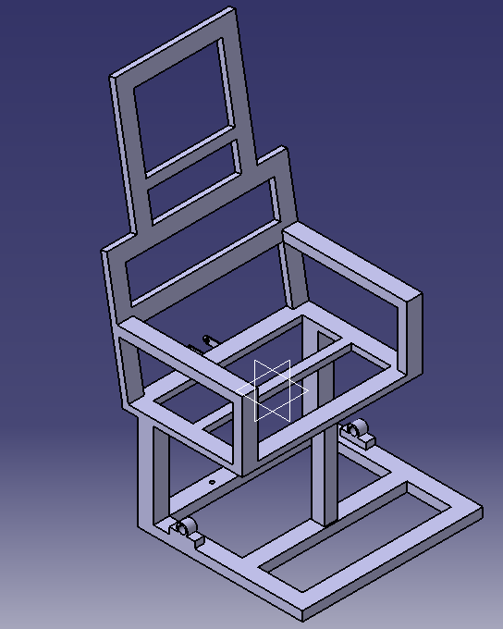

**Figure 4.1 Frame of Model**

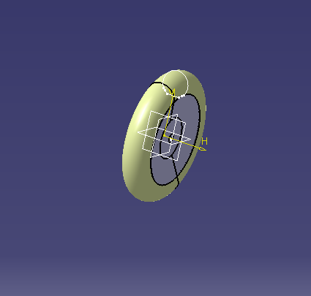

**Figure 4.2 Wheel of Chair**

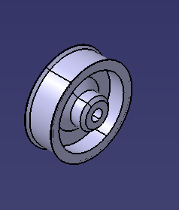

**Figure 4.3 Rim of Wheel**

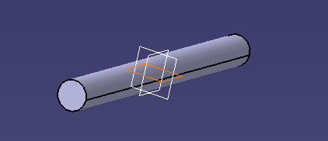

**Figure 4.4 Shaft**

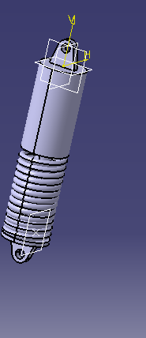

**Figure 4.5 Shock absorber**

**CHAPTER 5**

# SELECTION OF COMPONENTS FOR SETUP OR PROTOTYPE MODEL

**5.1 ESP32 Module**

The ESP32 is a family of low-cost and low-power system-on-chip microcontrollers that come equipped with dual-mode Bluetooth and integrated Wi-Fi. These microcontrollers are built using TSMC's 40 nm technology and are powered by either a Tensilica Xtensa LX6 dual-core or single-core microprocessor, a Tensilica Xtensa LX7 dual-core, or a single-core RISC-V microprocessor. Espressif Systems, a Chinese company based in Shanghai, is responsible for inventing and developing the ESP32. The microcontrollers feature integrated antenna switches, power amplifiers, RF baluns, low-noise receive amplifiers, filters, and power-management modules. They are designed to replace the ESP8266 microcontroller, which was a previous model.

**Specifications of ESP32 Module:**

1. Microcontroller: Dual core Xtensa LX6 microprocessor, 32 bit RISC-V
2. Clock speed: 240 MHz
3. SRAM: 520 kb
4. Flash memory: 4 mb
5. Operating voltage: 2.2 V to 3.6 V
6. DAC: Two 8 bit resolutions
7. ADC: 12 bit resolution with up to 18 channels

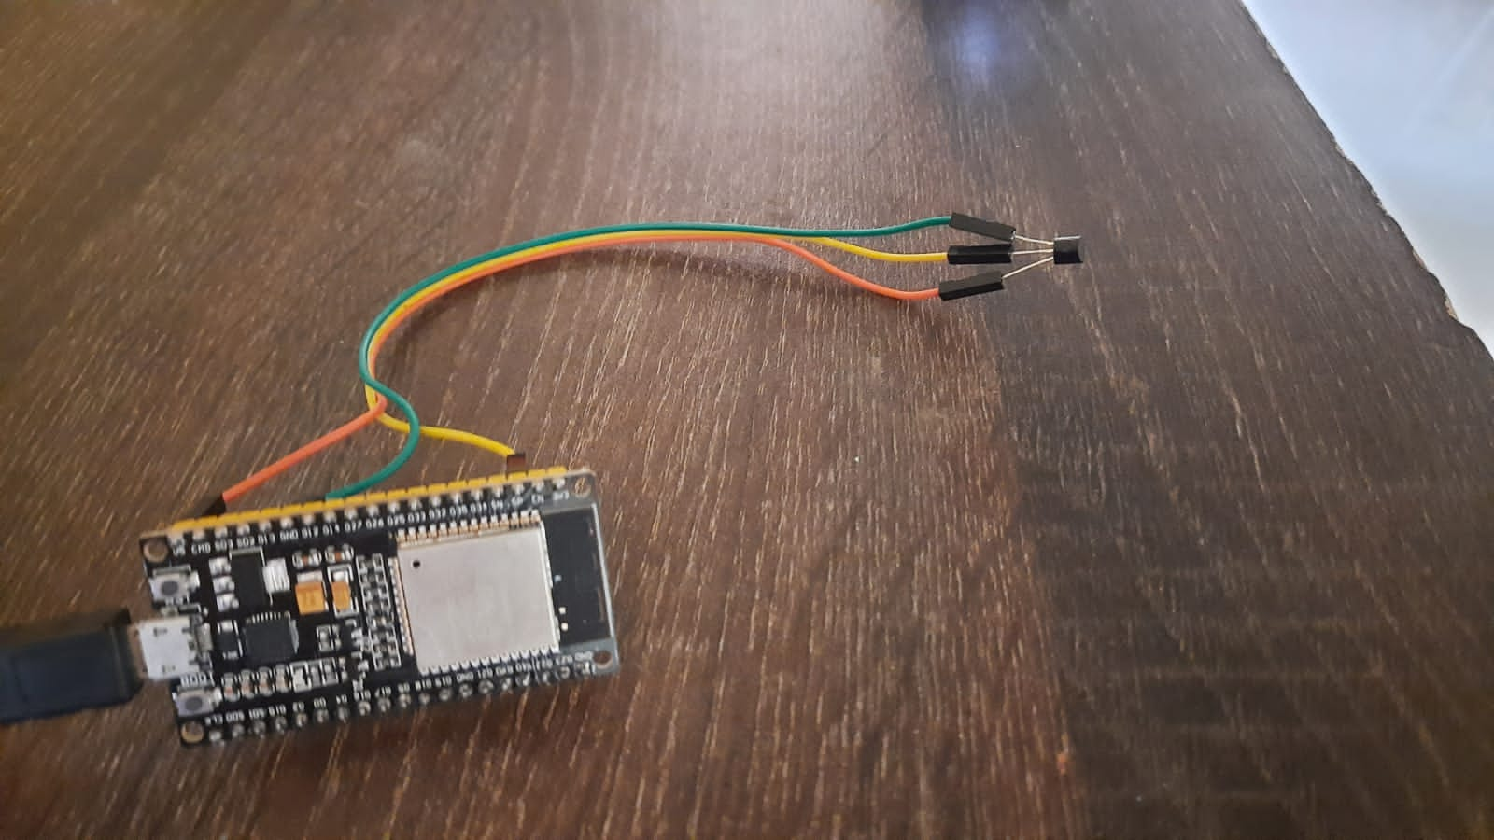

**Figure 5.1 ESP32 Module**

**5.2 Arduino UNO**

The Arduino Uno is a microcontroller board based on the ATmega328P microcontroller developed by Arduino. It is a well-liked forum for experts, academics, and hobbyists who want to construct electronic projects. The Arduino Uno board may be programmed using the Arduino Integrated Development Environment (IDE) and the programming language is based on Wiring, a simplified version of C/C++. Many digital and analogue input/output pins on the board can be utilised to connect sensors, actuators, and other electronic parts. It is a flexible board that is frequently used for a variety of projects, from straightforward LED blinkers to intricate robotics and Internet of Things applications.

**Specifications of Arduino UNO:**

1. Microcontroller: Atmega328p
2. Operating Voltage: 5V
3. Input Voltage: 7-12V
4. Digital I/O pins: 14
5. Analog Input Pins: 6
6. SRAM: 2 kb
7. Clock speed: 16 MHz

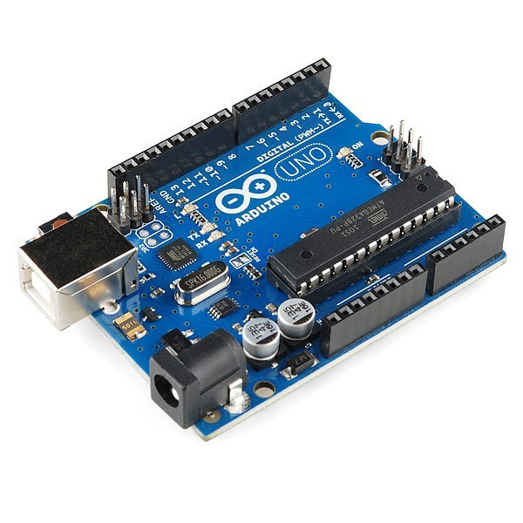

**Figure 5.2 Arduino UNO**

**5.3 Hc05 Bluetooth Module:**

The HC-05 is a popular Bluetooth module used for wireless communication between electronic devices. For simple communication with computers, microcontrollers, and other Bluetooth-enabled devices, it is based on the Bluetooth 2.0 standard and supports the Serial Port Profile (SPP).

**Specifications of Hc05 Bluetooth Module:**

1. Bluetooth Version: Bluetooth 2.0 + EDR
2. Operating Voltage: 3.3V
3. Bluetooth Frequency: 2.4 GHz ISM band
4. Transmit Power: Class 2, up to 4 dBm
5. Range: 10 meters (line of sight)
6. Data Rate: Up to 2.1 Mbps
7. Operating Current: 30 mA (typical), 10 mA (standby)
8. Sleep Current: 0.5 mA
9. Dimensions: 28 mm x 15 mm x 2.35 mm

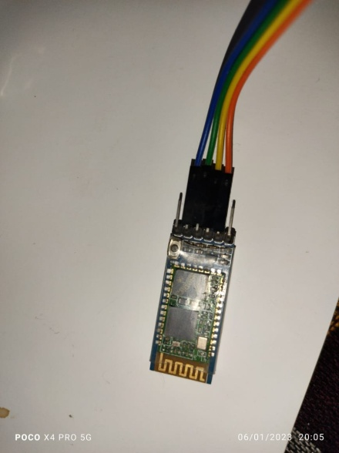

**Figure 5.3 Hc05 Bluetooth Module**

**5.4 MAX30102 Sensor:**

The widely used MAX30102 is a low-power sensor module that combines a photoplethysmography (PPG) sensor and an infrared LED for pulse oximetry and heart rate monitoring applications. It is frequently utilised in medical equipment as well as wearable health and fitness devices.

**Specifications of MAX30102 Sensor:**

1. Operating Voltage: 1.8V to 5.5V
2. Power Consumption: 0.7 mA (typical)
3. Operating Temperature: -40°C to +85°C
4. Optical Sensors: Red LED and Infrared LED
5. Sampling Rate: Up to 3200 samples per second
6. Heart-Rate Monitor: Measures heart rate and heart rate variability
7. Pulse Oximeter: Measures oxygen saturation in the blood
8. Dimensions: 14.0 mm x 14.0 mm x 2.8 mm

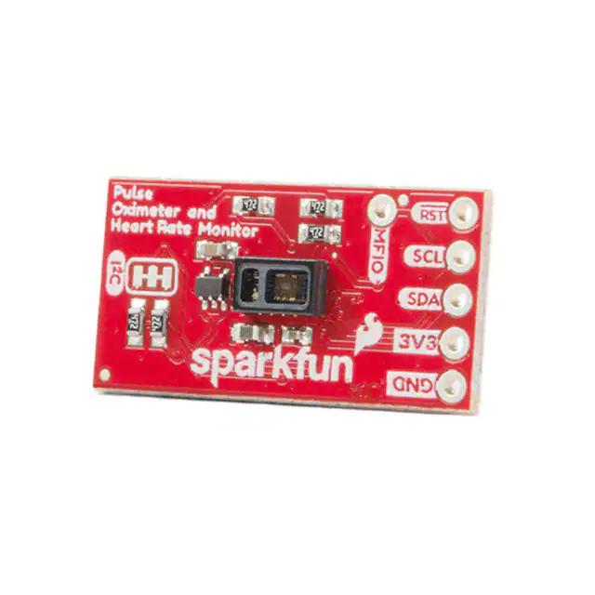

**Figure 5.4 MAX30102 Sensor**

**5.5 Temperature Sensor: (Ds1 8b 20 temp. sensor):**

A digital temperature sensor made by Maxim Integrated is the DS18B20. It is a 1-wire device that uses a single data line to connect to a microcontroller or computer. With an accuracy of 0.5°C in the range of -10°C to +85°C, the DS18B20 can measure temperatures from -55°C to +125°C.

**Specifications of Temperature sensor:**

1. High accuracy: The DS18B20 has an accuracy of ±0.5°C in the range of -10°C to +85°C, which makes it suitable for a wide range of applications.
2. Low power consumption: The DS18B20 operates at very low power levels, which makes it suitable for battery-powered applications.
3. Wide temperature range: The DS18B20 can measure temperatures from -55°C to +125°C, which makes it suitable for a wide range of applications, including industrial and scientific applications

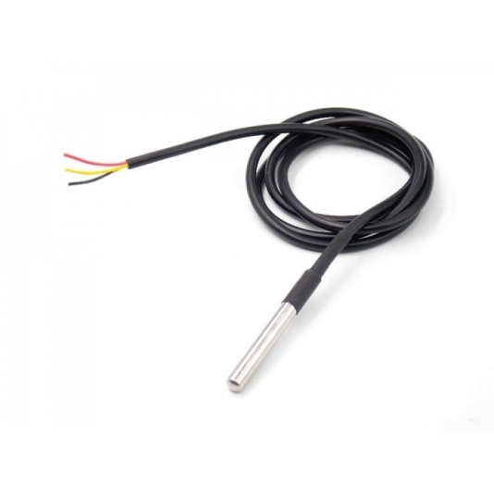

**Figure 5.5 Temperature Sensor**

**5.6 BLDC wheel hub motor:**

A wheel hub motor is an electric motor that is built inside a wheel. It is known as a BLDC (Brushless DC) wheel hub motor. It frequently serves as the propulsion system for electric vehicles like cars, scooters, and bicycles.

**Specifications of BLDC wheel hub motor:**

1. Rated Power: 350 W
2. Speed: 20-30 km/h
3. Rated voltage: 24V
4. Rotating Speed: 250-1000 RPM

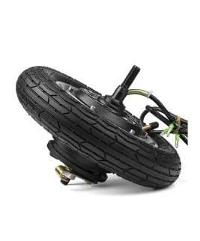

**Figure5.6 BLDC wheel hub motor**

**5.7 Micro-controller :( Brushless Sine Wave Controller YL-12)**

The Brushless Sine Wave Controller YL-12 is an electronic speed controller (ESC) for brushless DC motors that is microcontroller-based. It is frequently seen in electric scooters and bicycles.

**Specification of Micro-controller:**

1. Voltage: 24-36V DC
2. Power: 250-350W
3. Current: 16±1A
4. Under voltage: 25±0.5V

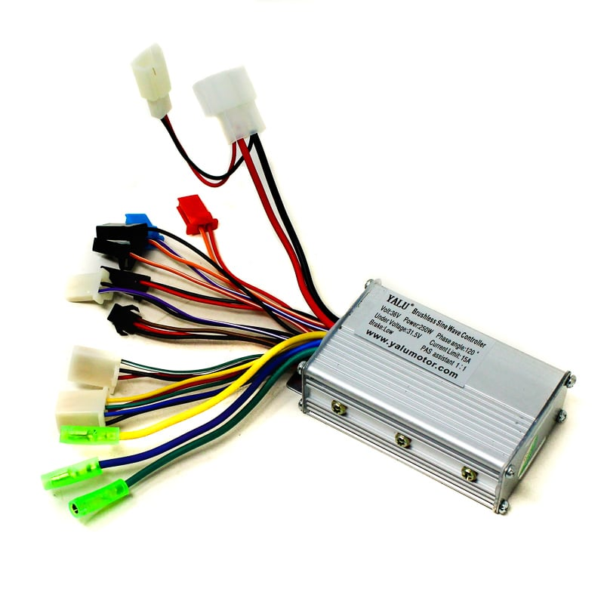

**Figure 5.7 Micro-controller**

**5.8 Jumper Wires:**

Electrical wires having connector pins at each end are known as jumper wires. Without using solder, they are utilised to link two locations in a circuit. Jumper wires are useful for both circuit modification and circuit troubleshooting.

**Specifications of Jumper wires:**

1. Current=4-20mA
2. Voltage=12 V
3. Rated Pressure=25kPA
4. Pitch=2.54 mm
5. Cable Length=20cm - 8Inch
6. Weight=30gm
7. Accuracy=0.25%F.S.

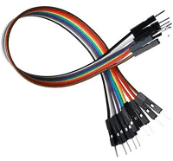**Figure 5.8 Jumper wires**

**CHAPTER 6**

# FABRICATION, WORKING AND TESTING

**6.1 FABRICATION:**

1. For our project, we choose a shaft and bearing based on the load calculation.
2. We choose medium carbon steel for the project in accordance with the design.
3. We looked through a variety of materials before choosing square box section material.
4. Thankfully we obtained this material which is having strong enough to handle load we acquire this from scrap with low cost or inexpensive cost.
5. After selection of material we go for next phase of fabrication process.
6. We constructed the chair with a tiny frame measuring 51 cm x 51 cm in accordance with our design.
7. We created chair that are both aesthetically pleasing and ergonomically pleasing to sit in.
8. We provided robust sitting support, backing support, and bottom support in response to the application of load.
9. We looked for shock absorbers in other bikes and also found the M80 shock absorber in garbage.
10. M80 bikes are vintage models that were used in the past for transporting big loads.
11. A sturdy frame measuring 51 inches by 15 inches was provided as a head rest.
12. We designed a maximum bed at the bottom for the battery, controller, and electronics that can readily support a battery load and shaft load.
13. Finally, we created a 12 inch by 7.8 inch back structure for the motor connection, which is crucial for autonomous driving.

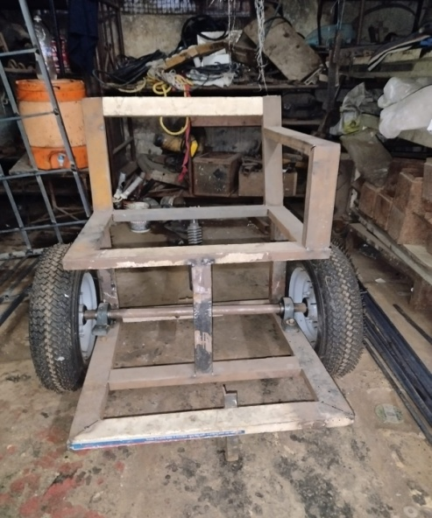

**Figure 6.1 Fabrication of Wheelchair**

**6.2 ASSEMBLY:**

1. During assembly, the wheel, bearing, and shaft assembly underwent joining.
2. The assembly is now joined at the middle of the chair. In order to balance the patient's weight while operating a wheelchair.
3. Then, the motor assembly and back frame were attached.
4. Following the aesthetic concept, cushioning has been added to the chair's sitting and backrest parts. The most critical component of the project is the IOT-based link at present.
5. Sensors, jumper wires, an Arduino, a Wifi module, a Bluetooth module, and the controller (the brain of the Internet of Things) have been utilized.
6. Next, the components are attached to the battery supply.
7. The chair movement circuitry and parameter sensor circuitry in the IOT architecture are independent of one another.
8. The max30102 and temperature sensor are both connected to the node's MCUESP32 wifi module during the sensor assembly using jumper wires such as Vcc, ground connection, SDA, SCL, etc.
9. The motor and battery are coupled via a controller in the chair movement circuitry assembly.
10. The system has been connected using series battery connections based on the voltage of the battery and motor.
11. The speed, signal, and ground jumper wires from the controller are now connected to the Arduino.
12. Arduino has been connected to the mobile via Bluetooth module of Hc05 which can transport and retrieve the data from mobile to Arduino for the movement of chair.
13. Similar to other connections, such as VCC, ground, and data or signal transfer cables, the Arduino to Hc05 connection is also made.
14. The data representation was finally completed for appropriate screen depiction on the laptop display.
15. The platform used for data interpretation and parameter representation is called Thinkspeak, and it is primarily connected through data cable.

**6.3 WORKING:**

* 1. As soon as the Bluetooth module and Arduino UNO controller are linked at the bottom, the chair may move.
  2. The mobile app Automation that we utilised to move the wheelchair using a mobile device.
  3. The app enables Bluetooth connectivity to mobile devices and offers a remote control.
  4. From that remote control we pushed the chair forward and backward as our demand.
  5. We used a linear actuator for the turning mechanism, however it was damaged during testing, therefore in our project, we can only move the wheelchair in a forward and backward motion.
  6. The major task at hand is to use a sensor to detect variables like blood pressure, heart rate, and SpO2.
  7. Data is transferred to the cloud each time a sensor is connected to a laptop through a data wire.
  8. The Thingspeak platform is then shown the cloud data in more detail.
  9. The ThinkSpeak platform offers efficient gauge, numerical, and graph representations of data.

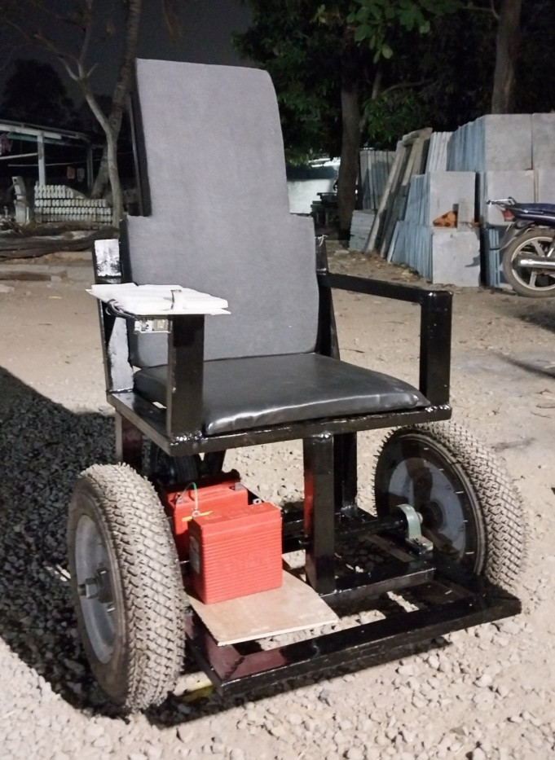

**Figure 6.2 IOT based Smart Medical Wheelchair**

**CHAPTER 7**

# RESULTS AND DISCUSSION

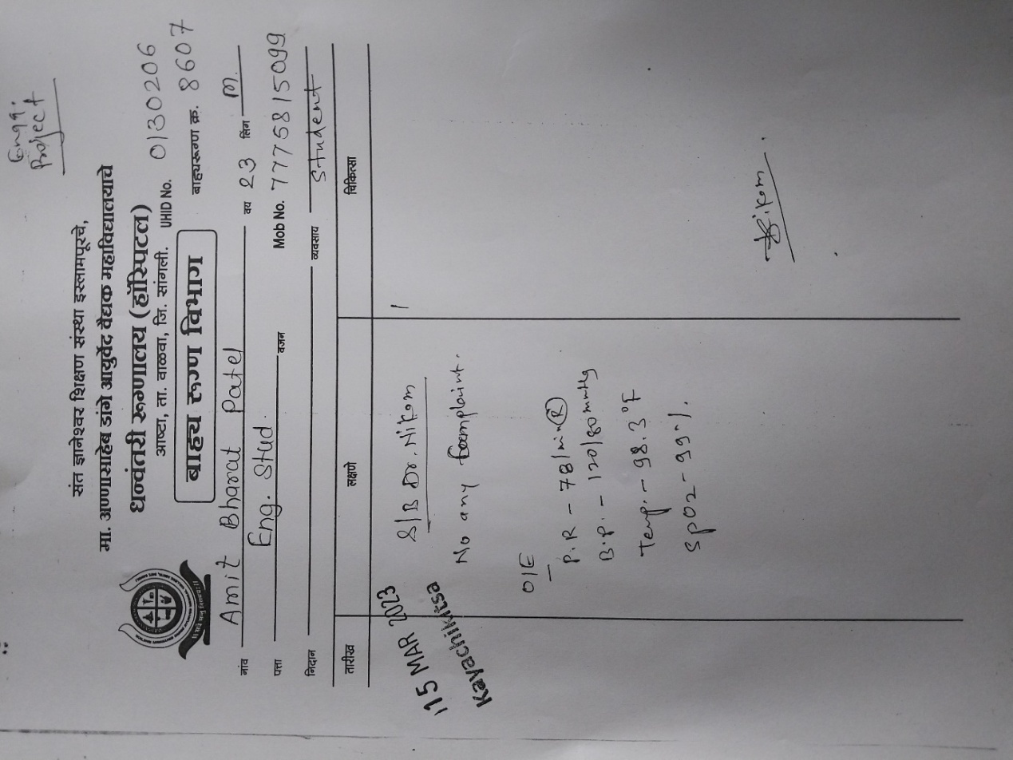

**Figure 7.1 Health parameters measured in Hospital**

We examined the outcomes of various health metrics from Ashta's Dhanvantri Hospital. And when we compared these results to those of our model, we discovered that they were essentially identical to hospital results.

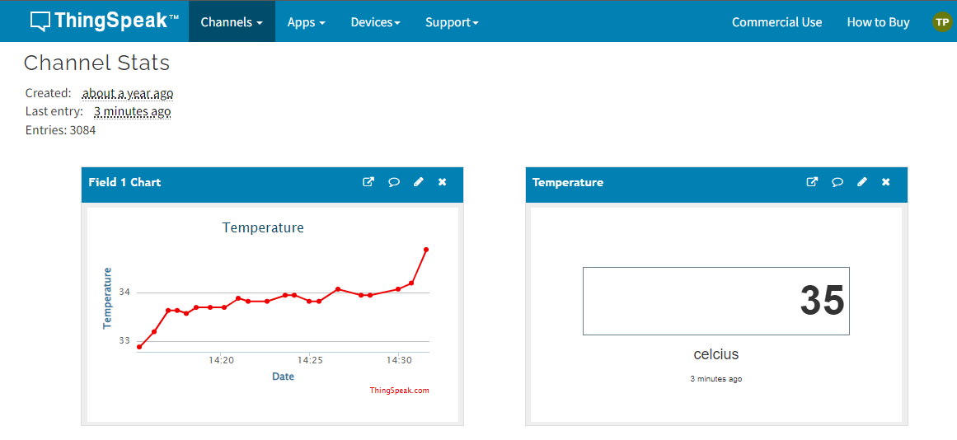

**Figure 7.2 Temperature measured by model**

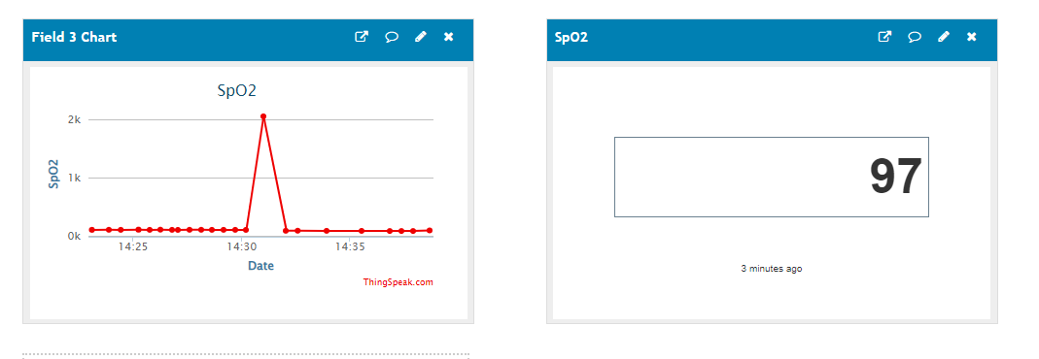

**Figure 7.3 SpO2 measured by model**

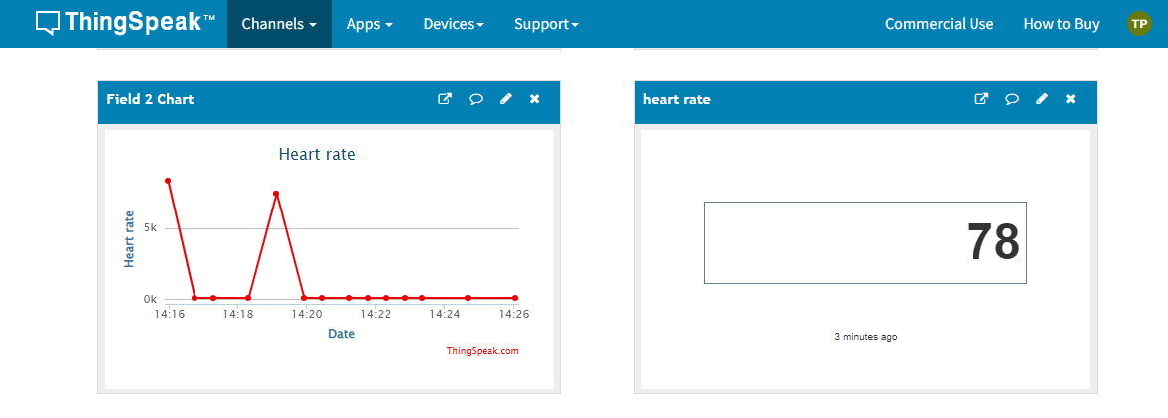

**Figure 7.4 Heart Rate measured by model**

**CHAPTER 8**

# CONCLUSIONS

1. The project's conclusion is that the outcomes of the Smart Medical Wheelchair and conventional hospital equipment are roughly equivalent.
2. The mobility and independence of people with disabilities, especially those with low upper body strength or mobility, could be considerably improved by smart medical wheelchairs.

# REFERENCES

**Journal Papers:**

[1]Kokate k, Agarkar A “Voice operated wheelchair”, International Journal of research in engineering and technology, Volume 3,Issue 2, Feb-2014.

[2] RahimunnisaK, Arunachalam A ,& Divyaa, V. AI-based smart and intelligent wheelchair. Journal of Applied Research and Technology, 18(6), 362-367. (2020)

[3] Alenzi E& Rao K. P. Trajectory Path Tracking Evaluation of Smart Wheelchair By Image Processing Technique. Journal of Computers & Signals (JCS), Vol (1). (2020).

[4] Keerthi Kumar M, Chaitra R , Manisha R, Priyanka C B, Syeda S, 2019, EEG Controlled smart wheelchair for disabled People, International Journalof Engineering Research & Technology (IJERT) NCRACES –(Volume 7, Issue 10) .(2019)

[5] Trefler E, Fitzgerald S, Hobson D, Bursick T, Joseph R. Outcomes of wheelchair systems intervention with residents of long-term care facilities. Assist Technol; 16(1):18–27 (2020)

[6] Jha P, Khurana P, Hand Gesture Controlled Wheelchair. Int J Sci Technol Res 9: 243–249. (2016)

[7] Drinnan, J, and Murray A. "Relation between heart rate and pulse transit time during paced respiration", Physiol. Meas. vol. 22, pp425–432.(2001)

[8] Kupkar P , Pandit P , Dhamdhere K , Jadhav P, “Android Controlled wheelchair”, Intelligent Control and Information Processing (ICICIP), Imperial Journal of Interdisciplinary Research (IJIR) Vol-2, Issue-6, 2016 .

[9]HuleA , Bandage R , Shah P , Mahajan R “android based application for wireless control of wheelchair”, International Journal of Research in Engineering and Technology (IJRET), Vol-4, Issue- Apr, 2015.

[10] Reis L, Faria M, Vasconcelos S. Invited paper: Multimodal interface for an intell. wheelchair. volume 325 of lecture Notes in Elect. Eng., pages 1–34. Springer Int. Publishing, 2015.

**Reference Books:**

1. V.B.Bhandari, “Design of Machine elements”, Tata McGraw Hill Education Pvt. Ltd., pp. 749-751, Edition-3, 2010