**A Review Study on the Bicycle with a Shaft Drive**

**Vinothkumar.M1, Logesh.P2, Mohankumar.K3, JaganBaskar.S4, NandhaKumaraa.S5,**

**1*Assistant Professor, Department of Mechanical Engineering, Paavai Engineering College, Namakkal, Tamilnadu***

**2,3,4,5*UG Student, Department of Mechanical Engineering, Paavai Engineering College,Namakkal, Tamilnadu. logeshpslv459@gmail.com***

**ABSTRACT**

The normal bicycle is the one of the medium of the travelling and used for riding, sports, riding in off road purposes. In recent years many accidents occurred in off-road riding bicycle due to the lack of torque required to drive and land the bicycle in its position and continue the ride safely specially in sports bicycle. The aim of this work is to overcome these problems by introducing new mechanical transmission system with the help of internal gear technology called shaft driven system to maximize the torque of off-road bicycle using gear and shaft transmission system with normal riding condition. A shaft driven bicycle is a bicycle that uses a shaft drive instead of a chain drive which contains two set of bevel gear at both the ends to make a new kind of transmission system and transmit motion through 90 degrees angle. It replaces the traditional methods and reduces the accidents to the hill riders.

**CHAPTER-1**

**INTRODUCTION**

Chainless bikes are not a new innovation. The first machines to resemble what we recognize as bicycles were propelled by a rider’s legs, but it didn’t take long to find an engineered alternative to human power. Solutions and tinkering from pioneering inventors turned to existing industrial and mechanical methods of turning gears. This ingenuity brought the shaft-drive system to the bicycle.

Although many inventors received patents, commercial development of the system was eventually stopped by the efficiency and relative low cost of the chain drive system.

**Reduced Drive Efficiency**

A shaft drivetrain has a lower efficiency than a chain or belt. The biggest energy losses are simply due to the change in rotation direction – once at the crank set and once again at the rear hub.

We don’t have a lot of efficiency data available here, but in 1983 Josef Keller compared an unspecified shaft drive with a single speed chain, and found a 7% difference in drive efficiency in the shaft. This was between 50 and 200 watts pedaling output.

**Gear Alignment**

Another hurdle for shaft drive systems is **gear alignment**. In order to reduce wear and increase drive efficiency, there is an optimal distance for the bevel gears to mesh.

All bicycle frames flex under a load, but if a frame is not stiff enough for a shaft system, it can result in imprecise gear meshing.

**Shaft-Driven Bicycle**

A shaft-driven bicycle uses rotational gears to propel the bicycle as opposed to a traditional chain or belt drive system. Shaft-drive systems are used in the automotive industry and have industrial purposes too. The forces created by turning pedals are still translated into forward motion.

A shaft-driven bicycle is unfamiliar to the eye. The first thing to notice is that the whole system is very clean, minimalist and built into the frame of the bike. That’s right – the shaft-drive doubles up as the chain stay of the frame.

**Working of Chainless Bicycle**

Starting at the front, the normal pedaling motion rotates a metal gear, referred to as a bevel gear. A bevel gear has grooves and must mesh with another of the same type to create further rotation and propulsion. The second of these gears is at one end of a shaft.

At the other end of this shaft, which goes towards the rear of the bike, is another bevel gear which completes the connection to a final gear attached to the rear wheel. This completes the connection between pedals and rear wheels, and thus can propel the bicycle forwards.

**CHAPTER-2**

**LITERATURE REVIEW**

**1. SHAFT DRIVEN BICYCLE**

**M. Sunil babu, MD Mushtaq quadri, V.Naga prasad, G.Kedarnath**

This project is developed for the users to rotate the back wheel of a two-wheeler using propeller shaft. Usually in two wheelers, chain and sprocket method is used to drive the back wheel. But in this project we will use bevel gears with drive shaft.

**2. DESIGN & FABRICATION OF SHAFT DRIVEN BICYCLE**

**Anmol Parashar, Seemant Purohit, Shrikant Malviya, Neeraj Pandey**

A shaft driven bicycle is a bicycle that uses a shaft drive instead of a chain which contain two set of bevel gear at both the ends to make a new kind of transmission system for bicycle for getting high reliability system, and more safe system

**3. CHAINLESS BICYCLE SYSTEM**

**Tripti Shrivastava, Dr. Pratesh Jayaswal**

Chainless Bicycle System (CBS) is a setup which makes bicycles run on the road without chains. CBS uses a shaft-driven concept; it uses a drive-shaft for the transmission of power from the pedals to the wheels in place of chains.

**4. DESIGN AND ANALYSIS OF SHAFT DRIVEN BICYCLE**

**V.Sharun, T.Narendaran, N.Methiran, K.Pravin, H.Akhil**

The conventional bicycle employs the chain drive to transmit power from pedal to the rear wheel and it requires accurate mounting & alignment for proper working. The least misalignment will result in chain dropping

**5. FABRICATION OF E-BIKE WITH REGENERATIVE BRAKING SYSTEM**

**Kumaresan.N, Bharath kumar.M, Praveen.M, Ramachandran.S**

In this system, regenerative braking mechanism reuses the energy created by the braking process and uses this energy to charge the battery for further use.

**6. SHAFT DRIVEN TRANSMISSION IN VELOCIPEDE**

**Allwin Glover C, Prabu Ram G**

The purpose of this investigation was to determine the power transmission from engine to rear wheel hub, through a new power transmission mechanism called shaft driven mechanism.

**CHAPTER-3**

**SOLIDWORKS**

**MODELING METHODOLOGY:**

SolidWorks is a [solid modeler](http://en.wikipedia.org/wiki/Solid_modeling), and utilizes a [parametric feature-based](http://en.wikipedia.org/wiki/Parametric_feature_based_modeler) approach to create models and assemblies. The software is written on [Para solid](http://en.wikipedia.org/wiki/Parasolid)-kernel.

Parameters refer to constraints whose values determine the shape or geometry of the model or assembly. Parameters can be either numeric parameters, such as line lengths or circle diameters, or geometric parameters, such as tangent, parallel, concentric, horizontal or vertical, etc. Numeric parameters can be associated with each other through the use of relations, which allows them to capture design intent.

**CHANGING VIEWS:**

It is best to carefully consider the presentation of what face goes with what view before beginning a part. However, if you have selected wrong and discover this well into the part constructions, may be possible to redefine the standard views. With the part showing and all sketches closed, select the view orientation tool on the Feature Tab, or Insert – Modify – View Orientation, or just press the space bar. The icon looks like a telescope. An orientation dialogue box will appear. Click on the push pin to keep the box open. Double click on the view name in the box which you wish to change. Then single click on the view you wish it to be. Finally, click on the update standard views, the center icon on the top of the box. You will get a warning message which states “Changing the standard view will change the orientation of any standard orthogonal, named and child views in the drawings of this model

**DESIGN PROCEDURE**

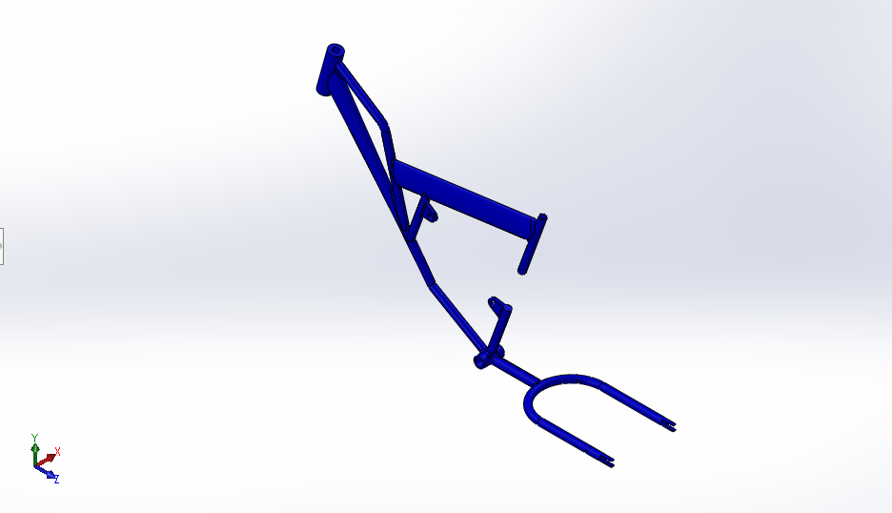

**Frame of bicycle**

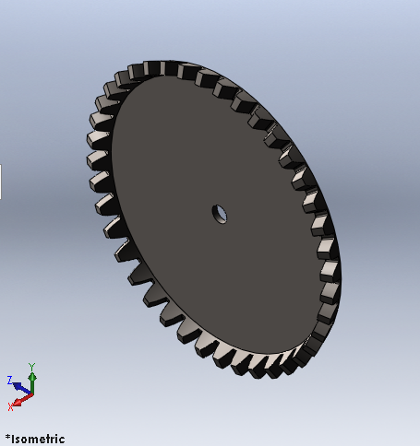

**Bevel Gear**

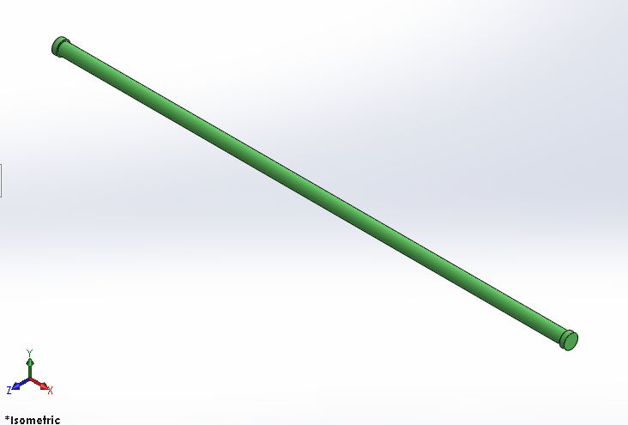

**Shaft**

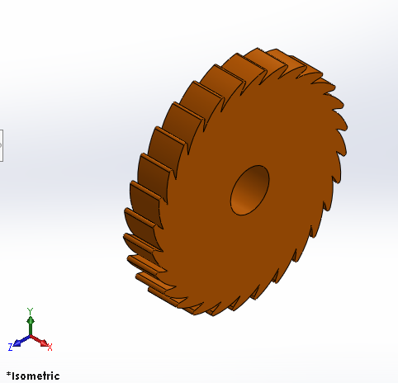

**Ratchet Gear**

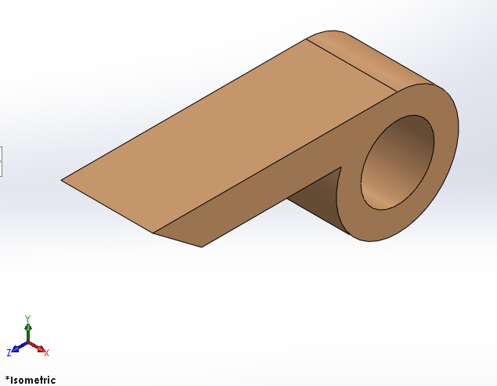

**Pawl**

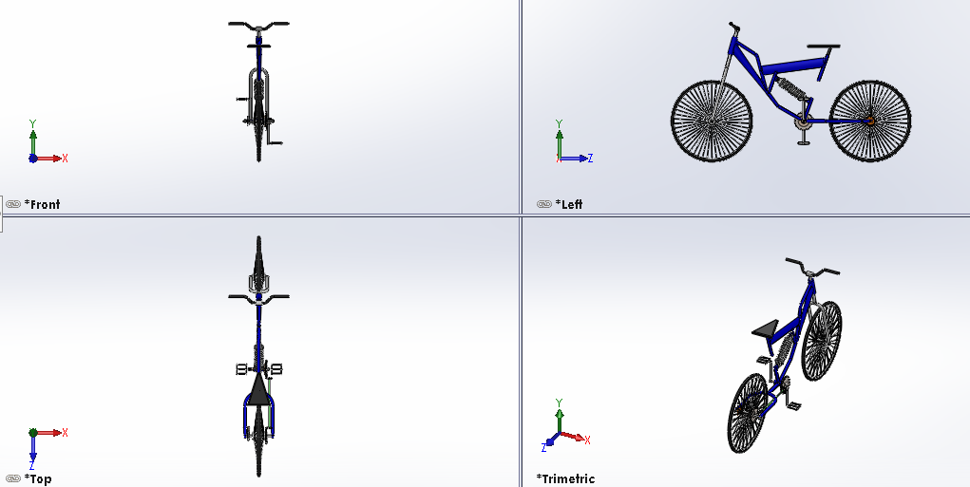

**Orthographic projection of shaft driven bicycle with reverse braking system**

**CHAPTER-4**

**ANSYS WORKBENCH**

ANSYS Workbench combines the strength of our core simulation tools with the tools necessary to manage your projects. You will work with your ANSYS Workbench project on the main project workspace, called the Projecttab. The project is driven by a schematic workflow, represented visually on a flowchart like diagram called the Project Schematic*.* To build an analysis, you add building blocks called systems to the Project Schematic; each system is a block of one or more components called cells, which represent the sequential steps necessary for the specific type of analysis.

**ANSYS WORKBENCH SYSTEMS**

The systems available in the Project tab Toolbox are divided into the following categories:

**• Analysis Systems**

Complete systems with all the necessary component cells already defined and ready to be populated. For example, a Static Structural analysis system includes all the cells needed for the analysis, Engineering Data through Results.

**• Component Systems**

Component building blocks which represent only a subset of a complete analysis. For example, you can use a Geometry component system to define your geometry and then connect the component system to several downstream systems, so component system can then be connected to several downstream systems, so that the downstream systems share the same geometry source.

**ANALYZING PROCEDURE OF BEVEL GEAR ASSEMBLY**

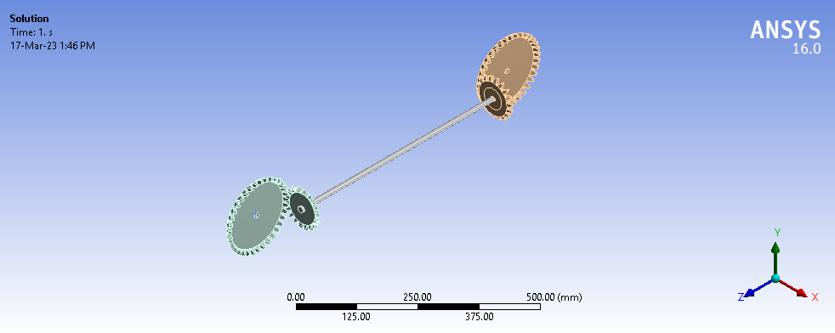

**Bevel gear assembly is imported in ansys workbench environment**

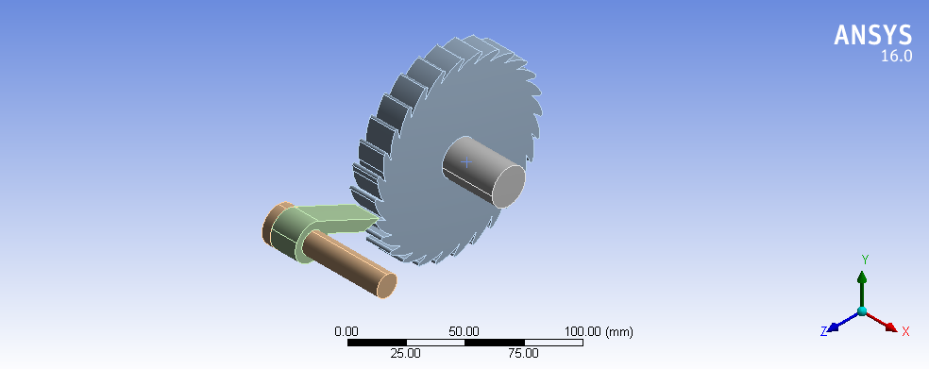

**Ratchet and pawl assembly is imported in ansys workbench**

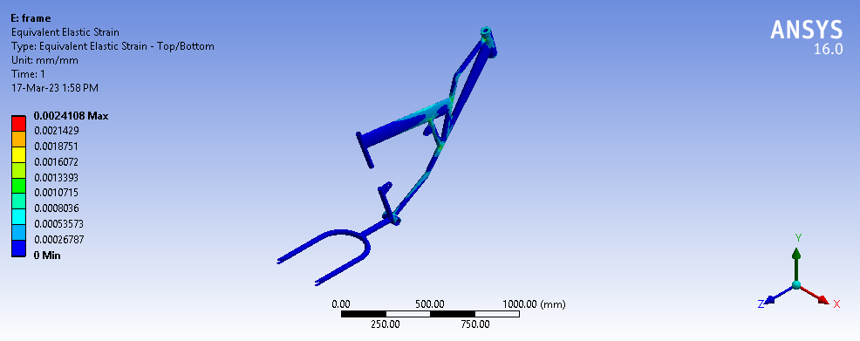

**Strain distribution**

**CHAPTER-5**

**CONCLUSION AND REFERENCES**

**CONCLUSION**

A strong multidiscipline team with a good engineering base is necessary for the Development and refinement of advanced computer programming, editing techniques, diagnostic Software, algorithms for the dynamic exchange of informational different levels of hierarchy. This project work has provided us an excellent opportunity and experience, to use our limited knowledge. We gained a lot of practical knowledge regarding, planning, purchasing, assembling and machining while doing this project work. We are proud that we have completed the work with the limited time successfully.

The drive Shaft with the goal of minimization of weight of shaft which was subjected to the constraints such as torque transmission, stress, strain, etc. As opposed to chain drive single piece drive shaft for rear wheel drive two-wheeler have been optimally deliberate and manufactured for easily power transmission. The solid shaft gives an upper limit value of torque transmission but at equivalent time due to augment in credence of shaft. The stress allotment and the maximum buckle in the drive shaft are the functions of the stacking of textile. The most sympathetic stacking of material layers can be used as the effectual tool to condense weight and stress acting on the drive shaft. The torque transmission capacity of the drive shaft has been premeditated by neglecting and making an allowance for the effect of centrifugal forces and it has been pragmatic that centrifugal force will diminish the torque transmission capacity of the shaft.

**REFERENCES**

1. **Yimin Gao and Mehrdad Ehsani.**
2. Electronic Braking System of EV And HEV Integration of Regenerative Braking, Automatic Braking Force Control and ABS. SAE paper 2001
3. **S. Kliauzovich,** “Analysis of control systems for vehicle hybrid powertrains,” TRANSPORT VGTU, vol. XXII, no. 2, 2007.
4. **J. Zhang, X. Lu, J. Xue, and B. Li,** “Regenerative braking system for series hybrid electric city bus,” The World Electric Vehicle Journal, vol. 2, no. 4, 2008.
5. **B. J. Varocky,** “Combined control of a regenerative braking and antilock braking system for hybrid electric vehicles,” International Journal of AutomotiveTechnology, vol. 9, no. 6, 2011
6. **S.J. Clegg** A Review of Regenerative Braking Systems. Institute of Transport Studies, University of Leeds, Working Paper 471 2012
7. **LOI WEI CHEONG,** “A development and use of a regenerative braking model for a parallel hybrid electric vehicle,” SAE Technical Paper Series, 2013.
8. **Ming-Ji Yang, H.-L. J.-Y.-K.** “A Cost-Effective Method of Electric Brake With Energy Regeneration for Electric Vehicles”, IEEE TRANSACTIONS ON INDUSTRIAL ELECTRONICS, VOL. 56, 2203-2212, june 2009.
9. **H. Wu, S. Cheng and S. Cui**, "A controller of brushless DC motor for electric vehicle", IEEE Trans, vol. 40, no. I, pp. 509- 513, January 2005 Rufer and P. Barrade, “A supercapacitorbased energy storage system for elevators with soft commutated interface”, The 36 IEEE Industry Applications Conference vol.2, pp.1413- 1418, 2001
10. **P. J. Grbovic, P. Delarue, P. Le Moigne, and P Bartholomeus**, “A bidirectional three-level dc-dc converter for the ultra-capacitor applications”, IEEE Trans. Ind. Electron., vol. 57, no. 10, pp. 415–3430, Oct. 2010.
11. **Aakash Patel, Hitesh Prajapati, Vivek Patel, Amit Patel,** “Design & Modelling of Chainless Bicycle with Gear Mechanism”, International Journal for Scientific Research & Development| Vol. 5, Issue 05, 2017.