**“Online Canteen Order System”**

1. **Author name: Ritheshnath Maharaj**

Student, Department of Computer Science Thakur Shivkumar Singh Memorial Engineering College, Burhanpur, Madhya Pradesh, India

E-mail: rideshnathmaharaj@gmail.com

**Guide name: Prof. Raj Kumar Verma**

Assistant professor, Department of Computer Science Thakur Shivkumar Singh Memorial Engineering College, Burhanpur, Madhya Pradesh, India

E-mail: rajvermaknw@gmail.com

# ABSTRACT

The online cafeteria ordering system has electronic menu boards that contain the details of the food, including the name, description, photo, price, etc. From this table, the user can select and order a specific item from four positions. The customer can select the desired item and pay the amount. Immediately after ordering, the people in the canteen find out about the order and prepare the order. Food is ready in advance and customers do not have to wait near the delivery point. The digitization of the canteen system will help to provide a better user experience and reduce the time spent. In the online cafeteria ordering system, the admin can manage functions such as: B. Add new foods, edit/remove foods, enable/disable foods based on season and availability. The admin can view the order details and update the grocery delivery status.

# INTRODUCTION

The online cafeteria ordering system has electronic menu boards that contain food details such as name, description, picture, price, etc. The user can select a specific item from this table, e.g., four slots, and order. The customer can select the desired item and pay the amount. Immediately after ordering, the people in the canteen find out about the order and prepare the order. Food is ready in advance and customers do not have to wait near the delivery point. The digitization of the canteen system will help to provide a better user experience and reduce the time spent. In the online cafeteria ordering system, the admin can manage functions such as: Add new foods, edit/remove foods, enable/disable foods based on season and availability. The admin can view the order details and update the grocery delivery status.

# EXPLANATION

Before creating any website, one has to go through the various processes involved in it. The multiple processes combined together to form a model which is used by every software developer to maintain the flow of cycle which creating any kind of application.

The Software Life Cycle Model (**SDLC**) is a conceptual framework that describes all activities of a software development project from planning to maintenance. This process is linked to several models, each with different tasks and activities. SDLC provides a set of steps that must be followed in order to design and develop software effectively.

**Waterfall Model: -** The waterfall model was the first process model introduced. It is also known as the linear sequential lifecycle model. It is very easy to understand and use. In the waterfall model, each stage must be completed before the next stage can follow, and the stages do not overlap. The waterfall model illustrates software development in a linear sequential process. This means that each stage of the development process is only possible after the previous stage has been completed. In this waterfall model, the phases do not overlap.

The flow of our project can be seen in the following diagram which gives a quick introduction of how our project will flow through multiple stages and what all functionality it will include and how the processes are related to each other through multiple stages.

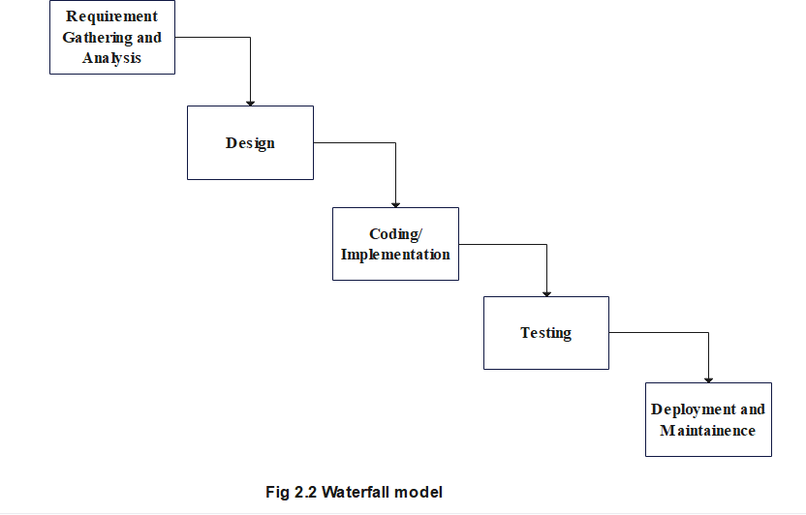

**Fig. Waterfall model**

**Objective of Project**

The purpose of this project is to provide quick service for students, staff, etc. The main purpose of the project is to manage the details of the cafeteria, the meals, the cafeteria type, and the staff. Manages all information about the canteen, bill payment, canteen staff and canteen. The aim of the project is to build an application program that reduces manual work in canteen administration. This system also relieves the canteen considerably, as the entire order process is computerized.

The multiple pages in our TrackerApp are home page, category page, dashboard page, sign in and login page.

**Home Page|** It includes the short description of the different categories of renting including with the button of the sign in, login page, trending trade and category.



**Sign in page|** This page is maintained for maintaining the track of users who have visited on our website, using their name, email-id, DOB, and password they can register their account on **Online Canteen Order System.**

**Login page|** This page will allow register user to access on the system by using the Phone number and password they can login to the system. We have kept an option of forgot password if a user forgot their password, then by using their Phone number they will get their password.

**Category page|** It will contain multiple categories and by clicking on them user can see a wide variety of food available in that kind of category, but for viewing the food present in different category user first have to login on these website.



# CONCLUSION

This paper discusses about developing an application for users within an institution which can be used to order food items from the canteens within an institution. The advantage of the system is that the people does not need to stand in queues to order food items in canteen. Since there is no queues, social distancing can be maintained. With this application the users can be able to view food items available rather than going into the canteen or food court and checking it. This app also supports online payment hence we can do cashless transactions.

# FUTURE SCOPE

Since the digital transformation is updating regularly, there would be many updates in application development in future. Technologies would also change simultaneously and bring up major changes in every sector. The system can be further expanded on to IOS and Web platforms easily since React Native framework is used. The order history of each user can be saved and can be fed as training set for a suggestion system which suggests food items based on past order history. Machine Learning can be integrated to do the same.

# REFRENCES

1. [www.w3school.com](http://www.w3school.com/)
2. [www.scribd.com](http://www.scribd.com/)
3. [www.google.com](http://www.google.com/)
4. [www.wikipedia.com](http://www.wikipedia.com/)
5. [WWW.stackoverflow.com](http://www.stackoverflow.com/)
6. [WWW.jssor.com](http://www.jssor.com/)
7. [WWW.youtube.com](http://www.youtube.com/)
8. [WWW.gfg.com](http://www.gfg.com/)
9. [WWW.javatpoint.com](http://www.javatpoint.com/)

10. [WWW.Boostrap.com](http://WWW.Boostrap.com)