# ONLINE HANDCRAFTED MARKETING SYSTEM

# Gayatri Mahajan1 Rachi Bhavsar2 Jagruti Mahajan3

1Dept. of Computer Science & Engg.,1Tha.Shiv Kumar Memorial Engg.College, Burhanpur(M.P.), India.

# ABSTRACT

Every state and region in India has its own distinctive art and skills, and these centuries-old know-how are ingrained in our culture. Craftsmen are skilled workers who create a variety of items, such as clothing,jeweler, tools, and home decor. This online market place for handmade goods enables customers to directly purchase goods (that are hand made) from a seller over the internet. Products created entirely by hand or with the aid of tools are referred to as handicrafts. The majority of shopping websites concentrate on clothing, electronics, and other items, but no one specifically focuses on products that are handmade.

**INTRODUCTION:**

This website offers beneficial opportunities for the seller to connect with the customer in a quicker, simpler, and more efficient manner. Our project, "ONLINE HANDCRAFTED MARKETING SYSTEM" aims to create a web application using PHP, HTML, JavaScript, and Ajax. The majority of handcrafts were unable to obtain the desired price for their goods, and in most cases, a broker or other third party benefited more than the original manufacturer. Unfortunately, our government was unable to offer an online sale of such products to a global audience so that any foreigner could purchase the most traditional art from their country. Foreigners also make up a significant portion of the market for handicraft products.

**OBJECTIVE:**

Demand for handmade goods The market for handmade goods in India has a lot of potential for meeting the expanding demand for such goods in an environmentally responsible way. A growing movement seeks to break the cycle by promoting his handmade and recycled goods. Using eco-friendly prodcts will undoubtedly result in an Independent society. Stationery, writing pads, meeting folders, computer printouts, drawing and document sheets, certificates and diplomas, luxury goods and diaries, photo frames, paper bags, and a variety of other items are all made from handmade materials. used to display goods and make ornaments. Because they are made from natural materials like wood and fibers, handcrafted items are environmentally friendly. Decorated with organic colors. Because it wasn't manufactured by a machine. As a result, it uses.

**GOALS:**

* An essential component of expanding and marketing your handmade business is creating your own website.
* Investigate fresh and original approaches to selling your goods to stay one step ahead of the competition.
* Keep track of every step of your sales, from initial inquiry to successful closing.
* Pick branding tactics that are specific to your handcrafted product.
* This post is for business owners that sell handcrafted goods like arts and crafts and are looking to create efficient marketing plans.
* Businesses that are well - established and generate sizable amounts of money have the funds to hire marketing and advertising agencies. Small businesses, such as one that manufactures jewellery out of a garage or one that operates a garment line from a person's bedroom, can't necessarily sell in the same way. However , firms that sell handcrafted goods have a variety of inventive marketing choices.

**INCENTIVES:**

* Work towards the stable growth of industry and crafts.
* To inspire Indian crafts men to pursue artisanal manufacturing as a career by protecting and promoting Indian cultural heritage.
* We work to raise the standard and output of handicrafts.
* In order to strengthen the craft and industry, the government of Nepal and its relevant agencies can use our practical proposals and guidance when developing policies and programs.

**EXPLANATION:**

A type of e-commerce called online craft buying enables customers to get products (handmade) or services directly from vendors online. Most online stores concentrate on selling gadgets, apparel, etc.; none, however , do so specifically with handmade goods. Tripura is well known throughout India for its handcraft goods and consumer goods, however due to inadequate transportation, customers cannot purchase the items. Our primary goal is to create shopping pages for As a result, it is advantage use to the government, customers, and business stakeholders in Tripura. This essay focuses on creating a website that will be helpful to those who reside in tiny towns or villages but wish to shop online.

**ACTIVITY DIAGRAM:**

An activity diagram is a **behavioral diagram** i.e. it depicts the behavior of a system .An activity diagram portrays the control flow from a start point to a finish point showing the various decision paths that exist while the activity is being executed.

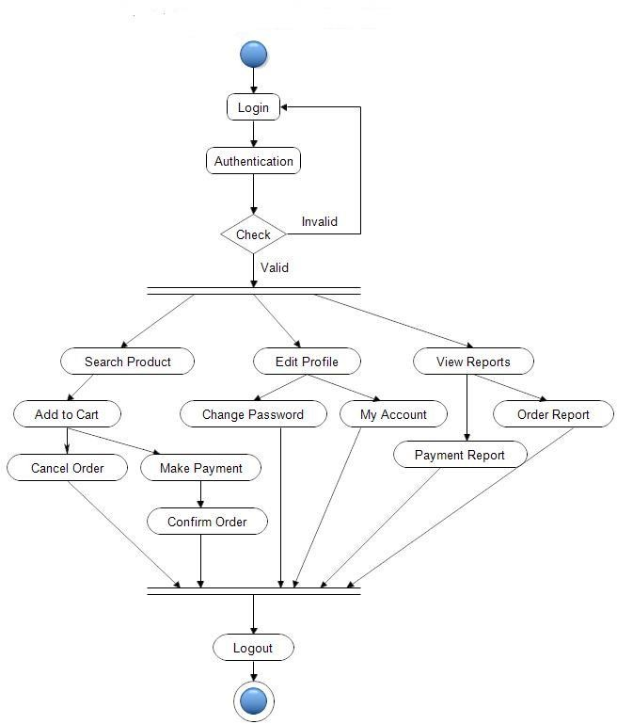

###### **HOME PAGE:** In our website the home page Will show the introduction of the our website Online Hand Crafted Marketing System.

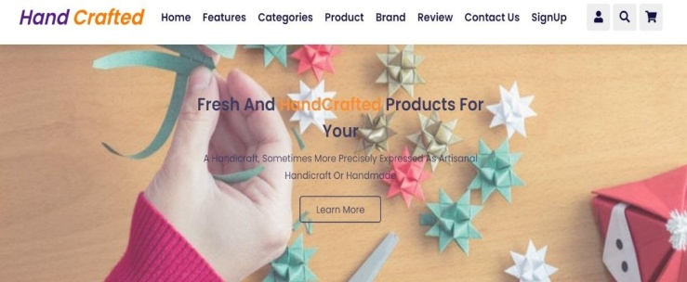

**Snapshot of Shipping Address & payment page**:A Shipping & payment page in website that allows users to give address for shipping and deliver the product and user can choose payment method also.

**Applications & Scope:**

India's handicraft I ndustry is particularly disorganized as a result of the undervaluation of the local market. As a result, there is potential for industry titans to enter and grow in this market in order to not only satisfy global demand but also benefit from greater domestic acceptance of his Demo Rough

beneath Cuticle. Any country or region's culture and customs can be expressed via handicrafts in a very significant way. The rich traditional arts, culture, skills, and talents that have a profound impact on people's lives and history can be preserved through handicrafts.

**Conclusion:**

The Handicraft Shopping website was created to offer a platform of web-based applications to allow people easily locate, view, and choose products. This website offers customers a productive means of conducting interactive product searches, and the search engine presents his products in response to user requests [9]. Users are given the option to submit their own reviews, and search engines categories user comments into positive and negative ratings based on. Because of its drag & drop functionality, it is simple to use. This website was created with simplicity of user interaction in mind, resulting in a very user-friendly environment for users to navigate the website. Users can access this website because of its compatibility.

**Summary:**

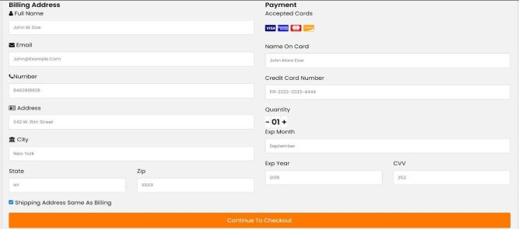One of the most varied sorts of work, crafts—more properly known as artisanal crafts involve the production of functional and adornment items wholly by hand or with very basic tools. The demand for handicrafts is rising daily as a result of its appeal. More handicrafts are sought after. The Internet, books, blogs, company brochures, and other secondary sources were used to gather the data for.Additionally, there were certain restrictions, including unwillingness to divulge private and sensitive information, economic restraints, and lack of experience. I've always admired the spirit of the entrepreneur and hoped to own it someday. I developed a wood and crafts company strategy as a result of my passion for the environment and my personal and professional interests. The

**Reference Research Paper**

1. Redzuan , M.(2010) . path analysis model of the development of handcraft industries in kelantan. Malaysia. Journal of American Science.

2. Bhattachar jee, s.(2012). E-Business connecting Handicraft of Tripura to Globalization -An entrepreneurial opportunity .Zenith International Journal of Business Economics &Management Research.

3.Chatarjee , A. Designing Handicraft using Information communication technology. Indian Journal of Export.

**References :**

**a)**

[WWW.W3school.com](http://WWW.W3school.com)

[WWW.stackoverflow.com](http://WWW.stackoverflow.com)

[WWW.jssor.com](http://WWW.jssor.com)

[WWW.youtube.com](http://WWW.youtube.com)

[WWW.reserchgate.net](http://WWW.reserchgate.net)

<https://www.craftmaestore.com/>

<http://www.cratejoy.com/sell/blog/7-websites-for-selling-crafts/>

[www.google.com](http://www.google.com)

[www.geeksforgeeks.com](http://www.geeksforgeeks.com)

[WWW.javapoint.com](http://WWW.javapoint.com)

**b ) Books**

Software engineering

PHP

DBMS

Ecommerce concept

IWT

.