WEB DEVELOPMENT FRAMEWORK DJANGO

USING TO CREATED JEWELLERY WEBSITE

# Bhagyashri Patil1 Riya Patil2

1Dept. of Computer Science & Engg.,1Tha.Shiv Kumar Memorial Engg.College, Burhanpur(M.P.), India.

# ABSTRACT

In this Western Collection, the customer can register themselves. The customer can see a list of jewellery available and can buy the jewellery of their own choice. Admin can register only for first time after that admin can check all the activity done by the customer. Customer can buy the jewellery and also add to cart the jewellery for some time. Customer can buy the jewellery by cash on delivery. Western Collection platform is basically used to build an application program which help people to find and buy latest design of jewellery with different categories like Gold, Silver, Diamond . It is useful in the way that it makes an easier way to buy products online.

# INTRODUCTION

“Western Collection” The main goal of this project was to create shopping cart, which allows customers to shop and purchase the jewellery products online. Moreover the projects is also designed in such a way it lets managers manage the products information. Customers can orders products, and they will be contacted to further process the orders.

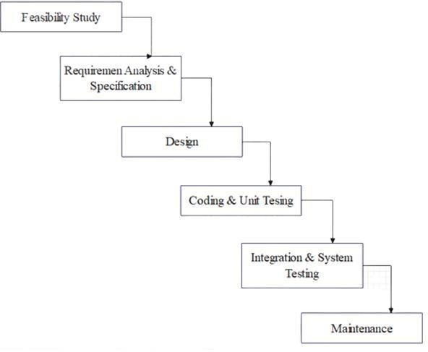

This system will follow the steps and rules to meet user requirements on demand and on time. Apart from this it will remove the difficulties faced by the admin to manage their shop and can be easily handled by the admin without any technical knowledge of the platform used and about the system. Through this system employees working under a particular shop can be easily managed.

# Motivation

* Keep going to buy products.
* Maintain your jewellery.
* Focus on the best products.
* Identify your choice.

# Waterfall Modal

Waterfall model is the very simple and easy model. It is also referred to as a linear- sequential life cycle model. In a waterfall model, each phase must be completed before the next phase can begin and there is no overlapping in the phases. The Waterfall model is the earliest SDLC approach that was used for software developme

# Use Case Diagram

Use case diagram is one of the visualized diagram of all the services our project or system provides. This diagram shows the interaction of a user with the system or

project. This shows the relationship of user and its different use case in which the user is being involved. This diagram shows our application interaction with the users or any other external system.

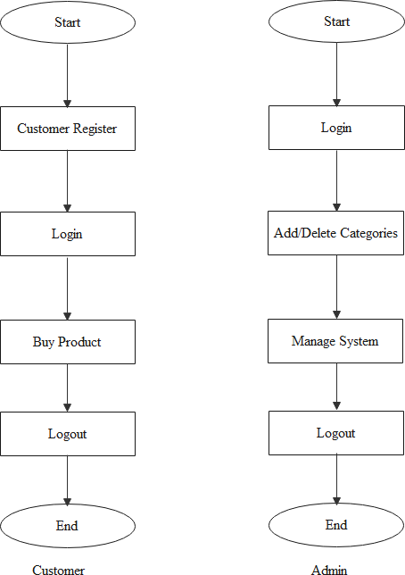

Fig B

# Activity Diagram

Activity diagram is one of the important diagram of unified modelling language, which shows the activity of the whole project.

Fig C

# Flow Diagram

This is a flow diagram of Western Collection showing the flow of the project. So that we can easily understand the working of the project.

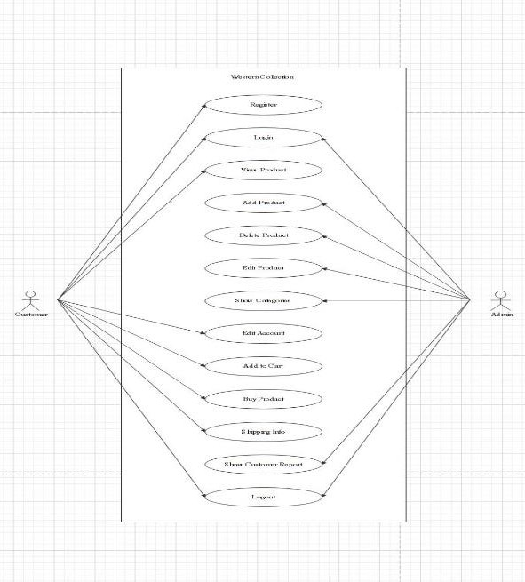

Fig D

# Connectivity steps with Database

* With the venv activate it, execute: python manage.py collectstatic
* 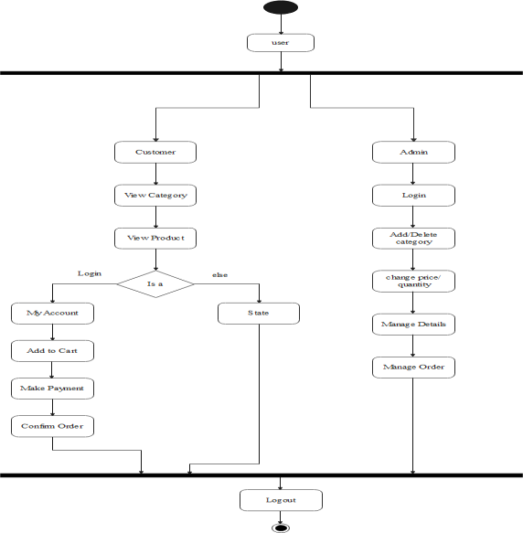Collect static is not necessary when debug is True (in dev mode)
* Create initial database:python manage.py migrate
* Load demo data (optional):python manage.py loaddata

fixtures/app_name_initial_data.json – app app.model_name

* Run server:python manage.py runserver

# Languages

We'll be using Python 3.1 for our languages. This is due to the fact that the django library is easily accessible and useful for making websites like what we're looking at. We'll also be making heavy use of the pytz library, the Olson tz database into Python and thus supports almost all time Zones.

# Future Scope

In the Western Collection the customer could subscribe for the price alerts which enable them to receive message when price for products fall below a particular level and when a new product is added. Customer can have multiple shipping and billing information saved. Customers can give feedback. And also payment gateway is added.

# Conclusion

Western Collection shop is fully designed and developed with python. Each code is clear and unambiguous. The frontend and backend are designed with python. This website is safe and secure to use for shopping jewellery. It helps them to shop product very easily. The website is to provide all facilities to sell any product, customer details to add, and to do payment by credit card or by cash on delivery.

# Acknowledgement

# We would like to say thank you and pay a heartly gratitude for the efforts of our project guide Prof. Neha Koge and HOD Vikas Yadav for providing there in valuable time and guidance through out the project development process, as well as our principal Dr. Manoj Kathane for there invaluable suggestion and ideas for developing our project in more better way, which helped us to learn and explore new

techniques and skills through out the course of completion this project.

# References

1. [www.google.com](http://www.google.com/)
2. [www.python.org](http://www.python.org/)
3. [www.jetbrains.com](http://www.jetbrains.com/)
4. [www.code.visualstudio.com](http://www.code.visualstudio.com/)
5. [www.w3schools.com](http://www.w3schools.com/)
6. [www.geeksforgeek.com](http://www.geeksforgeek.com/)
7. [www.udemy.com](http://www.udemy.com/)
8. [www.codeschool.com](http://www.codeschool.com/)
9. [www.codeacadmice.com](http://www.codeacadmice.com/)
10. [www.researchgate.net](http://www.researchgate.net/)
11. [www.tutorialpoint.com](http://www.tutorialpoint.com/)
12. [www.wikipedia.com](http://www.wikipedia.com/)
13. [www.projectidea.co.in](http://www.projectidea.co.in/)
14. [https://github.com](https://github.com/)

.