“Electro Mart”

1. **Author name: Prachi Mahajan**

Student, Department of Computer Science Thakur Shivkumar Singh Memorial Engineering College, Burhanpur, Madhya Pradesh, India

1. **Author name: Harshal Gavande**

Student, Department of Computer Science Thakur Shivkumar Singh Memorial Engineering College, Burhanpur, Madhya Pradesh, India

**3. Author name: Prajakta Gavande**

Student, Department of Computer Science Thakur Shivkumar Singh Memorial Engineering College, Burhanpur, Madhya Pradesh, India

**Guide name: Prof. Neha Koge**

Assistant professor, Department of Computer Science Thakur Shivkumar Singh Memorial Engineering College, Burhanpur, Madhya Pradesh, India

# ABSTRACT

The "Electro Mart - Online Shopping Service" project is a Python-developed web application software that uses Python as the user interface on a Pentium machine. Electro Mart’s main goal is to improve customer and supplier service. Save customer data, product receipts, add new customers, products and update, delete. The main features of the project entitled "Electro Mart" are: the high accuracy, flexibility and simplicity of the design file and the use of database tables representing entities and relationships between entities. This system requires you to maintain your own database. As information or details Our products are stored in a database for server-side functionality. The server process is used to manage the customer details and the items that are shipped to different locations based on the addresses provided by the customers.

# INTRODUCTION

# This project is about creating a virtual website "Site Electro Mart". Offers users various products available for purchase in the store. Online shopping is a form of electronic website that allows consumers to purchase goods or services directly from an Internet retailer through a web browser. Login and Registration This form allows the user to register by providing the required information, after the registration is completed and next time the user needs to login with the required credentials. Product Module: Module The main purpose of developing this module is to provide detailed information about the products of this Module. This module contains product description, details like price, quantity, product images. This dule gives you a clear idea of ​​the product.

**Customer Form:** This form contains information about the customer, such as: B. his contact details, his connection identifiers. Many The purpose of this module is to provide all functions related to the client. The customer can change, update, delete his own data.

**Order Form:** This side form has the main purpose of summarizing the order. Once the customer has selected what they wish to purchase, they must add that product to their shopping cart, then the order will be processed. The purpose of this form is to store all orders and order details.

# EXPLANATION

Before creating any website, one has to go through the various processes involved in it. The multiple processes combined together to form a model which is used by every software developer to maintain the flow of cycle which creating any kind of application.

The **SDLC** (Software development life cycle model) it consists of multiple phases from requirement gathering, designing, coding, testing, deployment, and maintenance also multiple models are available which according to the requirements and budgets are selected.

**Incremental Model**: **-** The development of the system is divided into several mini development projects. subsystems are then built up to form the final overall system. The request with the highest priority is implemented first. Once the request has been developed, the request for this increment is frozen.

The flow of our project can be seen in the following diagram which gives a quick introduction of how our project will flow through multiple stages and what all functionality it will include and how the processes are related to each other through multiple stages.

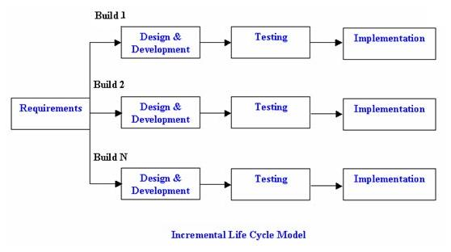

**Objective of Project**

The objectives of the project are:

• Management of all information on expenses, payments, registration, expenses.

• The project goal of creating an application reduces the manual effort for managing expenses.

• Keeps track of all details about users, registration, expenses.

• Like all financial planning, it is a process, not a product.

• Manage expense details. The main goal of the Money Info. project is to manage the details of expenses, categories, typologies, users, and subscriptions. Manages all information about expenses, payments, membership, expenses. The project is built entirely on the administration side, so only the administrator is granted access. The goal of the project is to create a program that reduces the manual work involved in managing expense, category, payment, and type. Tracks all types, users, registration details. The multiple pages in our website are home page, category page, trending cloths page, sign in and login page.

**Home Page|** It includes the short description of the different categories of renting including with the button of the sign in, login page, trending trade and category.

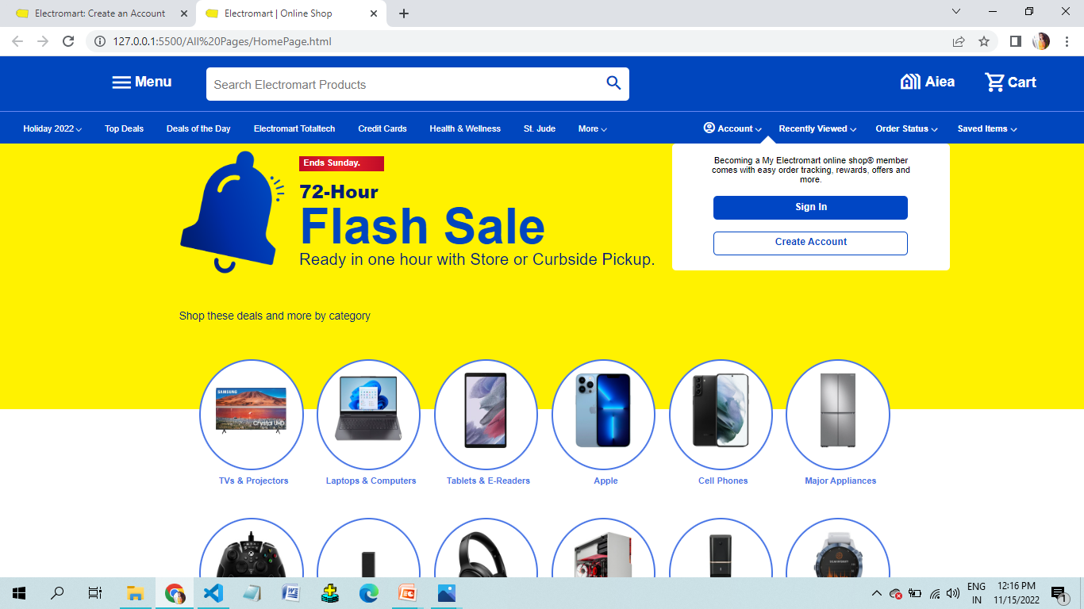

**Sign in page|** This page is maintained for maintaining the track of users who have visited on our website, using their name, email-id, DOB, and password they can register their account on **Electro Mart website.**

**Login page|** This page will allow registered user to access on the system by using the email-id and password they can login to the system. We have kept an option of forgot password if a user forgot their password, then by using their email- id they will get their password.

**Category page|** It will contain multiple categories and by clicking on them user can see a wide variety of Electro Mart available in that kind of category, but for viewing the cloths present in different category user first have to login on website.

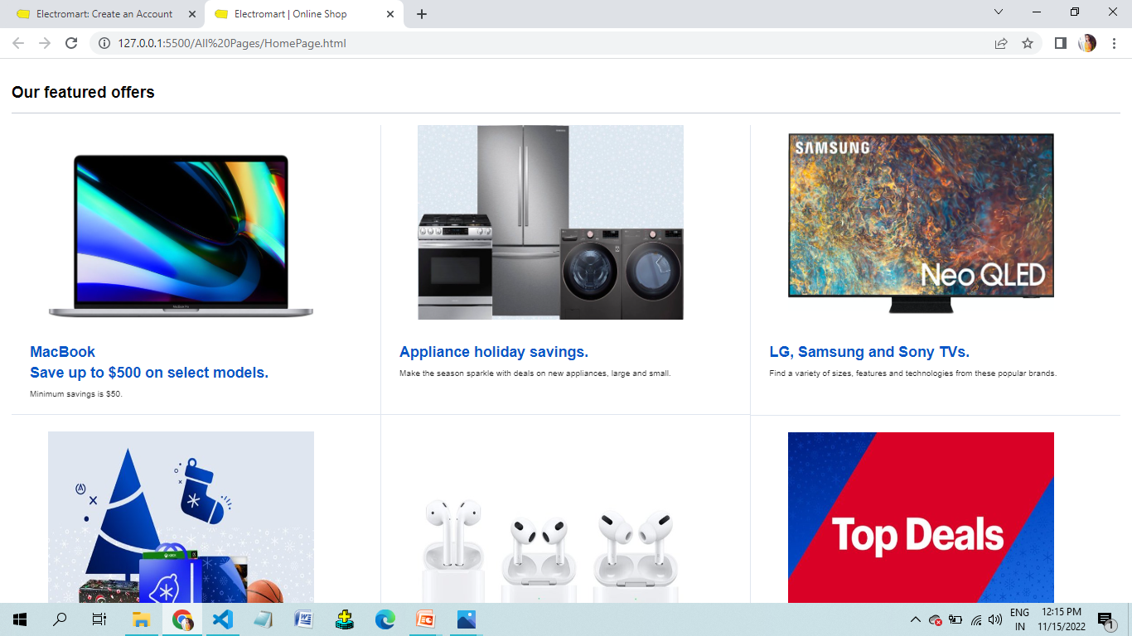

future use. The user does not require any kind of special application to view the site just need a browser and the internet connection for renting. it is the most widely used format which is comfort to use. The technology which we have used in our project including the front and back-end are HTML, CSS, JS, PHP for making our website responsive such that it can easily be compatible with the other devices, language, Java JSP, Servlet, my-sql for the back- end in storing data we have used the my-sql to store the database.

# FUTURE SCOPE

* Our application Also, if you see at the first glance that you find it to be complete but we want to make it still mature and fully automatic.
* As system is flexible you can generate more report and screen as and when required.
* The system is modified in future as per the owner requirement.
* In this system we can add more reports about users so more and more Information about Eelectromart website

# CONCLUSION

Electro Mart Shopping website was developed as a web application platform that allows you to easily search, browse and select products. This website provides users with an effective way to search for products interactively, and the search engine offers its products according to users' requirements. users have the ability to write their own reviews, and search engines loudly divide reviews into positive and negative reviews. Its drag and drop feature make it easy to use.

**REFERENCES:**

1. [WWW.W3school.com](http://www.w3school.com/)
2. [WWW.stackoverflow.com](http://www.stackoverflow.com/)
3. [WWW.jssor.com](http://www.jssor.com/)
4. [WWW.youtube.com](http://www.youtube.com/)
5. <https://www.craftmaestros.com/>
6. <https://www.cratejoy.com/sell/blog/7-websites-for-selling-crafts/>
7. [www.google.com](http://www.google.com/)
8. [www.wikipedia.com](http://www.wikipedia.com/)
9. [www.youtube.com](http://www.youtube.com/)
10. [www.scribd.com](http://www.scribd.com/)