**GYM MANAGEMENT SYSTEM WITH HEALTH ASSISTANT**

**Dr.Y.Arockia Raj *1 , Saravana Balaji N*2, Naveen Ganesh S M*3, Sabari Kishore R K*4, Rishi Babu R R*5**

*1Professor, Department of CSE, PSNA CET, Dindigul,TamilNadu, India

*2,3,4,5 Students, Department of CSE, PSNA CET, Dindigul, TamilNadu, India

**ABSTRACT**

Our Gym Management Software is a gym and health club membership management system. You can keep records on your members, their memberships, and have quick and easy communication between you and your members. Gym Management also includes a booking system, point of sale, banking, accounting, concessions and has a range of reports that help in the management of your club. Our Gym Management Software is a complete gym and recreation facility system program which looks after all of your members, memberships and activities. It is designed for gyms, recreation centers, and health clubs. Our Gym management Software provides lots of functions such data entry of customer, keeping records of all the things about customer’s fees, plan, and physical fitness which help to provide good quality of services to customer from Gym managers. In this proposed system also provide the total information about machinery and data of coaches is also stored in it. Services provided by Gym are also handled by this system .This system structure is become very simple to understand because of Data Flow Diagram provided by us. Context level Diagram and Some chart are also available in this case study. The demo of using the software such as customer detail form, data base of software is also provided by us.

**Keywords:** Admin , Trainer, User, Purchase, Chat.

1. **INTRODUCTION**

This project is designed to facilitate a gym center to automate its operations of keeping records and store them in form of a large and user friendly database further facilitating easy access to the personnel. It contains user module and gym trainer and administrator module. Admin is in charge of the site. Users can choose their trainers and can clear their doubts using the chat system. Users can also purchase gym related products in the site. The purchase data and payment data is send to the administrator of the site. So this site helps the user to clarify doubts with the gym trainer and also can purchase gym related products like health powder, shirts, etc… all the records are automatically generated as report. The Project was made in order to effectively and efficiently caters to requirements of the gym. Very frequently the person who generally holds the tasks to manage the center needs to keep records of all the transactions as well as data manually. Generally, In order to structure these tasks Separate Registers are maintained. This whole process thus becomes quite cumbersome for them to control manually. So this system is developed as a web application and both user and trainers can easily communicate and admin can sell gym related products using this site.

1. **EXISTING SYSTEM**

In existing system the process is full of manual work. The user needs to visit the nearest gym in person. Then they cannot choose trainers, since the gym contains only a limited trainers. Also the user can visit only the near by gym and he cannot know the details of other gym. For all the work is done manually and there is no automatic report generation available.

1. **DRAWBACKS OF EXISTING SYSTEM**

* It contains only manual process.
* It is time consuming.
* There is no chance of automatic reports.

1. **PROPOSED SYSTEM**

The proposed system is developed as a website. Where administrator is incharge of accepting the trainer records. More over the application contains sales of products which are related to gym, so that it can earn additional revenue. All the report are generated automatically.

1. **FEASIBILITY STUDY**

The objective of the feasibility study is not only to solve the problem but also to acquire a sense of its scope. The reason for doing this is to identify the most beneficial project to the organization.

There are three aspects in the feasibility study:

1. Technical Feasibility
2. Financial Feasibility
3. Operating Feasibility
4. **METHODOLOGY**

**6.1 Admin Module**

All the users of this system are displayed in this module. One can add new user or can update the details of an existing user. Here the password provided by the user is encrypted before saving them to the database for proper security. This module saves the details like address, phone and email. In order for the efficient Tracking of the system logs are maintained. As the logs will be in vast it will be a problem for user for checking the database. The Log View module can be searched based on the user and Records between a start date and end date.

**6.2 Trainer Module**

This attribute stores name of the person for usual identification. It stores that how much experience the trainer holds in such training. When there is a need for special training or something then experience counts. It stores the contact number of the trainer for any immediate communication required. This entity stores the information about the trainer who is hired by the gym administration to train their member to work out correctly. Working out correctly is the same as important as actually working out. This trainer could be hired on basis of hourly charges or special training for the member or they could be on an agreement like a permanent employee of the gym.

**6.3 Customer Module**

If the user has registered or already a member of the gym, they can open their account by logging in with credentials to have further options on the home screen. The options are extending the login page. After logging in users/members can view their profile or view the reports they generate in the past reports can be the payment information. If the user logged in and select the available package they want to opt. Then they can make payments through the payment interface. For the payment, the user/member has two options either go offline or online. If the user selects online then there will be a payment gateway where the user can by using debit, credit card, or net banking and after successful payment, the membership will be confirmed.

**6.4 Product Purchase**

Sale module gives you everything you need to give your staff and customers a great experience every day. Sell products, services, and classes; manage payment types, partial payments, deals and discounts and more. To improve your fitness business by knowing how your customers feel about your services, employees, and business. Get actionable insights based on the customer feedback that you have received. Get notified along with response details each time your business receives a negative customer feedback.

**6.5 Chat**

The main objective of the chat is to exchange the information about the workouts and further details like age, height, weight ,etc,. Help in defining the fitness of the person. The contact number of the member for any kind of communication with a member or maybe some announcement. The time management for each member is equally important so that there is a feasible number of members at the same time. This entity will help them manage the correct timing as they are divided into the batch and each batch is assigned to the trainer and member.

**6.6 Payment**

If the user logged in and select the available package they want to opt. Then they can make payments through the payment interface. For the payment, the user/member has two options either go offline or online. If the user selects online then there will be a payment gateway where the user can by using debit, credit card, or net banking and after successful payment, the membership will be confirmed. Where if the user opts for offline then the user has to go to physically to the gym and make payment.

1. **SYSTEM ARCHITECTURE**

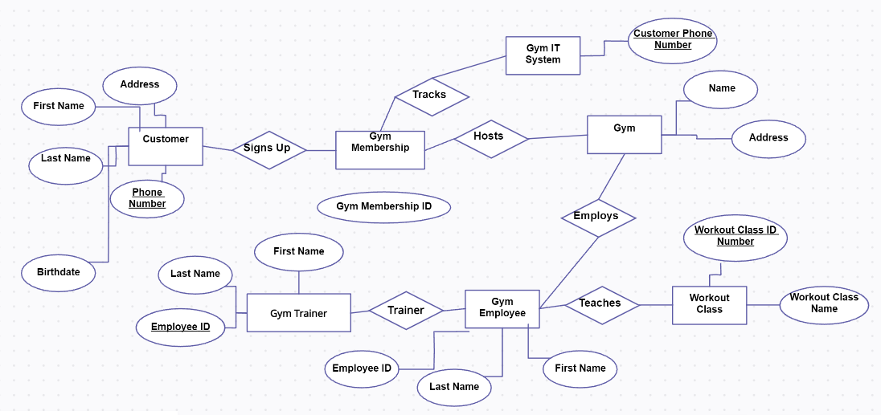

**Figure 1:**System architecture diagram

1. **RESULTS AND DISCUSSION**
   1. **Chat**

The user and trainer will interact with the chat after the trainer was selected by the user.

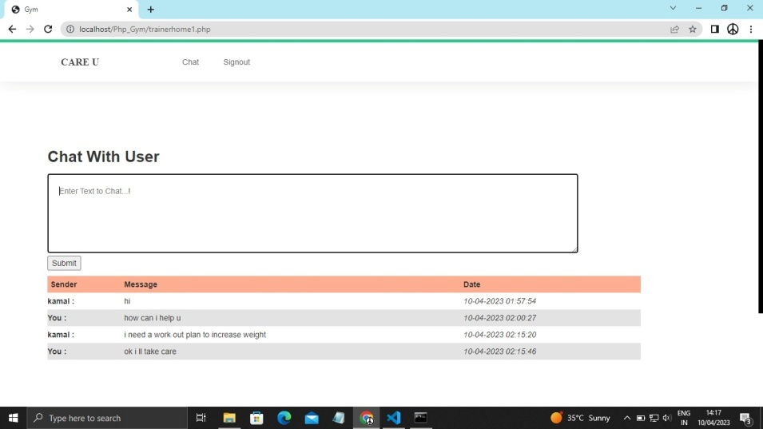

* 1. **Payment Method**

After the products were added to the cart after the confirmation the user can able to pay via our website

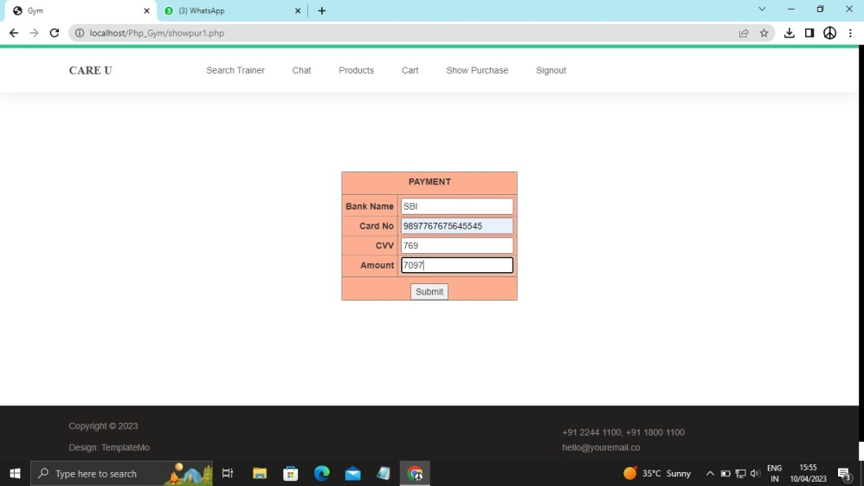

* 1. **Store**

The gym equipments , proteins and suits are available in this website.

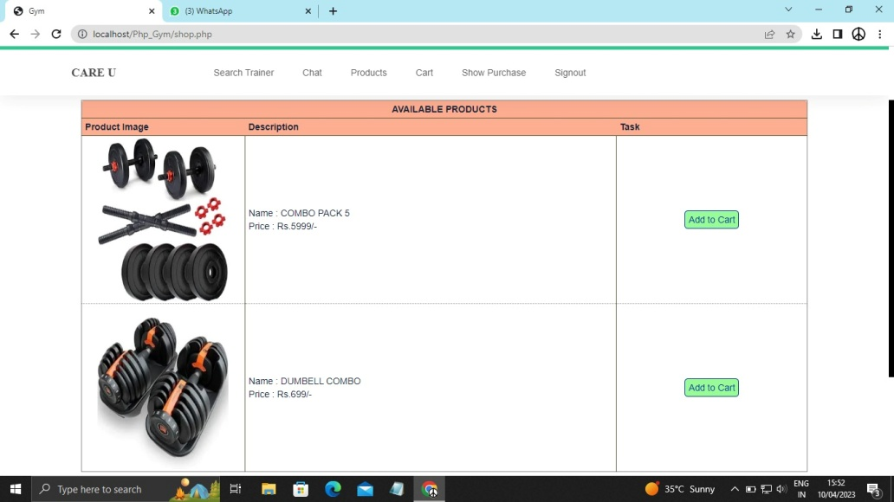

**8.4Cart**

The purchased product were added in the cart and waiting for the payment.

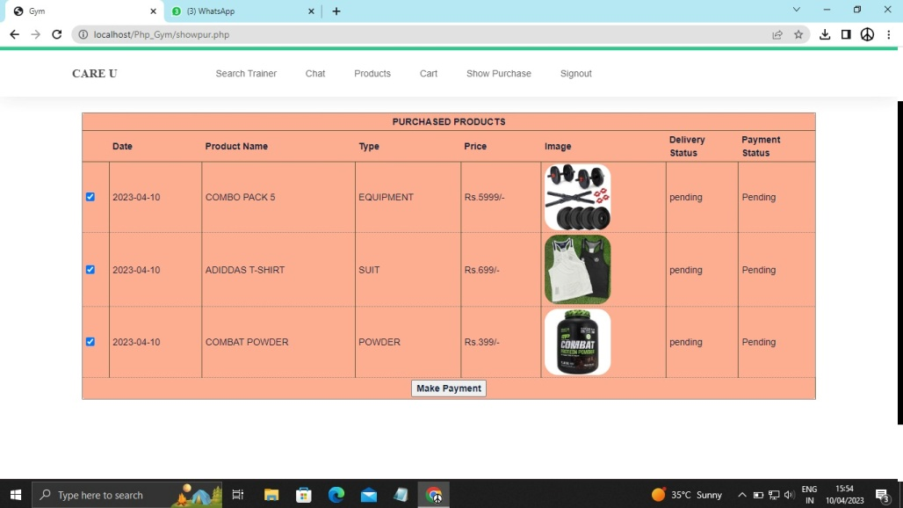

1. **CONCLUSION**

Hence this project is developed to be used by the administrator of the site and the trainer and the users. The user can select trainers and can clarify their doubts with the trainer, using the chat. The admin can create products and the products can be purchased by the users. So this site is helpful for the administrator to maintain and generate reports.

1. **REFERENCES**

[1] "Gym Management System" by CodeWithHarry: https://www.youtube.com/watch?v=5n5aJSKjWbQ

[2] "Gym Management System" by TechZooM: https://www.youtube.com/watch?v=QU4hXH8HZY4

[3] "Gym Management System" by Sourcecodester: https://www.sourcecodester.com/visual-basic-net/12138/gym-management-system-vbnet.html

[4] "Gym Management System" by FreeProjectz: https://www.freeprojectz.com/paid-projects/asp-net-projects/gym-management-system

[5] "Gym Management System" by W3Schools: https://www.w3schools.in/tag/gym-management-system-project-in-php/