PREPARATION, STUDY AND OPTIMIZATION OF EDM PROCESS PARAMETERS ON MACHINING OF 6063 AL WITH SiC AND GRAPHENE REINFORCEMENT

PVASUDEVA, M. Tech student, Department of mechanical engineering, JNTU college of engineering Anantapur, AP, India.

Dr. B. OMPRAKASH, Assistant professor, Department of mechanical engineering, JNTU College of engineering Anantapur, AP, India

**Abstract**:

In today’s world, aluminum plays a very important role in the various manufacturing industries due to its significant properties like high strength to low weight ratio, high resistance to corrosion, manufacturing flexibility etc. The present work includes the preparation of AMMC along with reinforcement by stir casting process. The matrix material used in the preparation of casting is Al6063 composite and 0.5 wt% SiC,0.5 wt% graphene nano particles are used as reinforcement materials. SiC and graphene are selected because they have high strength, high hardness, high thermal conductivity, high electrical conductivity, light weight than paper etc. The prepared Al6063-T6 reinforced with SiC and graphene is used for machining on edm machine.

Electrical discharge machining is prominent non-traditional machining approach that is capable of machining of geometrically convoluted and very hard composites. The main objective of the current work is to optimize the edm process parameters such as peak current, pulse-on-time, voltage and flushing pressure on machining of Al6063 reinforced with SiC and graphene. Experiments are carried out on edm machine to evaluate the MRR and TWR with different values of process parameters.

In this current work, Taguchi based mathematical model with 27 experiments was developed to optimize the edm process parameters. From the experimental results, it was noticed that peak current is more impacting on MRR and TWR followed by other parameters.

1. **INTRODUCTION:**

Wide range of composites have been developed in the present modern world. Even though there are many composites developed, aluminum composites play a prominent role due to their significant properties. The significant properties of aluminum composite are they are very rigid, durable and strong but possess light weight.

Nowadays, Industries like military, automobile, athletics, electrical components, space technology etc, are looking for light weight material with improved properties. For enhanced physical and mechanical properties, aluminum metal matrix composite plays a major role.

For any metal matrix composite, addition of reinforcement material significantly improves the properties of initial material. This improvement in properties can be done to enhance the hardness, toughness, wear resistance, corrosion resistance, strength, fatigue, creep, malleability, ductility etc according to industrial need. SiC, Al2O3, TiC, MoS2, B4C, TiB2, ZrO2, Graphite, Graphene, carbon nano tubes etc are the various types of reinforcements. The composite materials are very hard and difficult to machining by using conventional machining processes.

For machining of composites which are difficult to machine by conventional machining methods, Nontraditional machining methods like electical discharge machine (EDM), Electro chemical machining (ECM), Laser beam machining (LBM), EBM can be employed.

Among the various nontraditional machining methods, electrical discharge machine has established itself to be the most important method in shaping difficult-to-machine materials. EDM has been effectively used in large number of industrial areas such as automobile industries, aeronautical industries, surgical instruments manufacturing, toys manufacturing etc. In EDM, tool and work piece are of non-contact type in which a thin gap of about 0.025mm is maintained by a servo system.

From the literature survey, it can be observed that a lot of research has been done on EDM machining and on fabrication of aluminum metal. In this work, optimization of Edm process parameters is been done on machining of Al6063-T6 reinforced with SiC and graphene nano particles.

1. ***WORKING PRINCIPLE OF EDM:***

Electrical Discharge Machining (EDM) is a thermal erosion process used to remove material by a number of repetitive electrical discharges of small duration and high current density between the work piece and the tool.

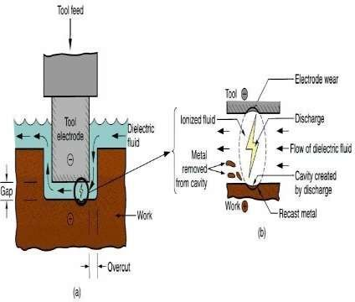

**FIG-1: EDM PRINCIPLE OF WORKING**

EDM is mainly used to machine high strength temperature resistant alloys and materials which are difficult-to-machine. EDM can be used to machine irregular geometries in small batches or even on job-shop basis. In EDM, as there is no direct contact between the workpiece and the electrode, hence there are no mechanical forces existing between workpiece and electrode but work material must be electrically conductive to be machined by EDM.

1. **MATERIALS**:

## **Composition of Al6063*:***

|  |  |
| --- | --- |
| **ELEMENTS** | **COMPOSITION (wt%)** |
| **Si** | 0.40- 0.44 |
| **Fe** | 0.20- 0.21 |
| **Cu** | 0.01 – 0.02 |
| **Mn** | 0.02 – 0.03 |
| **Mg** | 0.40 – 0.50 |
| **Zn** | 0.01 – 0.02 |
| **Ti** | 0.01 – 0.02 |
| **Cr** | 0.01 – 0.03 |
| **Al** | Balance |

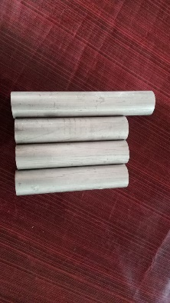

FIG -2: Al 6063 composite

* 1. **DIELECTRIC FLUID:**
* The dielectric fluid is a spark conductor, coolant, and also a flushing medium. The requirements are explained here ¬
* The dielectric fluid should have sufficient and stable dielectric strength to serve as insulation between the tool and work till the break down voltage is reached.
* It should de-ionize rapidly after the spark discharge has taken place.
* It should have low viscosity and good wetting capacity to provide effective cooling mechanism and remove the swarf particles from the machining gap.
* It should flush out the particles produced during the spark out of the gap. This is the most important function of the dielectric fluid. Inadequate flushing can result in arcing, decreasing the life of the electrode and increasing the machining time.
* It should be chemically neutral so as not to attack the electrode, the work piece, table or the tank.
* Its flash point should be high to avoid any fire hazards.
* It should not emit any toxic vapors or have unpleasant odors.
* It should maintain these properties with temperature variation, contamination by working residuals, and products of decomposition.
* It should be economical and easily available.

A number of properties of dielectric fluids need to be considered while selecting them for the operation.

1. Flash point

2. Dielectric strength

3. Viscosity

4. Specific gravity

5. Odor

6. Effect on health

* 1. **SILICON CARBIDE:**

Silicon carbide, also known as carborundum, is a compound of silicon and carbon. Silicon carbide is a semiconductor material as an emerging material for applications in semiconductor devices.

It is one of the most important industrial ceramic materials. It plays a key role in the industrial revolution and is still widely used as an abrasive and steel additive and structural ceramic.

**Properties of sic:**

* + - Molecular weight - 40.11g/mol
    - Melting point - 2730℃
    - Compound formula – SiC
  1. **GRAPHENE:**

Graphene is a material that has superior mechanical, electrical and thermal properties. Graphene stands out for being tough, flexible, light, and with a high resistance. It is five times lighter than aluminium material. With these properties, graphene has applications in the energy, construction, health, and electronics sectors.

* 1. **ELECTRODES:**

ELECTRODES In the EDM process, the shape of electrode is impressed on the work piece in its complimentary form and as such shape and accuracy of the electrode place a very important role in the final accuracy of the machined work piece.

The electrode material should have the following characteristics to serve as a good tool.

1. It should be good conductor of electricity and heat.

2. It should be easily machinable to any shape at reasonable cost.

3. It should produce efficient material removal rate from the work pieces.

4. It should resist the deformation during the erosion process.

5. It should exhibit low electrode wear rates.

6. It should be available in variety of shapes.

Various electrode materials used are graphite, copper, copper graphite, brass, zinc alloys, steel, tungsten, copper tungsten, silver tungsten etc.

1. **IMPORTANT PARAMETERS OF EDM**
2. Pulse on time
3. Pulse off time
4. Arc gap
5. Peak current
6. Duty cycle
7. Voltage
8. Flushing pressure
9. Over cut
10. **DISADVANTAGES OF EDM:**

* The wear rate on the electrode is considerably higher. Sometimes it may be necessary to use more than one electrode to finish the job
* The workpiece should be electrically conductive to be machined using the EDM process.
* The energy required for the operation is more than that of the conventional process and hence will be more expensive.

**6. LITERATURE SURVEY**

1. S. Roseline, V. Paramasivam, R. Anandha Krishnan, P.R. Lakshminarayanan Springer (2018), vol 275, Issue 2, 653-667. In this paper three reinforcement materials including zirconia (ZrO2), zirconia + aluminium oxide (ZrO2 +Al2O3) and fused zirconia aluminum (40FZA) with varying proposition as 5, 10 and 15% were used. However, from this study it can be evident that inclusion of 15% particle reinforcement of zirconia, fused alumina in Al6061 provides greater strength, toughness, high resistance to wear and corrosion on both experimental and numerical analysis.

2. S.Sivananthan, V.Rajalaxman Reddy materials today; proceedings (2017) aluminium oxide reinforced Al6061 alloy metal matrix composites have been prepared using stir casting process. Mechanical properties such as hardness, tensile strength and compression of composites have been tested and the values are compared with Al6061 alloy. Hardness, ultimate tensile strength and compression strength of Al6061 alloy increased with increasing weight fraction of aluminum oxide particles in aluminum matrix.

3. Modi, studied EDM process parameters so that the whole process is affected by the electrical and non-electrical. The project work rotating equipment metal removal rate (MRR) to improve and to monitor its impact on the surface finish is used. RSM and Taguchi's method are used to optimize the design. 4. Muthuramalingam and Mohan, discussed having an overview of the EDM process, modeling of process parameters, and influence of process parameters such as input electrical variables, pulse shape, and discharge energy on performance measures such as material removal rate, surface roughness, and electrode wear rate. From the review results, it has been observed that the efficacy of the machining process can be improved by electrical process parameters, and only less attention has been given to enhancing such parameters.

5. Venkatesh, discussed the effect of an increase in pulsed current on MRR, TWR, SR in alloy steels viz., EN31, EN8, HCHCr. The electrode materials viz. copper, brass, chromium copper. Results of the study suggested that SR increases with increases in pulse current. Chromium Copper electrode has been preferred for highest MRR, Dimensional accuracy and surface finish.

6. Vikas, investigated comparison of MRR for EN19 and EN41 in die sinking EDM machine using discharge current and voltage as input processing parameters. Taguchi method with S/N ratio and ANOVA suggested that discharge current in case of the EN41 material and EN19 material had a larger impact as compared to other processing parameters on the MRR.

7. Choudhary performed the experiments by using copper silicon carbide (CuSiCp) composite tool electrode on an EDM with selected input parameters on AISID3 die Steel workpiece. Microstructure analysis reveals the presence of micro-holes and cavities on the machined surface. The depth of re-solidified layer increases with increase of gap current.

8. Ponappa, investigated that EDM well geometrically complex parts that are extremely hard materials or traditional machining processes for machining difficult-to-machine building have established election. Regardless of machine stiffness electrically conductive thermal energy into the soil using its unique feature, die, and the automotive, aerospace and manufacturing of components for surgery has its distinct advantages. 9. R.Rajesh, were carried out “The Optimization of the Electro-Discharge Machining Process Using Response Surface Methodology and Genetic Algorithms.”.. optimization of operating parameters is an important action in machining, particularly for unconventional electrical type machining procedures like EDM. Since for an arbitrary desired machining time for a particular job, they do not provide the optimal conditions. To solve this task, multiple regression model and modified Genetic Algorithm model are developed as efficient approaches to determine the optimal machining parameters in electric discharge machine. In this paper, working current, working voltage, oil pressure, spark gap Pulse on Time and Pulse Off Time on Material Removal Rate (MRR) and Surface Finish (Ra) has been studied. Empirical models for MRR and Ra have been developed by conducting a designed experiment based on the Grey Relational Analysis.

7. **PREPARATION OF CASTING:**

Initially, a measured chemical composition of Al6063 was melted in the electrical furnace assisted graphite crucible at 8000C. The melt is super-heated until it gets the required fluidity. A mild steel impeller at the speed of 600 rpm is used to stir the molten metal to create the vortex. Two grams of Tetrachloroethane is added to the melt to remove the trapped gases from the melt. Silicon carbide and graphene nano particles each of 0.5 wt% are preheated in the preheater along with two grams of potassium hexa fluoro titanate for 3hours. To reduce moisture content, to avoid reactions from foreign particles and to increase the wettability between matrix and reinforcement materials, potassium hexa fluoro titanate is added. The molten Al6063 which is present in the furnace is stirred continuously and in 5 steps the preheated reinforcements are added to improve the distribution in the matrix and obtain better properties. The automatic mechanical stirring is carried out for 15 minutes at 800 rpm to turn the liquid into homogenous mixture. After perfect mixing of matrix and reinforcement, it is poured into the preheated mold with the help of gravity.

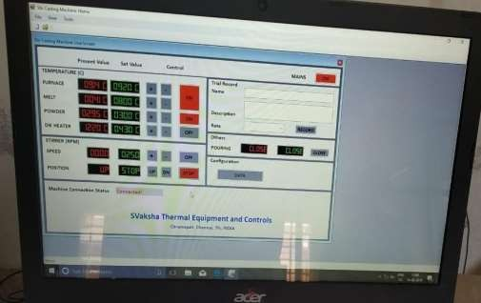

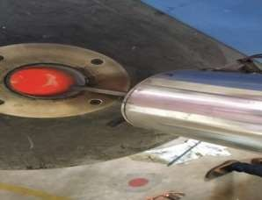FIG -3: STIR CASTING SETUP

FIG -4: MOLTEN Al6063

1. **EXPERIMENTAL SET-UP:**
   1. ***ELECTRIC DISCHARGE MACHINING:***

**Electrical discharge machining** (**EDM**), also known as **spark machining**, **spark eroding**, **die sinking**, **wire burning** or **wire erosion**, is a manufacturing process whereby a desired shape is obtained by using electrical discharges (sparks).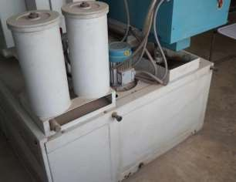

**Fig-5: EDM MACHINE**

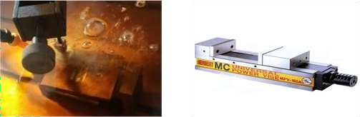

**Fig-6: TOOL HOLDER IN EDM**

1. **DESIGN OF EXPERIMENTS:**

To generate effective combination of process parameters by reducing number of experiments, Design of experiments is mainly used. More number of experiments should be done to get the better results in the optimization process. Therefore, in this work, Taguchi based mathematical model with 27 experiments is developed. From the literature survey, there are various parameters that affect the machining characteristics of EDM machine. They are pulse-on-time (Ton), Flushing pressure (P), pulse-off-time (Toff), Duty factor (TD), peak current (Ip), voltage(v), Spark gap. In this study, Ton, p, Ip and v are taken as input variables. MRR and TWR are taken as output variables.

**TABLE: CONSIDERED PROCESS PARAMETERS AND DIFFERENT LEVELS.**

|  |  |  |  |  |  |  |
| --- | --- | --- | --- | --- | --- | --- |
| **S.NO** | Parameter | symbol | units | Level 1 | Level 2 | Level 3 |
| 1. | Pulse-on-time | Ton | µs | 100 | 200 | 300 |
| 2. | Peak current | Ip | A | 20 | 30 | 40 |
| 3. | voltage | v | v | 40 | 50 | 60 |
| 4. | Flushing pressure | P | Kg/cm2 | 0.3 | 0.4 | 0.5 |

The above parameters are converted into 3 levels with each level having different parameter values. Using the above parameters 27 experiments have been conducted. MRR and TWR value is calculated for each experiment using the given below formula.

EVALUATION OF MRR: MRR = workpiece weight loss (grams) * 60 *60 (gm/hr)/ Machining time(s)

EVALUATION OF TWR: TWR= Tool weight loss (grams) *60 * 60 (gm/hr)/ Machining time (sec)

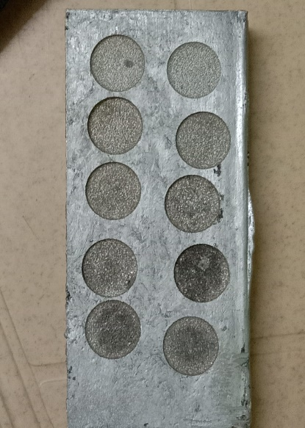

FIG – 7: WORK PIECE AFTER EDM

1. **RESULTS AND DISCUSSIONS:**

To generate the relationship between parameters MINITAB 21 has been used. To find the relative effect of one parameter on the other, analysis of variance (ANOVA) tool is used.

The responses for calculated MRR and TWR is shown in the below table.

**Table:**

|  |  |  |  |  |  |  |  |  |
| --- | --- | --- | --- | --- | --- | --- | --- | --- |
| **S. No** | **I** | **Ton** | **V** | **P** | **MRR** | **SNR for MRR** | **TWR** | **SNR for TWR** |
| **1** | 100 | 20 | 40 | 0.3 | 21.6 | 26.68 | 1.028 | 0.59 |
| 2 | 100 | 20 | 50 | 0.4 | 22.9 | 27.21 | 1.350 | 3.00 |
| 3 | 100 | 20 | 60 | 0.5 | 19.5 | 25.80 | 0.216 | 0.63 |
| 4 | 100 | 30 | 40 | 0.3 | 27.1 | 28.67 | 0.295 | 2.07 |
| 5 | 100 | 30 | 50 | 0.4 | 27.1 | 28.67 | 1.180 | 1.86 |
| 6 | 100 | 30 | 50 | 0.5 | 26.8 | 28.58 | 0.571 | 1.95 |
| 7 | 100 | 40 | 40 | 0.3 | 35.3 | 30.96 | 0.666 | 2.10 |
| 8 | 100 | 40 | 50 | 0.4 | 38.5 | 31.71 | 0.837 | 0.42 |
| 9 | 100 | 40 | 60 | 0.5 | 35.3 | 30.96 | 0.679 | 3.41 |
| 10 | 200 | 20 | 40 | 0.4 | 18.3 | 25.25 | 0.642 | 0.06 |
| 11 | 200 | 20 | 50 | 0.5 | 17.8 | 25.01 | 0.378 | 0.49 |
| 12 | 200 | 20 | 60 | 0.3 | 10.3 | 20.33 | 0.371 | 4.41 |
| 13 | 200 | 30 | 40 | 0.4 | 33.2 | 30.42 | 0.400 | 4.11 |
| 14 | 200 | 30 | 50 | 0.5 | 27.6 | 28.82 | 0.493 | 1.26 |
| 15 | 200 | 30 | 60 | 0.3 | 26.2 | 28.37 | 0.888 | -0.01 |
| 16 | 200 | 40 | 40 | 0.4 | 45.3 | 33.13 | 2.347 | 5.60 |
| 17 | 200 | 40 | 50 | 0.5 | 43.2 | 32.70 | 0.800 | 2.76 |
| 18 | 200 | 40 | 60 | 0.3 | 44.0 | 32.86 | 0.800 | 6.32 |
| 19 | 300 | 20 | 40 | 0.5 | 14.6 | 23.31 | 0.610 | 1.11 |
| 20 | 300 | 20 | 50 | 0.3 | 16.3 | 24.26 | 0.302 | 3.09 |
| 21 | 300 | 20 | 60 | 0.4 | 15.5 | 23.81 | 0.878 | 3.33 |
| 22 | 300 | 30 | 40 | 0.5 | 24.8 | 27.92 | 0.222 | 4.05 |
| 23 | 300 | 30 | 50 | 0.3 | 22.6 | 27.09 | 0.257 | 3.67 |
| 24 | 300 | 30 | 60 | 0.4 | 25.7 | 28.22 | 0.486 | -0.31 |
| 25 | 300 | 40 | 40 | 0.5 | 42.4 | 32.55 | 0.642 | 0.29 |
| 26 | 300 | 40 | 50 | 0.3 | 34.0 | 30.63 | 1.309 | 5.33 |
| 27 | 300 | 40 | 60 | 0.4 | 41.0 | 32.26 | 0.720 | 1.01 |

1. ***Effect of process parameters on Material removal rate:***

**Table: response table for SN ratio – MRR (Larger is better)**

|  |  |  |  |  |
| --- | --- | --- | --- | --- |
| **LEVEL** | **Ton** | **Ip** | **V** | **P** |
| **1** | 28.83 | 24.63 | 28.84 | 27.77 |
| **2** | 28.55 | 28.53 | 28.46 | 29.97 |
| **3** | 27.80 | 32.98 | 27.93 | 28.41 |
| **DELTA** | 1.03 | 8.34 | 0.91 | 2.20 |
| **RANK** | **3** | **1** | **4** | **2** |

From the above table, it is observed that peak current is the first important factor that is influencing on MRR. The next parameter is flushing pressure (P) and Ton, V are ranked at the third and fourth position.

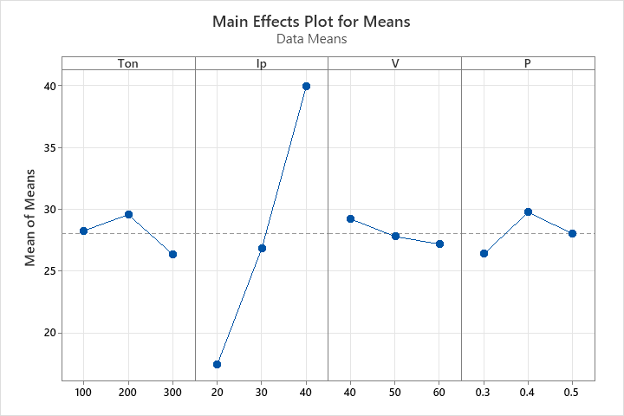

FIG – 8: MAIN EFFECTS PLOT FOR MRR

**11.Effect of process parameters on Tool wear rate (TWR*)***

**Table: Response table for SN ratio for TWR. (Smaller is better)**

|  |  |  |  |  |
| --- | --- | --- | --- | --- |
| **LEVEL** | **Ton** | **Ip** | **V** | **P** |
| **1** | 3.1 | 5.234 | 4.3 | 5.0 |
| **2** | 3.2 | 6.7 | 3.5 | 2.0 |
| **3** | 5.8 | 1.0 | 5.0 | 7.0 |
| **Delta** | **2.7** | **5.7** | **1.5** | **5.0** |
| **Rank** | **3** | **1** | **4** | 2 |

From the above table, it is observed that peak current is the most influencing factor on reducing the tool wear. The next parameter that influences the TWR is flushing pressure (P) and Ton, V are ranked at the third and fourth position

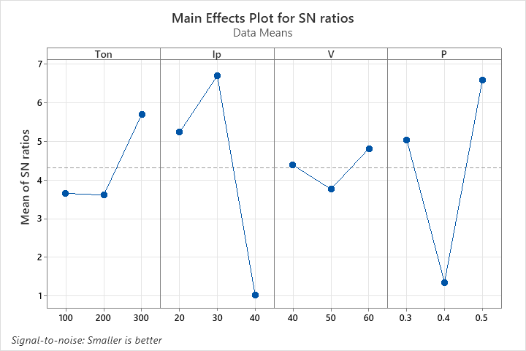

FIG – 9: MAIN EFFECTS PLOT FOR TWR

1. Regression equation for MRR:

MRR = 22.9-0.0743Ton+0.296Ip-0.260V-1.7P+0.00216Ton*Ip+0.0053Ip*V

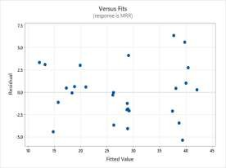 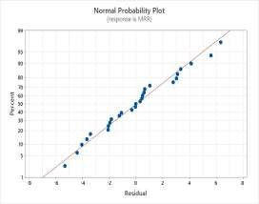

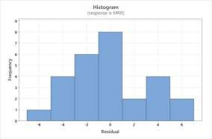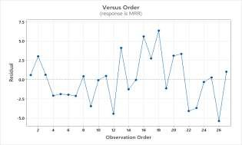

**CONCLUSIONS:**

Al6063 along with the reinforcements SiC and graphene are prepared by stir casting process and then considering the process parameters,the prepared casting is machined on electrical discharge machining. The primary objective of this project is to optimize the most influencing process parameters that affect MRR and TWR on EDM. From the experiments conducted in this study, peak current and flushing pressure are the most influencing factors that affect MRR and TWR. In this experimental study, the optimal process parameters that maximizes the MRR and minimizes the TWR are also found.