**WE-CODE**

**ABSTRACT**

In the context of a document file, **We-Code** is a large language model trained by OpenAI architecture. We-Code is designed to generate human-like responses to natural language input and can be used for a variety of applications, including chatbot, virtual assistants, and text generation. We-Code has been trained on a massive amount of text data and can understand and respond to a wide range of topics and questions. As a tool for document creation, We-Code can assist with writing reports, drafting emails, and generating other types of written content.

**INTRODUCTION**

Welcome to our AI-powered conversational assistant! This application is designed to provide you with a personalized and engaging conversational experience, similar to ChatGPT. The technology behind We-Code is based on openAI and natural language processing techniques, which allow the model to analyze and understand large amounts of text data. We-Code has been trained on vast amounts of text from the internet, allowing it to understand a wide variety of topics and respond to queries with impressive accuracy. With an extensive knowledge base and the ability to learn from every interaction, We-code can provide you with accurate and up-to-date information on a wide range of topics. From technology and science to culture and entertainment, there's no limit to what you can explore with our AI-powered conversational assistant. We-Code is trained on a vast corpus of data, enabling it to understand and respond to a wide range of user queries, from simple questions to complex discussions on various topics. Whether you need help with your homework, want to plan your next vacation, or simply need someone to talk to, our AI chat application is always ready to assist you.

**PROJECT DESCRIPTION**

A project that uses HTML, CSS, and React JavaScript involves creating a web-based application that allows users to interact with an AI language model similar to ChatGPT. The front-end of the application is developed using HTML and CSS to create an interface that allows users to input their queries and receive responses from the AI model.React JavaScript is used to develop the application's user interface and manage its state. The application can be designed to have various functionalities, such as input validation, user authentication, and data visualization, depending on the specific requirements of the project.PI integration is a critical component of this project, as it enables the application to communicate with the AI language model and retrieve responses to user queries. This involves integrating the AI model's API with the application's code, which can be done using various programming languages and tool. The model used for the development is:-

### INCREMENTAL MODEL

### Incremental Model is a process of software development where requirements divided into multiple standalone modules of the software development cycle. In this model, each module goes through the requirements, design, implementation and testing phases. Every subsequent release of the module adds function to the previous release. The process continues until the complete process is not executed.

### Characteristics of Incremental model:-

* + - * Errors are easy to be recognized.
      * Easier to test and debug
      * More flexible.
      * Simple to manage risk because it handled during its iteration.
      * The Client gets important functionality early.

### Block diagram:-

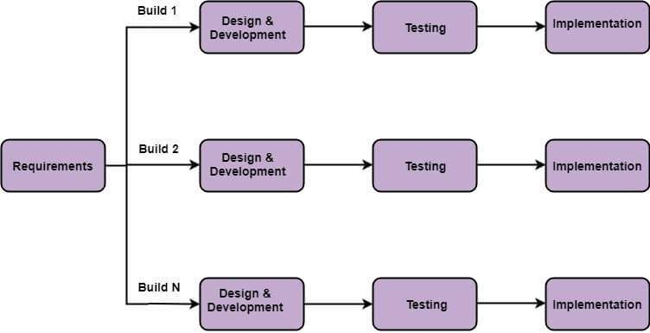

**Fig 2.2 Incremental model**

* **Requirements gathering**: In this phase, the project requirements are gathered and analyzed. The requirements are then prioritized, and the highest priority requirements are selected for the first increment.
* **Design**: In this phase, the software design is developed based on the selected requirements. The design is reviewed and refined, and the software architecture is defined.
* **Implementation**: In this phase, the software is developed according to the design specifications. The software is coded, tested, and integrated into the existing system.
* **Testing**: In this phase, the software is tested to ensure that it meets the requirements and functions as intended. The testing process is iterative, and any issues are identified and resolved before moving on to the next increment.
* **Deployment**: In this phase, the software is deployed and released to users. The deployment process may involve additional testing and verification to ensure that the software is stable and meets user need.
* **Maintenance**: In this phase, the software is maintained and updated as needed. Maintenance may involve bug fixes, security updates, and new features or functionality.

**ADVANTAGES**

* Efficient communication: We-code provides an efficient means of communication, allowing users to quickly and easily obtain information or assistance without the need for human intervention.
* Versatility: We-code can be used for a wide range of tasks, from answering simple questions to generating complex text like articles, essays, and even stories.
* Availability: We-Code is available 24/7 and can be accessed from anywhere with an internet connection, making it a convenient tool for users across the globe.

**DISADVANTAGES**

* Dependence: Users may become too dependent on We-Code, leading to a loss of critical thinking and problem-solving skill.
* Security and Privacy: We-Code collects and processes data, which could pose privacy and security risks for user
* Unintended Consequences: As with any technology, there may be unintended consequences or unforeseen outcomes that arise from the use of We-Code.

**CONCLUSION**

In conclusion, developing a language model like is a complex and challenging task that requires a significant amount of resources, including data, computational power, and expertise in natural language processing and machine learning.However, the benefits of such a model are numerous, including the ability to understand and generate human-like responses to a wide range of input and queries, improving communication between humans and machines, and advancing research in natural language processing.The potential applications for a model like We-Code are vast, including customer service chatbots, personal assistants, language translation tools, and more. As technology continues to evolve, language models like We-Code will likely become increasingly sophisticated and impactful.

**REFERENCES**

"The Architecture of Open Source Applications" edited by Amy Brown and Greg Wilson.

"Designing Data-Intensive Applications" by Martin Kleppmann.

"Python Machine Learning" by Sebastian Raschka.

"Applied Artificial Intelligence" by Mariya Yao, Adelyn Zhou, and Marlene Jia.

<https://getbootstrap.com/>

[www.w3school.com](http://www.w3school.com/)

[www.wikipedia.com](http://www.wikipedia.com/)

[www.youtube.com](http://www.youtube.com/)