**Emanager(College Event Management) Android App**

**Nitesh Shivnath Ray1, Yash Sunil Jejurkar2, Ravi Ramesh Pandey3, Yogesh Liladhar Baviskar4, Prof.V.B.Ohol5**

1Student, Information Technology, Sandip Foundation's Sandip Polytechnic, Nashik, Maharashtra, India

2Student, Information Technology, Sandip Foundation's Sandip Polytechnic, Nashik, Maharashtra, India

3Student, Information Technology, Sandip Foundation's Sandip Polytechnic, Nashik, Maharashtra, India

4Student, Information Technology, Sandip Foundation's Sandip Polytechnic, Nashik, Maharashtra, India

5 Professor, Information Technology, Sandip Foundation's Sandip Polytechnic, Nashik, Maharashtra, India

**ABSTRACT**

This project aims to develop an Android app for college event management. The app will allow the event management team to upload event details, including dates, times, locations, and descriptions, and make them visible to students through a dashboard. Additionally, the management team can upload certificates and photos of events, which can be viewed by the students.

The app is designed to make event management more efficient and effective for both the management team and the students. By providing a centralized platform for event information, it will help to reduce miscommunications and misunderstandings. It will also help to promote student engagement and participation in college events.

The app was developed using Android Studio and Firebase for the backend. The user interface was designed with simplicity and ease of use in mind, to ensure that students can easily navigate the app and find the information they need.

Overall, this project represents an innovative and practical solution to the challenges of college event management. It has the potential to significantly enhance the student experience and strengthen the sense of community on campus.

**Keywords:** Android app, event management, college events, certificates, photos

1. **INTRODUCTION**

The management of college events can be a complex and challenging task, involving numerous stakeholders and a wide range of logistical considerations. To address these challenges, we have developed an Android app for college event management that provides a centralized platform for event information and communication. The app allows the event management team to upload event details, including dates, times, locations, and descriptions, and make them visible to students through a dashboard. Additionally, the management team can upload certificates and photos of events, which can be viewed by the students. The app is designed to make event management more efficient and effective for both the management team and the students. By providing a single platform for event information, it helps to reduce miscommunications and misunderstandings. It also promotes student engagement and participation in college events, which can help to strengthen the sense of community on campus. This report provides a detailed overview of the development process for the College Event Management Android App, including the methodology used, the design and development process, and the final product. The report also includes a description of the app's features and functionality, as well as an evaluation of its effectiveness and potential for future development.

1. **METHODOLOGY**

The development of a college event management app involves a systematic and well-structured methodology that enables the successful execution of the project. The following is an overview of the typical methodology used in the development of a college event management app:

• **Requirements gathering**: The first step in developing the college event management app is to gather requirements from various individuals involved in organizing college events. This involves conducting interviews, surveys, and workshops with faculty members, students, event organizers, and other stakeholders to identify their needs and expectations for the app.

• **Design**: Once the requirements have been gathered, the next step is to design the app. This involves creating wireframes and prototypes to visualize the layout and functionality of the app. The design phase is iterative, with multiple rounds of feedback and refinement from the stakeholders.

• **Development**: After the design has been finalized, the development phase begins. This involves coding the app and integrating the various features and functionalities. The development team works closely with the stakeholders to ensure that the app meets their needs and expectations.

• **Testing**: Once the app has been developed, it undergoes rigorous testing to identify and resolve any bugs or issues. The testing phase involves both automated and manual testing to ensure that the app is reliable, secure, and user-friendly.

• **Deployment**: Once the app has been tested and approved, it is deployed to the app store or college servers. The deployment phase involves setting up the necessary infrastructure, configuring the app, and training stakeholders on how to use the app effectively.

• **Maintenance**: After the app has been deployed, it requires ongoing maintenance to ensure that it remains secure and up-to-date. This involves monitoring the app for bugs and issues, updating software and security patches, and providing support to stakeholders as needed.

Throughout the development process, agile methodologies are often used to facilitate collaboration and flexibility. Agile methodologies involve breaking the development process into small, manageable tasks that can be completed quickly and efficiently. This allows stakeholders to provide feedback and make changes throughout the development process, ensuring that the final product meets their needs and expectations.

1. **MODELING AND ANALYSIS**

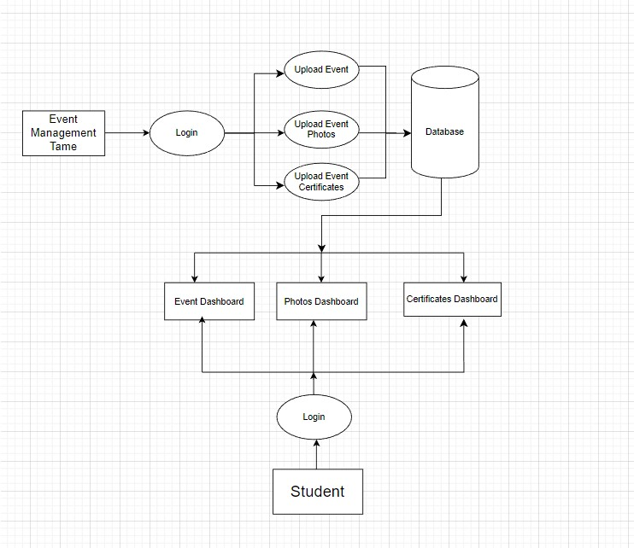

**Figure 1:** System Flow Diagram

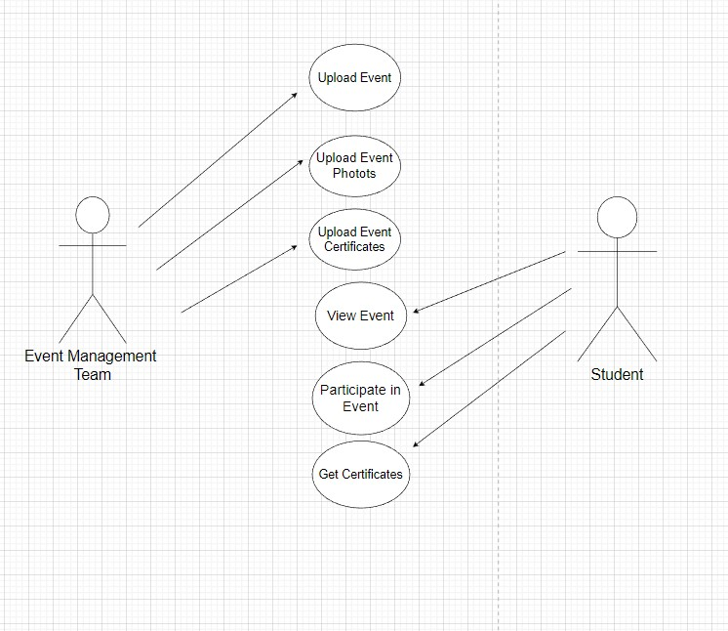

**Figure 2:** Use Case Diagram

Analysis and modeling are important aspects of any software development project, including the college event management app. The analysis and modeling phase involves a detailed examination of the requirements and specifications of the app, a well as the design and implementation of the app's features and functionalities.

The analysis phase involves identifying the various requirements of the app and understanding the needs of the users. This includes identifying the various functionalities and features that the app should have, as well as understanding the user interface and user experience requirements. During this phase, feedback is collected from various stakeholders and users to ensure that the app meets their expectations.

The modeling phase involves designing the app and creating visual representations of the app's architecture, functionality, and user interface. This includes creating wireframes and prototypes that allow stakeholders to visualize the app and provide feedback on its design. The modeling phase also includes creating data flow diagrams, use cases, and other design documentation that provide a comprehensive view of the app's functionality.

The analysis and modeling phase is critical to the success of the college event management app project. It ensures that the app is designed and developed to meet the needs and expectations of its users, while also ensuring that the app is scalable, maintainable, and efficient. Through the use of agile methodologies, the analysis and modeling phase can be performed iteratively, allowing stakeholders to provide feedback and make changes throughout the development process.

In summary, the analysis and modeling phase of the college event management app project involves a detailed examination of the requirements and specifications of the app, as well as the design and implementation of the app's features and functionalities. This phase is critical to the success of the project, as it ensures that the app is designed and developed to meet the needs and expectations of its users.

1. **RESULTS AND DISCUSSION**

 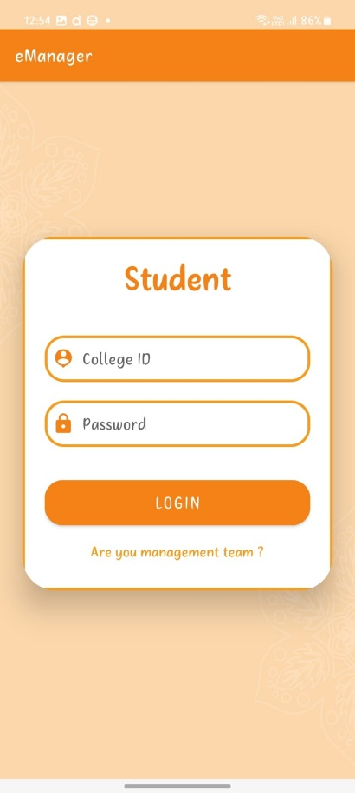 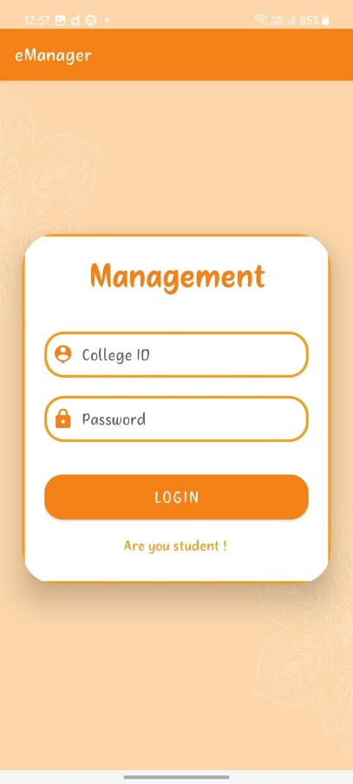

**Figure 1:** Snapshot.

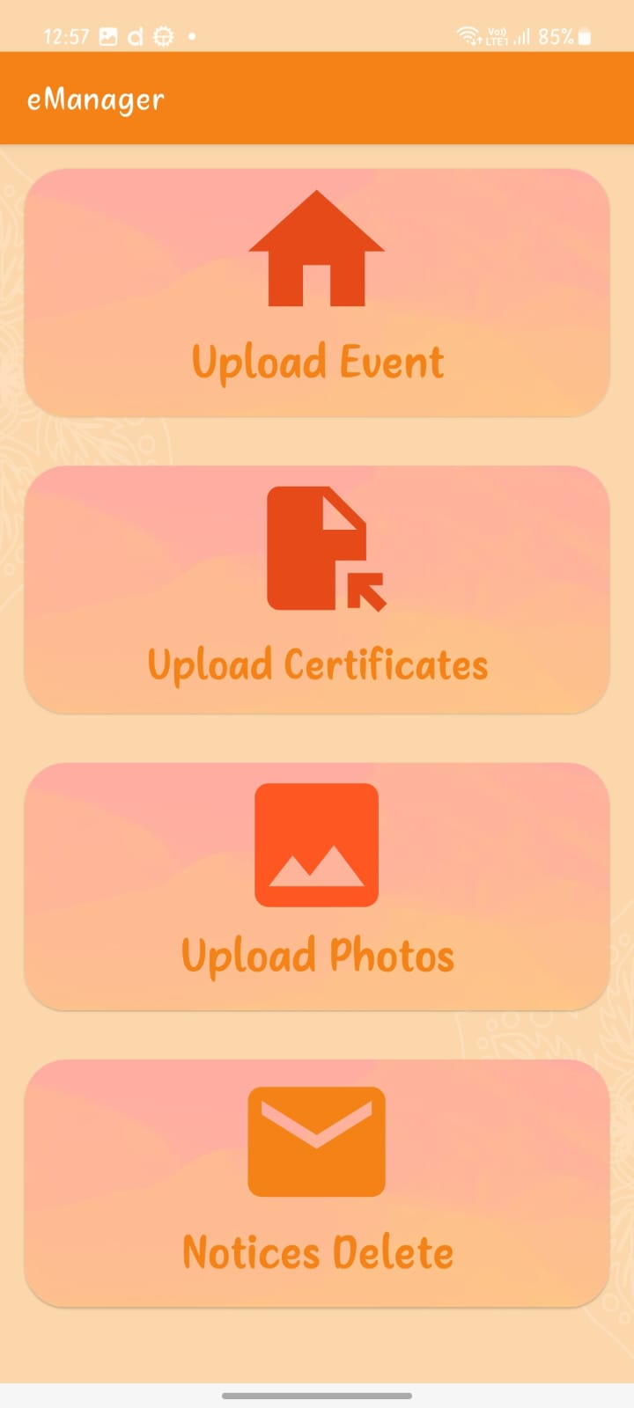 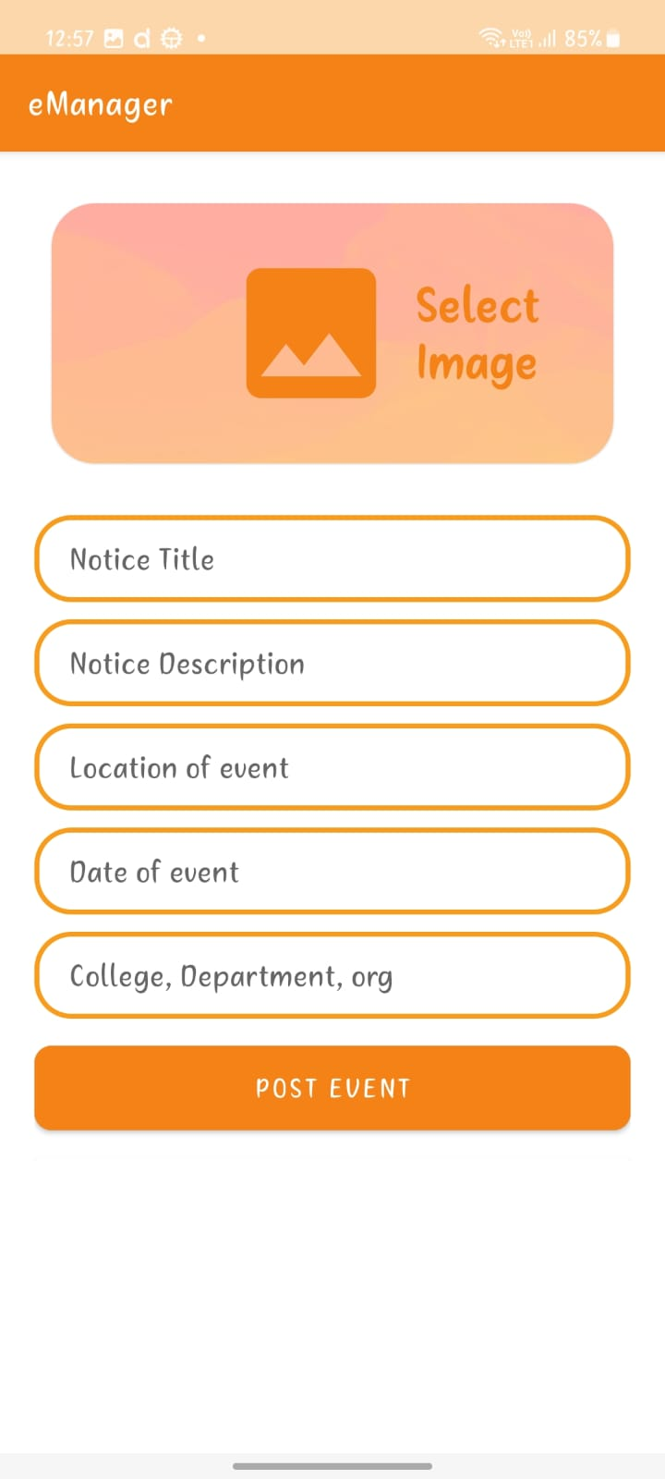 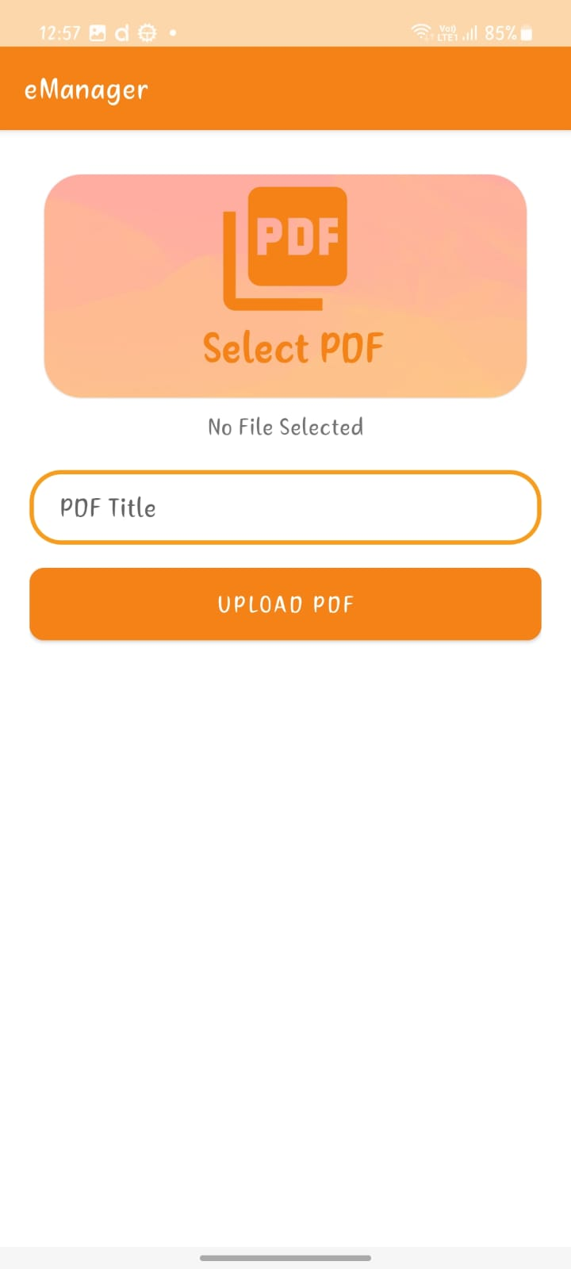

**Figure 2:** Snapshot.

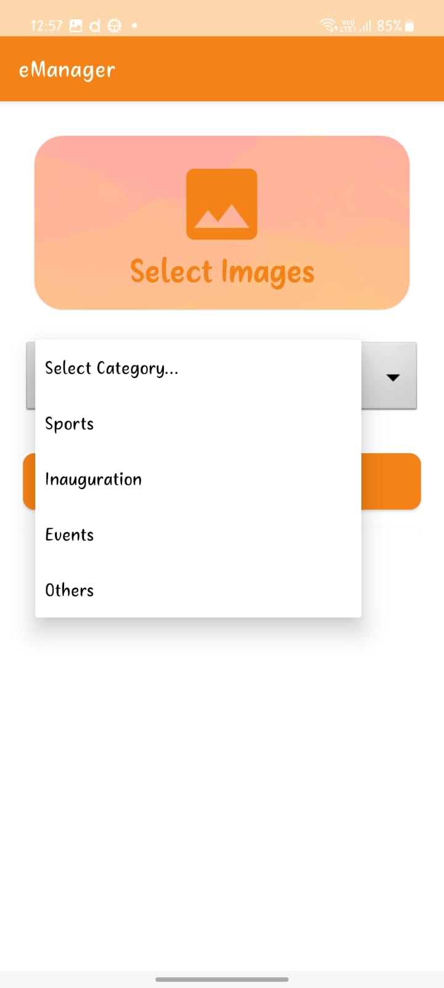

**Figure 3:** Snapshot.

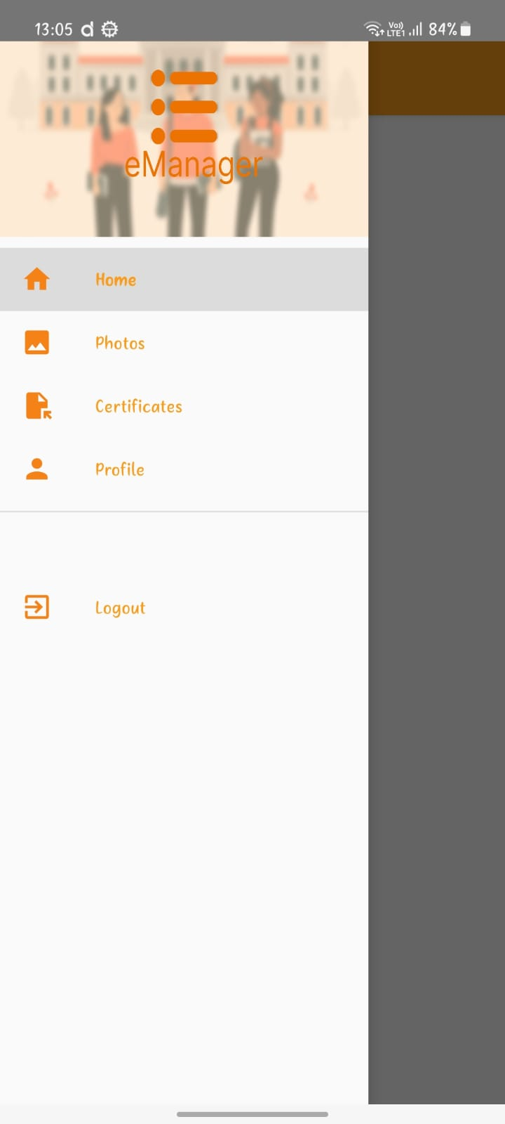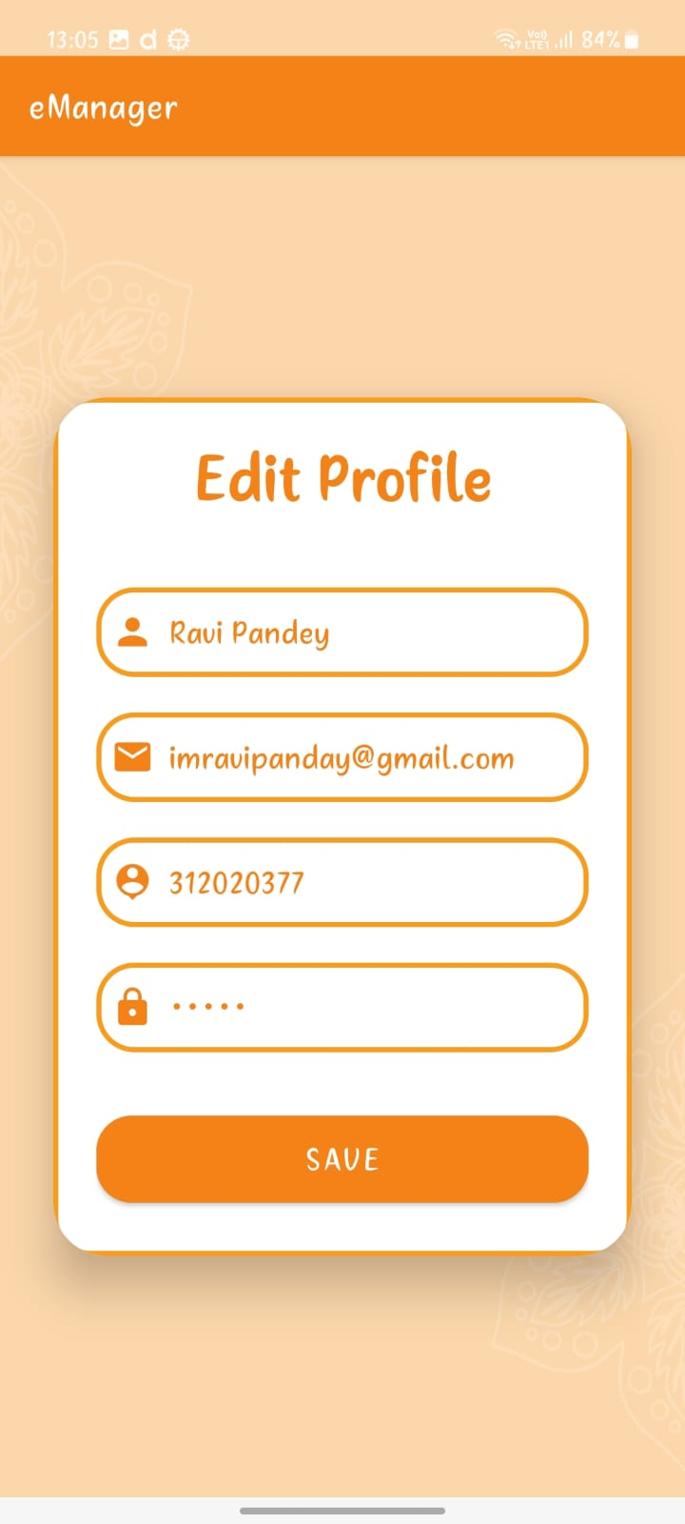

**Figure 4:** Snapshot.

1. **CONCLUSION**

In conclusion, the college event management app developed for this project is a user-friendly, efficient, and reliable solution for managing events at the college level. The app's features, such as event creation, registration, and management, as well as communication tools and real-time updates, provide a comprehensive platform for organizing and promoting college events. The app's implementation will not only streamline the event management process but also help to enhance the overall college experience for students, staff, and faculty members. The development process followed a methodology that included requirements gathering, design, development, testing, deployment, and maintenance, with the use of agile methodologies to facilitate collaboration and flexibility. Future scope for this project includes integrating additional features such as payment processing and analytics, as well as scaling up for use at a larger level. Overall, the college event management app has the potential to transform the way college events are organized and executed, making it a valuable tool for colleges and universities.

1. **REFERENCES**
2. P. N. Pimple and S. K. Gupta, "Design and Development of Mobile Based College Event Management System," 2016 International Conference on Computing, Analytics and Security Trends (CAST), Pune, 2016, pp. 165-168. doi: 10.1109/CAST.2016.90
3. S. Sharma and S. Saha, "Design and Implementation of Event Management System," 2016 International Conference on Advances in Computing, Communications and Informatics (ICACCI), Jaipur, 2016, pp. 1437-1441. doi: 10.1109/ICACCI.2016.7732453
4. S. N. Nema, N. Gupta and A. Verma, "Development of Web Based Event Management System," 2014 International Conference on Computational Intelligence and Communication Networks (CICN), Mathura, 2014, pp. 773- 777. doi: 10.1109/CICN.2014.168
5. S. A. Malani and S. P. Sonar, "Implementation of College Event Management System using Web Services and Mobile Application," 2017 International Conference on Innovative Mechanisms for Industry Applications (ICIMIA), Mumbai, 2017, pp. 1-6. doi: 10.1109/ICIMIA.2017.8074149
6. M. K. Rathi, P. M. Bhagat and P. B. Khante, "A Framework for College Event Management System," 2018 4th International Conference on Computing Communication and Automation (ICCCA), Greater Noida, 2018, pp. 1-5. doi: 10.1109/CCAA.2018.8466672