**FUTURE WITH 5TH GENERATION INTELLIGENT TECHNOLOGY**

**Anjali Deepak Shah**

**EXTC branch, Mumbai, India.**

**Abstrac**t- This paper presents the results of a detailed survey on the fifth generation (5G) cellular network architecture that are helpful in improving the architecture and meeting the demands of users. In this the prime focus is on the 5G cellular network architecture, massive multiple input multiple output technology and device-to-device communication (D2D).This paper also give information about 5G which is the future network technology and has three requirements: eMBB(5G enhanced mobile broadband) eMBB delivers high quality internet access even under harsh environmental condition, uRLLC (Ultra-Reliable Low latency communication) uRLLC has the potential to provide up to 99.99% reliability,with latency measured in milliseconds and mMTC(Massive machine type communication)Poised to support billions of sensors and devices for potential use. 20Gbps Dl and 10Gbps Ul. Stand alone and Non stand alone architectures, network slicing and more.

**Index terms**-SA,NSA,D2D,MIMO,SLICING

1. **INTRODUCTION**

5G is designed to do a variety of things that can transform our lives, including giving us faster download speeds, low latency, and more capacity and connectivity for billions of devices—especially in the areas of virtual reality (VR), the IoT, and artificial intelligence (AI).

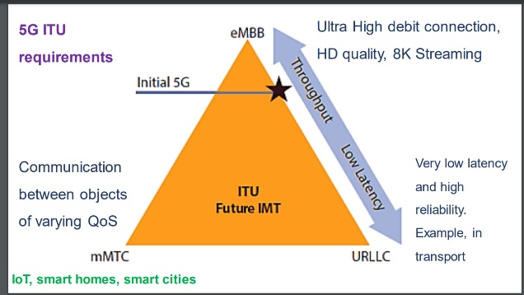  
   
For example, with 5G, you can access new and improved experiences including near-instant access to cloud services, multiplayer cloud gaming, shopping with augmented reality, and real-time video translation and collaboration, and more.

The previous generations of mobile networks are 1G, 2G, 3G, and 4G.

**First generation- 1G**  
1980s: 1G delivered analog voice.

**Second generation - 2G**  
Early 1990s: 2G introduced digital voice (e.g. [CDMA](https://www.qualcomm.com/research)- Code Division Multiple Access).

**Third generation - 3G**  
Early 2000s: 3G brought mobile data (e.g. CDMA2000).

**Fourth generation - 4G LTE**  
2010s: 4G LTE ushered in the era of mobile broadband.

1G, 2G, 3G, and 4G all led to 5G, which is designed to provide more connectivity than was ever available before.

5G is a unified, more capable air interface. It has been designed with an extended capacity to enable next-generation user experiences, empower new deployment models and deliver new services.

With high speeds, superior reliability and negligible latency, 5G will expand the mobile ecosystem into new realms. 5G will impact every industry, making safer transportation, remote healthcare, precision agriculture, digitized logistics and more a reality.

**II. 5G CELLULAR NETWORK ARCHITECTURE**

To contemplate 5G network in the market now, it is evident that the multiple access techniques in the network are almost at a still and requires sudden improvement. Current technologies like OFDMA will work at least for next 50 years. Moreover, there is no need to have a change in the wireless setup which had come about from 1G to 4G. Alternatively, there could be only the addition of an application or amelioration done at the fundamental network to please user requirements.

To meet the demands of the user and to overcome the challenges that has been put forward in the 5G system, a drastic change in the strategy of designing the 5G wireless cellular architecture is needed. In present wireless cellular architecture, for a mobile user to communicate whether inside or outside, an outside base station present in the middle of a cell helps in communication.

So for inside users to communicate with the outside base station, the signals will have to travel through the walls of the indoors, and this will result in very high penetration loss, which correspondingly costs with reduced spectral efficiency, data rate, and energy efficiency of wireless communications.

To overcome this challenge, a new idea or designing technique that has come in to existence for scheming the 5G cellular architecture is to distinct outside and inside setups [8]. With this designing technique, the penetration loss through the walls of the building will be slightly reduced.

This idea will be supported with the help of massive MIMO technology [15], in which geographically dispersed array of antenna’s are deployed which have tens or hundreds of antenna units. Since present MIMO systems are using either two or four antennas, but the idea of massive MIMO systems has come up with the idea of utilizing the advantages of large array antenna elements in terms of huge capacity gains.

To build or construct a large massive MIMO network, firstly the outside base stations will be fitted with large antenna arrays and among them some are dispersed around the hexagonal cell and linked to the base station through optical fiber cables, aided with massive MIMO technologies.

The mobile users present outside are a usually fitted with a certain number of antenna units but with cooperation a large virtual antenna array can be constructed, which together with antenna arrays of base station form virtual massive MIMO links. Secondly, every building will be installed with large antenna arrays from outside, to communicate with outdoor base stations with the help of line of sight components.

The wireless access points inside the building are connected with the large antenna arrays through cables for communicating with indoor users. This will significantly improves the energy efficiency, cell average throughput, data rate, and spectral efficiency of the cellular system but at the expense of increased infrastructure cost

As the 5G wireless cellular network architecture consists of only two logical layers: a radio network and a network cloud. Different types of components performing different functions are constituting the radio network.

The network function virtualization (NFV) cloud consists of a User plane entity (UPE) and a Control plane entity (CPE) that perform higher layer functionalities related to the User and Control plane, respectively. The 5G cellular network architecture is explained in [8] and [20].

It has equal importance in terms of front end and backhaul network respectively. In this paper, a general 5G cellular network architecture has been proposed as shown in figure. It describes the interconnectivity among the different emerging technologies like Massive MIMO network, Cognitive Radio network, mobile and static small-cell networks.

This proposed architecture also explains the role of network function virtualization (NFV) cloud in the 5G cellular network architecture. The concept of Device to Device (D2D) communication, small cell access points and Internet of things (IoT) has also been incorporated in this proposed 5G cellular network architecture. In general, this proposed 5G cellular network architecture may provide a good platform for future 5G standardization network.

general 5G cellular network architecture.

[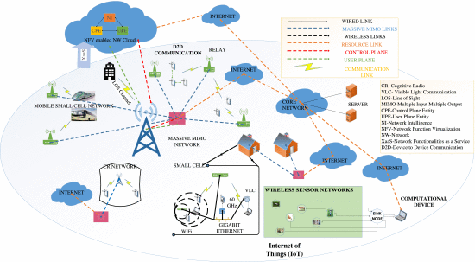](https://ieeexplore.ieee.org/mediastore_new/IEEE/content/media/6287639/7042252/7169508/gupta3-2461602-large.gif)

* **Radio-links**, includes the development of new transmission waveforms and new approaches of multiple access control and radio resource management.
* **Multi-node and multi-antenna transmissions**, includes designing of multi-antenna transmission/reception technologies based on massive antenna configurations and developing advanced inter-node coordination schemes and multi-hop technologies.
* **Network dimension**, includes considering the demand, traffic and mobility management, and novel approaches for efficient interference management in complex heterogeneous deployments.
* **Spectrum usage**, includes considering extended spectrum band of operation, as well as operation in new spectrum regimes to provide a complete system concept for new spectrum regimes that carefully addresses the needs of each usage scenario.

Now the topics which will integrate a subset of the technology components and provides the solution of some of the goals which are identified earlier are [21]:

* **Device-to-Device (D2D) communications** refers to direct communication between devices allowing local exchange of user plane traffic without going through a network infrastructure.
* **Massive Machine Communications (MMC)** will form the basis of the Internet of Things with a wide range of application fields including the automotive industry, public safety, emergency services and medical field.
* **Moving Networks (MN)** will enhance and extend linking together potentially large populations of jointly moving communication devices.
* **Ultra-dense Networks (UDN)** will be the main driver whose goals are to increase capacity, increase energy efficiency of radio links, and enable better exploitation of under-utilized spectrum.
* **Ultra-reliable Networks (URN)** will enable high degrees of availability.

**III. 5G NSA/SA/CORE/SLICING NETWORK**

In this section, we identify several technologies, ranked in perceived importance, which will be crucial in future wireless standards.

In 5G, the core network has evolved as cloud-native and can run as a scalable setup in virtualized environments. 5GCore comprises multiple functions that run as individual microservices which can scale as per needs. Airtel opted for 5G Non-Standalone (NSA), while Jio has opted for 5G Standalone (SA).

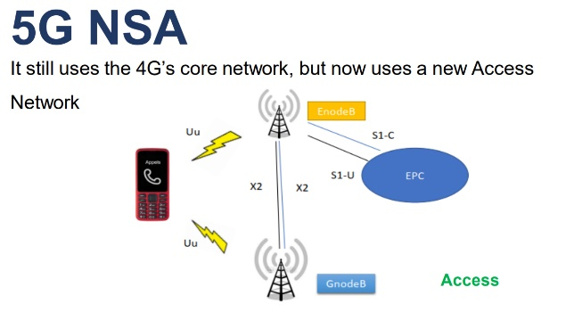

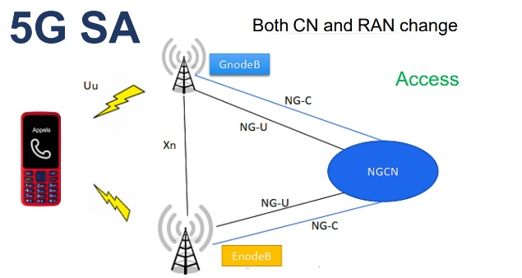

The main difference of NSA (Non-Standalone Architecture) and SA (Standalone Architecture) is that NSA anchors the control signaling of 5G Radio Networks to the 4G Core, while the SA scheme connects the 5G Radio directly to the 5G core network, and the control signaling does not depend on the 4G network at all. NSA, as the name suggests, is a 5G service that does not ‘stand alone’ but is built over an existing 4G network. SA, on the other hand, allows completely independent operation of a 5G service without any interaction with an existing 4G core.

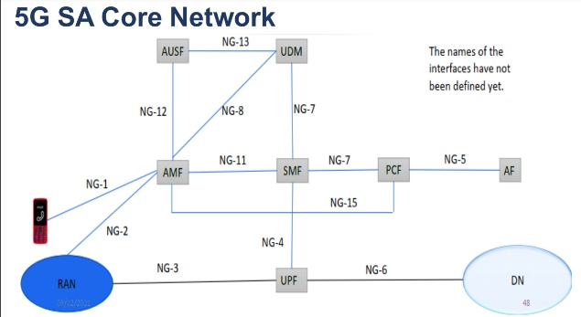

The 5G Core is like the heart and brain of the 5G Networks. The 5GC acts as an enabler for next-generation networks. The Core consists of a Data layer, Control plane and User plane. The Core is a Service Based Architecture (SBA) that drives, and implements the quality of service, enforces policy, Authentication, Signalling, Analytics, Gateway functions etc., and everything related to the networks and functionalities for 5G.

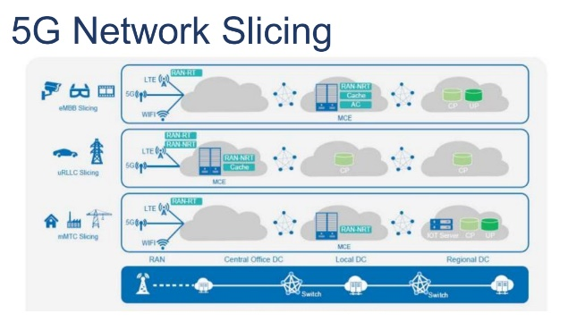

It can be defined as a network configuration that allows multiple networks (virtualized and independent ) to be created on top of a common physical infrastructure. This configuration has become an essential component of the overall [5G architectural landscape](https://www.viavisolutions.com/en-us/what-5g-architecture). Each “slice” or portion of the network can be allocated based on the specific needs of the application, use case or customer.

While services like smart-parking meters value high reliability and security are more forgiving with respect to latency, others (like driver-less cars) may need ultra-low latency (URLLC) and high data speeds. Network slicing in 5G supports these diverse services and facilitates the efficient reassignment of resources from one virtual network slice to another.

The applications that are enabled or enhanced by the [5G](https://www.viavisolutions.com/en-us/node/61549) need greater bandwidth, more connections and lower latency than was achievable with previous generations. Each use case will have its own unique performance requirements, making the one-size-fits-all approach to service delivery obsolete.

The [3GPP](https://www.3gpp.org/about-3gpp) has recognized network slicing to be an essential overall component of 5G. This has made slicing an ongoing focus for working groups developing 5G core architecture with network slicing as an integral feature. 3GPP technical specification (TS) 23.501 defines stage 2 with slicing included, while TS 22.261 specifies the provisioning of network slices, association of devices to slices and performance isolation during normal and elastic slice operation.

[Release 16](https://www.3gpp.org/release-16) of the 3GPP 5G specification includes 5G opportunities like low latency [industrial IoT](https://internetofthingsagenda.techtarget.com/definition/Industrial-Internet-of-Things-IIoT) and autonomous driving. Among the study, items included in 3GPP release 16 are the 5G core solutions to enable cellular IoT and the bandwidth and cost implications of unlicensed NR spectrum.

**Advantages of 5G Technology**

5G is designed to connect numerous embedded sensors virtually in low data, power and mobility.

* 5G technology works 10 times faster than 4G and so it is easier to download files/ videos just in seconds.
* Data rates of 5Gbps or more can be achieved.
* Decreases traffic load.
* Provides consistent and uninterrupted connectivity through the world.
* 5G provides 10 times decrease in latency.
* It is manageable with previous generations.

**IV. RESULT**

As per Qualcomm, 5G uses a bit of all spectrum — from below-1GHz to mmWave — enabling a wide range of use cases.

5G is also faster than 4G with peak data rates of up to 20Gbps and average data rates of over 100Mbps. 5G will also enable a hundred-time increase in traffic capacity and network efficiency, alongside offering a real-time access to data owing to 1ms end-to-end latency.

**V. CONCLUSION**

5 G Wireless Technology is smarter, interconnecting the entire world without limits. Itis designed to provide exceptional and unparalleled data capacities, unhindered volumes of calls and massive transmission of data. Our future would have universal and unrestricted access to information, interaction, and entertainment that would open up and channel a new dimension to our lives. Furthermore, government and authorities can use this innovation as a tool for good governance and build healthier environments that will undoubtedly promote continued investment in next-generation technology, 5G. The biggest noticeable benefits will be speed. 5G is expected to deliver somewhere between speeds that range from ~50 Mbit/s to over a giga bit. Meaning you'll get home broadband-like speed wherever you are. That's going to make a huge difference when it comes to downloading movies, large files, or playing

**ACKNOWLEDGEMENT**

The standardization process involves people from all parts of the world, and we acknowledge the efforts of our colleagues in the wireless industry in general and in 3GPP RAN in particular. Without their work and contributions to the standardization, this book would not have been possible.

I would sincerely thank MTNL,BSNL for providing useful resources and material for my research.

I would also like to thanks Qualcomm .

**REFERENCES**

[1] 3GPP-standards organisation associated with ITU

[2] 5G-https://en.wikipedia.org/wiki/5G

[3] Li, X.; Samaka, M.; Chan, H.A.; Bhamare, D.; Gupta, L.; Guo, C.; and Jain, R. (2017). Network slicing for 5g: challenges and opportunities. IEEE Internet Computing, 21(5), 20-27

[4] Lin, B.S.P. (2021). Toward an ai-enabled SDN-based 5g & IOT network. Network and Communication Technologies, 5(2), 1-7

[5] P. Schulz et al., “Latency Critical IoT Applications in 5G: Perspective on the Design of Radio Interface and Network Architecture” in IEEE Communications Magazine, 55(2): 70-78, 2017.

[6] https://www.qualcomm.com>5G

**AUTHOR**

First Author- Anjali Deepak Shah

Lecturer ,ME(E & C)

Mumbai ,India.

Email [id-anjushah2007@gmail.com](mailto:id-anjushah2007@gmail.com)

Second Author- Mahi Deepak Shah

Second Year of diploma

Mumbai,India.

Email [id-mahi30shah@gmail.com](mailto:id-mahi30shah@gmail.com)