“Hospital Management System”

1. **Author name: Radheyan Patil**

Student, Department of Computer Science Thakur Shivkumar Singh Memorial Engineering College, Burhanpur, Madhya Pradesh, India

E-mail: [Radheypatil1999@gmail.com](mailto:Radheypatil1999@gmail.com)

**Author name: Abdul Faizan**

Student, Department of Computer Science Thakur Shivkumar Singh Memorial Engineering College, Burhanpur, Madhya Pradesh, India

E-mail: fzfaizy800@gmail.com

**3. Author name: Aayush Bathav**

Student, Department of Computer Science Thakur Shivkumar Singh Memorial Engineering College, Burhanpur, Madhya Pradesh, India

E-mail: Vaishnavim438@gmail.com

**Guide name: Prof. Raj Kumar Verma**

Assistant professor, Department of Computer Science Thakur Shivkumar Singh Memorial Engineering College, Burhanpur, Madhya Pradesh, India

E-mail: rajvermaknw@gmail.com

# ABSTRACT

The design of our hospital management system includes registering patients, storing their data in the system and scheduling appointments with doctors. Our software can assign each patient a unique identifier and automatically stores details about each patient and staff. User can search availability of doctors and patient data by ID. The Hospital Management System is accessible with a username and password. The administrator or the receptionist has access to it. Only they can add data to the database. The data can be recovered easily. The user interface is very intuitive. The data is well protected for personal use and makes the data processing very fast. mainly has two modules. One is at the management level and the other at the user level, i.e. H. patients and doctors. The app maintains authentication to access the app. The administrator's job includes managing doctor information and patient information. In order to achieve this, a database for the patient and one for the doctors was developed, to which the administrator has access. Complaints submitted by the user will be processed by the authorities. patient forms include appointment confirmation, prescriptions. You can also pay your medical bills online.

**INTRODUCTION**

# The project "Hospital Management System with Python and Django" includes Patients Registration, archiving of data and information as well as electronic processing. Each patient is assigned a unique identifier and the system automatically stores information about each patient and doctor. The search function informs you about the current status of each

# room. Through the ID, the admin can check

the availability of the doctor as well as the

dates.

A username and password are required to access the hospital management system. Administrative or medical staff have access to it. Data entry into the database is restricted to them. Access to information is easy. A lot of attention has been paid to the design of this interface. Since the data is well protected for personal use, it can be processed in a short time. Hospital Management System has been designed and developed to bring real practical benefits to the hospital and the people who use it. It is easy to use, versatile and easy to use. It is intended for use in small hospitals and covers a limited number of hospital management and administrative procedures. A comprehensive hospital management system that provides critical information across the hospital, including but not limited to hospital administration, patient care and billing, in one seamless stream. Clinical process analysis and pricing are two aspects of the hospital management system that aim to improve the quality and efficiency of hospital management. Developing your organization and improving the efficiency and quality of work is possible thanks to the hospital management system. Good basic process management is essential to the success of a hospital as it allows for better management of processes and procedures.

**EXPLANATION**

Before creating any website, one has to go through the various processes involved in it. The multiple processes combined together to form a model which is used by every software developer to maintain the flow of cycle which creating any kind of application.

The **SDLC** (Software development life cycle model) it consists of multiple phases from requirement gathering, designing, coding, testing, deployment, and maintenance also multiple models are available which according to the requirements and budgets are selected.

**Waterfall Model: -** The waterfall model was the first process model introduced. It is also known as the linear sequential lifecycle model. It's very easy to understand and use. In the waterfall model, each stage must be completed before the next stage can follow, and the stages do not overlap. The waterfall model illustrates software development in a linear sequential process. This means that each stage of the development process is only possible after the previous stage has been completed. In this waterfall model, the phases do not overlap.

The flow of our project can be seen in the following diagram which gives a quick introduction of how our project will flow through multiple stages and what all functionality it will include and how the processes are related to each other through multiple stages.

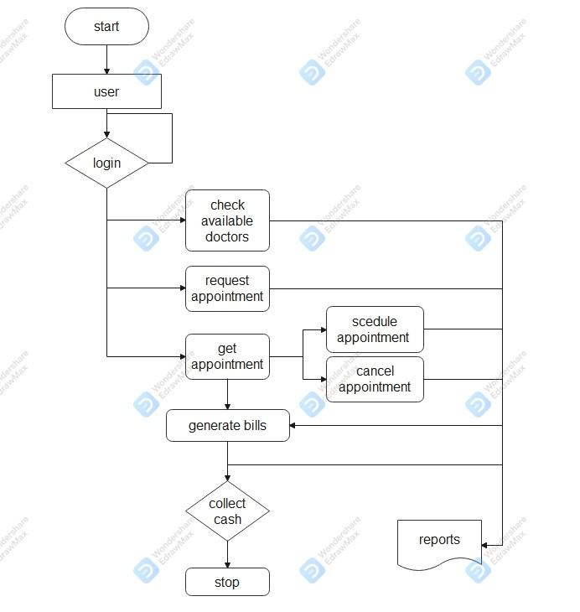

**Objective of Project**

1. Definition of Hospital - People suffering from various diseases can rely on the best medical care available in hospitals, which are an integral part of our daily lives. It is extremely important that hospitals keep detailed records of all of their day-to-day operations, including patients, doctors, wards, nurses, and other hospital staff.
2. Development of an automated system - Recording all activities and related evidence on paper has become very time-consuming and error-prone in recent years. It is also a very inefficient and time-consuming process, especially given the continued increase in population and number of people using the facility. The process of capturing and filing all of these documents is extremely cumbersome, inefficient, and error-prone.
3. Storage of information about various diseases and the medicines available to treat them – This is where our hospital management system stores all patient records from admission to discharge. This is important information that every hospital should be aware of. This system also records all the details of the medication administered to the patient, which prepares the hospital staff for situations when a natural disaster occurs and doctors are unable to visit the hospital and due to a natural disaster, no network is available, so here, in this case, can Hospital staff can review the recent history of previously treated patients with a similar illness.

Putting focuses on the designing perspective we have created a website rather than choosing a mobile application, website easily loads on the user’s devices without consuming memory. We have designed our website in such manner that it is compatible to almost all devices including the laptops of different brands, mobile phone, tablets and many more.

**Home Page|** It includes the short description of the different categories of renting including with the button of the sign in, login page, trending trade and category.

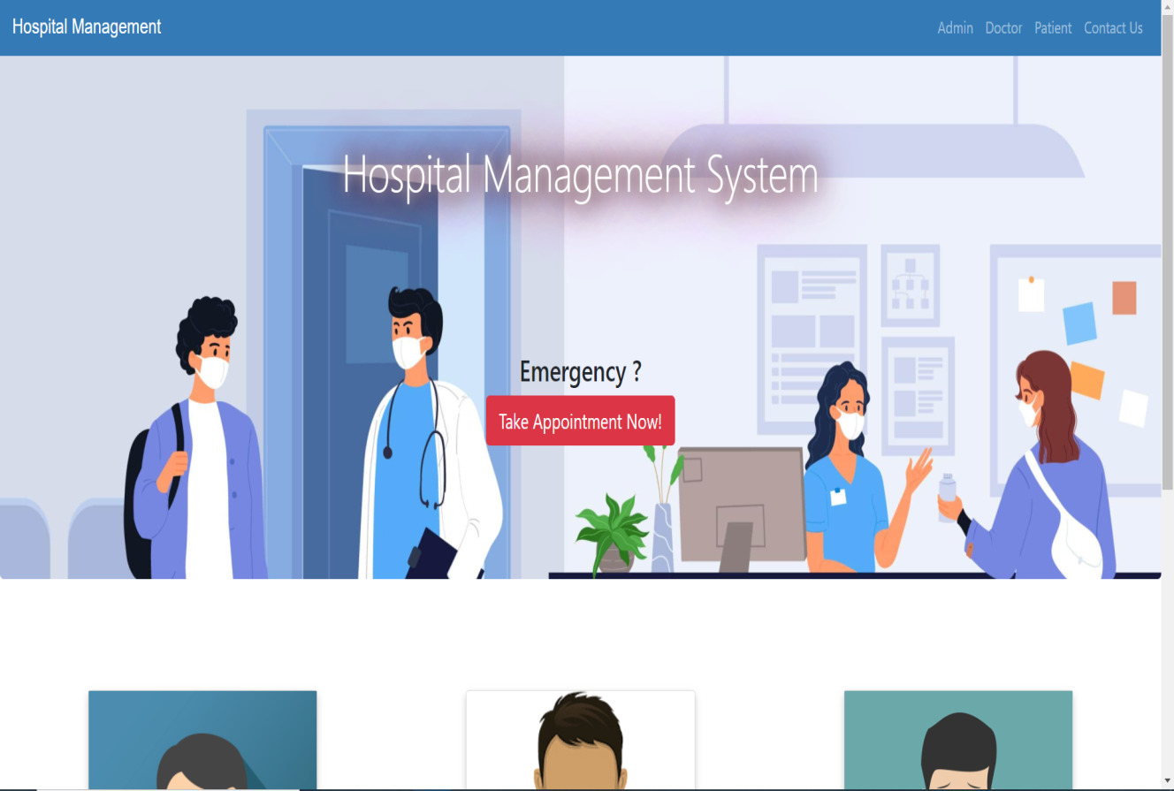

**Sign in page|** This page is maintained for maintaining the track of users who have visited on our website, using their name, email-id, DOB, and password they can register their account on **Hospital Management System website.**

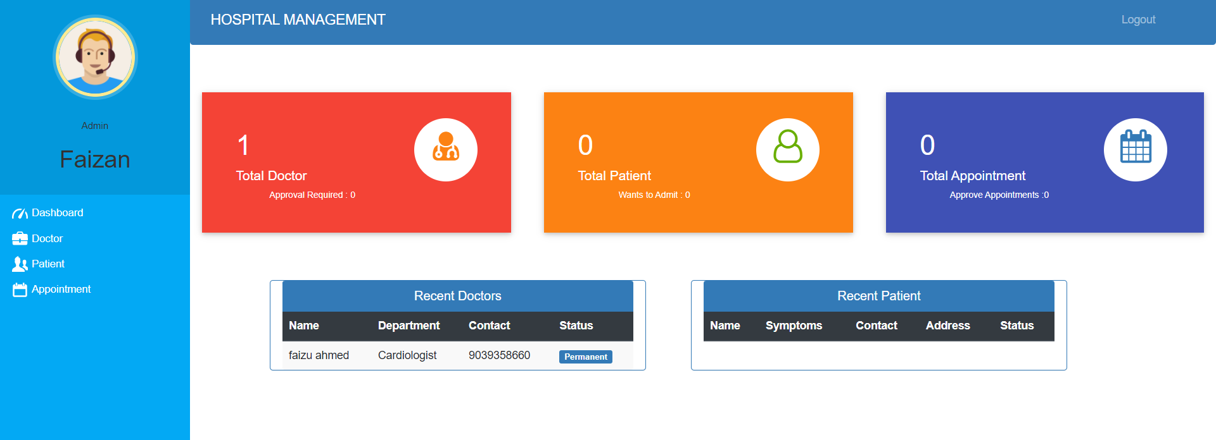

**Login page|** This page will allow registered user to access on the system by using the email-id and password they can login to the system. We have kept an option of forgot password if a user forgot their password, then by using their email- id they will get their password.

# FUTURE SCOPE

The system is to be used as an application to support hospitals, clinics, practices, or other healthcare facilities. The intent of the system is to increase the number of patients that can be adequately treated and managed. When a hospital management system is file-based, hospital management must work hard to protect files. They are easily damaged by fire, insects, and natural disasters. It can also be lost due to loss of data and information.

# CONCLUSION

Working on the project was a great experience. It helped us understand the importance of planning, design, and implementation that we have learned so far in our theory books. We were able to let our creativity run free and work as a team at the same time. She also recognized the importance of teamwork and communication in this project. The project was successfully completed after many hours and efforts. This project has gone through a series of releases, bug fixes, bug fixes, bug-free improvements, further improvements to the hospital management system and interactivity, making it more reliable and user-friendly.

**REFRENCES**

1. John Duckett, HTML and CSS: Design and Build Websites, 2015.
2. Mastering HTML, CSS & JavaScript Web Publishing Paperback, 2016.
3. Elma Sri Remez, Fundamentals of Database System, Seventh Edition, 2017.
4. Ronald J. Leach, Introduction to Software Engineering, 2017.
5. C Severance-IEEE Project Management journal, 2018.
6. P Kyriakakis, A Chatzigeorgiou-IEEE PHP Web Application, 2019.
7. [www.w3school.com](http://www.w3school.com/)
8. [www.scribd.com](http://www.scribd.com/)
9. [www.google.com](http://www.google.com/)
10. [https://geekforgeeks.com](https://geekforgeeks.com/).