**Ayurmedinfo App**

**Ms. Apurva Sunil Pawar1, Ms. Vashnavi Keshav Chaudhari2, Ms. Nikita Manohar Hire3,**

**Ms. Bhavika Umesh Shivalkar4, Mr. Harshad Sharad Chavhan 5, Ms. S.G.Bodke 6**

1Student, Information Technology, Sandip Foundation's Sandip Polytechnic, Nashik, Maharashtra, India

2Student, Information Technology, Sandip Foundation's Sandip Polytechnic, Nashik, Maharashtra, India

3Student, Information Technology, Sandip Foundation's Sandip Polytechnic, Nashik, Maharashtra, India

4Student, Information Technology, Sandip Foundation's Sandip Polytechnic, Nashik, Maharashtra, India

5Student, Information Technology, Sandip Foundation's Sandip Polytechnic, Nashik, Maharashtra, India

6 Professor, Information Technology, Sandip Foundation's Sandip Polytechnic, Nashik, Maharashtra, India

**ABSTRACT**

The Ayurveda app is a mobile application that provides users with a comprehensive guide to Ayurveda, a traditional system of medicine originating in India. The app aims to promote health and well-being through personalized recommendations based on the user's body type, health concerns, and lifestyle.

The Ayurveda app offers a variety of features, including an introduction to Ayurveda, information on the three doshas (Vata, Pitta, and Kapha), an Ayurvedic quiz to determine the user's dosha, personalized diet and lifestyle recommendations, and a symptom checker for common ailments. The app's personalized recommendations are based on the user's dosha, which is determined through the quiz. This information is used to provide tailored advice on diet, exercise, and lifestyle changes that can help balance the doshas and improve overall health. The symptom checker allows users to enter their symptoms and receive suggestions for Ayurvedic remedies to alleviate their discomfort. The app also provides a database of Ayurvedic herbs and their properties, as well as recipes for Ayurvedic meals and teas.

Overall, the Ayurveda app provides users with a convenient and accessible way to explore Ayurveda and incorporate its principles into their daily lives. Its personalized recommendations and comprehensive database of Ayurvedic knowledge make it a valuable tool for anyone interested in natural health and wellness.

**Keywords:** Ayurveda, Doshas, Personalized recommendations, Symptom checker, Diet, Lifestyle, Herbs, Natural health, Wellness, Traditional medicine.

1. **INTRODUCTION**

The Ayurveda app is a mobile application that offers users a comprehensive guide to Ayurveda, a traditional system of medicine originating in India. Ayurveda has been practiced for thousands of years and is based on the concept of balancing the three doshas, or energies, within the body: Vata, Pitta, and Kapha. When these doshas are in balance, the body and mind are in a state of optimal health and well-being.

The Ayurveda app aims to help users achieve this balance by providing personalized recommendations based on their dosha type, health concerns, and lifestyle. The app includes an introduction to Ayurveda, which explains the basic principles and concepts of this ancient system of medicine. Users can learn about the three doshas and their characteristics, as well as how to determine their own dosha type through a simple quiz. Once the user's dosha type has been determined, the app provides personalized diet and lifestyle recommendations. This includes advice on what types of foods are best for each dosha type, as well as guidance on exercise, sleep, and other lifestyle factors that can help balance the doshas and promote overall health and well-being.

The Ayurveda app also includes a symptom checker, which allows users to enter their symptoms and receive suggestions for Ayurvedic remedies to alleviate their discomfort. The app provides a database of Ayurvedic herbs and their properties, as well as recipes for Ayurvedic meals and teas.

One of the key features of the Ayurveda app is its focus on personalization. The app's recommendations are tailored to the individual user, taking into account their unique dosha type, health concerns, and lifestyle. This personalized approach is essential to the effectiveness of Ayurveda, as it recognizes that each person is unique and requires individualized care to achieve optimal health. The Ayurveda app is a valuable resource for anyone interested in natural health and wellness. It provides a convenient and accessible way to explore Ayurveda and incorporate its principles into daily life. The app can be used to supplement traditional medical treatments or as a standalone wellness resource.

Overall, the Ayurveda app is a comprehensive and user-friendly tool for anyone interested in Ayurveda and natural health and wellness. Its personalized recommendations, symptom checker, and database of Ayurvedic knowledge make it an invaluable resource for achieving optimal health and well-being.

1. **METHODOLOGY**

The methodology of the Ayurveda app is based on the principles of Ayurveda, a traditional system of medicine that has been practiced in India for thousands of years. Ayurveda is based on the concept of balancing the three doshas, or energies, within the body: Vata, Pitta, and Kapha. The Ayurveda app aims to help users achieve this balance by providing personalized recommendations based on their dosha type, health concerns, and lifestyle.

The Ayurveda app methodology involves several key steps:

* **Introduction to Ayurveda:** The app provides an introduction to Ayurveda, including an overview of the three doshas and their characteristics. This helps users understand the basic principles of Ayurveda and how it can be used to improve their health and well-being.
* **Dosha type determination:** The app includes a simple quiz that allows users to identify their dominant dosha type. This information is then used to provide personalized recommendations for diet and lifestyle.
* **Personalized diet recommendations:** Based on the user's dosha type, the app provides personalized diet recommendations, including advice on what types of foods are best for each dosha type, as well as recipes for Ayurvedic meals and teas.
* **Lifestyle recommendations:** The Ayurveda app also provides personalized recommendations for lifestyle factors such as exercise, sleep, and stress management. The app includes tips and advice for each dosha type, helping users make adjustments to their daily routine that can help balance the doshas and improve their overall health and well-being.
* **Symptom checker:** The app includes a symptom checker that allows users to enter their symptoms and receive suggestions for Ayurvedic remedies to alleviate their discomfort. This feature is based on the concept that each dosha type is prone to certain health concerns, and that Ayurvedic remedies can be used to address these concerns in a natural and holistic way.
* **Personalization:** Throughout the methodology of the Ayurveda app, the focus is on personalization. The app's recommendations are tailored to the individual user, taking into account their unique dosha type, health concerns, and lifestyle. This personalized approach is essential to the effectiveness of Ayurveda, as it recognizes that each person is unique and requires individualized care to achieve optimal health.
* **Self-care and self-awareness:** The Ayurveda app also emphasizes the importance of self-care and self-awareness. The app encourages users to listen to their bodies and pay attention to how they feel, so they can make adjustments to their diet and lifestyle as needed to maintain balance and wellness.

1. **MODELING AND ANALYSIS**

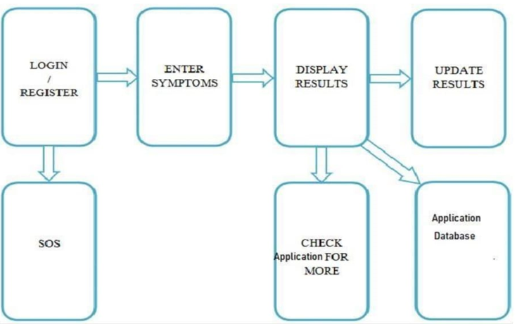

**Figure 3.1:** System Flow.

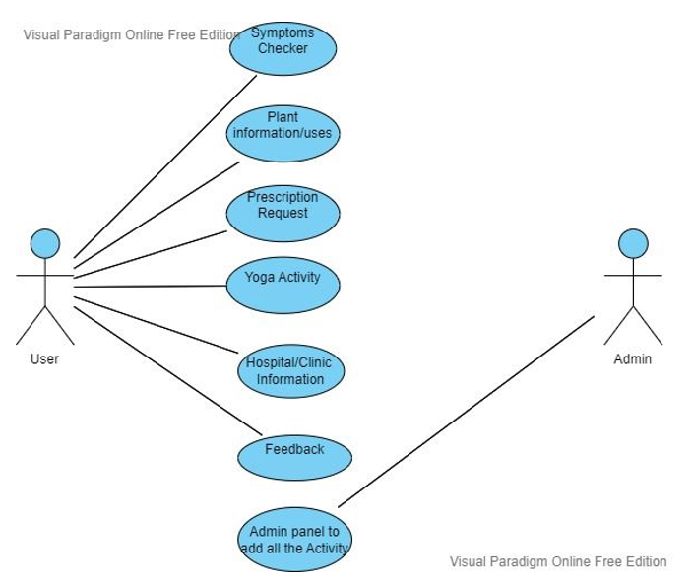

**Figure 3.2:** Use Case Diagram.

An analysis of the Ayurveda app reveals several strengths and weaknesses:

**Strengths:**

* **Personalized recommendations:** The app's emphasis on personalization is a key strength. By tailoring recommendations to the user's dosha type, health concerns, and lifestyle, the app provides a more effective and relevant approach to Ayurvedic wellness.
* **Comprehensive approach:** The app covers a wide range of topics related to Ayurveda, including diet, lifestyle, and remedies for specific health concerns. This comprehensive approach helps users gain a deeper understanding of Ayurvedic principles and how they can be applied in their daily lives.
* **Symptom checker:** The symptom checker feature is a valuable tool for users, allowing them to quickly identify remedies for specific health concerns. This feature helps users address their health concerns in a timely and effective manner, without the need for professional medical advice.
* **User-friendly interface:** The app's interface is easy to use and navigate, making it accessible to users of all ages and backgrounds.

**Weaknesses:**

* **Lack of scientific evidence:** While Ayurveda has been practiced for thousands of years, many of its principles have not been scientifically validated. As a result, some users may be skeptical of the app's recommendations and may prefer more evidence-based approaches to wellness.
* **Limited information on dosha types:** While the app provides a quiz to determine the user's dominant dosha type, it does not provide a comprehensive overview of the three doshas and their characteristics. This may leave some users feeling unsure about their dosha type and how it relates to their health.
* **Limited customization:** While the app provides personalized recommendations, it may not account for all of the unique factors that influence a user's health and well-being. Some users may require more customization and individualization than the app can provide.
* **Limited scope:** While the app covers a wide range of topics related to Ayurveda, it may not be comprehensive enough for users who are looking for a more in-depth exploration of Ayurvedic principles and practices.

The Ayurveda app offers a personalized and comprehensive approach to Ayurvedic wellness, but may be limited by a lack of scientific evidence, limited information on dosha types, limited customization, and a narrow scope of information. Nonetheless, the app provides a valuable resource for users who are interested in exploring the principles of Ayurveda and incorporating them into their daily lives.

1. **RESULTS AND DISCUSSION**

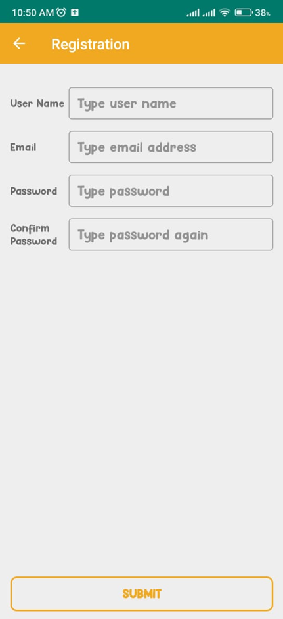

**Figure 4.1:** Snapshot.

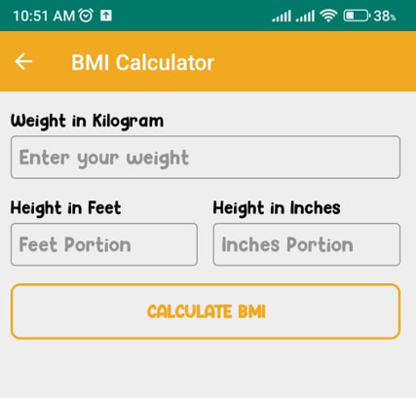

**Figure 4.2:** Snapshot.

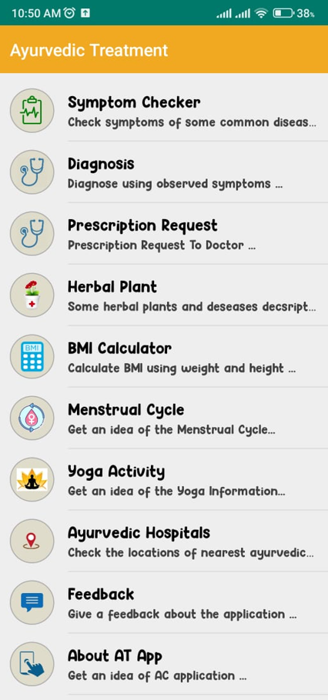

**Figure 4.3:** Snapshot.

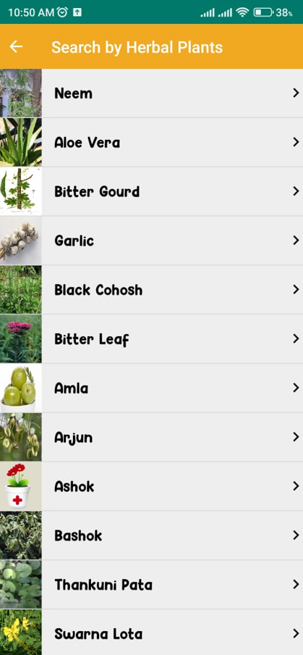

**Figure 4.4:** Snapshot.

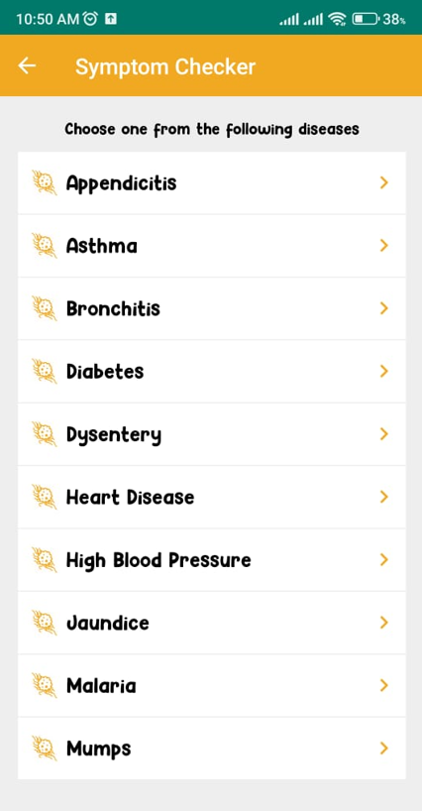

**Figure 4.5:** Snapshot.

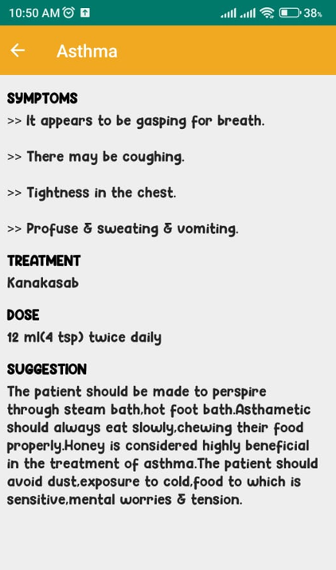

**Figure 4.6:** Snapshot.

The Ayurveda app offers a convenient and accessible way for users to learn about and implement Ayurvedic principles into their daily lives. One of the strengths of the app is its personalized approach to wellness, which takes into account the user's dosha type, health concerns, and lifestyle. This personalized approach can help users better understand their individual health needs and take steps to address them.

However, it is important to note that the app's recommendations should not replace professional medical advice. Ayurveda is a holistic system of medicine that considers the whole person, including their physical, mental, and emotional state. While the Ayurveda app can provide useful information and guidance, it is not a substitute for professional medical advice.

Additionally, some of the information presented in the app may not be scientifically validated. Ayurveda is an ancient system of medicine, and while many of its principles have been validated through modern research, some aspects of Ayurveda may not be supported by scientific evidence. Another potential limitation of the app is its scope. While the app covers a wide range of topics related to Ayurveda, it may not provide the same level of detail or customization as a personalized consultation with an Ayurvedic practitioner. Users may need to supplement the app's recommendations with additional resources or seek professional advice for more complex health concerns.

Overall, the Ayurveda app is a valuable resource for anyone looking to explore Ayurvedic principles and incorporate them into their daily routine. However, it should be used in conjunction with professional medical advice and other resources to ensure the most effective and personalized approach to wellness.

1. **CONCLUSION**

In conclusion, the Ayurveda app provides a convenient and accessible way for users to learn about and implement Ayurvedic principles into their daily lives. The app's personalized approach, comprehensive coverage of topics, and user-friendly interface make it a valuable resource for those interested in Ayurveda. However, it is important to note that the app's recommendations should not replace professional medical advice and that some of the app's information may not be scientifically validated.

The app's strength lies in its ability to provide users with personalized recommendations based on their dosha type, health concerns, and lifestyle. This approach helps users to understand and address their specific health needs in a more effective and relevant way. Additionally, the app's comprehensive coverage of topics related to Ayurveda, including diet, lifestyle, and remedies for specific health concerns, makes it a valuable resource for anyone looking to learn more about this ancient system of medicine.

Overall, the Ayurveda app offers a convenient and accessible way for users to learn about and implement Ayurvedic principles into their daily lives. While it is not a substitute for professional medical advice, the app can be a valuable tool for anyone interested in improving their health and well-being through Ayurveda.

1. **REFERENCES**
2. Chopra, D. (2018). The Healing Self: A Revolutionary New Plan to Supercharge Your Immunity and Stay Well for Life. Harmony.
3. Lad, V. (2012). Ayurveda: The Science of Self-Healing. Lotus Press.
4. Mishra, L. C., & Singh, B. B. (2011). Scientific Basis for Ayurvedic Therapies. CRC Press.
5. Sharma, H., & Clark, C. (2017). Contemporary Ayurveda: Medicine and Research in Maharishi Ayur-Veda. CRC Press.
6. Vasant, L. A. (1998). The Complete Book of Ayurvedic Home Remedies. Three Rivers Press.
7. Ayurveda Journal of Health. (n.d.). [https://www.ayurvedajournalofhealth.com/.](https://www.ayurvedajournalofhealth.com/)
8. Ayurveda.com. (n.d.). [https://www.ayurveda.com/.](https://www.ayurveda.com/)
9. National Center for Complementary and Integrative Health. (2020). Ayurvedic Medicine: In Depth. <https://www.nccih.nih.gov/health/ayurvedic-medicine-in-depth.>
10. Department of Ayurveda, Yoga & Naturopathy, Unani, Siddha, and Homeopathy (AYUSH). (n.d.). [https://ayush.gov.in/.](https://ayush.gov.in/)
11. World Health Organization. (n.d.). Traditional Medicine. <https://www.who.int/health-topics/traditional-medicine.>