**E – Learning App**

**Ms. Priyanka Valmik Naikvade1, Ms. Diksha Laluman Gangurde2,**

**Ms. Sambodhi Subhash Jagtap3, Mr. Bhushan Raybhan Deore4, Mrs. S. A. Lavangade 5**

1Student, Information Technology, Sandip Foundation's Sandip Polytechnic, Nashik, Maharashtra, India

2Student, Information Technology, Sandip Foundation's Sandip Polytechnic, Nashik, Maharashtra, India

3Student, Information Technology, Sandip Foundation's Sandip Polytechnic, Nashik, Maharashtra, India

4Student, Information Technology, Sandip Foundation's Sandip Polytechnic, Nashik, Maharashtra, India

5 Professor, Information Technology, Sandip Foundation's Sandip Polytechnic, Nashik, Maharashtra, India

**ABSTRACT**

An e-learning app is a digital platform that enables users to access educational resources and training materials from anywhere at any time. This app provides a flexible and personalized learning experience that can be tailored to individual learning styles, preferences, and needs.

The e-learning app typically contains a variety of multimedia content such as videos, interactive quizzes, animations, and simulations, as well as forums for collaboration and discussion. Users can also access learning analytics and progress reports to track their performance and identify areas that require improvement. The main advantage of an e-learning app is its accessibility and convenience, as learners can access the platform from any device with an internet connection. This makes learning more flexible and enables users to study at their own pace, which can be particularly beneficial for working professionals or those with busy schedules.

Overall, e-learning apps have transformed the way we approach education and training, making it easier and more convenient for people to access high-quality learning resources and improve their skills and knowledge.

**Keywords:** E-learning, Application, Multimedia, Personalized, Accessible, Progress tracking, Collaboration, Convenience, Lifelong learning, Gamification.

1. **INTRODUCTION**

E-learning applications have emerged as a popular alternative to traditional classroom-based education. With the rise of digital technology, online learning has become more accessible and user-friendly, making it an attractive option for students, professionals, and lifelong learners. E-learning apps are at the forefront of this trend, offering users a flexible and personalized learning experience that can be accessed from anywhere at any time.

E-learning applications typically include a range of multimedia resources such as videos, interactive quizzes, simulations, and games. These resources are designed to cater to different learning styles and preferences, making the learning experience more engaging and effective. The app may also provide features such as progress tracking, personalized recommendations, and collaboration tools to enhance the learning experience further. One of the primary advantages of e-learning applications is their accessibility and convenience. Users can access the app from any device with an internet connection, meaning that they can learn on-the-go, on their commute, or from the comfort of their own home. This flexibility makes e-learning applications particularly appealing to working professionals or individuals with busy schedules who may not have the time or resources to attend traditional classes.

E-learning applications offer users a personalized learning experience that can be tailored to their individual needs and preferences. Users can choose the topics they want to study, the pace at which they learn, and the resources they use. This flexibility allows users to focus on areas they need to improve or learn new skills in a more efficient and effective way. E-learning applications often incorporate gamification into their design, which involves using game elements such as points, badges, and leaderboards to incentivize and motivate learners. This approach can make learning more engaging and enjoyable, as learners are rewarded for their progress and achievements.

E-learning applications also provide opportunities for collaboration and community building, which can enhance the learning experience. Users can interact with other learners, share resources and ideas, and participate in discussion forums. This collaborative approach can foster a sense of community and support, making learning more social and enjoyable. Despite the many advantages of e-learning applications, there are also challenges and limitations to this approach. One potential challenge is the need for reliable internet connectivity, which may not be available in some areas or may be costly. Another challenge is the potential for social isolation, as e-learning may be a solitary experience. Additionally, some learners may struggle with self-discipline and motivation when learning online.

E-learning applications have transformed the way we approach education and training, offering a flexible and personalized learning experience that can be accessed from anywhere at any time. These apps provide a range of multimedia resources and features that cater to different learning styles and preferences, making the learning experience more engaging and effective. While there are some challenges and limitations to this approach, e-learning applications have the potential to democratize education and training, making it more accessible and affordable for all. As technology continues to evolve, we can expect e-learning applications to play an increasingly important role in the future of education and training.

1. **METHODOLOGY**

The methodology of developing an e-learning app involves several key steps:

* **Needs Assessment:** Conducting a needs assessment to identify the target audience, learning objectives, and desired outcomes of the e-learning app.
* **Content Development:** Developing content that is engaging, informative, and interactive using a variety of multimedia resources such as videos, simulations, and quizzes.
* **User Interface Design:** Designing an intuitive and user-friendly interface that allows users to navigate the app easily and access the content they need.
* **Technology Selection:** Selecting appropriate technologies for app development and content delivery, such as learning management systems, web-based platforms, or mobile apps.
* **Prototyping and Testing:** Creating a prototype of the app and conducting user testing to ensure that it meets the needs of the target audience and is easy to use.
* **Implementation and Deployment:** Launching the app and making it available to users on the desired platforms, such as the App Store or Google Play.
* **Maintenance and Updates:** Monitoring and maintaining the app to ensure that it continues to function effectively, updating content as needed and addressing any bugs or technical issues that arise.

Overall, the methodology of developing an e-learning app requires careful planning and execution, with a focus on creating engaging and interactive content and designing an intuitive and user-friendly interface. By following these steps, developers can create e-learning apps that offer a personalized and effective learning experience to users.

1. **MODELING AND ANALYSIS**

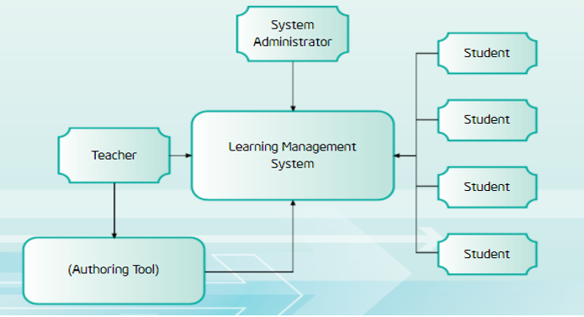

**Figure 3.1:** System Architecture.

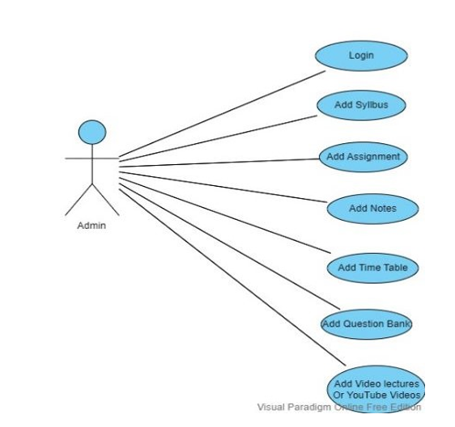

**Figure 3.2:** Use Case Diagram.

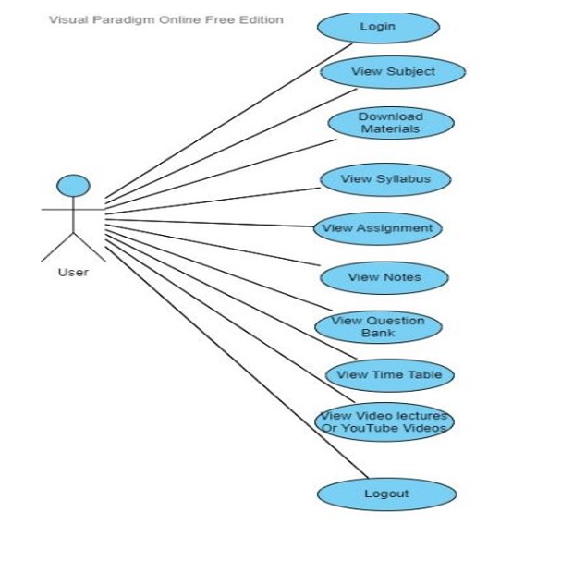

**Figure 3.3:** Use Case Diagram.

In this analysis of e-learning apps, we will examine some of the key features and aspects of these apps that contribute to their effectiveness and success in education.

First, e-learning apps should be designed with a focus on user experience and user interface. The app should be intuitive and easy to navigate, with clear instructions and a logical flow of content. Additionally, the app should be visually appealing, with engaging multimedia resources that enhance the learning experience. Another important aspect of e-learning apps is the quality of the content. The content should be relevant, up-to-date, and well-organized. It should also be presented in a variety of formats, such as text, video, and audio, to cater to different learning styles.

Personalization is also crucial for the effectiveness of e-learning apps. The app should provide learners with the ability to customize their learning experience to suit their needs and preferences. This can include features such as progress tracking, adaptive assessments, and personalized recommendations based on the learner's performance. Collaboration and interaction are also essential features of effective e-learning apps. The app should provide learners with opportunities to collaborate with instructors and peers, such as through discussion forums or virtual classrooms. These interactions can facilitate knowledge sharing, feedback, and support, which can enhance the learning experience.

Finally, the app should be regularly updated and maintained to ensure its effectiveness and relevance over time. This includes fixing any bugs or technical issues, updating content to reflect current trends and developments, and incorporating feedback from users to improve the app's usability and effectiveness.

Overall, e-learning apps have the potential to provide learners with a personalized, flexible, and engaging learning experience. However, the success of these apps depends on various factors such as user experience, quality of content, personalization, collaboration, and maintenance. By focusing on these aspects, developers can create e-learning apps that are effective, engaging, and transformative in the education sector.

1. **RESULTS AND DISCUSSION**

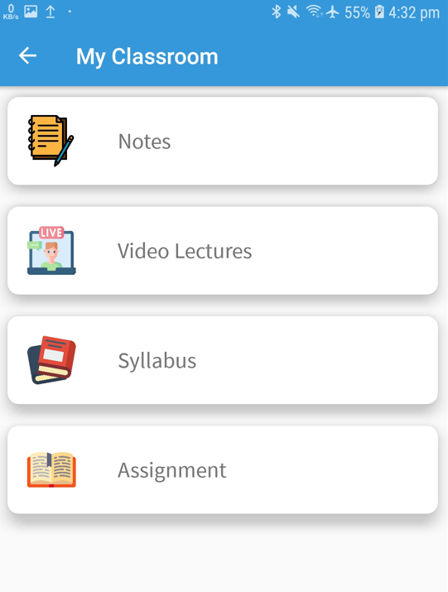

**Figure 4.1:** Snapshot.

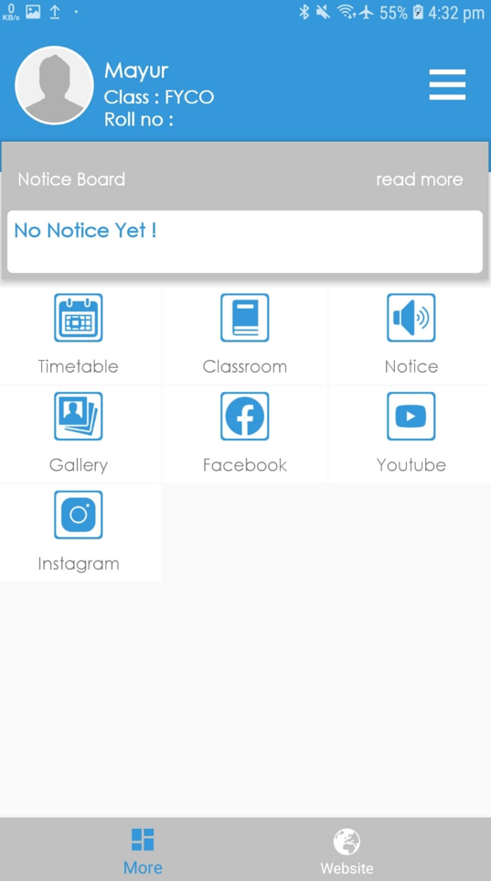

**Figure 4.2:** Snapshot.



**Figure 4.3:** Snapshot.

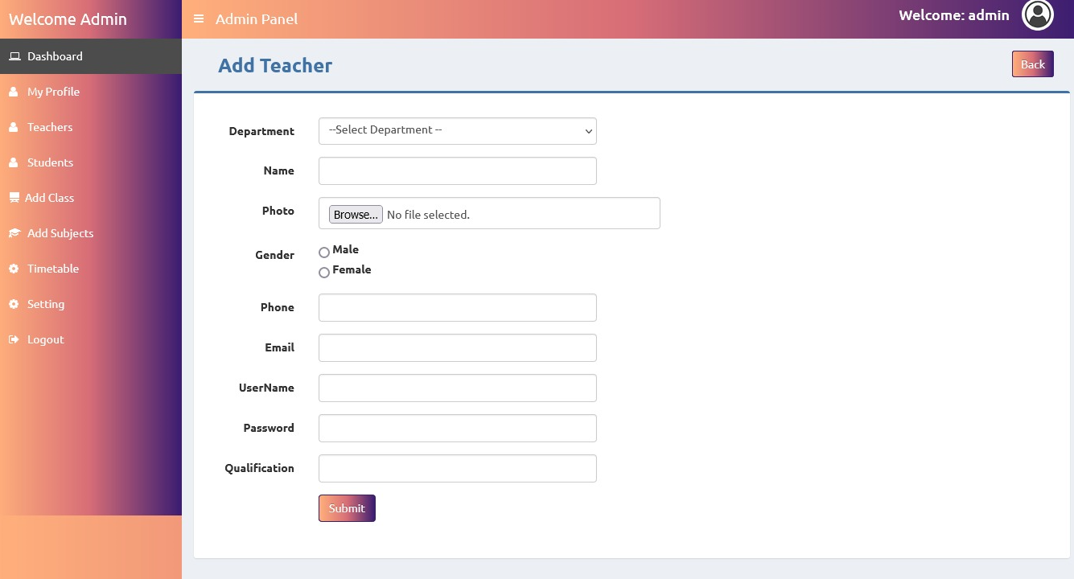

**Figure 4.4:** Snapshot.

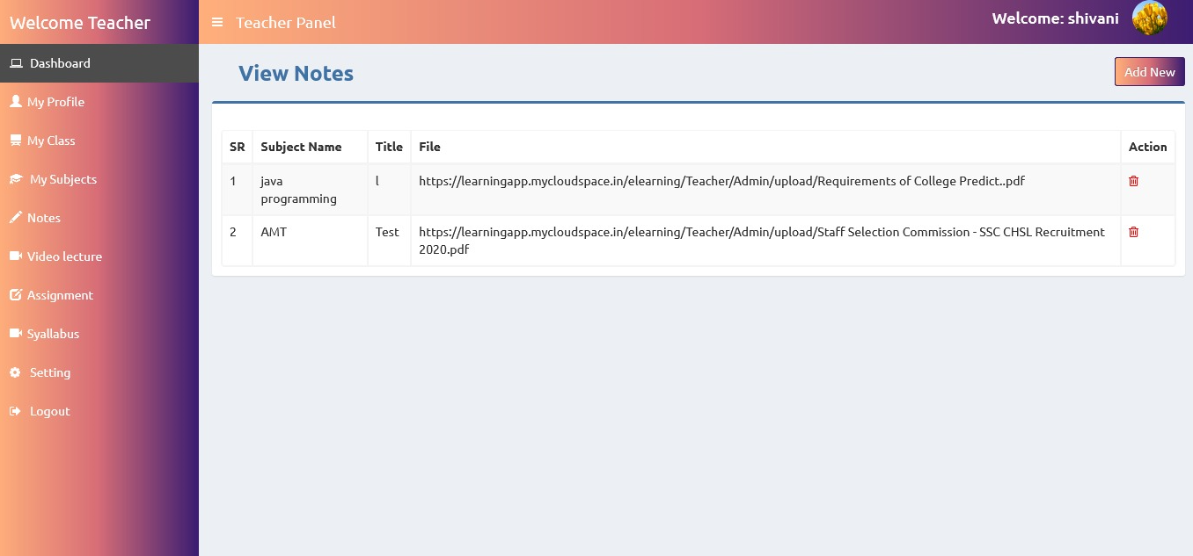

**Figure 4.5:** Snapshot.

The development and use of e-learning apps have brought significant changes to the traditional education system. With the advancements in technology and the rise of mobile devices, e-learning apps have become increasingly popular and essential in providing learners with the flexibility and convenience to access educational materials at their own pace and convenience. In this discussion, we will explore some of the benefits and limitations of e-learning apps and their impact on education.

One of the most significant advantages of e-learning apps is the flexibility they offer. Learners can access educational materials and complete assignments at their own pace and convenience, making it easier for them to balance their studies with other commitments such as work or family. This flexibility allows learners to take charge of their learning and personalize their experience, which can lead to better engagement and higher levels of motivation.

E-learning apps also provide learners with a wide range of multimedia resources, such as videos, simulations, and quizzes, which can make learning more interactive and engaging. These resources can help learners to understand complex concepts better and provide opportunities for them to apply their knowledge in real-world situations. However, e-learning apps also have some limitations. For example, they may not be suitable for all types of learners, and some learners may prefer the traditional classroom setting. Additionally, the lack of face-to-face interaction with instructors and peers may hinder some learners' ability to fully engage with the material and may limit their opportunities for collaboration and discussion.

Another limitation of e-learning apps is the potential for distraction. Learners may be more prone to distractions such as social media, emails, and notifications when using mobile devices, which can negatively impact their ability to focus on learning. Despite these limitations, e-learning apps have the potential to transform education and provide learners with the skills and knowledge they need to succeed in their chosen fields. As technology continues to evolve, e-learning apps will likely become even more advanced and sophisticated, providing learners with even more personalized and effective learning experiences.

In conclusion, the development and use of e-learning apps have brought significant changes to the education system. While they have their limitations, e-learning apps offer learners flexibility and a wide range of multimedia resources that can make learning more engaging and interactive. As technology continues to advance, e-learning apps will play an increasingly important role in providing learners with the skills and knowledge they need to succeed in the future.

1. **CONCLUSION**

In conclusion, e-learning apps have become increasingly popular and essential in today's digital age. They offer a convenient and flexible way for learners to access educational content and materials from anywhere at any time. The development of e-learning apps involves a comprehensive methodology that includes needs assessment, content development, user interface design, technology selection, prototyping and testing, implementation and deployment, and maintenance and updates. E-learning apps can provide a personalized and effective learning experience to users through engaging and interactive content and an intuitive and user-friendly interface. However, it is essential to consider the effectiveness and quality of the content and instructional design to ensure that the app meets the desired learning outcomes. Overall, the development and use of e-learning apps have the potential to transform education and provide learners with the skills and knowledge they need to succeed in their chosen fields.

1. **REFERENCES**
2. Khan Academy. (2021). Khan Academy. Retrieved from <https://www.khanacademy.org/>
3. Coursera. (2021). Coursera. Retrieved from <https://www.coursera.org/>
4. Udemy. (2021). Udemy. Retrieved from <https://www.udemy.com/>
5. edX. (2021). edX. Retrieved from <https://www.edx.org/>
6. Codecademy. (2021). Codecademy. Retrieved from <https://www.codecademy.com/>
7. Duolingo. (2021). Duolingo. Retrieved from <https://www.duolingo.com/>
8. Rosetta Stone. (2021). Rosetta Stone. Retrieved from <https://www.rosettastone.com/>
9. Udacity. (2021). Udacity. Retrieved from <https://www.udacity.com/>
10. Skillshare. (2021). Skillshare. Retrieved from <https://www.skillshare.com/>
11. LinkedIn Learning. (2021). LinkedIn Learning. Retrieved from <https://www.linkedin.com/learning/>
12. Bonk, C. J., & Khoo, E. (2014). Adding some TEC-VARIETY: 100+ activities for motivating and retaining learners online. Open World Books.
13. Clark, R. C., & Mayer, R. E. (2016). E-learning and the science of instruction: Proven guidelines for consumers and designers of multimedia learning. John Wiley & Sons.
14. Huang, R., Liu, D., & Tlili, A. (2019). What drives learners' continuance intention to use MOOCs? The perspectives of trainers and learners. Computers & Education, 142, 103641.
15. Kirschner, P. A., Sweller, J., & Clark, R. E. (2006). Why minimal guidance during instruction does not work: An analysis of the failure of constructivist, discovery, problem-based, experiential, and inquiry-based teaching. Educational psychologist, 41(2), 75-86.
16. Siemens, G. (2013). Massive open online courses: Innovation in education? In Rethinking pedagogy for a digital age (pp. 31-64). Routledge.
17. Sitzmann, T. (2011). A meta-analytic examination of the instructional effectiveness of computer-based simulation games. Personnel Psychology, 64(2), 489-528.
18. Wiley, D., & Hilton III, J. L. (2018). Defining OER-enabled pedagogy. The International Review of Research in Open and Distributed Learning, 19(4).