**Abstract:**

**A Review on Zigbee Technology and its Application in Wireless Communication**

Madhuvanthi.S[Student] Angelpriyadharshini .V[Student]

[madhu.s.saminathan@gmail.com](mailto:madhu.s.saminathan@gmail.com)

angelveeramani2000@gmail.com

ZigBee Technologies provides various advantages over other communication interfaces. ZigBee Technologies are constantly used in WSN (Wireless Sensor Network) to provide an interface between sensors and also transfer data to the end user with low power consumption and high efficiency.ZigBee Technologies are also used to monitor various prospects of the human body including their physical work like walking, heartbeat rate, and more. Zigbee technologies help utilize the WSN to the maximum. Several types of research are in progress on the applications of Zigbee Technologies. In this paper, we discuss the research made in enhancing the usage of WSNs and their implementations. Most of the research focuses on enhancing Zigbee Technology, and also on implementing the Zigbee Technology to enhance routing scheme, Tree Construction Framework, Mobile Interface, etc. Various ideas on the implementation of Zigbee Technologies are discussed and elucidated with applications.

**Introduction:**

Zigbee Technology is a power-efficient, cheap, low-data rate networking protocol used to implement automation and remote control applications. IEEE and Zigbee technologies united and kept the name Zigbee. Zigbee is used in devices having low power capacity. Zigbee uses three frequencies as their standard, which are 2.4GHz, 915MHz, and 868MHz which provide a data transfer rate up to 250Kbps, 40Kbps, and 20Kbps respectively. The most important advantage of Zigbee Technologies is the ability to support mesh networks. Mesh Networks have nodes interconnected with each other in multiple pathways and are dynamically updated as the nodes are added.

**MIHBS: A Mobile Interface of High Bandwidth for Wireless Sensor Networks**

This Idea involves introducing hardware to the headset port which is used to transfer data from the sensors surrounding the Mobile phone, mostly Zigbee Sensor which transfers data at 250Kbps. They have used **Lempel-Ziv-Welch Coding Scheme** to implement an interface to use a high bandwidth which is 52% higher than a high bandwidth network. They use an enhanced Lempel-Ziv-Welch-Huffman Scheme to overcome the lack of power of theheadset port and also allow enhanced data transfer. Thus, increasing the efficiency of transferring data from the sensor to the user. The resultant universal interface transfers data fromthe headset port in a high bandwidth to provide a better WSN (Wireless Sensor Network).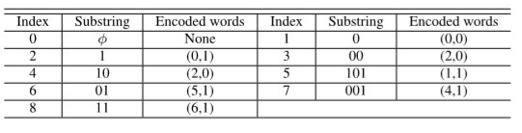

Example using LZW-Huffman Encoding

**Low-Power Low-VHF Ad-Hoc Networking in Complex Environment**

The lower portion of a very high frequency is often used less due to the difficulty in producing low-power systems and miniature antennas to transmit data. In this paper, they implement a newly developed antenna with a low-powered Zig-bee radio operating at 2.4 GHZ and a bi-directional converter to convert the VHF(Very High Frequency) waves to the lower portion of the frequency. 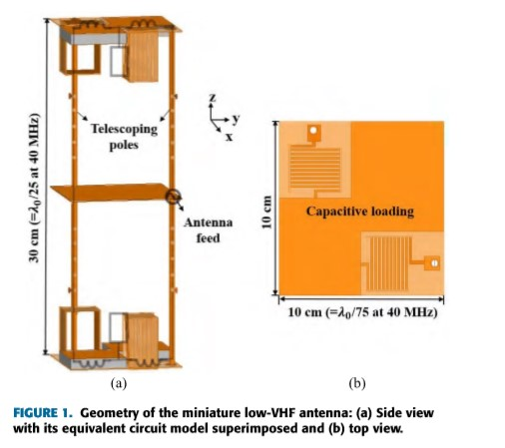

The main objective of this idea is to use higher penetration provided by the lower frequency of the VHF to be used in Non-Line-of-Sight complex regions and in outdoors to solve the problems of Packet Error Rate, Fading, Radio Signal Strength and increase the coverage of the radio, where there are several interferences by other communication networks. They archived a low power specifically a 5mW module capable of running efficiently in various environments. The used antenna provides an insertion gain greater than other antennas similar in size aspects. It also established a highly reliable and persistent point-to-point communication that can be used in vehicles to map close-range places.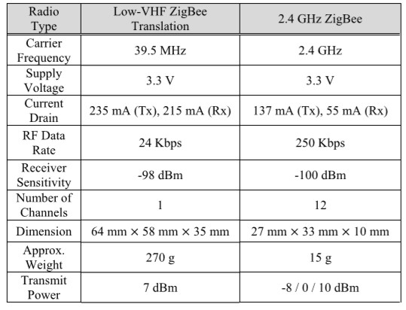

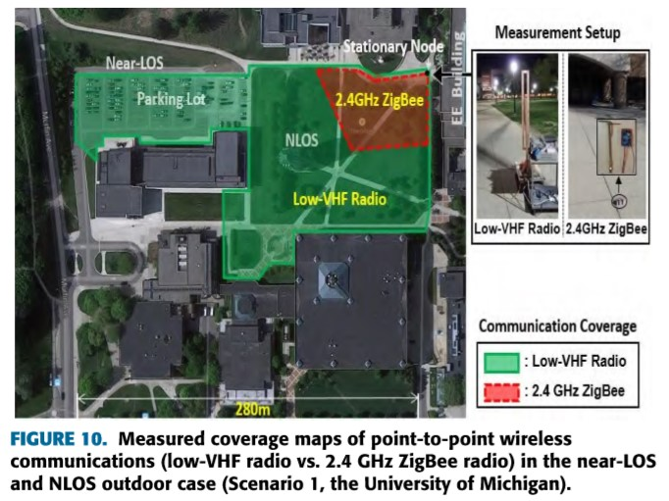

**Obstacle Avoidance Routing Scheme Through Optimal Sink Movement for Home Monitoring and Mobile Robotic Consumer Devices**

Home Automation through Zigbee devices is archived through atransfer of data between nodes using multi-hop communication to reach the end user. But, the reliability of this transfer due to the obstacles in a home environment is questionable. To overcome said problem a mobile sink can be utilized but, the movement pattern of the mobile sink is vital to transfer data error-free. The idea is to implement a mobile sink obstacle avoidance routing scheme for the mobile sink to collect data from the nodes by traversing in the route determined by the algorithm. This reduced energy consumption and increased performance, life span,and reliability. This also reduces the strain of the nodes near the sink as the sink moves in the best way for nodes to interact in reduced multi-hop transfer. This efficiency can be utilized for home automation products including robotic vacuum cleaners, personal security robots, etc… In research the sensor uses IR to determine the obstacles in the path that are to be used to provide an efficient route for the mobile sink. Also, the mobile sink implements obstacle avoidance to find the shortest path to static nodes to collect data.

**A Mobility-Aware Node Deployment and Tree Construction Framework for ZigBee Wireless Networks**

Zig-Bee modules are used as they consume low power and are cheaper to set up apersonal area network. A tree topology is followed to connect the wireless sensor network to deliver data. But, often due to the mobility of the nodes the efficient data transfer is reduced. This is conventionally overcome using the route reconstruction method but, it consumes a large number of resources and also needs frequent changes based on the movement of the nodes. The concept to overcome this, as proposed is to, analyze the node mobility pattern and provide an efficient path to reduce the frequency of the route reconstruction and also ensure that the transmission of data between the mobile nodes is efficient. Also, to increase the data delivery ratio and reduce the data loss in the transmission of data which is archived by enabling overhearing nodes that transfer data to the respective node if it is still in the system. The primary proposal is to set up the routers in a topology that ensures efficient data transfer between the nodes and the end user. This moves the nodes highly probabilistic and enables the completion of the framework.

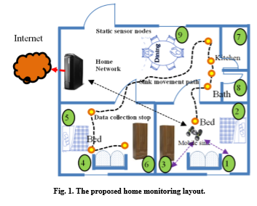

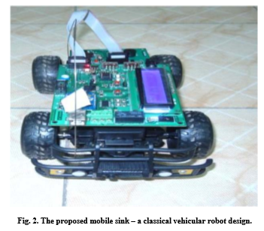

**ZigBee-Assisted Power Saving Management for Mobile Devices**

Wi-fi transmission on mobile devices consumes a large amount of energy which is a problem for energy-constrained devices. To save power on mobile devices a Power Saving Management (PSM) has been standardized on mobile devices. But they cannot adapt to the dynamic traffic pattern and also respond fast to the wake-up packet. To solve this, they used the in-built low-power interface (like Bluetooth, Zig-Bee) to send the wake-up packet reducing the power wasted in the process of waiting for packets. This scheme is called Zig-Bee Power Saving Management (ZPSM). This has shown a significant power usage reduction by the devices using ZPSM.

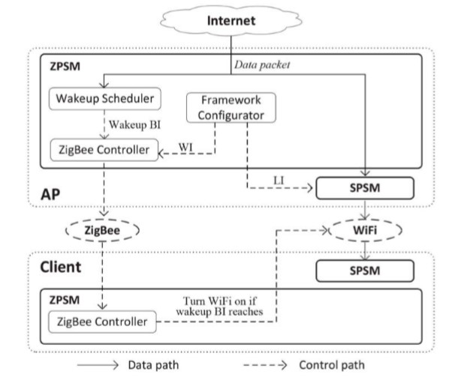

**Link Technologies and Blackberry Mobile Health(mHealth):**

Mobile Systems are currently being used to monitor, record, and relay a variety of health-related data applications. Electronic Health Records (EHR) enable easy exchange of medical information among patients. There are seven key capabilities that EHR systems are expected to provide. eHealth/mHealth is expected to increase performance and decrease costs.it also has its own set of challenges like the quality of service and security. It has been the two odds even from traditional methods. The main factor repels is that if we implement a security mechanism it leads to overheads that require extra bandwidth. The IEEE defines a communication standard that is optimized for low-power wireless wearables that can be worn by humans. A list of medical monitoring applications under WBAN includes Blood pressure, heart pulse, temperature, respiration, pulse oximeter (SpO2), electroencephalogram, electrocardiography (ECG), electromyography, motion detection, cochlear implant, artificial retina, audio, and voice. There are currently numerous proprietary low-power sensor technologies in the market. Those suitable for the health context include [30]: Sensium, ANT+, Body LAN, and Z-Wave.

**Optimizing Data Forwarding from Body Area Networks in the Presence of Body Shadowing with Dual Wireless Technology Nodes**

For communication, these WBANs usually employ radio frequency (RF) technologies that operate in the industrial, scientific, and medical (ISM) radio bands. Although RF is the only practical mechanism to forward data in this scenario, still some problems remain. RF signals will be suffered considerably by body shadowing in a highly variable way concerning to human body. This makes communication between on-body nodes, and off-body, very unreliable. RF-based WBANs in the face of body shadowing there is a fundamental tradeoff: Either consume more energy for retransmissions or channel coding to increase reliability and suffer also higher delay or reduce delay and energy at the cost of reduced reliability. To solve this problem we present a new WBAN architecture that uses two communication technologies. One network is formed between on-body nodes and is realized with capacitive body-coupled communication (BCC), while an IEEE 802.15.4 radio frequency (RF) network is used for forwarding data to the gateway. A network layer protocol is designed to manage communication and is responsible for relay selection and data forwarding. The performance results indicate that the proposed system is more efficient than a state-of-the-art scheme in terms of energy and delay under different realistic channel conditions, application loads, and performance constraints.

**Free Side-Channel Cross-Technology Communication in Wireless Networks**

Enabling direct communication between wireless technologies immediately brings significant benefits including, but not limited to, cross-technology interference mitigation and context-aware smart operation.FreeBee-a novel cross-technology communication technique for direct unicast as well as cross-technology/channel. The key concept of FreeBee is to modulate symbol messages by shifting the timings of periodic beacon frames. Wi-Fi has access to a virtually unlimited amount of information via the Internet, it consumes a considerable amount of power, causing battery problems in mobile devices. Conversely, the ZigBee network often operates as a standalone and has limited information, but is extremely energy efficient. Thus, both networks can be enhanced via mutual supplementation, demonstrating the positive side of coexistence.AFreeBee framework that allows direct communication between heterogeneous senders and receivers. FreeBee requires no hardware modification. Extensive testbed experiments on three popular wireless technologies, WiFi, ZigBee, and Bluetooth, reveal that our design offers reliable symbol delivery within less than a second. An examination of real WiFi deployment patterns in a shopping mall area finds that FreeBee can save 78.9% of the energy otherwise wasted by the WiFi interface.

**Coexistence of ZigBee-Based WBAN and WiFi for Health Telemonitoring Systems**

Telemonitoring via wireless body area networks (WBANs) is evolving as personalized medicine and home-based mobile health. A WBAN consists of small, intelligent medical sensors which collect physiological parameters such as electrocardiogram, electroencephalography, and blood pressure.ZigBee targets applications that require low data and long battery life.However,ZigBee faces many problems while with the interference of the Wi-Fi network. Most of these problems are caused by the overlapping of Channels over the other. To solve this problem, we have proposed an adaptive load control algorithm that controls only the WiFi traffic generated from delay-tolerant applications and dynamically to guarantees that the delays experienced by ZigBee sensors do not exceed the maximally tolerable delay period.

**Conclusion:**

Zigbee Technologies has implemented various concepts to their technology improving and providing various methodologies to introduce a WSN and also use sensors on an efficient basis. Zigbee Technologies has introduced compression and transfer techniques to increase data transfer and also prevent data loss. Zigbee Technologies also has explored the lower frequency ranges to improve penetration and perform data transfer in a complex environment. Zigbee Technologies have also used mobilesink-based Network paths to improve node data transfer to the end user. Zigbee technologies haveintroduced a new framework to better the usage of network resources to improve user experience in the Network. Zigbee technologies also has introduced other means to save power and also reduce the consumption of other devices.

**Reference:**

1) Liang Sun, Lei Wang, Jian Fang, Jialin Liu, And Can Ma, “MIHBS: A Mobile Interface of

High Bandwidth for Wireless Sensor Networks”, Journal: Special Section On

Collaboration For Internet Of Things IEEE ACCESS, Page:8235-8244, Volume 7, 2019.

2) Jihun Choi, Fikadu T. Dagefu, Brian M. Sadler, and Kamal sarabandi, “Low-Power

Low-VHF Ad-Hoc Networking in Complex Environments”, Journal: IEEE Transactions

on Consumer Electronics, Page:24120-24127, Volume 5, 2017.

3) PrasenjitChanak, Indrajit Banerjee, Jin Wang, and R. Simon Sherratt, “Obstacle

Avoidance Routing Scheme Through Optimal Sink Movement for Home Monitoring

and Mobile Robotic Consumer Devices”, Journal: IEEE Transactions on Consumer

Electronics, Page:596-604, Vol. 60.

4) Yuan-Yao Shih, Wei-Ho Chung, Pi-Cheng Hsiu, and Ai-Chun Pang, “A Mobility-Aware

Node Deployment and Tree Construction Framework for ZigBee Wireless Networks”,

Journal: IEEE Transactions on Vehicular Technology, Page:2763-2779, VOL. 62, NO. 6,

July-2013.

5) Hua Qin and Wensheng Zhang, “ZigBee-Assisted Power Saving Management for

Mobile Devices”, Journal: IEEE Transactions on Mobile Computing, Page:2933-2947,

Volume:13, No. 12, December 2014.

6) SasanAdibi, Senior Member, IEEE, “Link Technologies and Blackberry Mobile Health(mHealth)”, Journal: IEEE TRANSACTIONS ON INFORMATION TECHNOLOGY IN BIOMEDICINE, Page:586-597, Volume 16, NO. 4, JULY 2012.

7) AntoniosArgyriou, Member, IEEE, Alberto Caballero Breva, and Marc Aoun, “Optimizing Data Forwarding from Body Area Networks in the Presence of Body Shadowing with Dual Wireless Technology Nodes”, Journal: IEEE Transactions On Mobile Computing, Page:632-644, Vol. 14, No. 3, March 2015.

8) Song Min Kim, Shigemi Ishida, Member, IEEE, Shuai Wang, and Tian He,” Free Side-Channel Cross-Technology Communication in Wireless Networks”, Journal: IEEE/ACM TRANSACTIONS ON NETWORKING,Page:2974-2987, Volume 25, NO. 5, OCTOBER 2017.

9) Yena Kim, Student Member, IEEE, SeungSeob Lee, Student Member, IEEE, and SuKyoung Lee, Member, IEEE,”Coexistence of ZigBee-Based WBAN and WiFi for Health Telemonitoring Systems**”,**Journal: IEEE JOURNAL OF BIOMEDICAL AND HEALTH INFORMATICS,Page:222-230, VOL. 20, NO. 1, JANUARY 2016.