E – VOTING SYSTEM USING BLOCK CHAIN

# Mrs.G.Mariammal,M.E*1, Sivasankar K*2, Srinath R*3,

# Sriram M*4, Surya K N*5

*1 Assistant Professor, Department of CSE, PSNA CET, Dindigul, TamilNadu, India.

*2,3,4,5Students, Department of CSE, PSNA CET, Dindigul, TamilNadu, India.

# ABSTRACT

The consumption of enormous time in the election booth paves a vital role in reducing the voting percentage of a country. This can be overcome with the help of online voting system which provides you a user friendly and secured environment where user can easily vote from their location. For some years, online voting has emerged as a substitute for paper-based elections to reduce redundancies and anomalies. The recent point of view adopted in the past two decades shows that it has not been as successful for some period because of the cloud encryption and privacy observed. Here we use cooperative block chain methods to maintain information protection. We use cooperative blockchain, which means that an administrating entity owns the block chain (e.g., election commission), so therefore no unapproved access may be created from outside. This system requires a good internet connection of any private network sectors of an android or an iOS operating mobile phones, laptops and tablets with conditioned chargeable batter. Further the system collects the unique primary identification card, voter id and mobile number with respect to the voter's country to ensure no fraud or malpractice while voting. It professes to catch the protection and details the problems confronting the executive in block chain, and gives an better explanation of the online voting process. Through internet via voting the voter's time is minimized and the voting can be done quicker. Thus, the rate of voting can be increased by this online voting system.

# 1.INTRODUCTION

Online voting using blockchain is a new and innovative way of conducting elections that promises to provide a secure and transparent method of voting. The use of blockchain technology, which is known for its decentralized and immutable nature, ensures that the voting process is tamper-proof and transparent. Traditional voting systems have been criticized for their susceptibility to hacking, vote manipulation, and lack of transparency. Online voting using blockchain technology aims to overcome these challenges by creating an immutable and decentralized ledger of all transactions related to the voting process. This means that every vote is recorded on the blockchain, verified by multiple nodes in the network, and is resistant to any kind of manipulation or alteration. The use of blockchain technology also ensures that the privacy of voters and their votes is maintained. With the increasing digitization of our world, online voting using blockchain technology is a promising solution for conducting secure, transparent, and efficient elections.

Online voting using blockchain technology is a revolutionary concept that has the potential to transform the way we conduct elections. The current voting systems, which are based on paper ballots or electronic voting machines, have faced criticism for their lack of security and transparency. This has led to concerns about the integrity of the electoral process, with some experts calling for a more secure and transparent method of voting.Blockchain technology, which is the underlying technology behind cryptocurrencies such as Bitcoin, has gained attention in recent years for its decentralized and secure nature. By using blockchain technology, online voting can be conducted in a decentralized and tamper-proof manner, making it impossible for any single entity to manipulate or alter the results of the election.In a blockchain-based voting system, each vote is recorded as a transaction on the blockchain, which is then verified by multiple nodes in the network. This creates an immutable ledger of all transactions related to the voting process, ensuring the transparency and integrity of the electoral process. Moreover, the use of blockchain technology ensures the anonymity of the voters and their votes, protecting their privacy and preventing voter coercion or intimidation.The benefits of online voting using blockchain technology are numerous. It provides a faster and more efficient way of conducting elections, reducing the costs and increasing voter participation. Moreover, it eliminates the need for physical polling stations, making it more convenient for voters to cast their votes. Additionally, online voting using blockchain technology can be used to conduct secure and transparent referendums, enhancing democratic decision-making.In conclusion, online voting using blockchain technology is a promising solution for improving the integrity and transparency of the electoral process. While it is still in its early stages, the potential benefits of this innovative technology cannot be ignored. As more countries explore the use of blockchain-based voting systems, it is likely that we will see a significant shift towards a more secure, efficient, and transparent method of conducting elections.Elections are fundamental pillar of a democratic system enabling the general public to express their views in the form of a vote. Due to their significance to our society, the election process should be transparent and reliable so as to ensure participants of its credibility. Within this context, the approach to voting has been an ever-evolving domain. This evolution is primarily driven by the efforts to make the system secure, verifiable and transparent. In view of its significance, continuous efforts have been made to improve overall efficiency and resilience of the voting system. Electronic voting or e-voting has a profound role in this. Since its first use as punched-card ballots in 1960’s, e-voting systems have achieved remarkable progress with its adaption using the internet technologies (Gobel et al, 2015). However, evoting systems must adhere to specific benchmark parameters so as to facilitate its widespread adoption. These parameters include anonymity of the voter, integrity of the vote and non-repudiation among others. Blockchain is one of the emerging technologies with strong cryptographic foundations enabling applications to leverage these abilities to achieve resilient security solutions. A Blockchain resembles a data structure which maintains and shares all the transactions being executed through its genesis. It is primarily a distributed decentralized database that maintains a complete list of constantly germinating and growing data records secured from unauthorized manipulation, tampering, and revision. Blockchain CORE Metadata, citation and similar papers at core.ac.uk Provided by UWL Repository allows every user to connect to the network, send new transactions to it, verify transactions and create new blocks (Rosenfeld, 2017; Kadam et al, 2015; Nakamoto, 2009). Each block is assigned a cryptographic hash (which may also be treated as a finger print of the block) that remains valid as long as the data in the block is not altered. If any changes are made in the block, the cryptographic hash would change immediately indicating the change in the data which may be due to a malicious activity.

# 2.PROBLEM STATEMENT

The basic methodology as applied to online voting system would involve giving voter realistic voting tasks to accomplish using a variety of ballot designs.Voting task performance is measured using variables such as accuracy,time, and work load. In online voting mechanism each voter receives a unique ballot code. The ballot code has an arbitrary length and is generated randomly to help prevent manipulation. Online voting system sends virtual ballot papers, including the ballot code, to the voters before the election. The voters can then use their email clients to return their votes to the voting server.The voting server collects the votes and filters out duplicate and invalid votes. Each voter can then check her/his vote online to ensure that her vote has been counted correctly.

# 3.EXISTING SYSTEM

This is the present voting system used in India. In this system vote is cast using electronics ballet. In this we cast our vote in a hardware machine. This is a gathering of some counter and registers. This voting system is quite easy, simple. It has advantage like mobility, secure, flexibility for election commission. But in today world all people are so much busy that they don’t have time to vote. This paper presents a perspective in the electronic voting process. That includes but not limited to identifying the polling process, The polling process the actual voting process used on the polling.

# 4.PROPOSED SYSTEM

The proposed framework is the Blockchain web based democratic framework with biometric unique finger impression utilizing aadhaar card. Itdecides the specific citizen by his/her unique finger impression whether he/she is a legitimate elector or not. It permits specific citizen to make the choice on the web. The polling process continues until the voting time ends and update the database in the server. Biometric internet casting a ballot framework utilizes aadhaar card to recover the total insights regarding the citizen. Furthermore the votes are put away in a blockchain server and saw to the public this guarantee a dependable climate.

# 5.METHODOLOGY

To facilitate online voting using blockchain, a smart contract is utilized. A smart contract is a self-executing contract that is written in code and is deployed on the blockchain. The smart contract contains the rules and logic for the online voting process, including how votes are cast, counted, and verified. It ensures that the voting process is transparent and secure by eliminating the need for intermediaries. Once a voter casts their vote, the smart contract will automatically process it, validate it, and record it on the blockchain. The use of smart contracts in online voting using blockchain enhances the accuracy, transparency, and security of the process, and eliminates the potential for fraud or human error**.**Tokenization: In some online voting systems, the use of tokens is implemented to ensure that each vote is unique and verifiable. Tokens can be generated using a cryptographic process, and each token is assigned to a specific voter. When a voter casts their vote, their token is used to validate the vote, and the vote is recorded on the blockchain.Decentralization: One of the key benefits of blockchain technology is its decentralized nature. In the context of online voting, this means that there is no central authority controlling the process. Instead, the voting process is managed by a network of nodes that are distributed across the blockchain network. This ensures that the voting process is transparent and resistant to tampering or manipulation.

Security: The use of blockchain technology ensures that the online voting process is highly secure. Each vote is recorded on the blockchain, which is resistant to tampering or manipulation. Additionally, the use of cryptography and smart contracts ensure that each vote is verified and validated before being recorded on the blockchain.

Transparency: Another benefit of blockchain technology is its transparency. All votes are recorded on the blockchain, which is publicly accessible. This means that anyone can view the results of the vote and verify that the process was fair and transparent.

Overall, the use of blockchain technology in online voting has the potential to enhance the accuracy, security, and transparency of the voting process. While there are still challenges that need to be addressed, such as ensuring voter privacy and preventing voter coercion, the use of blockchain technology provides a promising solution for online voting.

# 

**6.SYSTEM ARCHITECTURE**

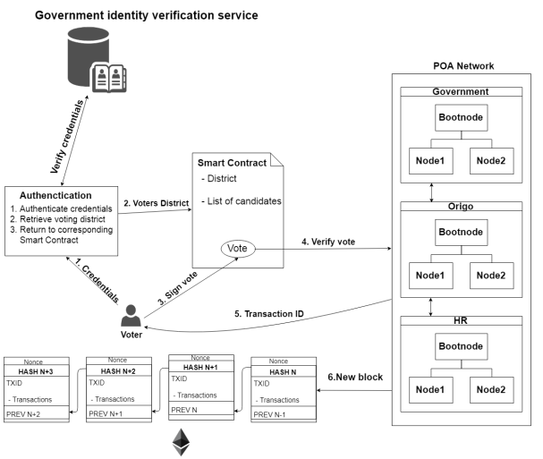

**Figure 1:** System architecture diagram

# 7.RESULTS AND DISCUSSION

## LoginPage

## 

# 

Voter has to give their username and password and should press the sign in button .If the username and password matches then he will be moved to the next page.

## 7.2Admin Dashboard

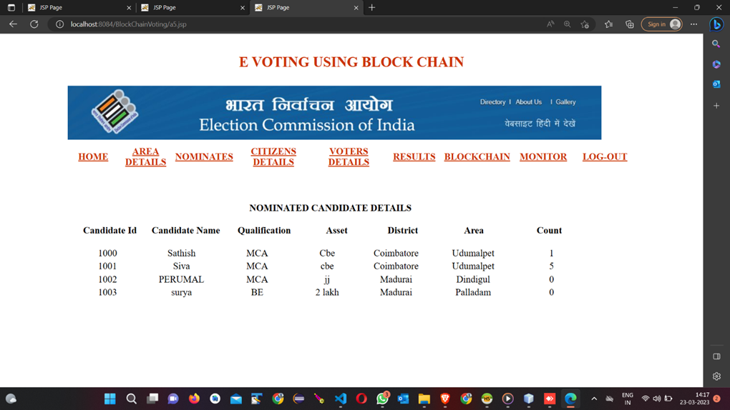

The role of the admin is to manage the Nominates and voters details . The admin dashboard contains area details , results,etc.

# 8.CONCLUSION

Nowadays,Blockchain innovation is utilized in different fields.It is acquiring notoriety day by day.As an outcome with the assistance of blockchain, casting a ballot framework should be more secure,advanced and reliable.This application will give straightforwardness and practical political race by ensuring the protection of voter.Encryption is utilized in the system.No votes are altered in the system,it will distinguish the altered votes and resolve it.This prompts accomplish transparency.The primary explanation for this framework is to introduce a thought of execution of blockchain in casting a ballot framework.

# 9.REFERENCES

1. Francesco Restuccia, Salvatore D’Oro, Salil S. Kanhere, Tommaso Melodia, and Sajal K. Das, "Blockchain for the Internet of Things: Present and Future," IEEE Internet of Things Journal, vol. 1, no. 1, pp. 1-8, January 2018.
2. Fischer, Donald (March 2, 2016). "Are site reliability engineers the next data scientists". TechCrunch. Retrieved June 17, 2021.
3. College Election System using Blockchain Aanchal Mani1, * , Samarjeet Patil2 , Soham Sheth 3 and Lakshmi Sudha Kondaka4, 2022.
4. Online Voting System using Blockchain,Aju Chhabria; Ashish Bablani, 2022.
5. Vivek S K, et.al., “E-Voting System using Hyperledger Sawtooth”, International Conference on Advances in Computing, Communication & Materials (ICACCM), pp. 29-35, 2020,
6. Shubham Gupta, Divanshu Jain, Milind Thomas Themalil, “Electronic Voting Mechanism using Microcontroller ATmega328P with Face Recognition”, Proceedings of the Fifth International Conference on Computing Methodologies and Communication (ICCMC 2021), pp. 1471-147, 2021.
7. Naseer Abdulkarim Jaber Al-Habeeb, Dr. Nicolae Goga, Haider Abdullah Ali1, Sarmad Monadel Sabree Al-Gayar, “A New E-voting System for COVID-19 Special Situation in Iraq”, The 8th IEEE International Conference on E-Health and Bioengineering – EHB, 2020.
8. Roopak T M, Dr. R Sumathi, “Electronic Voting based on Virtual ID of Aadhar using Blockchain Technology”, Proceedings of the Second International Conference on Innovative Mechanisms for Industry Applications (ICIMIA 2020), pp. 71-75, 2020
9. Ganesh Prabhu S, et.al., “Smart Online Voting System”, 7th International Conference on Advanced Computing and Communication Systems (ICACCS), pp. 632-634, 2021
10. Vivek S K, et.al., “E-Voting System using Hyperledger Sawtooth”, International Conference on Advances in Computing, Communication & Materials (ICACCM), pp. 29-35, 2020,
11. Shubham Gupta, Divanshu Jain, Milind Thomas Themalil, “Electronic Voting Mechanism using Microcontroller ATmega328P with Face Recognition”, Proceedings of the Fifth International Conference on Computing Methodologies and Communication (ICCMC 2021), pp. 1471-147, 2021
12. Naseer Abdulkarim Jaber Al-Habeeb, Dr. Nicolae Goga, Haider Abdullah Ali1, Sarmad Monadel Sabree Al-Gayar, “A New E-voting System for COVID-19 Special Situation in Iraq”, The 8th IEEE International Conference on E-Health and Bioengineering – EHB, 2020.
13. Roopak T M, Dr. R Sumathi, “Electronic Voting based on Virtual ID of Aadhar using Blockchain Technology”, Proceedings of the Second International Conference on Innovative Mechanisms for Industry Applications (ICIMIA 2020), pp. 71-75, 2020
14. Ganesh Prabhu S, et.al., “Smart Online Voting System”, 7th International Conference on Advanced Computing and Communication Systems (ICACCS), pp. 632-634, 2021 .