CREATED ECOMMERCE WEBSITE TO SWEET STORE

# Bhavesh Mahajan1 Harshal Sonwane2 Mayur Patil3

1Dept. of Computer Science & Engg.,1Tha.Shiv Kumar Memorial Engg.College, Burhanpur(M.P.), India.

# ABSTRACT

# The aim of this project is to provide the sweets online, through the website. This system can be used as a online sweet shop for customer and customer can get the information about the sweets products easily, in these website customer can order sweets online

# INTRODUCTION

Kundan sweets provides healthy and affordable sweet and variety of sweet products to the customer. It is famous for its sweets in burhanpur city as well as many nearby districts since last many years and its service has earned it a lot home among all the customers. This shop also helps in giving employment to many unemployed youth. Sweets such are boiled, while others such as burfi are baked, while others such as Mysore Pak are roasted, while others such as jalebi are fried.

# Aside from that, the rising agriculture sector, as well as the introduction of numerous programs aimed at increasing the country's output of sweet shops, is pushing the market. Further more, the Indian government is always working to improve the domestic supply of edible oil and minimize reliance on imports.Everything in India is a little sweeter the people, the cuisine. Every region of the country joyfully celebrates festivals as well as modest triumphs in life. And, of course, celebrating with sweets is something that every Indian cherishes.People have become found of internet shopping as online businesses revolutionized the way customers shop. Sugar confections are sweet, sugar-based sweets that are typically consumed as sweet. Sugar sweets, chocolates, candied fruits and nuts, chewing gum, and even ice cream fall into this category. Chocolate confections, as well as sugar-free variants of sugar confections, are often considered as a separate category.

**Methodology**

**1.SDLC**

Software Development Life Cycle (SDLC) is a process used by the software industry to design, develop and test high quality softwares. The SDLC aims to produce a high-quality software that meets or exceeds customer expectations, reaches completion within times and cost estimates

.

SDLC is a process followed for a software project, within a software organization. It consists of a detailed plan describing how to develop, maintain, replace and alter or enhance specific software. The life cycle defines a methodology for improving the

quality of software and the overall development process..

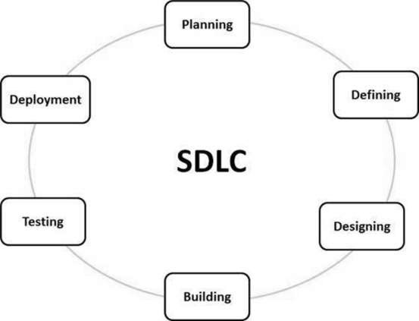

**Type of SDLC:-**

1. Waterfall Model
2. RAD Model
3. Spiral Model
4. Incremental Model
5. Iterative Model
6. Agile Model
7. V-Model

**a)Iterative Model**

In the Iterative model, iterative process starts with a simple implementation of a small set of the software requirements and iteratively enhances the evolving versions until the complete system is implemented and ready to be deployed.

An iterative life cycle model does not attempt to start with a full specification of requirements. Instead, development begins by specifying and implementing just part of the software, which is then reviewed to identify further requirements. This process is then repeated, producing a new version of the software at the end of each iteration of the model.

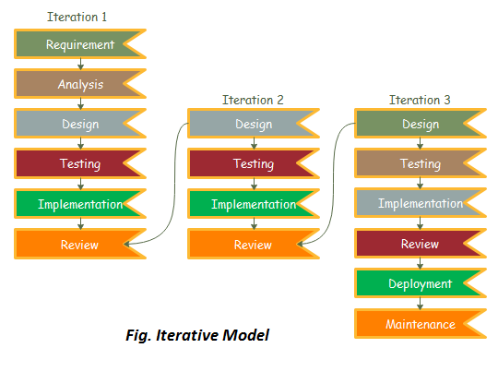

**2.Diagram**

**a) DFD (Data Flow Diagram):-** The data flow diagrams (DFD) depict the information flow and the transforms that are applied on the data as it moves from to output. The data flow diagram are used to represent the system at any level of abstraction information flow. A Data flow diagram is graphical tool that allows system analysis (and system user) to depict the flow of data in information system

**a.1)DFD LEVEL- 0 :-** Highest abstraction level DFD is known as Level 0 DFD, which depicts the entire information system as one diagram concealing all the underlying details. Level 0 DFDs are also known as context level DFDs.

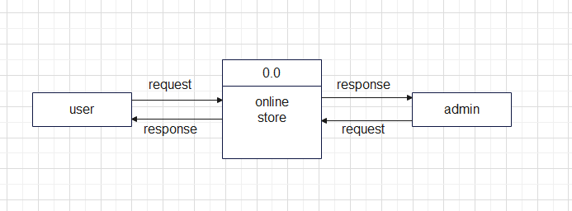

**a.2)DFD LEVEL- 1 :-** In 1-level DFD, a context diagram is decomposed into multiple bubbles/processes. In this level, we highlight the main objectives of the system and breakdown the high-level process of 0-level DFD into subprocesses.

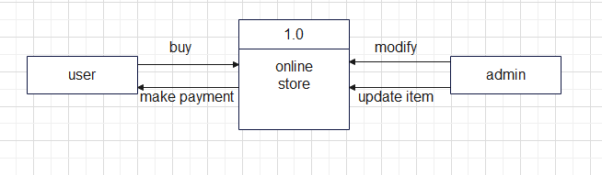**b)Sequence Diagram** The sequence diagram represents the flow of messages in the system and is also termed as an event diagram. It helps in envisioning several dynamic scenarios. It portrays the communication between any two lifelines as a time-ordered sequence of events, such that these lifelines took part at the run time. In UML, the lifeline is represented by a vertical bar, whereas the message flow is represented by a vertical dotted line that extends across the bottom of the page. It incorporates the iterations as well as branching.

## Purpose of a Sequence Diagram

1. To model high-level interaction among active objects within a system.
2. To model interaction among objects inside a collaboration realizing a use case.

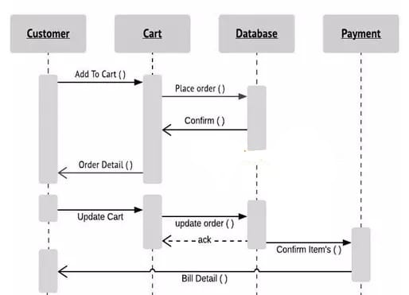

**c)Activity Diagram:-** In UML, the activity diagram is used to demonstrate the flow of control within the system rather than the implementation. It models the concurrent and sequential activities.The activity diagram helps in envisioning the workflow from one activity to another. It put emphasis on the condition of flow and the order in which it occurs. The flow can be sequential, branched, or concurrent, and to deal with such kinds of flows, the activity diagram has come up with a fork, join, etc.It is also termed as an object-oriented flowchart.

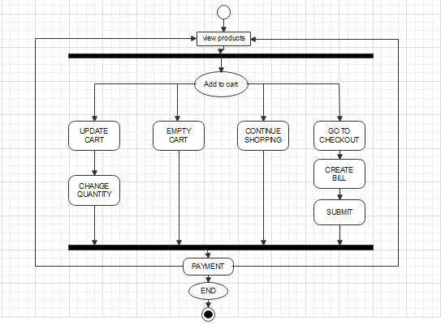

**d)Usecase diagram :-** A use case diagram is used to represent the dynamic behavior of a system. It encapsulates the system's functionality by incorporating use cases, actors, and their relationships. It models the tasks, services, and functions required by a system/subsystem of an application. It depicts the high-level functionality of a system and also tells how the user handles a system.

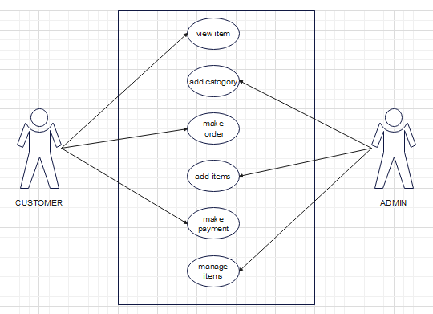

**IMPLEMENTATION**

**A. Technologies Used**

Various front-end and back-end technologies are available in this era of digitalization. The technologies used in this project are discussed briefly in the following sections.

**1.Front End Technologies**

***a) HTML***

It stands for Hypertext Markup Language, and it is the most widely used language to write Web Pages. Hypertext refers to the way in which Web pages (HTML documents) are linked together. Thus, the link available on a webpage is called Hypertext. As its name suggests, HTML is a Markup Language which means you use HTML to simply "mark-up" a text document with tags that tell a Web browser how to structure it to display (Musciano & Kennedy,1996). Originally, HTML was developed with the intent of defining the structure of documents like headings, paragraphs, lists, and so forth to facilitate the sharing of scientific information between researchers. Now, HTML is being widely used to format web pages with the help of different tags available in HTML language.

***b) CSS***

CSS (Powell, 2010) stands for Cascading Style Sheets. CSS describes how HTML elements are to be displayed on the screen, paper, or in other media. CSS saves a lot of work. It can control the layout of multiple web pages all at once.

**c)JavaScript/JQuery**

JavaScript (JS) is a high level, interpreted programming language. JavaScript has curly-bracket syntax, dynamic typing, prototype-based object-orientation, and first-class functions.

Alongside HTML and CSS, JavaScript is one of the core technologies of the World Wide Web (Flanagan, 2006). JavaScript enables interactive web pages and is an essential part of web applications. The vast majority of websites use it, and major web browsers have a dedicated JavaScript engine to execute it. JavaScript provides the facility to validate the form on the client-side so data processing will be faster than server-side validation

**d)BootStrap**

Bootstrap (Shenoy & Sossou, 2014) is a free and open-source CSS framework directed at responsive, mobile-first front-end web development. It contains CSS and (optionally) JavaScript-based design templates for

typography, forms, buttons, navigation, and other interface components.

To use bootstrap, we are required to either install in our system or use CDN. CDN is short for content delivery network. A CDN is a system of distributes servers that deliver pages and other web content to a user, based on the geographic locations of the user, the origin of the

webpage and the content delivery server

**2. Back End Technologie**

**a)Php**

## PHP is a general-purpose scripting language geared toward web development. It was originally created by Danish-Canadian programmer Rasmus Lerdorf in 1993 and released in 1995. The PHP reference implementation is now produced by The PHP Group. PHP was originally an abbreviation of Personal Home Page, but it now stands for the recursive initialism PHP: Hypertext Preprocessor.

## User Manual

**a)Software Requirements:**

• Browser: Internet Explorer or Mozilla Firefox or Opera

• IDE : VS Code Studio

• Language : PHP

• Other Tech **:** HTML, CSS and JavaScript

• Operating system: Any Windows version/ MAC

**b)Hardware Requirements:**

• Processor: Intel Pentium IV or above

• Ram: 1GB or more

• Hard Disk: 40 GB or more

**c)Step to Run Project :**

**Step 1**:- Firstly start your laptop/pc .

**Step 2**:- Now install python setup for coding of PHP language .

**Step 3**:- After that install vs code .

**Step 4**:- XAMP for installing PHP .

**Step 5**:- In vs code we write coding for project . to run the project select brouser google chrome . Open one of the browser enter your url <http://127:0:0:1:9898> .

**RESULTS**

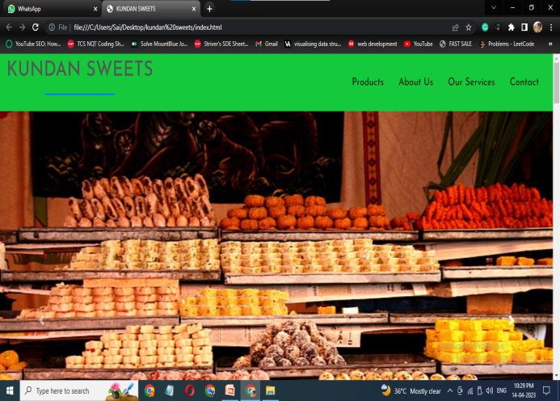

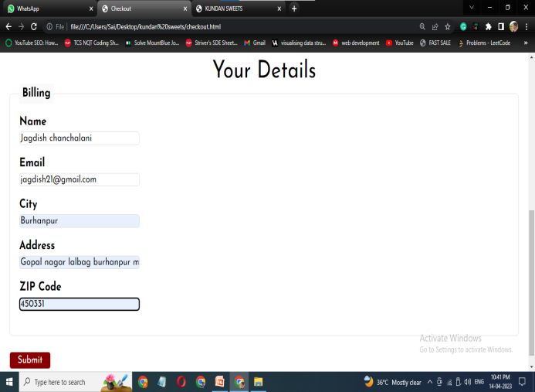

**CONCLUSION**

The purpose of this project is to manage the online sweets shopping . It helps to customer to search and buy sweets , also make the payment on delivery for it .It helps to people to book desired product at there prefer time

**REFERENCES**

**a) Websites**

1. [**www.w3schools.com**](http://www.w3schools.com)
2. [**www.geeksforgeeks.com**](http://www.geeksforgeeks.com)
3. **www.phpproject.com**
4. [**www.tutorialspoints.com**](http://www.tutorialspoints.com)
5. [**www.learnigpoints.com**](http://www.learnigpoints.com)
6. [**www.tutorialshub.com**](http://www.tutorialshub.com)
7. [**www.phpconcept.com**](http://www.phpconcept.com)
8. [**www.google.com**](http://www.google.com)
9. [**www.phponlean.org**](http://www.phponlean.org)
10. [**www.javatpoint.com**](http://www.javatpoint.com)

**Reference Research Paper**

[1] John Duckett ,HTML and CSS : Design and Build Websites,2015.

[2] Mastering HTML ,CSS & Javascript Web Publishing Paper back,2016.

[3] Elmasri Ramez ,Fundamental sofDatabase System, Seventh Edition,2017.

[4] RonaldJ. Leach, Introduction to Software Engineering,2017.