NESTED MART AND GROCERY AS ECOMMERCE WEBSITE

# Fiza Khan1 Kajal Gupta2

1Dept. of Computer Science & Engg.,1Tha. Shiv Kumar Memorial Engg.College, Burhanpur(M.P.), India.

# ABSTRACT

This Research paper studies about a Online grocery as Ecommerce Website . Grocery is website in which many variety of products are sell and in this website it is similar like ecommerce website as flipkart. Online grocery store permits customer to submit online orders for products. The online store system presents an online display of all products which want to sell. This website helps customers to choose products and add products to shopping cart. This website saves lot of time of customers.

# INTRODUCTION

Nested Mart and Grocery is a electronic e-commerce website in which customers shop online and add products to the shopping cart and customer can buy as many products as they want according to their needs and according to their household necessities. Online shopping can save customer precious time and money also because online shopping has little less price as the work in grocery.

In this website, Grocery is a PHP framework laravel based website. Groceries are of different types products such as music, books, etc. But this website contain amul products, coffee products, etc. Online Grocery have easy payment options, and etc.

# Methodology

### SDLC

Software Development Life Cycle (SDLC) is a process used by the software industry to design, develop and test high quality softwares. The SDLC aims to produce a high-quality software that meets or exceeds customer expectations, reaches completion within times and cost estimates. Replace and alter or enhance specific software. The life cycle defines a methodology for improving the quality of software and the overall development process.

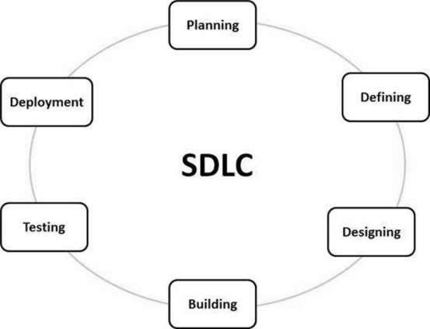

**Type of SDLC:-**

* 1. Waterfall Model
  2. RAD Model
  3. Spiral Model
  4. Incremental Model
  5. Iterative Model
  6. Agile Model
  7. V-Model

**(a)Incremental Model**

Incremental Model is a process of software development where requirements divided into multiple standalone modules of the software development cycle. In this model, each module goes through the requirements, design, implementation and testing phases. Every subsequent release of the module adds function to the previous release. The process continues until the complete system achieved.

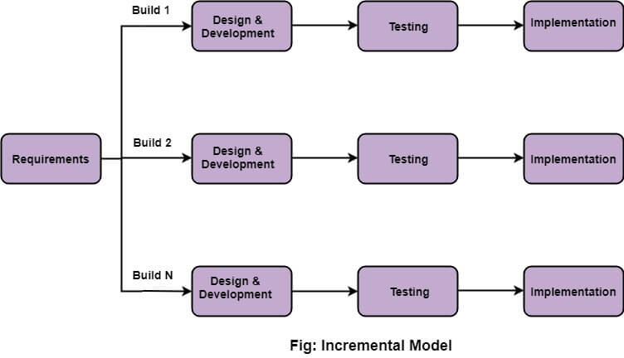

**2.Diagram**

**(a)DFD (Data Flow Diagram):-** The data flow diagrams (DFD) depict the information flow and the transforms that are applied on the data as it moves from to output. The data flow diagram are used to represent the system at any level of abstraction information flow. A Data flow diagram is graphical tool that allows system analysis (and system user) to depict the flow of data in information system.

**a.(1)DFD LEVEL- 0:-** Highest abstraction level DFD is known as Level 0 DFD, which depicts the entire information system as one diagram concealing all the underlying details. Level 0 DFDs are also known as context level DFDs.

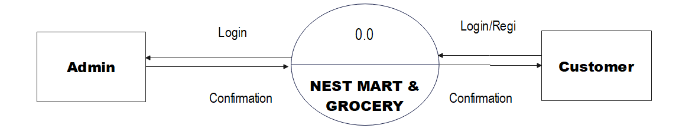

**a.(2)DFD LEVEL- 1 :-** In 1-level DFD, a context diagram is decomposed into multiple bubbles/processes. In this level, we highlight the main objectives of the system and breakdown the high-level process of 0-level DFD into sub-processes.

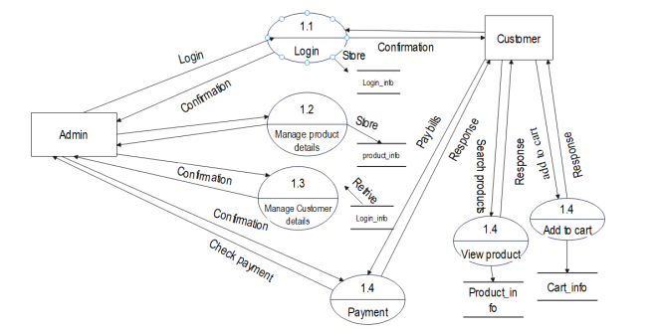

**(b)Sequence Diagram**:-The sequence diagram represents the flow of messages in the system and is also termed as an event diagram. It helps in envisioning several dynamic scenarios. It portrays the communication between any two lifelines as a time-ordered sequence of events, such that these lifelines took part at the run time. In UML, the lifeline is represented by a vertical bar, whereas the message flow is represented by a vertical dotted line that extends across the bottom of the page. It incorporates the iterations as well as branching.

Purpose of a Sequence Diagram

1. To model high-level inter-action among active objects within a system.
2. To model interaction among objects inside a collaboration realizing a use case.

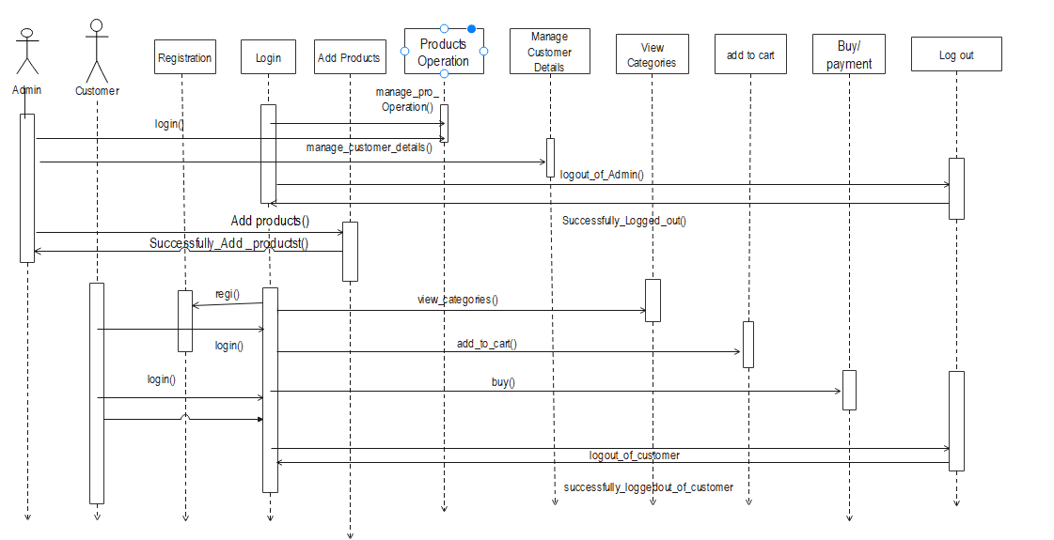

## (c)Activity Diagram:- In UML, the activity diagram is used to demonstrate the flow of control within the system rather than the implementation. It models the concurrent and sequential activities. The activity diagram helps in envisioning the workflow from one activity to another. It put emphasis on the condition of flow and the order in which it occurs. The flow can be sequential, branched, and to deal with such kinds of flows, the activity diagram has come up with a fork, join, etc.

**Activity diagram for user**

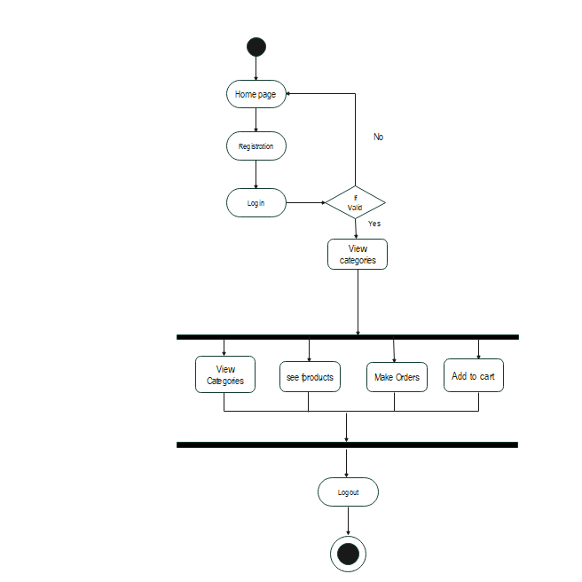

**Activity diagram for Admin**

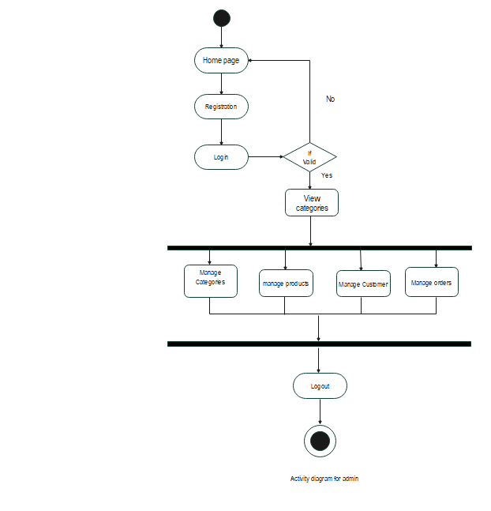

(d) **Usecase diagram:-** A use case diagram is used to represent the dynamic behavior of a system. It encapsulates the system's functionality.

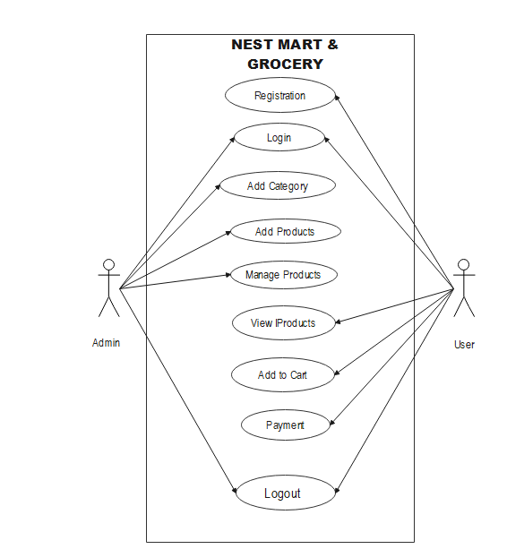

**IMPLEMENTATION**

1. **Technologies Used**

Various front-end and back-end technologies are available in this era of digitalization. The technologies used in this project are discussed briefly in the following sections.

### Front End Technologies

#### HTML

It stands for Hypertext Markup Language, and it is the most widely used language to write Web Pages. Hypertext refers to the way in which Web pages (HTML documents) are linked together. Thus, the link available on a webpage is called Hypertext. As its name suggests, HTML is a Markup Language which means you use HTML to simply "mark-up" a text document with tags that tell a Web browser how to structure it to display (Musciano & Kennedy,1996). Originally, HTML was developed with the intent of defining the structure of documents like headings, paragraphs, lists, and so forth to facilitate the sharing of scientific information between researchers.

1. **CSS**

CSS (Powell, 2010) stands for Cascading Style Sheets CSS describes how HTML elements are to be displayed on the screen, paper, or in other media.

CSS saves a lot of work. It can control the layout of multiple web pages all at once.

### C) JavaScript

JavaScript (JS) is a high level, interpreted programming language. JavaScript has curly- bracket syntax, dynamic typing, prototype-based object-orientation, and first-class functions.

Alongside HTML and CSS, JavaScript is one of the core technologies of the World Wide Web (Flanagan, 2006). JavaScript enables interactive web pages and is an essential part of web applications. The vast majority of websites use it, and major web browsers have a dedicated JavaScript engine to execute it. JavaScript provides the facility to validate the form on the client-side so data processing will be faster than server-side validation.

### d)BootStrap

Bootstrap (Shenoy & Sossou, 2014) is a free and open-source CSS framework directed at responsive, mobile-first front-end web development. It contains CSS and (optionally) JavaScript-based design templates for typography, forms, buttons, navigation, and other interface components.

To use bootstrap, we are required to either install in our system or use CDN. CDN is short for content delivery network. A CDN is a system of distributes servers that deliver pages and other web content to a user, based on the geographic locations of the user, the origin of the webpage and the content delivery server.

**2.Back End Technologies**

**a)PHP**

**PHP** is a server-side scripting language designed specifically for web development. It is open-source which means it is free to download and use. PHP allows web developers to create dynamic content and interact with databases. PHP is known for its simplicity, speed, and flexibility —features that have made it a cornerstone in the web development world. PHP is used by 77.4% of all the websites whose server-side programming language.

1. **Laravel**

[**Laravel**](https://www.geeksforgeeks.org/laravel-installation-and-configuration/) is a free and open-source web PHP framework, which is based on **MVC (Model-View-Controller) architecture. It is a easy understand language used for backend. This language is mostly used to build the modern applications**

* 1. Model
  2. View
  3. Controller
* **Model:** It interacts with the database.

This is responsible for handling the logical part of the web application as well as how the data is stored in the database .

* **Views:** User Interface. It contains everything which a user can see on the screen. In laravel views are not the same as they are in basic MVC structure.
* **Controller**: It helps to connect Model and View and contains all the business logic. It is also known as the “Heart of the application in MVC”. When a user raises an HTTP request, the controller receives the request and sends back the appropriate response.

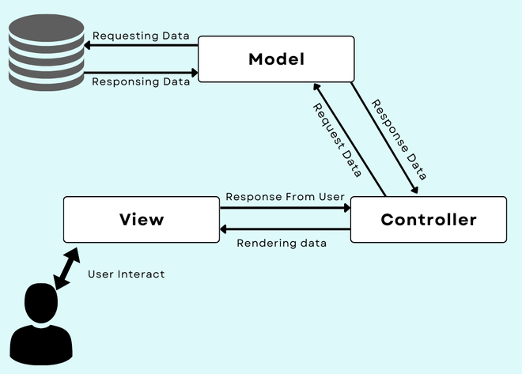

# User Manual

### Software Requirements:

* Browser: Internet Explorer or Mozilla, Firefox or Opera
* IDE : VS Code Studio
* Language : Python
* Other Tech **:** HTML, CSS and JavaScript
* Operating system: Any Windows version/ MAC

### Hardware Requirements:

* Processor: Intel Pentium IV or

above

* Ram: 1GB or more

Hard Disk: 40 GB or more

### c)Step to Run Project :

**Step 1**:- Firstly start your laptop/pc .

**Step 2**:- Now install php setup for coding of php language .

**Step 3**:- After that install vs code .

**Step 4**:- install laravel for code run .

### Step 5: In vs code we write coding for project. And Run the Application on Localhost Windows Xampp Server

**Step 6:** Open one of the browser enter your url http://127:0:0:1 .

### RESULTS

**Home :** This is the home page of Grocery

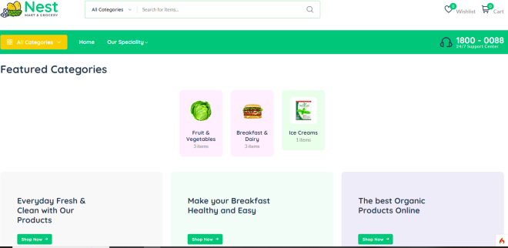

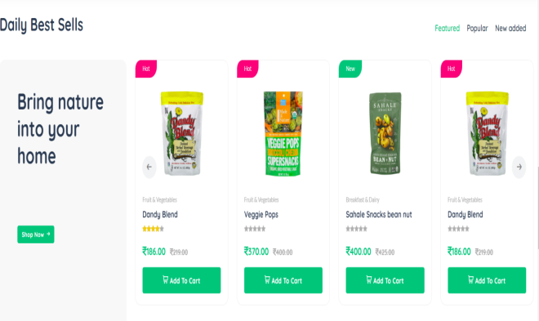

**Login:** This is login page

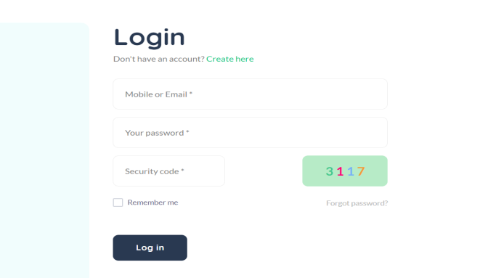

# CONCLUSION

After analyzing the results obtained, the project developed can be considered satisfiable. It can be concluded that the website will be very helpful to Customers as it provides all Grocery resources required in daily life. As the project works as an Grocery cum E-Commerce Website. To conclude, the project is developed using the proper Software Engineering process, following the Incremental Model of SDLC. A Project Control List was created after doing the feasibility study for functionalities as well as non- functional requirements. Then proper schema and tables that were supposed to be required in the development process were made and relationships between each table were drawn. For this ER Diagram was made which has been illustrated in the paper.

**REFERENCES**

# Websites

* 1. [**www.w3schools.com**](http://www.w3schools.com/)

# [www.geeksforgeeks.com](http://www.geeksforgeeks.com/)

* 1. **www.laravelproject.com**

# [www.tutorialspoints.com](http://www.tutorialspoints.com/)

* 1. [**www.learnigpoints.com**](http://www.learnigpoints.com/)

# [www.google.com](http://www.google.com/)

# [www.javatpoint.com](http://www.javatpoint.com/)

1. **Books**

# Software engineering

* 1. **PHP**
  2. **Ecommerce concepts**

# DBMS

1. **Reference Research Paper**

### Learning PHP, MySQL, JavaScript, and CSS: A Step-by-Step Guide to Creating Dynamic Websites – by Robin Nixon

* 1. Beginning PHP and MySQL From Novice to Professional" by W Jason Gilmore.