**ABSTRACT**

This research paper consist about working and Fundamentals of leading technology Laravel - PHP framework PHP is Object Oriented Methodology. Object Oriented Methodology is a methodology employed in the development of computer software that aims to guide the development process by analyzing the system requirements in a structured manner. It is designed to facilitate the creation of robust and efficient software systems using an approach that is centered around the use of objects, which are the fundamental building blocks of the software.Its working and Implementations we have included in this research Paper.

Laravel is a PHP framework where PHP is a scripting language that is versatile in its application likewise Laravel has introduced many more features in the field of development it is used to develop web panels , e-Commerce websites , CRM, and Api's for Android and IOS applications.

**Introduction**

**PHP** - PHP is a scripting language that is versatile in its application, but it has found particular success in the field of web development. Created by a Danish-Canadian programmer named Rasmus Lerdorf in 1993, PHP was initially released to the public in 1995. The PHP Group is currently responsible for maintaining and updating the reference implementation of the language. Originally, the abbreviation PHP stood for Personal Home Page, but it has since been rebranded as the recursive initialism PHP: Hypertext Preprocessor.

**Laravel** -Laravel is a software framework for developing web applications, which boasts a sophisticated and graceful syntax. Its structure and functionality provide developers with a solid foundation to build upon and allows them to concentrate on the development process itself without being hindered by the details of implementation.

**Database**

**Database -** Usually in PHP we use database like MYSQL ,It is most popular to be used with PHP.PHP and Laravel both support integration with databases using various methods, such as PDO (PHP Data Objects) and Eloquent ORM (Object Relational Mapping) in Laravel. These techniques enable developers to carry out essential tasks such as creating, reading, updating, and deleting data in the database.

Using PDO in PHP, developers can establish a secure and adaptable connection with databases, working with different database management systems such as MySQL, PostgreSQL, SQLite, and more. They can execute SQL queries to manipulate the data as required.In Laravel, Eloquent ORM provides developers with an even more sophisticated approach to database integration. Eloquent ORM utilizes an object-oriented programming (OOP) paradigm, simplifying the code and minimizing the time required to create SQL queries. It also offers a clear and intuitive syntax for creating database tables, defining relationships between tables, and querying data.

By using either PDO or Eloquent ORM, developers can effectively integrate databases with PHP and Laravel applications, empowering them with the flexibility and tools they need to develop efficient, robust, and scalable web applications.

**Front-end and Back end**

**Front-end:-** When it comes to the UI/Front end of web development using Laravel/PHP , HTML, CSS, JavaScript and Bootstrap are the primary languages employed. HTML provides the foundation of website structure, which is then refined and embellished by additional technologies such as CSS, JavaScript and Bootstrap. CSS is utilized to regulate the presentation, layout, and formatting of website content, while JavaScript controls the functionality of various elements.

**Back end:-**We use PHP as a back end language. PHP is a platform independent language. It is a highly level concept which is based on object oriented programming. The back end generally include a web server that hosts an application, where we use PHP (Localhost)which communicates with a database (using MYSQL ) to serve up the information that the front end present.

**Introduction To The Project “THE BOOK SPOT”**

THE BOOK SPOT is an online book store that allows user to search and purchase book online based on different categories and subject. The selected books are displayed and the user can order their books online. Using this website the user can purchase a book online instead of going out to a book store and wasting time. Online book store is an online website where the customer can purchase book online. Through a web browser the customer can search for a book by its tittle , later it can add to the shopping cart and finally purchase it using cash on delivery method. The books are divided into different categories like Hinduism , Educational , Programming Languages , Motivational etc.

**Screenshot & Result of Project**

**Homepage-:**



**Contact Us Page**

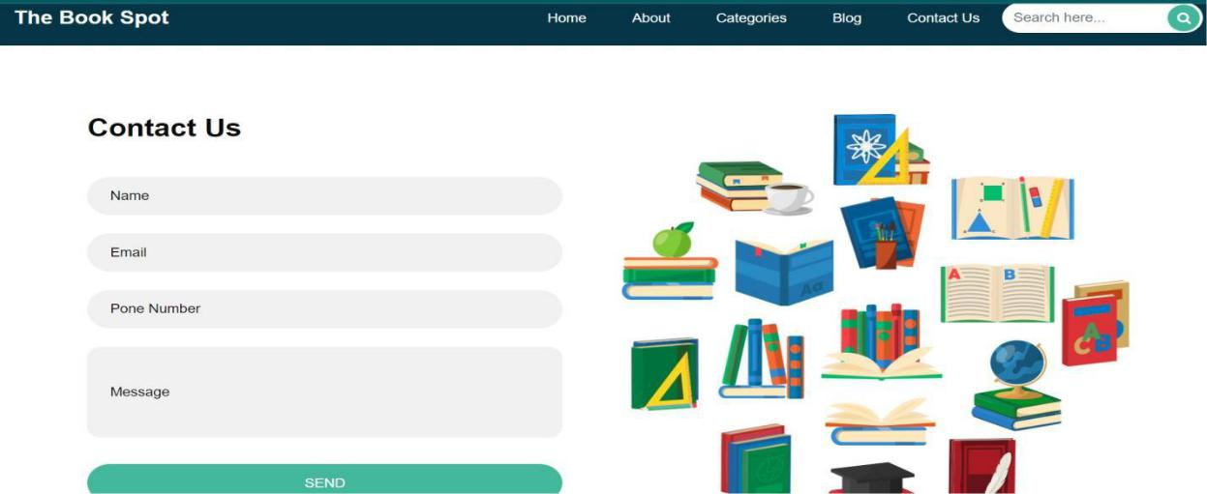

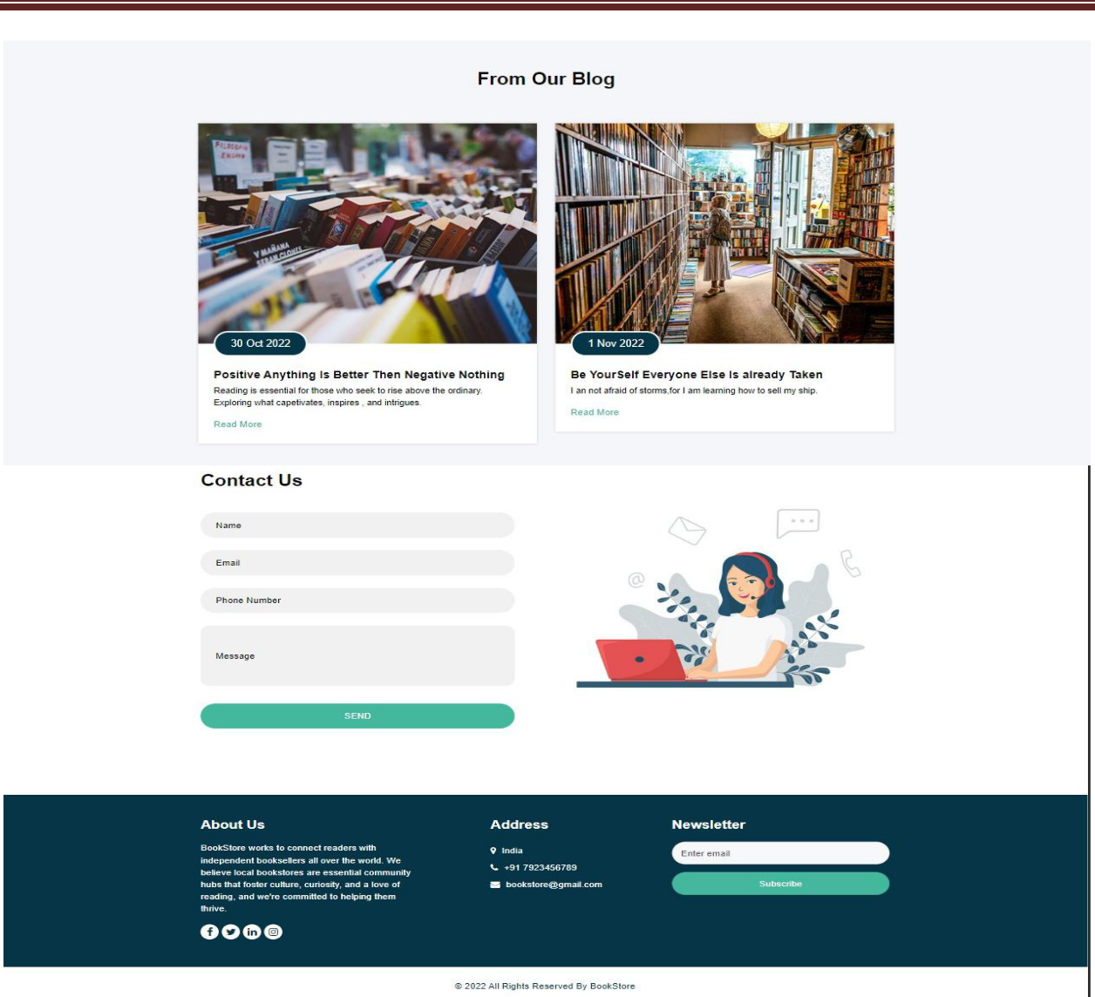

**\**

**Add to Cart Page**



**User Login Page**

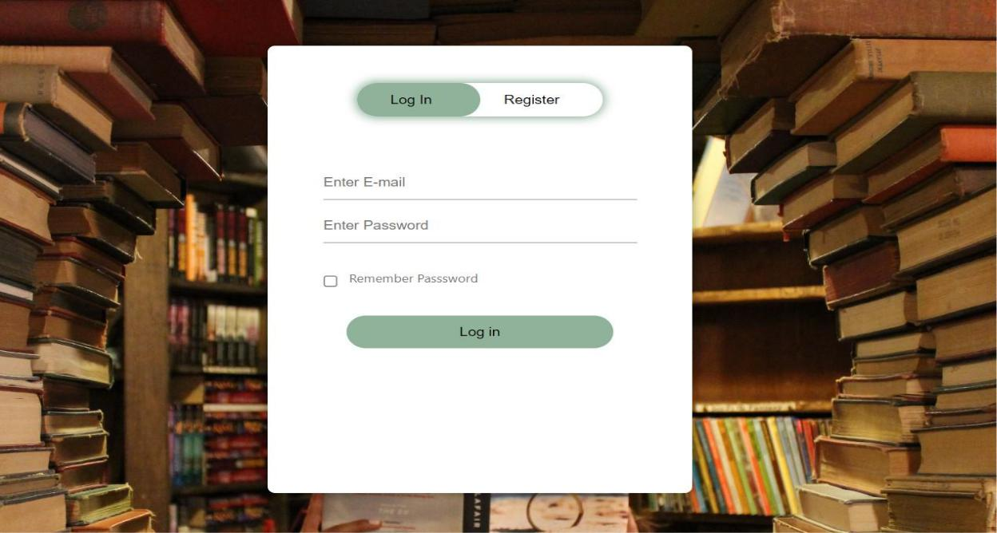

**Explanation**This is Login page of website where user can login by Username and Password.

If user login successfully than user can add products to cart and order books.

**Admin Login Page**



**CONCLUSION**

**Conclusion :-** Online bookstore has many advantages compared to its counterparts such as physical book store, the online bookstore allows it's user to shop at one place where in physical store the books are scattered at the different places which consumes a lot of time and online bookstore helps in saving that time and it also avoids the problem of unavailability of books at physical store as numerous vendors from different places sell their books at one place. This project is efficient in maintaining users records and can perform operations on it, also reduces the work load on the shop owner of knowing the quantity of books available and which books are available and keeps the records of how many books are purchased and sold.

**REFERENCES**

* Software Engineering and project Management(Technical Publications)

* [www.w3school.com](http://www.w3school.com)

* [www.wikipedia.com](http://www.wikipedia.com)

* [www.tutorialspoint.com](http://www.tutoilspoint.com)

* [www.youtube.com](http://www.youtube.com)

* <https://getbootstrap.com>