# CREAED ECOMMERCE WEBSIT

# USING PHP

# Harshal Surdakar 1 Mohit Pachpande 2

1Dept. of Computer Science & Engg.,1Tha.Shiv Kumar Memorial Engg.College, Burhanpur(M.P.), India.

# ABSTRACT

“Fashion Point” is a PHP project that can buy men’s ware through online services. This program was developed by using PHP , HTML , MySQL5 , andJavascript.The system is basically easier to understand, the customer should create an account first to order some clothes or other items. Then the user will choose their preferable product and add them to the shopping cart in order to check out the product .The admin has animport an trole here,he manages all the daily transactions , adding new products , setting up the product offers, and monitoring customer information.

# INTRODUCTION

# This project is a web based shopping system for an existing shop. The project objective is to deliver the online shopping application into PHP platform. This project is an attempt to provide the advantages of online shopping to customers of a real shop. It helps buying the products in the shop any where through internet by using an website. Thus the customer will get the service of online shopping and home delivery from his favorite shop. This system can be implemented to any shop in the locality or to multinational branded shops having retail outlet chains. If shops are providing an online portal where their customers can enjoy easy shopping from anywhere, the shops won’t be losing any more customers to the trending online shops such as flipkart , orebay.

# This is online shopping Website which provides facility for purchasing Jeans, Shirt/T-Shirt, Watch,Perfume and many more items.

**Methodology**

**1.SDLC**

Software Development Life Cycle (SDLC) is a process used by the software industry to design, develop and test high quality softwares. The SDLC aims to produce a high-quality software that meets or exceeds customer expectations, reaches completion within times and cost estimates

.

SDLC is a process followed for a software project, within a software organization. It consists of a detailed plan describing how to develop, maintain, replace and alter or enhance specific software. The life cycle defines a methodology for improving the

quality of software and the overall development process..

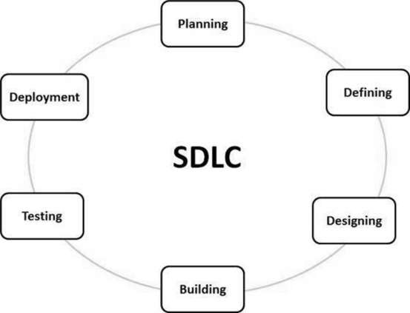

**Type of SDLC:-**

1. Waterfall Model
2. RAD Model
3. Spiral Model
4. Incremental Model
5. Iterative Model
6. Agile Model
7. V-Model

**a)Iterative Model**

In the Iterative model, iterative process starts with a simple implementation of a small set of the software requirements and iteratively enhances the evolving versions until the complete system is implemented and ready to be deployed.

An iterative life cycle model does not attempt to start with a full specification of requirements. Instead, development begins by specifying and implementing just part of the software, which is then reviewed to identify further requirements. This process is then repeated, producing a new version of the software at the end of each iteration of the model.

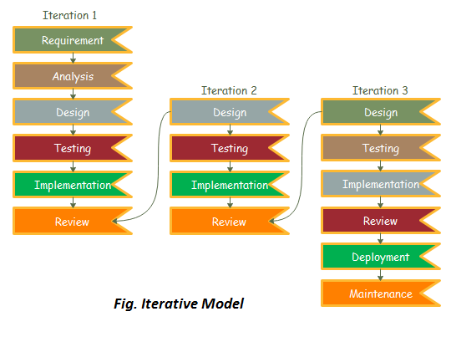

**IMPLEMENTATION**

**A. Technologies Used**

Various front-end and back-end technologies are available in this era of digitalization. The technologies used in this project are discussed briefly in the following sections.

**1.Front End Technologies**

***a) HTML***

It stands for Hypertext Markup Language, and it is the most widely used language to write Web Pages. Hypertext refers to the way in which Web pages (HTML documents) are linked together. Thus, the link available on a webpage is called Hypertext. As its name suggests, HTML is a Markup Language which means you use HTML to simply "mark-up" a text document with tags that tell a Web browser how to structure it to display (Musciano & Kennedy,1996). Originally, HTML was developed with the intent of defining the structure of documents like headings, paragraphs, lists, and so forth to facilitate the sharing of scientific information between researchers. Now, HTML is being widely used to format web pages with the help of different tags available in HTML language.

***b) CSS***

CSS (Powell, 2010) stands for Cascading Style Sheets. CSS describes how HTML elements are to be displayed on the screen, paper, or in other media. CSS saves a lot of work. It can control the layout of multiple web pages all at once.

**c)JavaScript/JQuery**

JavaScript (JS) is a high level, interpreted programming language. JavaScript has curly-bracket syntax, dynamic typing, prototype-based object-orientation, and first-class functions.

Alongside HTML and CSS, JavaScript is one of the core technologies of the World Wide Web (Flanagan, 2006). JavaScript enables interactive web pages and is an essential part of web applications. The vast majority of websites use it, and major web browsers have a dedicated JavaScript engine to execute it. JavaScript provides the facility to validate the form on the client-side so data processing will be faster than server-side validation

**d)BootStrap**

Bootstrap (Shenoy & Sossou, 2014) is a free and open-source CSS framework directed at responsive, mobile-first front-end web development. It contains CSS and (optionally) JavaScript-based design templates for

typography, forms, buttons, navigation, and other interface components.

To use bootstrap, we are required to either install in our system or use CDN. CDN is short for content delivery network. A CDN is a system of distributes servers that deliver pages and other web content to a user, based on the geographic locations of the user, the origin of the

webpage and the content delivery server

## User Manual

**a)Software Requirements:**

• Browser: Internet Explorer or Mozilla Firefox or Opera

• IDE : VS Code Studio

• Language : PHP

• Other Tech **:** HTML, CSS and JavaScript

• Operating system: Any Windows version/ MAC

**b)Hardware Requirements:**

• Processor: Intel Pentium IV or above

• Ram: 1GB or more

• Hard Disk: 40 GB or more

**c)Step to Run Project :**

**Step 1**:- Firstly start your laptop/pc .

**Step 2**:- Now install python setup for coding of PHP language .

**Step 3**:- After that install vs code .

**Step 4**:- XAMP for installing PHP .

**Step 5**:- In vs code we write coding for project . to run the project select brouser google chrome . Open one of the browser enter your url <http://127:0:0:1:9898> .

**RESULTS**

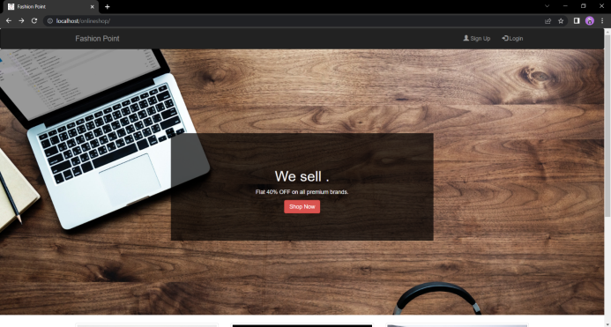

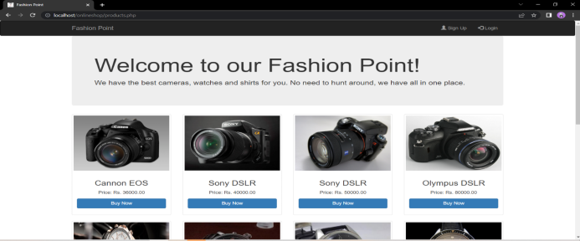

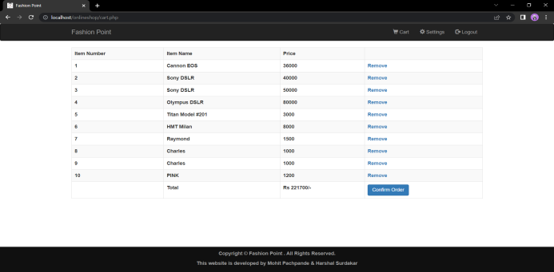

**CONCLUSION**

Fashion point shop is fully designed and developed with php. Each code is clear and un ambiguous.The frontend and backend are designed with php.This website ssafe and secure to use for shopping Jeans ,Shirts T –Shirts , Watch , Perfumeetc. It helps them to shop product very e asily .The website is to provide all facilities to sell any product, customer details to add, and to do paymentbycredit card orbycash on delivery

**ACKNOWLEDGEMENS:-**

Fashion industry well growth is regularly we make a stratup to fashion accessories to provide low cost to consumer . customer time sever is fashion point I well make to chain for local shopkeeper to sell their product limited rates for customer we provides consumer goods Fashion Point has used various customer acquisition techniques to build its user base. The company has focused on providing a seamless user experience, with features such as easy returns and cash on delivery, to build customer loyalty

**REFERENCES**

**a) Websites**

1. [**www.w3schools.com**](http://www.w3schools.com)
2. [**www.geeksforgeeks.com**](http://www.geeksforgeeks.com)
3. **www.djangoproject.com**
4. [**www.tutorialspoints.com**](http://www.tutorialspoints.com)
5. [**www.learnigpoints.com**](http://www.learnigpoints.com)
6. [**www.tutorialshub.com**](http://www.tutorialshub.com)
7. [**www.pythonconcept.com**](http://www.pythonconcept.com)
8. [**www.google.com**](http://www.google.com)
9. [**www.pythonlean.org**](http://www.pythonlean.org)
10. [**www.javatpoint.com**](http://www.javatpoint.com)

**b)Reference Research Paper**

[1] John Duckett ,HTML and CSS : Design and Build Websites,2015.

[2] Mastering HTML ,CSS & Javascript Web Publishing Paper back,2016.

[3]Elmasri Ramez ,Fundamental sofDatabase System, Seventh Edition,2017.

[4] RonaldJ. Leach, Introduction to Software Engineering,2017.

[5] CSeverance-IEEE Project Management journal,2018.

[6] MaccHills,PClint-IEEE

Software Evolution , 2018.

[7] PKyriakakis, A Chatzigeorgiou-IEEE PHP WebApplication,2019.

[8] SGupta , BBGupta – IEEE Journal of Computer Scienceand Technology , 2020 .

[9] JLiebowitz-IEEEITProjects,2020..

.