WASTAGE MANAGEMENT SYSTEM

Author name: Bharti Jumade

Student, Department of Computer Science Thakur Shivkumar Singh Memorial Engineering College, Burhanpur, Madhya Pradesh, India

E-mail: bhartijumade170@gmail.com

Author name: Jyoti Choudhary

Student, Department of Computer Science Thakur Shivkumar Singh Memorial Engineering College, Burhanpur, Madhya Pradesh, India

E-mail: jyoti2tsec@gmail.com

Author name: Ruchika Nikam

Student, Department of Computer Science Thakur Shivkumar Singh Memorial Engineering College, Burhanpur, Madhya Pradesh, India

E-mail: nikamruchika40@gmail.com

Guide name: Prof. Raj Kumar Verma

Assistant professor, Department of Computer Science Thakur Shivkumar Singh Memorial Engineering College, Burhanpur, Madhya Pradesh, India

E-mail: rajvermaknw@gmail.com

ABSTRACT

Waste management is all those activities and action required to manage waste from its inception to its final disposal. In this website includes types of wastage management such as food waste. Food is one of the necessities of humans, and it stands first among all basic needs-food. Food wastage has risen to a new high. there are many people who wish to donate food to the needy people but are unaware of how exactly they can execute that. Our website revolves around helping the needy by connecting NGOs and common people.

INTRODUCTION

This project serves the sensible handling of food waste. People waste a lot of food every day. We must therefore reduce the problem of food waste via the Internet. In densely populated countries like India, food waste is a big problem. Food waste is the main problem of food shortages, we see many people throwing food away, even edible food. This problem is not only about food waste, but also about wasting money. It causes many environmental problems such as pollution, global warming, and climate change. Food waste is not only a sign of pollution or famine, but also of many economic problems.

If someone wasted food, input food amount and address details in this app and then food donor details from admin store. The donor can create an account and whenever they waste food, they can login and ask the admin. The admin also saves the data of the buyer (orphanage, destitute). After that, the admin checks the donor request and sends the alert message as the time to collect the meal. And the steward, through his neighbor agent,

collects food from the donor, and then distributes it to the nearest orphanages or poor people. Once the food is received by the agent from the admin, give that donor an alert. If the donor needs details about the orphanage with help, he can ask the admin and collect data from the orphanage. This food redistribution project is a highly successful social innovation tackling food waste and food poverty. User data is kept confidential as a separate account is maintained for each user.

HISTORY

Food waste management in India is becoming a critical issue due to the continuous growth of Indian population. Indians waste as much food as the whole of Britain consumes - a number that does not necessarily indicate our love of gluttony as it affects our own people. Most food is wasted at weddings, cafeterias, hotels, social and family events, and households. However, food waste is a terrifying problem, as is food waste in India. of our roads, dumpsters and landfills pollute our environment and we have enough evidence to prove it. On average, 40% of the food produced was wasted. That means 7.5 tons of food is thrown away every day. About 84.7% of all registered waste was thrown away, the rest was given away to the poor or some animals.

MOTIVATION

According to the knowledge, technology advances and develops day by day. Above, the main motto is to help those in need. Many people who want to donate to organizations in need can benefit from the project idea. Also, many organizations like to ask for various things they need like clothes, grain, books, paraphernalia, etc.

EXPLANATION

Food Wastage Management project in PHP is a web-based technology that manages foods. This application provides the interface between food donors and those who require the food. In this application, food donor enters their food quantity details and addresses.

Home:

This. the home page of where we provide all the navigations for the desired tools here user can access all of them and here, we provided some basic update management tools for adding, updating, and deleting for the wastage Management system. in the shop date.

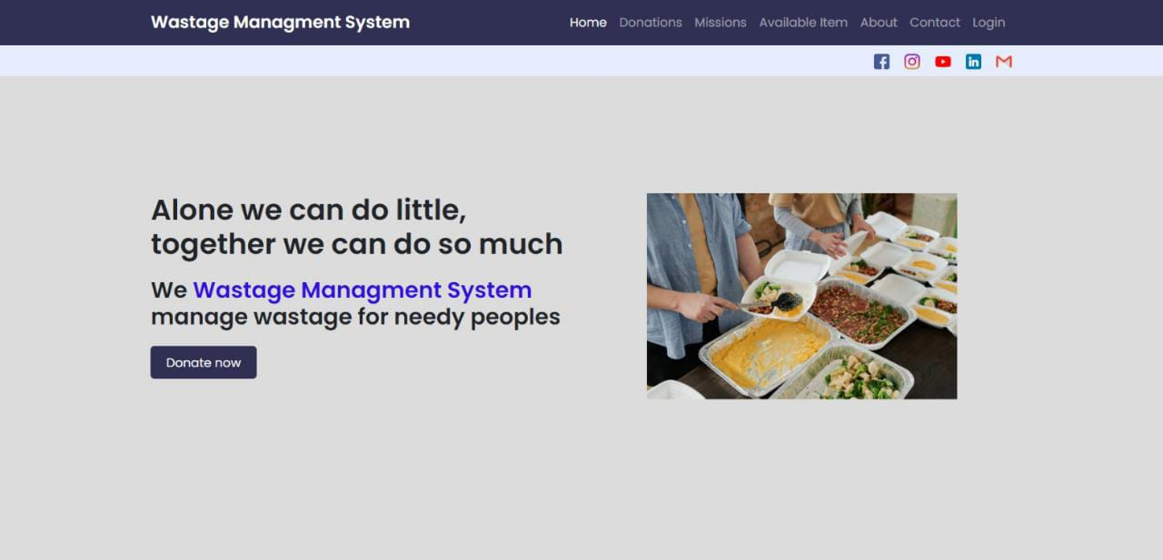

Category page:

It will contain multiple categories and by clicking on them user see a wide variety of things available in that kind of category, but for viewing the present in different category user first have to login on website.

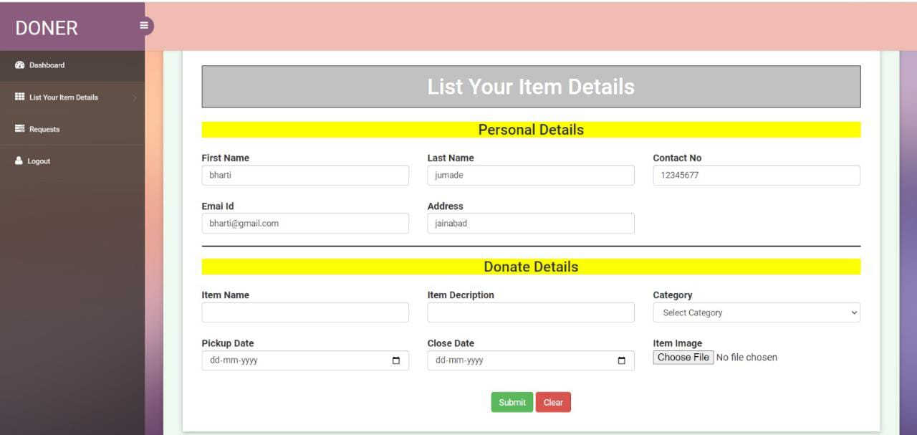

OUR MISSION:

We have delivered Wastage or Donation to needy people.

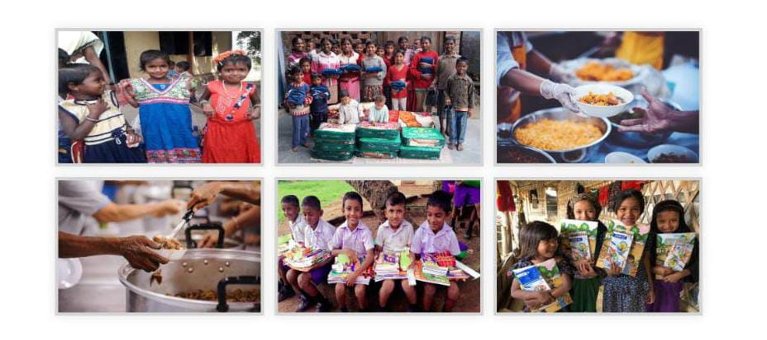

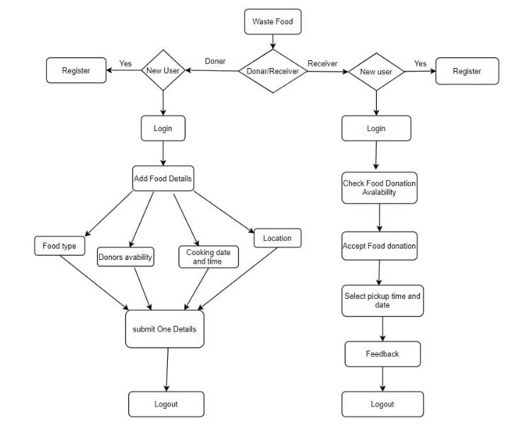

Fig 1: Flow Chart

Methodology

SDLC

Software Development Life Cycle (SDLC) is a process used by the software industry to design, develop and test high quality software’s. The SDLC aims to produce a high-quality that meets or exceeds customer expectations, reaches completion within times and cost estimates

SDLC is a process followed for a software project, within a software organization. It consists of a detailed plan describing how to a detailed plan detailed plan describing how to develop, maintain, replace, and alter or enhance specific software. The life cycle defines a methodology for improving the

quality of software and the overall development Process.

Waterfall Model

The waterfall methodology is a linear project management approach, where stakeholder and customer requirements are gathered at the beginning of the project, and then a sequential project plan is created to accommodate those requirements.

The Phases of the Waterfall Model

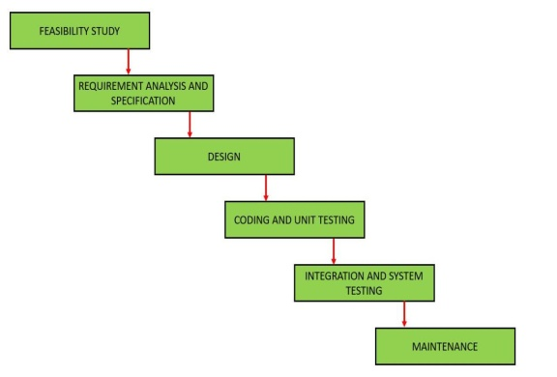

Fig 4: Waterfall Model

ADVANTAGES

User can play character in saving food wastage and help the needy.

You can gift food from home easily.

Easy to used and user friendly.

Food wastage will be reduced

FUTURE SCOPE

Also, we extend our website to have many types of donating user likewise from organization such as restaurants, family, or a single user.

Adding the time & date of each snack shared by users.

Adding the location facility to our website. The donating user should identify the location of the share food.

CONCLUSION

Our study has look into the problem of food waste that has many serious side effect economically and socially. However, the waste of the food can be prevented or at lowest decreased using political rules and technology.

REFERENCE

www.w3school.com

www.codeschool.com

www.codeacademic.com

www.bestitutorial.com

www.sourcecodeonline.com

www.tutorials point.com

www.geeksforgeeks.com

Guerrero LA, Maas G, Hogland W. Solid waste management for cities in developing countries, Waste Management,2013; 33(1):220-132.

Ayesha Anzer, Hadeel A. Tabaza, and Wedad Ahmed, Hassan Hajjdiab,” A Food Wastage Reduction Mobile Application” 2018 6th International Conference on Future Internet of Things and Cloud Workshops.

