FOOD SAFTEY PREDICTION USING MACHINE LEARNING

|  |  |  |
| --- | --- | --- |
| V. Sudheethi (19A91A0559),  CSE, B.Tech,  Aditya Engineering College, Surampalem | Authors: N.R.L.Vineela (19A91A0538), CSE, B.Tech,  Aditya Engineering College, Surampalem | M.Jessica (19A91A0536), CSE, B.Tech,  Aditya Engineering College, Surampalem |

Guide: Mr.M.Kalyan Ram,MCA,M.Tech(PhD),

Associate Professor

Aditya Engineering College

**ABSTRACT**

Currently, the most significant difficulty faced by food makers is food quality decline during storage, which is fought by expensive packing, which incurs large monetary and environmental expenses. By slowing microbial growth and providing moisture and gas barrier qualities, edible packaging can safeguard food quality and improve shelf life. Researchers are working on new approaches to maintain food quality as there is increased spoiling of food owing to a range of other factors such as humidity, temperature, and a variety of other impacts. As a result, effective food spoilage tracking techniques are essential to keep food quality levels stable. As different fields are regarding food science so machine learning has been a path for modelling the information and for analysis. For some years both deep learning as well as machine learning (ML) purposes to foodborne illness. To ensure that food safety management systems are operating properly, it is crucial to monitor possible dangers to food safety along the full supply chain for food.

***Keywords*** *–* : *expensive packing, spoilage tracking, data analysis, monitoring, deep learning applications, food safety.*

**1. INTRODUCTION**

The use of machine learning (ML), an emerging technique, has demonstrated its ability to combine various types of data, such as unstructured and also structured data, with the aim to develop predictions about food safety. In this case, the data refers to the existence of problems related to food safety. Computers are taught to acquire via the input data at hand in machine learning (ML). Learning is the process of turning information (based on an algorithm that learns, such as classification and prediction) into knowledge (such as historical data) as an input.

The following paper includes a literature review that aims to find relevant machine learning (ML) applications for food safety, classify and summarise these applications, classify and discuss the different types of data used in ML modelling, and offer suggestions for sources of data and input which os given for Machine learning modelling. Provided review could give a good start for the future studies and useful for further implementation of machine learning and its applications in food safety and prediction.

**2. LITERATURE REVIEW**

The technology utilised in this study is called machine learning. In this situation, machine learning approaches can be useful. It has made significant progress in recent years Many illnesses have been linked to foodborne microorganisms, particularly in underdeveloped nations. This has a significant economic effect. It's critical to keep them under control, and doing so depends heavily on early diagnosis.Wiley article on machine learning and food safety prediction was released in the month of June 2021, yet the study only looked at different machine learning types of models and data types. They ultimately reached the conclusion that although they are still in the beginning stages, food-borne illness tracking and prediction are growing quickly.. [1]

a K- nearest Neighbours which have already predicted the fibre content in 2021 in the month of August. As considering the 8 goods which have same characteristics which fall under the same category.This was happened in the Australia packed food packets which only shown the fibre content in them.So furtherly this can be also implemented with 14 different categories and check the majority of the fiber which is consumed.[2]

So, the nutritional information which is widely used through KNN and used to check the fiber content in beverages and packed foods. The programme outperforms an existing human nutrition prediction technique and can estimate fibre content on a big scale. [3]

Maetal (2021) also demonstrated how neural networks may be used to forecast the amount of carbohydrate content , protein content , and salt which are consumed through packaged meals based on their constituents. This can be furtherly used for predicting the amount of fibre intake in the packed food items. not yet been done using machine learning approaches, despite the significance of fibre as a component of a healthy diet.[4]

**3.METHODOLOGY**

Decision Tree:

These are mostly used for the purpose of classification and regression purposes.These are non – parametric technique which is a supervised learning.The main aim is to learn the rules which have been obtained when a model is built and that predicts the final target variable. The easiest way is to form a tree.

The most known supervised learning which is used in classification with regression problems is known for decision tree.

The purpose of employing to construct a tree is to build a train model and used for further prediction of target variable which has gained knowledge on the previous uploaded data.

* Data cleaning and structuring are necessary for decision trees. You must handle missing values, encode categorical variables, and

scale continuous features while pre-processing your data.

* Gini Impurity and Information Gain are the most used splitting criteria for decision trees. Information Gain evaluates the decrease in entropy following a split, whereas Gini Impurity assesses the likelihood of misclassification of a randomly selected piece.
* The optimal split is chosen at each node to start the iterative process of building the decision tree. Based on the selected splitting criterion, the algorithm will divide the data into subsets and repeat until a stopping requirement is satisfied.
* Pruning the tree is a strategy used to stop the decision tree from becoming overfit. It entails cutting down portions of the tree's branches that don't significantly increase accuracy.
* By traversing the tree depending on the input characteristics, the tree may be used to forecast the target variable of new data points after it has been constructed.
* A decision tree's performance may be improved by adjusting a variety of factors, including the maximum number of leaf nodes, the minimum number of items provided that leads to splitting of node and that leads to building of the decision tree.

**Hardware requirements:**

* Hard Disk - 500GB
* Monitor
* RAM - 8GB
* Input Devices - Keyboard, Mouse

**Software requirements:**

* Google Colab,Visyal Studio Code
* Windows 10/Windows 8
* Python
* Libraries Used – Matplotlib,NumPy,Pandas,Sklearn etc.

**4. ALGORITHMS USED**

**Decision Tree Algorithm:**

• As a method of supervised learning, decision trees may be used to solve both classification and regression problems, however they are most frequently employed to solve classification problems. It is a herb-structured classifier where each leaf node indicates the outcome and interior nodes contain dataset properties and decision rule branches.

• The Selection Terminal and the Leaves Node are the two nodes that make up a decision tree. A Leaf node indicates the outcome of the choice and has no more branches, whereas a Decision node represents the option and has several branches.

• The features of the given dataset are utilised to run the tests or get the conclusions.

• Based on specified conditions, it offers a visual representation of every option for solving a dilemma or making a decision.

• The categorization and Regression Trees Method, or CART in short, is the technique we use to create a tree. • It is referred to as a tree of decisions since, like a tree, it starts with the base node and expands on successive branches to produce an organised system like a tree.

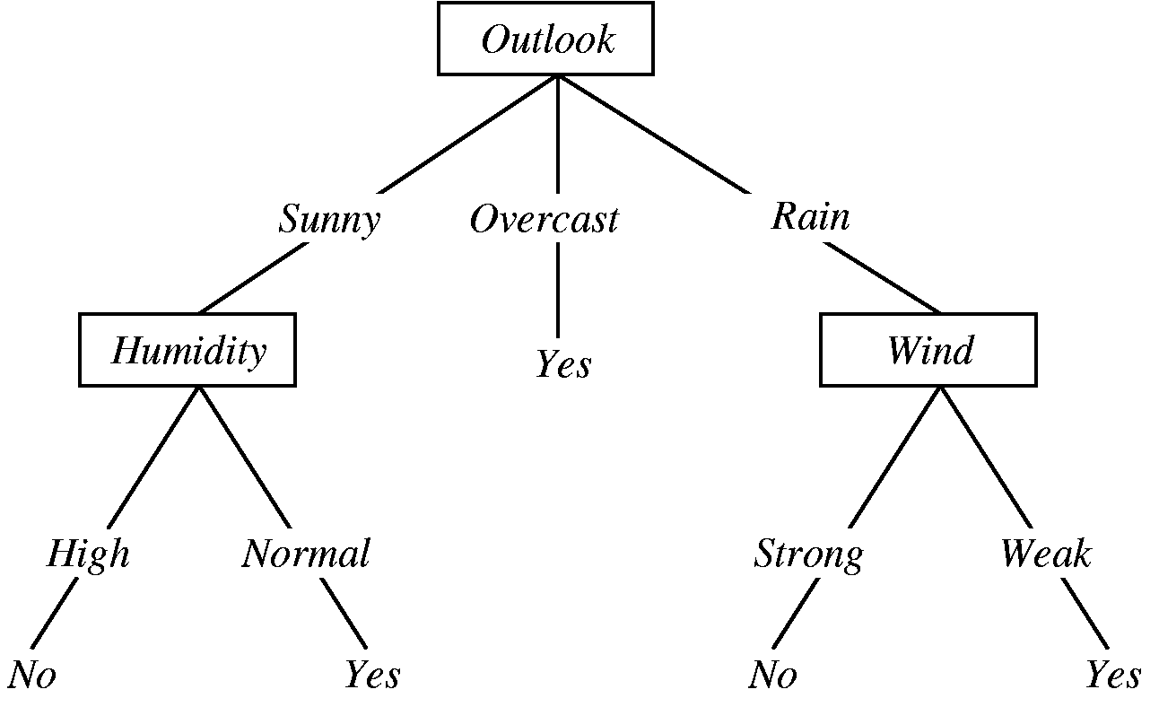

**5. EXPERIMENTAL RESULTS**

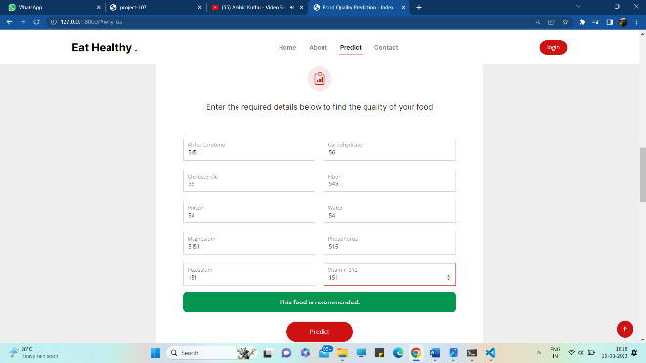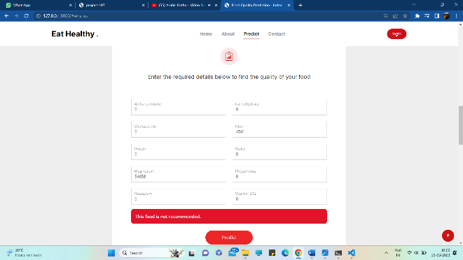

**6. FLOWCHART**

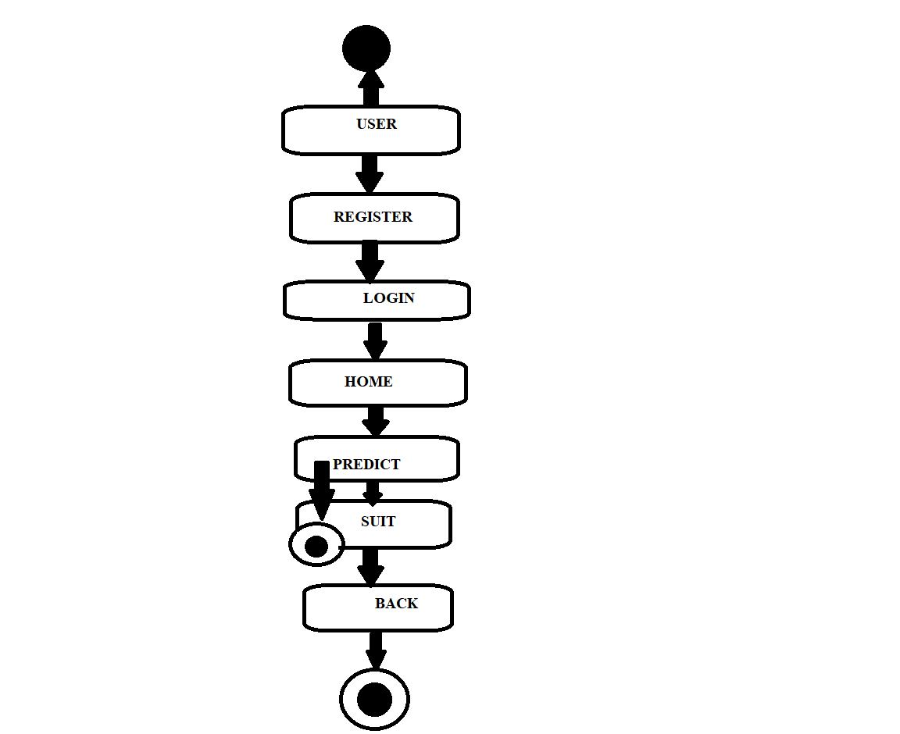

**7. ADVANTAGES**

* Getting a good accuracy and gives good results.
* Better records on the dataset.
* Runtime is high.
* A simple and cost-effective approach to consume the packed food.
* Good production and quality of yield can be achieved.
* Less Complexity and Easy Identification.

**8. CONCLUSION AND FUTURE SCOPE**

In this work, machine learning (ML) models for tracking and forecasting food safety are identified and evaluated. A thorough literature search turned up 114 pertinent research, 75% of which were recent (5 years) publications. The application of machine learning and track of the food safety has been expanding so rapidly . Strong predictive accuracy in the recovered studies shows that ML models could be a useful tool for tracking and foreseeing food safety. Because of its natural model structure and ease of incorporating expert knowledge, decision trees are the most frequently used method for considering structured information among the different machine learning models utilised in the 114 research.

The usage of machine learning in the food business will likely continue to expand in the upcoming years due to the growing need for safe, high-quality, and sustainable food items. To make sure that these algorithms do not reinforce pre-existing prejudices or create new ones, it is crucial to guarantee that they are developed and applied with openness and accountability. Also, we can create a mobile application that is beneficial for all users and uses deep learning, which has a more lot of promise in food security and predictions.

**9. REFERENCES**

[1]<https://www.researchgate.net/publication/343236511_Machine_Learning_Based_Approach_on_Food_Recognition_and_Nutrition_Estimation>

Machine learning based approach on Food recognition and nutrition estimation.

[2] <https://www.irjet.net/archives/V8/i4/IRJET-V8I4702.pdf>

Website on diet recommendation using Machine learning.

[3]<https://ift.onlinelibrary.wiley.com/doi/epdf/10.1111/1541-4337.12868>

Application of machine learning to monitor and prediction of food safety:A review

[4] Overview of Google Collaboratory

<https://research.google.com/colaboratory/faq.html#:~:text=Colaboratory%2C%20or%20%E2%80%9CColab%E2%80%9D%20for,learning%2C%20data%20analysis%20and%20education>.

[5]Sciket- Learn User Guide(Scikit-Learn)

<https://scikit-learn.org/stable/user_guide.html>

[6]Understanding Machine Learning: From Theory to Algorithms 2014 by Shai Shalev-Shwartz and Shai Ben-David Published 2014 by Cambridge University Press.

[7]<https://www.cs.huji.ac.il/~shais/UnderstandingMachineLearning/understanding-machine->learning-theory-algorithms.pdf