PYTHON MOST POPULAR WEB DEVELOPMENT FRAMEWORK DJANGO

AND THIS USING TO CREATED SEARCH PLACEMENT WEBSITE

# Bhuvaneswari Salode1 Swati Nemade2

1Dept. of Computer Science & Engg.,1Tha.Shiv Kumar Memorial Engg.College, Burhanpur(M.P.), India.

# ABSTRACT

In this Search Placement the applicants and companies can register them selves .Both are provided with different roles. The applicant can see a list of jobs available and can apply to any that matches his/ her skillset .Similarly,the companies can add new jobs and select the applicants who have applied for that job. A Search Placement helps both the job seekers and recruiters finding the right organization for the employees.

# INTRODUCTION

Focuses on the best job for jobseekers. The company publishes its vacancies and displays suitable jobs to find good candidates.It helps jobseekers to post their resume, search for jobs, view several job list.It show the vacancy, description, location of various companies and provides the candidate an option to apply the job.

This project is about recruitment process which is done online. Here the recruitment process is controlled by the system. This project will allow the individual to apply for the job desirous vacancy in the company which will be available in the company. The person after reisration will have an account and will have an account and will then be called the Applicable user. If it is eligible, it will interact with the system for updates.

**Goals**

# The purpose of this project is to develop the user friendly and interactive website which willallow the candidate to apply for the job vacancy available in the company. The person will beable to see the vacancies if present. He/She can apply for any number of jobs he/she wishes to apply. Hewill be able to register for that and will be notified for which jobs from his selected jobs, he/she iseligible.

# The company will be able to post these vacancies on its website on the Internet, so there is no need to advertise your company’s vacancy in any place other than your site. Any user will be able to see the vacancy in the company by opening the company’s site.releases .

**Motivation**

* Set Goals & Look for ward to obstacles.
* Think about getting back to work.
* Identify your motivation.
* Maintain your positivity.
* Focus on the best job for you.

**Features**

1. **Administrator**

Admin is trator can manage the entire website:

1. Manage complete job seeker section, employer section and posted job.
2. Admin user can view the job seeker’s applications for each job and send message to any job seeker or job provider.
3. Admin user can add edit countries ,cities ,salaries range ,qualification ,institutes ,job industries,websiteads.
4. **Job Provider Company**

After job provider registration it can perform some action:

1. Add Edit company’s profile, Post new job vacancies and Edit Deactivate posted jobs
2. Job provider can see the list of job seekers who has applied for the job
3. Job provider can see and download the jobseeker’s resume
4. Job provider can send message to any jobseeker
5. **JobSeeker**

After job seeker registration it can perform some actions:

1. Search for jobs.
2. Apply Online for desire job.
3. Add Edit profile in formation including qualification ,experience, and skills.
4. Limitation
5. It can be difficult to me as ure the in effectiveness.
6. It attracts bad candidates.
7. There’s a lot of competition.

**Methodology**

This web application is to be conceived in its current form as a dynamic site-requiring constant updates both from the seekers as well as the companies. The objective of the project is to enable jobseekers to place their resumes and find appropriate jobs while companies to publish the in vacancies and find good candidates.

It enables jobseekers to post their resume, look for jobs, view personal job listings. It will provide various companies to put their vacancy profile on the location and even have an choice to search candidate resumes .A partfrom job-seekers

And Companies there’ llbeanad min module to manage complete Portal also as job seeker and corporation.

**Requirement&Analysis**

* Best way for employers to Find job: Search Placement.
* Employee,EmployerorAdmininthisProject.
* In this Project, the employer uploads the details of the company and responds to the application received for the job.
* Employee can search and apply jobs through location and position on this website.

**Waterfall Modal**

The Waterfall Model was the first Process Model to be introduced. It is also referred to as a linear-sequential life cycle model. It is very simple to understand and use. In a waterfall model, each phase must be completed before the next phase can begin and there is no overlapping in the phases.

The Waterfall model is the earliest SDLC approach that was used for software development.

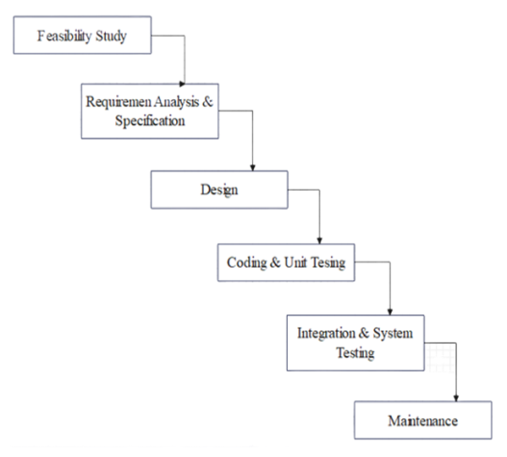

Fig A

**Connectivity steps with Database**

* With the ven vactivateit , execute :python manage.py collectstatic
* Collect static is not necessary when debugis True (in dev mode)
* Createinitial database:python manage.pymigrate
* Load demo data (optional):python manage.py load data fixtures/app_name_initial_data.json – app app. Model_name
* Run server :pythonmanage.py runserver

**Languages**

We'll be using Python 3.1 for our languages. This is due to the fact that the django library iseasily accessible and useful for making websites like what we're looking at. We'll also be makingheavy use of the pytz library, the Olson tz database into Python and thus supports almost all timeZones.

**Applications**

Providing job to qualified jobseeker and selects the eligible candidates based on the requirement of the company.To modify the process of recruitment by replacing the traditional method of recruitment.

Fig A

**Flow Diagram**

This is a flow diagram of Search Placement Showing the flow of the project. So that we can easily understand the working of the project.

**Future Scope**

Search Placement is like a meeting point to the recruiters as well as the job seekers which decrease the respond time as correspond to the offline process. There are many use an employment agency to expedite this process. Many placement agencies are bringing their services online.

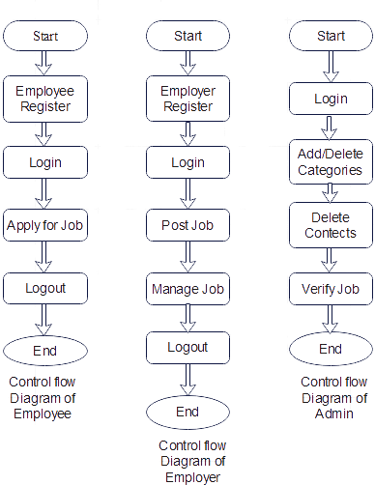**Conclusion**

We came to the conclusion that the website fully fulfill the requirement of job search and placement of the User or Students administrative. Also the Portal has the ability to Understand the User analysis and provide the best functionality to the operator.

**References**

1. [www.python.org](http://www.python.org)
2. [www.jetbrains.com](http://www.jetbrains.com)
3. [www.code.visualstudio.com](http://www.code.visualstudio.com)
4. [www.w3schools.com](http://www.w3schools.com)
5. [www.geeksforgeek.com](http://www.geeksforgeek.com)
6. [www.udemy.com](http://www.udemy.com)
7. [www.codeschool.com](http://www.codeschool.com)
8. [www.codeacadmice.com](http://www.codeacadmice.com)
9. [www.tutorialpoint.com](http://www.tutorialpoint.com)
10. [www.wikipedia.com](http://www.wikipedia.com)
11. [www.projectidea.co.in](http://www.projectidea.co.in)
12. <https://github.com>