Truck Count and Load Analysis using Image Processing and Machine Learning

Eti Sri Harika1, Gadi LokiVenkat2,Maddipati Rajkumar3, Dr. T. Rama Reddy4

1,2,3 U.G Student, Department of CSE Professor,

Aditya Engineering College Department of CSE,

Surampalem, A.P, India Aditya Engineering College

[19a91a0509@aec.edu.in](mailto:19a91a0509@aec.edu.in)1 Surampalem, A.P, India

[19a91a0510@aec.edu.in](mailto:19a91a0510@aec.edu.in)2 [ramareddy.t@aec.edu.in](mailto:ramareddy.t@aec.edu.in)4

[19a91a0532@aec.edu.in](mailto:19a91a0532@aec.edu.in)3

*Abstract***-Around the world the technological advancements are ailing to make the lives even better. To curtail the losses incurred by collusion during unloading of materials in the construction sector an Machine Learning based system is proposed to make use of the technology which helps to reduce the losses due to lack of personal monitoring of materials dumping. The proposed system is able to count the number of vehicles unloaded and also it analyses the amount of load received. Few Machine Learning concepts are used to analyse the captured images from the cameras. At the end of the day the owner will be able to see the final data in an excel sheet that comprises of count of load, quantity of load, the date and time at which the load arrived etc.**

***Keywords***: *Machine Learning, Construction, Load Analysis.*

**1. INTRODUCTION**

The construction sector is one of the biggest industries in the economic scenario as it is a potential employment generator. Building construction contractors or companies are generating revenues from new constructions, renovation, upgradation and maintenance of residential and commercial buildings. Various stages of construction require dumping of different materials like red soil, sand, black metal etc., in the site. Initially fill up the land using gravel and in the further stages the resources that are used for any construction sector are staggeringly high. During the process of downloading these materials lot of scams are happening in counting the loads and quantity of the loads in liaison with supervisors and other monitoring staff which incurs huge losses to the contractor or company. Owners are not completely aware of the count and quantity of the loads that are being received. Proper monitoring of the number of load vehicles received and proper analysis of the quantity of load received is very much necessary in order to run out of losses

Now a days the world is running around the technology. In order to overcome the difficulties faced by the commoners in the construction sector an Image Processing assisted Machine Learning based system is proposed to make use of the technology to reduce the losses due to lack of personal monitoring of the load vehicles while dumping the materials. The proposed system is able to count the number of vehicles. In addition to that this methodology helps in analyzing the amount of load present in each vehicle and also stores that information in an excel sheet. The proposed methodology reduces human involvement and counters the frauds while receiving the load.

**2. LITERATURE REVIEW**

**1. An Automatic System for Counting and Capturing the Pictures of Moving Vehicles in Real-Time.**

This paper presents a cheap, versatile, programmed vision based moving vehicle location and capturing framework in genuine time employing a single video camera. Vehicle tallying is done considering a littler window from the centralized computer. This displayed a genuine time programmed vehicle checking system, which performs well in numerous activity sceneries with complex foundations. It can be utilized for identifying, tallying and capturing the vehicles in different paths and for any course of the activity stream. This paper presented a genuine time programmed vehicle tallying framework, which perfoms well totally different activity sceneries with complex foundations [1]

**2. An automatic vehicle detection method based on traffic videos**

A vision-based vehicle area methodology is shown in this paper. An flexible establishment showing and updating technique is proposed to recognize closer see districts in video courses of action.

With the prior data of the vehicle appearance, the conceivable vehicle ranges are removed from the closer see regions and the touched vehicles are hence confined. At long final, the hypothesized districts are affirmed by comparing their appearances with the as of presently arranged vehicle appear. The execution of the proposed technique is affirmed on recordings captured underneath adaptable conditions, and incredible comes approximately are finished in fact in overpowering action conditions[2].

**3. Automatic Number Plate Recognition system for Vehicle Identification using Optical Character Recognition**

In this paper, the programmed vehicle recognizable proof framework utilizing vehicle permit plate is displayed. The created framework to begin with identifies the vehicle and after that captures the vehicle picture. Vehicle number plate locale is extricated utilizing the picture division in an picture. Optical character acknowledgment strategy is utilized for the character acknowledgment. The coming about information is at that point utilized to compare with the records on a database so as to come up with the particular data just like the vehicle’s proprietor, put of enlistment, address, etc. The framework is actualized and reenacted in Matlab, and it execution is tried on genuine picture[3].

**4. Object detection and classification by cascade object training**

This technique identifies a few objects of intrigued among broadened objects, which in this case, were mugs with saucers with contrasting colours. In this paper, a demonstrate is prepared and it is utilized to identify different coloured mugs with saucers from a set of distinctive objects. The framework is prepared utilizing Cascade Coach Graphical Client Interface (GUI), and the testing is done utilizing MATLAB. Here a show was prepared to distinguish and name mugs, particularly – glasses with saucers with distinctive colors from other objects a set of 50 positive pictures were taken to prepare the show, collected from Google Images[4].

**5. Identification of Plant Disease using Image Processing Technique**

This paper bargains with Alternaria, Bacterial Scourge and Cercosporin Leaf Spot this programmed ailment discovery utilizing picture preparing methods in MATLAB. It includes stacking an picture, picture pre-processing, picture division, include extraction and classification. Improvement of programmed location framework utilizing progressed innovation like picture handle encourage to back the agriculturists inside the recognizable proof of illnesses at an early or introductory organize and supply accommodating information for its administration. This framework is utilized to distinguish the plant illnesses and give arrangements to recuperate from the malady. It appears the influenced portion of the leaf in rate[5].

**3.PROPOSED METHODOLOGY**

# This system involves these steps:

* Firstly, a data model is created using Google’s Teachable Machine.
* The model consists of images of Load truck that has no load, partially filled load and Fully filled Load.
* Now we use this model in PyCharm and by importing specific libraries and packages we write some code.
* Now our model is ready to put into implementation.
* As soon as the vehicle enters the construction sector, it is made to stand in a bay and using the cameras installed the image of the truck is captured.
* That image now analysed and information like the date and time at which the load truck arrived, the quantity of load present in the truck are stored in an excel sheet and this can be further used by the stake holder for reference and billing purpose.

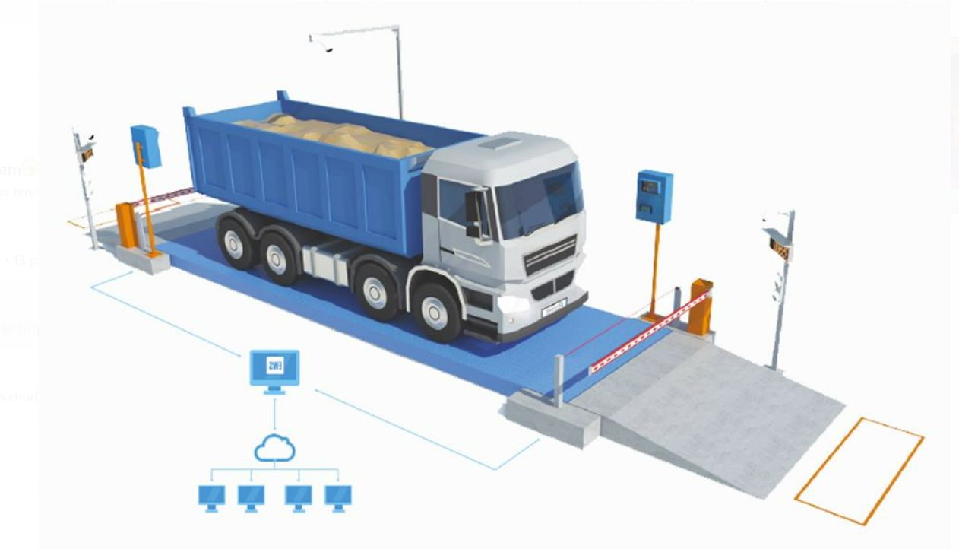

**Hardware requirements:**

* System : Intel core i5, i7 and 2GHz Minimum
* RAM : 4GB or above
* Hard Disk : 10GB or above
* Input Device : Keyboard and Mouse
* Output Device: Monitor or PC
* Camera : A good quality cam

**Software requirements:**

* Teachable Machine
* Opencv
* Cvzone
* Openpyxl
* Datetime
* TensorFlow
* Pycharm IDE
* Python IDLE

**4. ALGORITHMS USED**

**CNN Algorithm:**

Convolutional Neural Networks (CNNs) are counterfeit neural systems mostly utilised for image and video processing. It is a deep learning model that is meant to extract and learn features from photos or other multidimensional input data automatically. CNNs are made up of several layers of linked nodes, each of which conducts a convolution operation on a tiny part of the input data. The convolution process applies to the input data a series of learnable filters, allowing the network to recognise distinct patterns and characteristics at different levels of abstraction.

CNNs often feature pooling layers, which minimise the spatial scale of the output from the convolution layers, and fully connected layers are which aggregate the output from the previous layers to form a final prediction, in addition to the convolution layers. Because of its capacity to automatically learn and extract relevant characteristics from vast volumes of data, CNNs have become increasingly popular in computer vision and other fields of deep learning.

**VGG-16 Algorithm:**

VGG16 is a CNN model. The architecture of the VGG16 model consists of convolutional layers with 3x3 filters and max-pooling layers with 2x2 filters, followed by three fully connected layers. VGG16 is often used as a pre-trained model for transfer learning. Transfer learning could be a procedure where a pre-trained show, such as VGG16, is used as a starting point to train a new model on a different but related task or dataset. Convolutional layers are typically used in transfer learning with VGG16 as feature extractors, replacing or fine-tuning fully connected layers to adapt the model to a new task or dataset, while fully connected layers are typically used in transfer learning with a pre-trained model to extract relevant features from the input images.

Because VGG16 has been extensively trained to identify and extract meaningful features from images, using it can save a considerable amount of time and computational resources. This can be especially helpful for tasks in environments with little training data or limited resources.

**5. EXPERIMENTAL RESULTS**

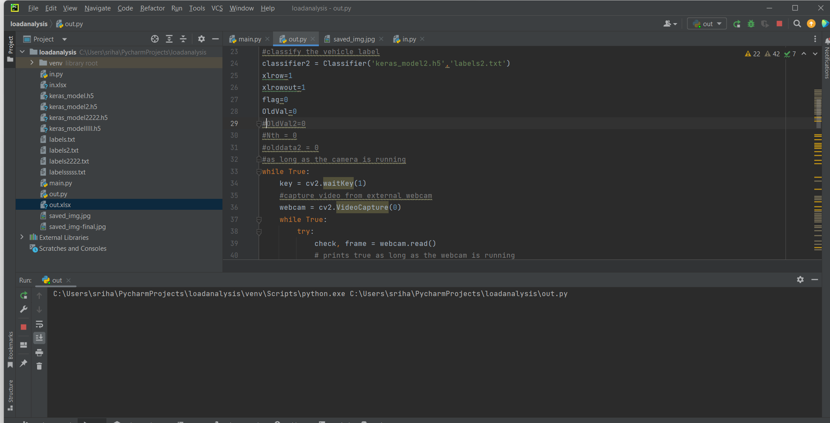

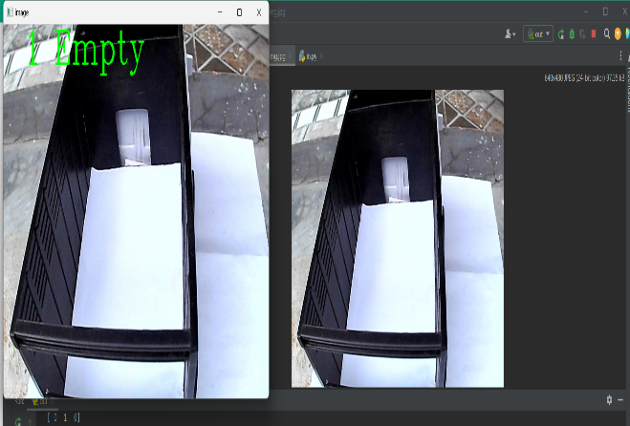

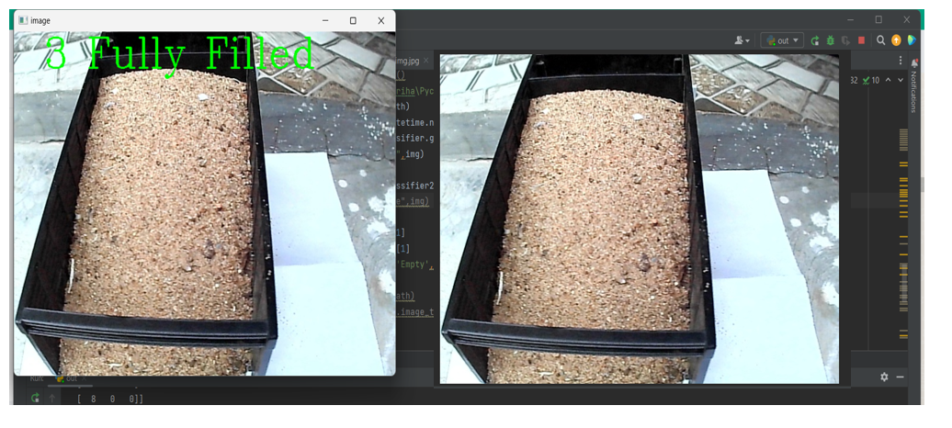

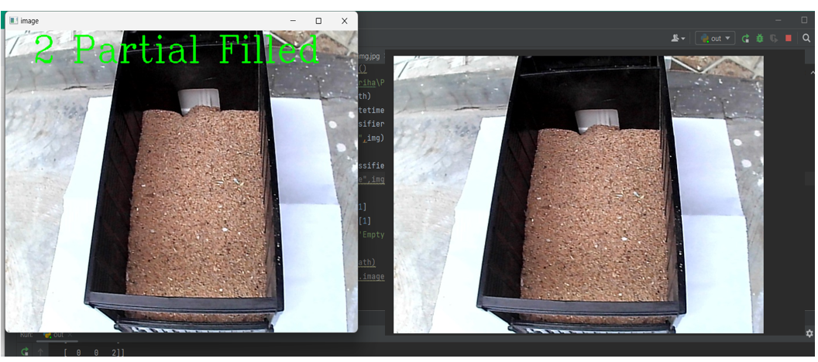

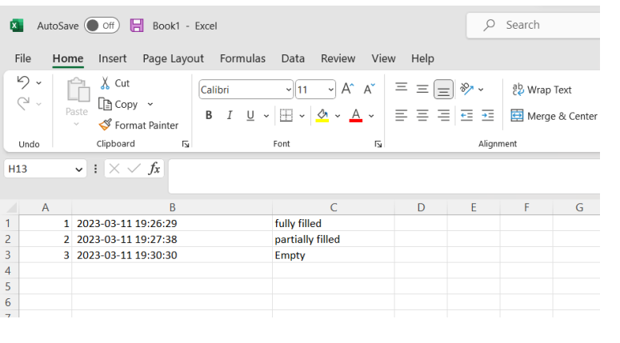

**Report for incoming Truck**

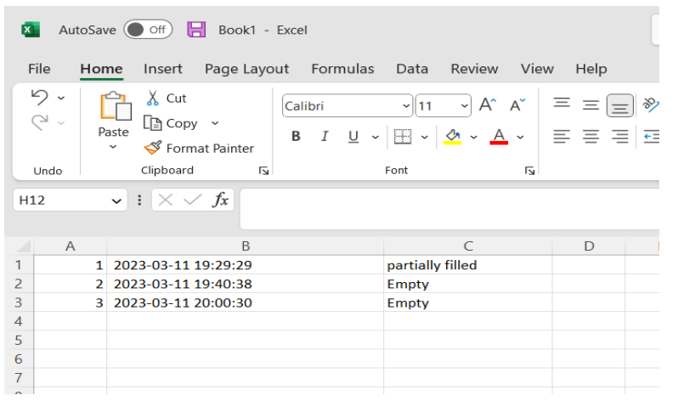

**Report for outgoing Truck**

**6. ARCHITECTURE DIAGRAM**

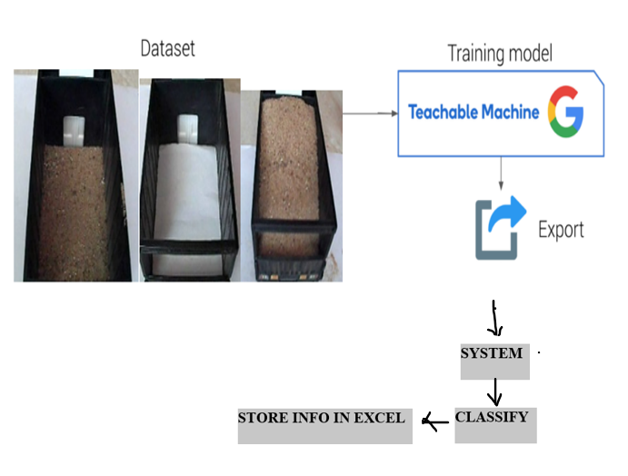

**7. ADVANTAGES**

* This proposed system reduces loss to the owners of the construction sector.
* By this system auto generated receipts can be produced after analyzing the load received that contains the total number of trucks of load received, amount of load present in the vehicle etc.
* Human involvement can be minimized.
* With affordable cost analysing the load can be done.

**8. CONCLUSION AND FUTURE SCOPE**

The proposed methodology deals with Truck count and its load analysis using Machine Learning techniques. It includes stacking an image and pre-processing. The proposed system is able to count the number of vehicles unloaded and also it analyses the amount of load received by which vehicle at which time. The proposed methodology reduces human involvement and counters the frauds while receiving the load. Using this proposed methodology while dumping of the required materials for the construction proper analysing the load and count of the trucks can be made. At the end of the day the owner will be able to see the final data in an excel sheet that comprises of count of load, quantity of load, the time at which the load arrived etc. By using this proposed methodology, there will be no loss for owners who are constructing their own house and this is also useful for contractors who take the contract by building and selling the flats. This data is all stored in Excel sheet.

**Future Scope**

However, the proposed methodology is only limited to a single vehicle entering the bay, it can be extended to multiple number of load vehicles entering into the bay. Also, in future scope we can also extend our model such that all this information is sent to the stake holder’s WhatsApp number. To improve the precision of the model, more rigorous training with a large dataset can be carried out – expanding the number of positive and negative images. As a future enhancement we can extend our methodology for checking the quality of the load received etc. In the proposed methodology user captures the image of the truck and that image is used for analysing purpose, but as the future scope we can automate this capturing process using IoT technology where we can make use of sensors which detects the vehicle presence and automatically captures the image and that image is sent as an input to our model.

**9. REFERENCES**

[1] Manoj Perera, Koichi Harada “An Automatic System for Counting and Capturing the Pictures of Moving Vehicles in Real-Time “ 0-7803-7848-2K)3/$17.00 @2003 IEEE.

[2] Qiong Cao, Rujie Liu, Fei Li, Yuehong Wang” AN AUTOMATIC VEHICLE DETECTION METHOD BASED ON TRAFFIC VIDEOS” Proceedings of 2010 IEEE 17th International Conference on Image Processing September 26-29, 2010, Hong Kong

[3] Muhammad Tahir Qadri, Sir Syed “AUTOMATIC NUMBER PLATE RECOGNITION SYSTEM FOR VEHICLE IDENTIFICATION USING OPTICAL CHARACTER RECOGNITION” 2009 International Conference on Education Technology and Computer.

[4] Ahmed Masud Chowdhury , Jafrina Jabin, Erteza Tawsif Efaz, “Object detection and classification by cascade object training” 978-1-7281-9615-2/20/$31.00 ©2020 IEEE.

[5] Abirami Devaraj, Karunya Rathan, Sarvepalli Jaahnavi and K Indira “Identification of Plant Disease using Image Processing Technique” International Conference on Communication and Signal Processing, April 4-6, 2019, India.