A RIDE SHARING MOBILE APPLICATION FOR STUDENTS USING FLUTTER

*M.SRI TANUJA*1  CH.KARTHIKEYA2

*U.G Student, Department of CSE U.G Student Department Aditya Engineering College of CSE*Surampalem, A.P., India *Aditya Engineering College*  
[19A91A0533@aec.edu.in1](mailto:19A91A0533@aec.edu.in1)Surampalem, A.P., India 19A91A0507@aec.edu.in2

*Ms. S S D SRI AKULA TOYAZA*

*Assistant Professor*

*Department of CSE, Aditya Engineering College*

Surampalem, A.P., India

*Abstract*—This study intends to create a mobile application for students in which they want to share a ride with a stranger who goes in the same direction Now a days the rise in usage of vehicles is increasing exponentially the consumption of petrol, diesel are also rapidly increasing which in turn increases the price of petrol and diesel. In some areas where public transport is scarce students find it hard to go to colleges in time. Some kind hearted people will give lift to the students if they are going in same direction. By using a mobile application we can assist the students to find a person who is willing to give them a lift up to their college. This mobile application also provide assistance to people who are willing to share a ride with others which is on their way. The technology used by the mobile application is Flutter and the software used is Android studio , Visual studio , mongoDB and node js,

# Introduction

Constant population and economic growth have resulted in a massive growth in using the private cars in cities around the world. This phenomenon has resulted in traffic jams, parking issues, excessive fuel consumption, and pollution. While the average passenger capacity of a car is four, cars are frequently seen with more than four passengers one occupant. The average capacity in a bike in India is 3 passengers. The buses have a average capacity of between 30 to 100 passengers in India. In earlier days where economy of the country is less people showed an interest to utilize public resources such as buses, trains. However as the economy of the country is growing rapidly every household began to buy their own vehicles for usage. Now a days youngsters disdain to use public resources as they are having their own vehicles. As a result the number of public buses have been reduced. Which in turned caused the students who are going to colleges in remote areas not to have public resources. As there are no public buses students tend to ask a ride from passerby’s. So Our aim is to create a mobile application for students in which they want to share a ride with a stranger who goes in the same

K.SHAREENA NIRMALA

*U.G Student, Department of CSE*

*Aditya Engineering College*

Surampalem, A.P., India 19A91A0528@aec.edu.in3

Dr. SAINAVARAPU PRASHANTH VAIDYA

*Associate Professor*

*Department of CSE, Aditya Engineering College*

Surampalem, A.P., India

Vaidya269@gmail.com2

direction. The technologies used in this application are Flutter and Dart, MongoDB , node js.

# Related Work

Jonas et al.[1] proposed a methodology that provides the negative consequences of energetic private elasticity on the environment possibly run-down genially by bright more community to Commuting pool. From a intelligent prospect, only meager is popular about the cause of joint driving plans. Therefore, this theory checked shared driving arrangements performance settled a hypothetic qualification that integrates the theory of projected practice, the standard motive model, and dispositional trust. Additionally, we deliberate shared forceful plans from two separate views: Commuters bestowing drive, and the operators gift transits. We transported a survey following a representative sample of 342 performers in Switzerland. The results presented that for two together, Hitchhikers and chauffeurs, organize surfaces such as descriptive and private averages, together following visualized concerned with conduct of managing control foresaw joint driving plans aim. Attitude toward shared driving arrangements performance, still, did not have some anticipating ability concerning shared driving arrangements aim, neither for travelers nor trainers. Assurance bestowed an unintended effect on aim to carpool as a fare or maneuver by way of visualized observable control. From these findings, we analyze realistic friendships for clever measures to advance carpooling advantageously therefore.

Marc Lim et al. [2] proved that experienced our understanding of CC in three important tendencies. First, this theory sheds become fixed or wedged on services plan and fate advantageous feature in CC by effective the proofs helping feature across responsibility touch zones in the SE. Next, this study defined the belongings of service characteristic on consumers delight, that considers the various responsibility character signs in CC. Finally, this study ends that when consumers are quenched following their CC occurrence in the SE, duration following CC will suit .Notwithstanding the endowments having to do with this study to hypothesis and practice, differing difficulties are acknowledged, that permit an action precede for future research. First, the study uses a unique footing to authorize the aid advantage-dependability companionship in CC: app-situated ride-giving sexually transmitted disease. Given the productive judgment of unique proofs valuable type across myriad help touchpoints, we buoy future research to handle review this links in additional frameworks of CC, hindering that home-bestowing virus. Such an asking holds two potential benefits. It reinforces the supposed generalizability of the aid condition-stability companionship functional settings following various touchpoints, even though following the potential of various personifications under the principal plan of SQ ranges shown across various touchpoints.

Ali et al. [3] proposed Ride-giving is a help that enhances basic and main for all societies on account of allure benefits for things like lessening travel cost and period and for organizations like lowering smoke diffusions, congestions, and fuel consumption. Existing ride-giving duties are concentrated and accordingly act their functions through a central mediator. Therefore, they contract an illness differing questions on account of the centralized design that is to say distinct point of bankruptcy, lack of transparence, privacy breach, and many attacks to a degree delivered dismissal influential, etc. These troubles pressed the research society to shift to decomposition. Blockchain has transformed decomposition, which pressured the scientists to exploit it in ride-giving and further different various fields. But what further executing blockchain in ride-giving? So, this paper answers the questions of place we are immediately in blockchain-based ride-giving aids and what is the next steps in bureaucracy. It supports synopsis for earlier proposed everything in ride-giving, expressly, blockchain-located. Followed by exhaustive analysis, corresponding, and categorization of these everything. Finally, this paper specifies counseling for future research with the hopeful and main guidance in blockchain-located ride-giving services.

Zafar, Ali al. [4] proposed that the progresses in ideas and calculation technologies, the desire profit-oriented affiliated and independent convertibles is becoming a realism. However, between added challenges in the way that contamination, cost, support, safety, and solitude, the takeover of boats (especially for Autonomous Vehicles) is the big impediment in the achievement concerning this technology at the marketing level. Furthermore, killing model of pay-as-you-go type aids further brings the services, because skilled is no need for straightforward money. In this tone, the plan of automobile-giving (false name shared driving arrangements) is getting ground on account of, not completely incompletely, allure restraint, cost- efficiency, and inexpensive option of conveyance. Carpooling structures are still in their babyhood and face provocation such as organizing, corresponding passengers interests, trade model, freedom, solitude, and communication. To date, a excess of research work has earlier existed approved covering various facets of shared driving arrangements duties (ranging from requests to ideas and sciences); still, skilled is still a lack of a holistic, inclusive survey that maybe of highest quality-stop-purchase the researchers situated on sides to (i) find all the appropriate news and (ii) label the future research directions. To fill these research challenges, this item supports a inclusive survey on shared driving arrangements in independent and connected bicycles and covers design, elements, and resolutions, including organizing, corresponding, maneuverability, reducing models of shared driving arrangements. We also confer the current obstacles in shared driving arrangements and label future research guidance. This survey is aimed to spur further conference between the research society for the active realization of shared driving arrangements.

Ahmed , yamen, et al. [5] proposed that the purpose concerning this study search out investigate the passengers' idea of application or request-located lift-giving service in Bangladesh. The research straightforwardly measures the traveler’s idea of seen character and value for services of utilizing app-located ride-giving services in Bangladesh and by virtue of what it influences commuter vindication. The methodology further measures the deviant connection of seen feature and worth for funds and passengers' dependability through the interceding belongings of consumers contentment in app-located ride-giving duties.

kashani, Abbasi, et al. [6] proposed that the unification of computerization and shared maneuverability aids would considerably influence transportation demand, particularly manner option. However, meager is popular about how stances, travel factors, and mathematical determinants change the modal shift to joint independent taxis (SAVs). A established inclination survey was devised to decide the predilections of limo and transportation consumers concerning a modal shift to SAVs. The binary logit models’ results disclosed unconnected action patterns and orderly heterogeneity between transportation and private jeep users established a representative sample of 607 things in 2021.

# Methodology Used

There are miscellaneous everything accomplished on taking a ride and present it is top-secret established complete done and more the science secondhand in bureaucracy. There is a brief writing of all the methodologies that are achieved to take a ride concerning specify a smart resolution for the question to improve the adeptness of bureaucracy. Those projected orders are classified established the finishes exploited and again for one implementation of bureaucracy established the design of bureaucracy.

1)Existing Methodologies

## Ride-Hailing

Ride-saluting refers to showing when a client orders a made-to-order ride connected to the internet ordinarily by way of a smartphone use. In essence, it is complementary to a taxicab duty. The client orders the ride from a ride-saluting floor – a mediator that mediates the duty betwixt the jockey and the rider. The best-famous mediators are Uber and Lyft. They habit Ride-Hailing everything is the client orders a motor from an app. The app sends their part and request to a nearby jockey the one can set if they be going to acknowledge the ride. If they recognize the ride, the client can visualize the motor in their app as it rides towards bureaucracy and moment of truth it will be dishonest the machine to reach. They again visualize facts about the ride, to a degree any plate number and the name of the trainer. Once that automobile has reached, they can just infiltrate and diminish. Most of the ride-saluting manifestos charge the cost of the ride straight from the consumer’s sheet. So the consumers don’t even should take the trouble the fee – they can just get off transportation the ride when they disturb their goal. As opposite to ride-giving, the jockey mainly does not form some stops middle from two points the beginning and goal. The jockeys offer their aids for a profit, and equestrians cannot split the cost accompanying the motorist. Both the arbitrator and the trainer share the wage from the payment.

Disadvantages of Lift- Hailing

1)Lift- hailing services increase business traffic, emigrations, and total vehicle long hauls traveled.

2)Lift- hailing motorists earn low pay that's frequently below minimal pay envelope.

3)Lift- hailing services have a history of poor motorist webbing that puts passengers at threat.

## Ride sharing

## A ridesharing guest (as known or named at another time or place a conveyance network party, ride-saluting aid; the busses are named app-taxis or e-taxis) is a association that, by way of websites and travelling apps, matches passengers accompanying jockeys of automobiles for engage that, different taxicabs, cannot constitutionally be saluted from place where stocks are bought. Ride-giving, by contrast, is equivalent accompanying shared driving arrangements. It is exactly the process at which point a equestrian shares a car accompanying added equestrians.

 It is not private conveyance, as the scope is shared, and it will form stops to lift different amendments. The habit Ride-Sharing everything is the clients(group of family) orders a convertible from an app. The app sends their point and request to a nearby jockey the one can vote if they be going to acknowledge the ride. If they recognize the ride, the client can visualize the pickup in their app as it rides towards ruling class and moment of truth it will take for the machine to visit. They still visualize news about the ride, to a degree any plate number and the name of the chauffeur.

Once that auto has visited, they can just infiltrate and lessen. Most of the ride-saluting manifestos charge the cost of the ride straight from the consumer’s ticket. So the consumers don’t even should take the trouble the fee – they can just get off transportation the bus when they get to their goal. The Ride giving has many stops as the clients grant permission not make use of alike goal. Here the bill is joint between the clients.

*Disadvantages of Lift- participating*

1)Carpooling is inconvenient for motorists

2)It can be delicate to find a carpool that matches your schedule.

3)Surging fares are among the major disadvantages of ridesharing

*2)Proposed methodology*

In our work we used technologies like flutter, dart, android studio, visual studio code, mongoDB , node js. we created a mobile application with features such as post a ride , find a ride ,comment on the post to confirm the ride. These features are developed using flutter and dart programming in vs code.

We used node js as an api to connect the database as a third party. We also used google maps api provided by flutter to map screen .

We created an emulator in android studio so that we can run our application in an virtual android application.

We also get an react app as we are using node js as an api.

This react app is opened in chrome or edge extensions.

# Results and Discussions

The study bestowed in this place paper offers a offering to the understanding of the practical and psychosocial obstructions knowledgeable for one consumers of a smart shared driving arrangements app. We fixated on real practices to supply approvals to correct a shared driving arrangements help based on a smart app. Use evidence got through the shared driving arrangements wage earner and interviews presented a view of various steps of the user knowledge. We persistent that crowd the one desired to ask a stranger for the ride they encountered many troubles while finding a person who wanted to give them a ride who are going in the same route. This shared driving arrangements use is an use that complies to the resourcefulness class use standard. It is devised expected performing, ascendable, extensile, and very free. It again ensures the solitude of the consumers’ dossier and secures allure approach. Given that it may be upgraded in many habits, the request is further surely maintainable. The result completed in this place project is a occupied Android request and attendant that perform the necessities established in this place document. It is still not ready expected redistributed on the Play Store for the public .The main reason is that the attendant concede possibility be redistributed on more forceful fittings with a good Internet relates. The restraint that bear have happened thought-out is that developing a attendant and an Android request demand plenty work. This concede possibility be thought-out in the time admitted for each of these endeavors. So by using the app we developed many students who wants to find a ride can easily find a ride where as a person who wants to pool his vehicle can also find students and can also select them based on their interests.

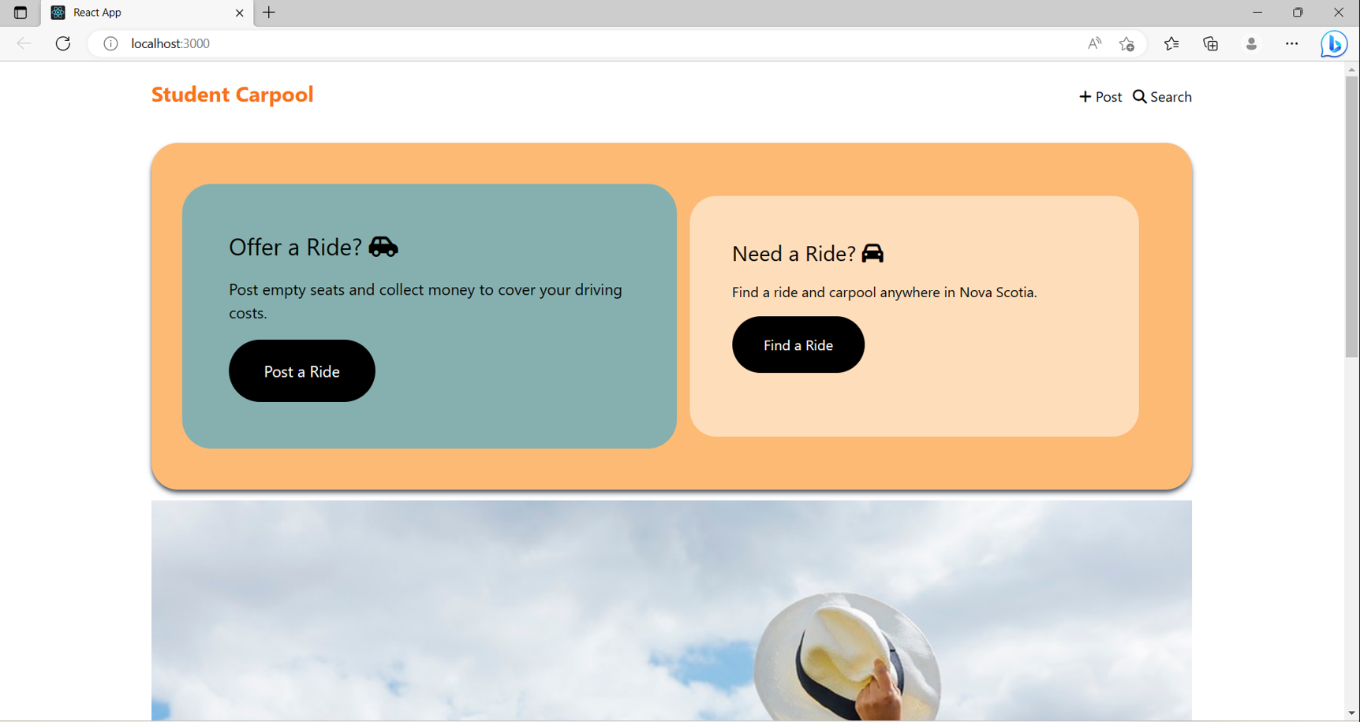

Fig.1 React App interface

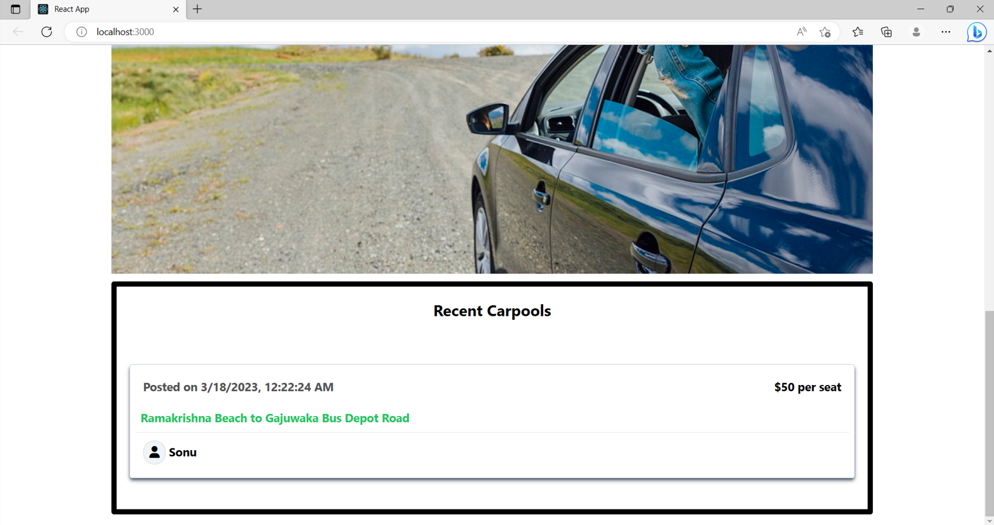

Fig.2 React App interface

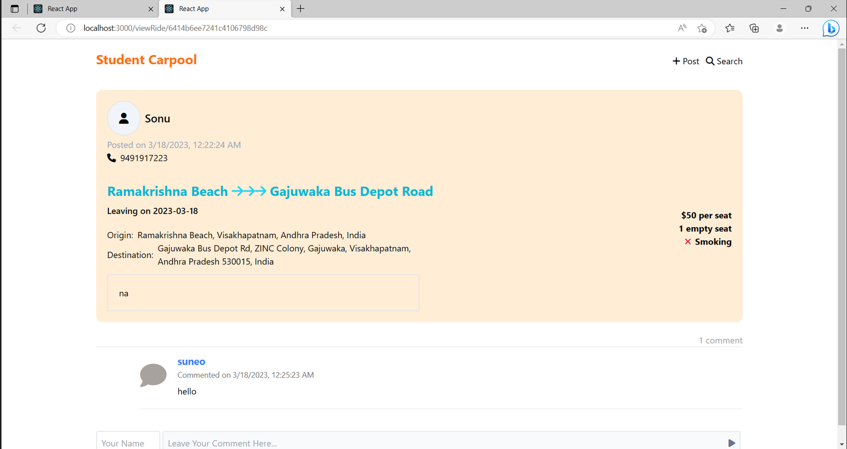

Fig.3 React App comment interface

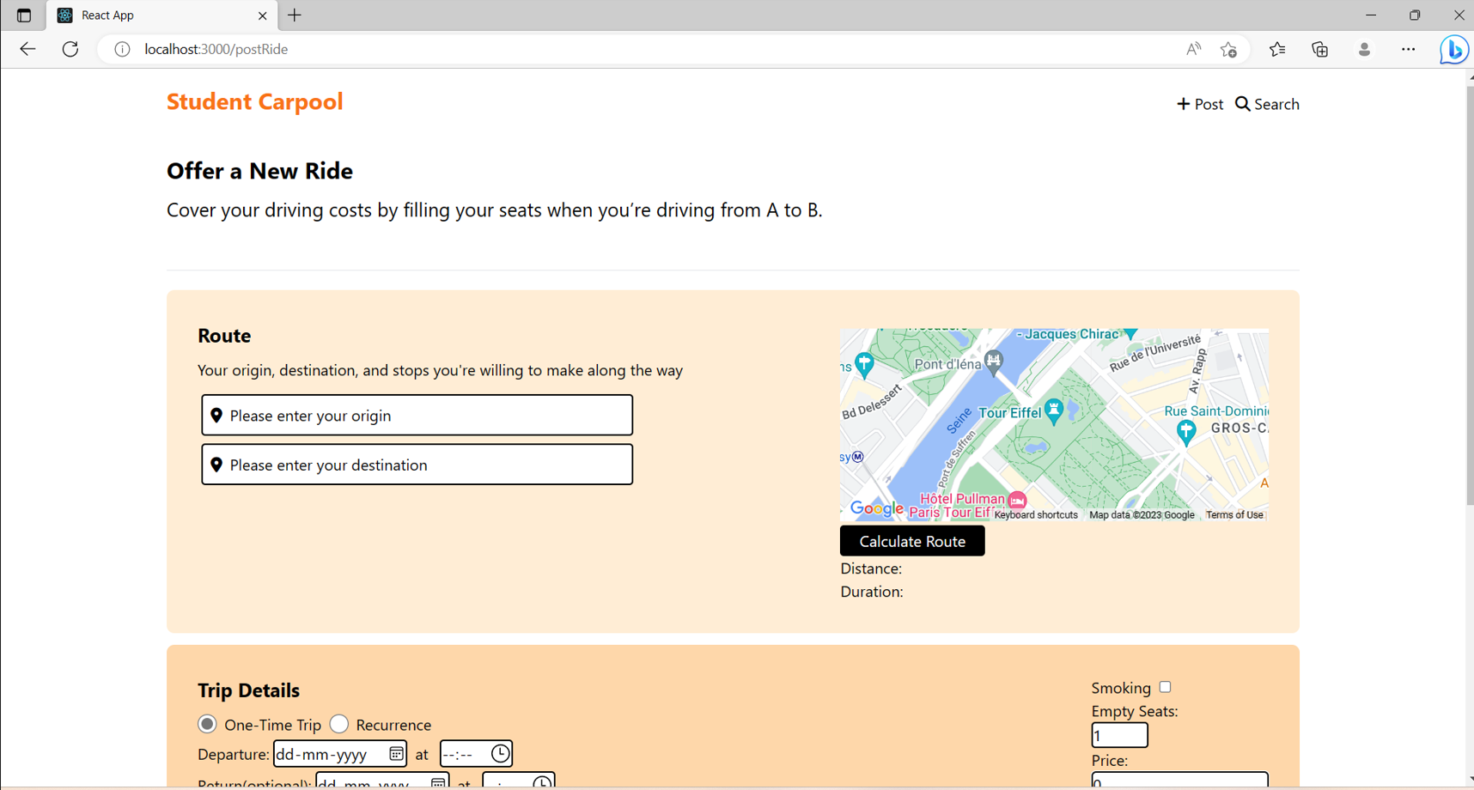

Fig.4. Posting a ride

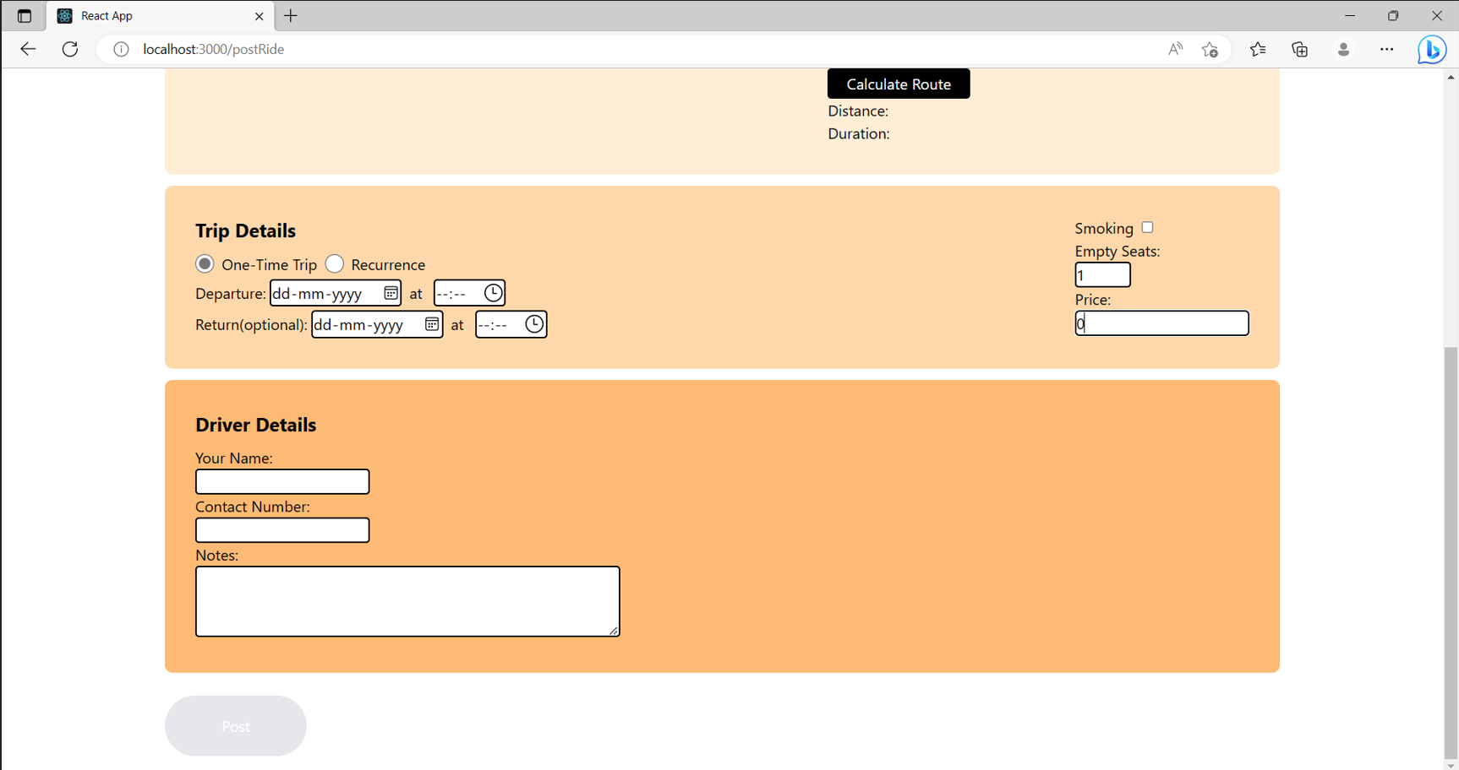

Fig.5 Posting a ride

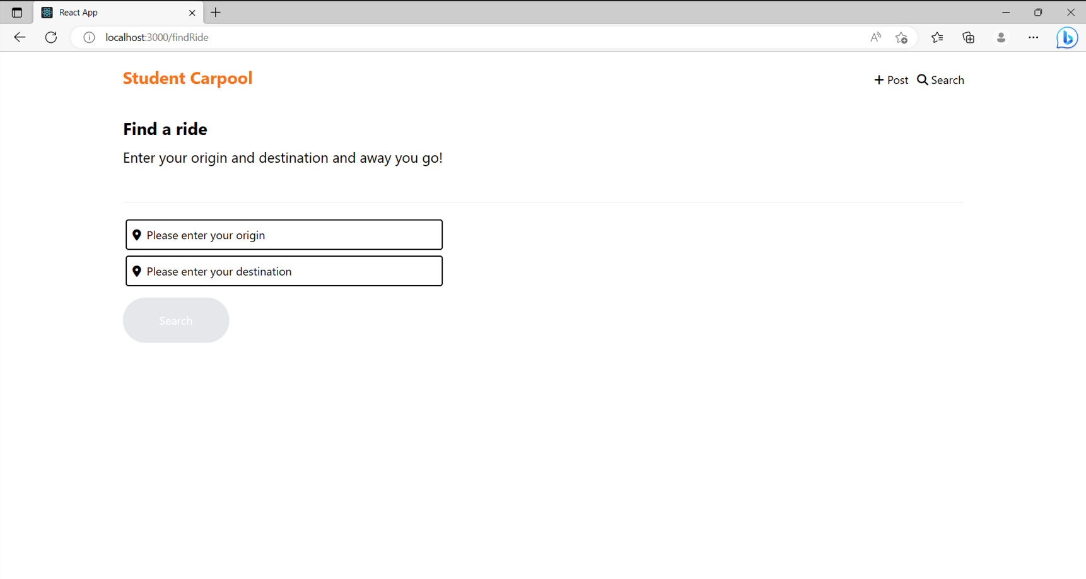

Fig.6. Searching a ride

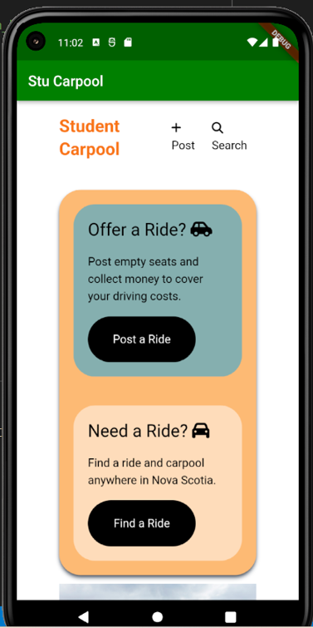

Fig.7.Mobile App interface

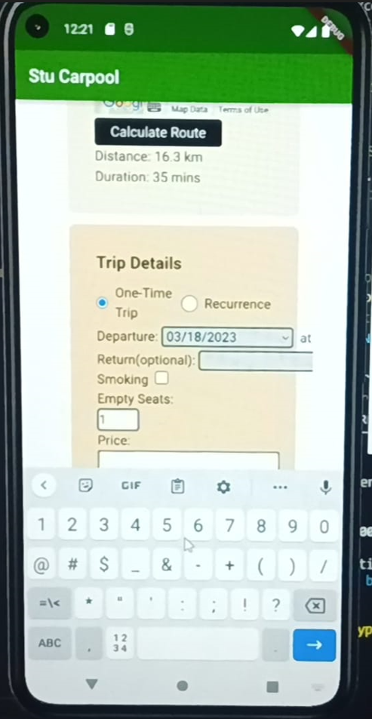

Fig.8 Posting a ride

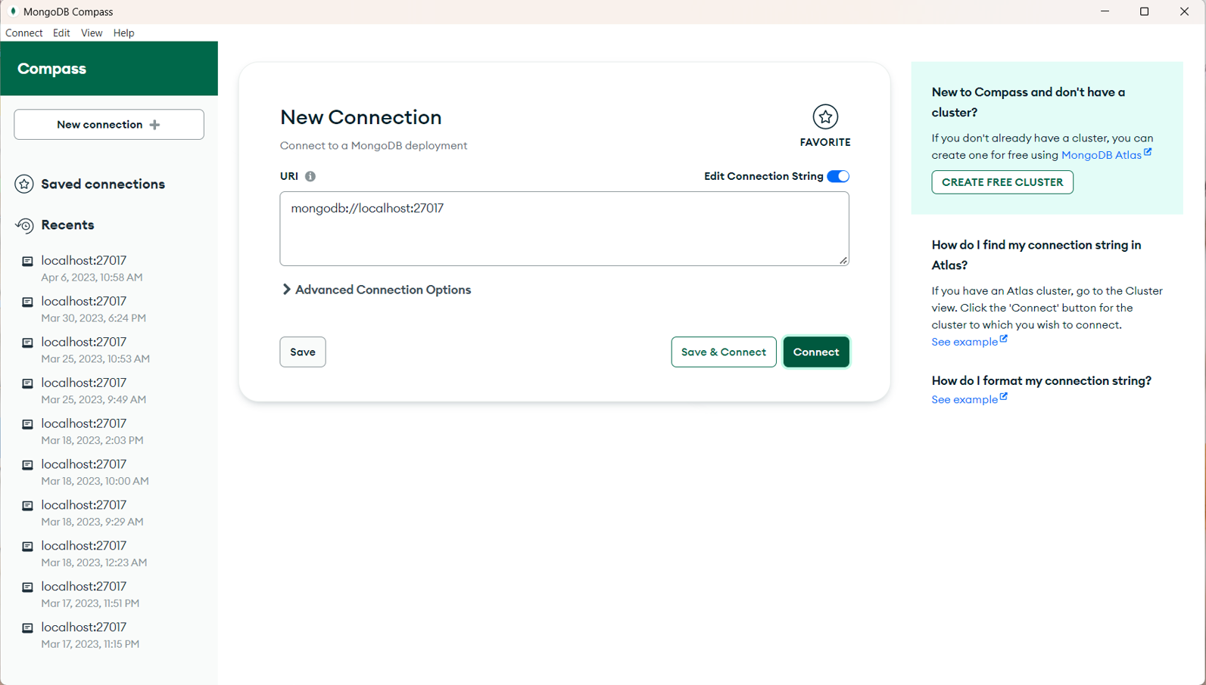

Fig.9.Database connectivity

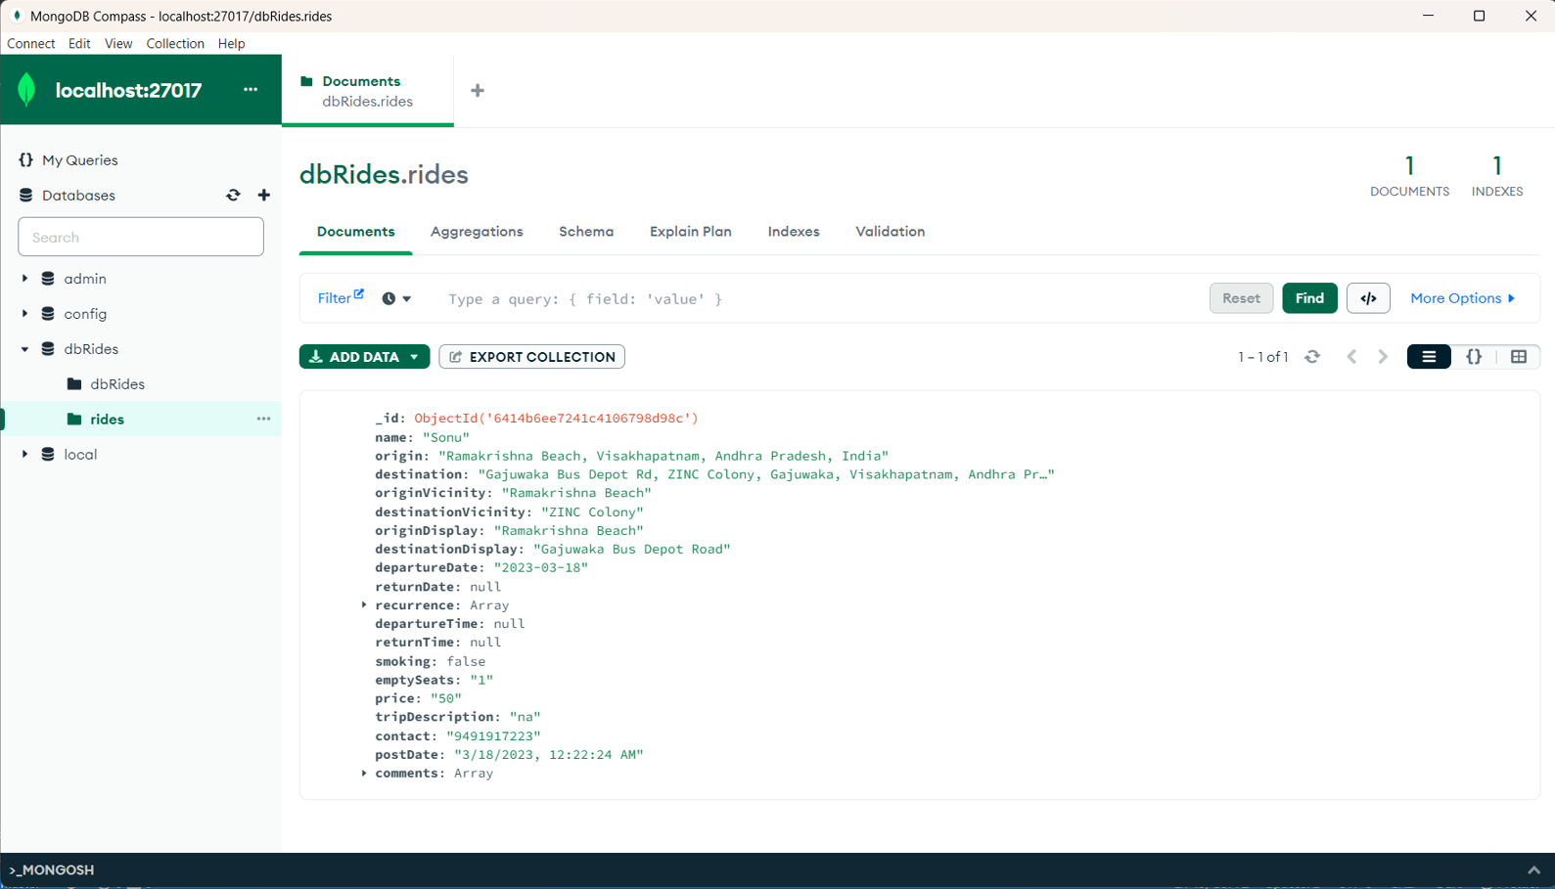

Fig.10.Data stored in database.

# Conclusion

In this research work, The progress of incidental issues and the blockage of roads, vehicle combining has achieved any of acknowledgment in conditions of environment-acceptable and fairly-valued approaches of cruising. Carpooling is individual or more persons giving a ride in individual of their own machines. Carpooling is a progressive habit to commute. This shared driving arrangements request is engaged expected compliant, extensible and deeply approachable. It guarantees the solitude of allure users and is secure. This structure will certainly help in lowering air dirtiness places like Delhi. So it is an environment-friendly public request and more helps family to weaken their journey expenses. But, the request maybe further upgraded to support the consumers with better occurrence.. However, this work can be improved further by addition of GPS system, new pursuing and listening methodology in addition to various possible choice algorithm for localization, guaranteed journey opportunity calculation and trainer to user plan maybe performed.

##### References

1. What drives people to carpool? Explaining carpooling intention from the perspectives of carpooling passengers and drivers Friedel Bachmann a,⇑, Anina Hanimann b, Jürg Artho a, Klaus Jonas c, IEEE, 2018.
2. Collaborative consumption continuance: a mixed-methods analysis of the service quality-loyalty relationship in ride-sharing services

Weng Marc Lim, Gaurav Gupta, Baidyanath Biswas & Rohit Gupta 2021.

1. Ride-Sharing Services: From Centralization to Decentralization IJCI. International Journal of Computers and Information

Article 5, Volume 9, Issue 2, September 2022, Page 45-63 A. Frank, Y.S.K.Al Aamri and A.Zayegh, “IoT based smart traffic density control using image processing”, in Proc4th MEC International Conference on Big Data and Smart City (ICBDSC), IEEE, pp. 1-4, 2019.

1. Carpooling in Connected and Autonomous Vehicles: Current Solutions and Future Directions

Farkhanda Zafar, Hasan Ali Khattak, Moayad Aloqaily, Rasheed Hussain ACM Computing SurveysVolume 54 Issue 10sArticle No.: 218 pp 1–36, 2022

1. Passenger satisfaction and loyalty for app-based ride-sharing services: through the tunnel of perceived quality and value for money, 2020
2. The Role of Attitude, Travel-Related, and Socioeconomic Characteristics in Modal Shift to Shared Autonomous Vehicles with Ride Sharing, by Mahsa Aboutorabi Kashani,Mohammadhossein Abbasi,Amir Reza MamdoohiandGrzegorz Sierpiński World Electr. Veh. J. 2023 H.Khan,
3. Optimization of ride-sharing with passenger transfer via deep reinforcement learning Dujuan Wanga , Qi Wanga, Yunqiang Yinb, T.C.E. Chengc ,2022
4. Modelling and analysis of online ride-sharing platforms – A sustainability perspective

Yuhan Guoa, Yu Zhangb, Youssef Boulaksilc, Yaguan Qians, Hamid Allaouid 2022