**Formulation and Evaluation of Multipurpose herbal cold cream**

**Arti Vishvakarma, Guide Sandhya Godi**

**Abstract**

The main aim of our work is to develop a herbal cream which can give multipurpose effect, like moisturizer, reduce acne and skin irritation, reduce skin diseases like eczema, psoriasis, dry skin, wrinkles, rashes etc. and also adding glow to the face. We have used two herbal extracts in our preparation which are Neem and aloe vera Aloe Vera gel. Aloe vera gel is used as a moisturizer, to reduce pimples and acne and also used for treatment of burn wounds. Neem is used as an antifungal and anti-inflammatory and it is also used to reduce scar, pigmentation, redness and itching of the skin.From that time the materials which are used to promoting appearances or to beautify the skin are called as cosmetics Cream was formulated and evaluated by different evaluation parameters such as pH,viscosity, spreadbility physical appearance and irritancy test. Stability testing for prepared formulation was performed by stirring it at different temperature condition for time period 24th for 1 week. To know parameters like odour, pH, smoothness of cream

**INTRODUCTION**

Cosmetics are the products which are generally used to beautify the skin and also to purify the skin .The cosmetics are the word derived from Greek word – ‘kosmesticos’ which means to adorn. Cold cream is the water in oil emulsion . Cold cream gives the prolonged contact time in the site of application as compared to the other semisolid dosage form or formulation. They give elegancy to the skin and it is not that much greasy. Due to the oil phase, it gives an emollience to the skin. The function of the cold cream is for restoring moisture to dry skin, it allows to eliminate the waste materials from the pores and also cools the body . It is easily watered washable and easy to wash away. They are non-irritating when applied on the skin. The water phase gives extra conservation to the skin. It gets liquefy at body temperature. It gets penetrated via the epidermis of the skin via the natural pores. More recently anti-aging creams have been manufactured which can retain younger looking skin for many years. The best cleansing agents are cleansing creams, soap and water. [1]

Cream is defined as semisolid emulsions which are oil in water (o/w) or water in oil (w/o) type and these semisolid emulsions are intended for external application. Cream is classified as oil in water and water in oil emulsion. It is applied on outer part or superficial part of the skin and its main ability is to remain for a longer period of time at the site of application. The function of a skin cream is to protect the skin against different environmental condition, weather and gives soothing effect to the skin. There are different types of creams like cleansing, cold, foundation, vanishing, night, massage, hand and body creams.[2] Several medicinal plants have been used as cosmetics since ancient times, and have shown promising effects on various skin ailments such as acne, blackheads, age spots, skin rashes. allergies and skin rashes, skin aging, wrinkles, whitening skin etc. Some of the most common plants such as Aloe vera, Azadirachtaindica, Annona squamosa, Aterocarpusheterophyllus. Carica papaya, Centellaasiatica, Curcuma long. Mangiferaindica, Moringa citrifolia, Ocimum sanctum, Phyllanthus emblica, Psidium gujajuva, njidi, gujajuva, nje, etc. and Unani programs for their beauty products. Because of the enormous advantages offered by Sesame Oil, it has become a fundamental piece of the way of life for many people. Additionally, this sesame oil is brimming with antioxidants that assist you to fight free radicals and keeping your skin away from ageing and wrinkles. Newish sesame oil (til oil) powerful calming property helps in decreasing aggravation and growing on the skin. Kneading your and scalp with sesame oil. The sesame oil has obscuring properties that assistance in holding the regular shade of your . In the event that you are experiencing balding, applying Sesame Oil to your scalp will help make your solid.

**Prepration of cold cream**

**● Procurement** **of material**: - Neem, Turmeric, Aloe Vera collected from Thakur Shivkumarsingh Memorial Pharmacy college garden.

**● Material**:- Neem oil , Sesame oil ,Turmeric powder, Aloe vera ,Beeswax , Borax , Vitamin E capsule, Rose water.

**● Preparation** **of herbal** **cold** **cream** :-

The formulation can be prepared by adding two different phases which are as follows.

**Phase** 1 : Melt beeswax in a china dish on to hot plate .To this, all the oils is added and then heat on a hot plate at 70°c.

**Phase** 2: Then in a 100ml beaker , borax was dissolvend heated along with Rose Water on a hot plate at 70°c.

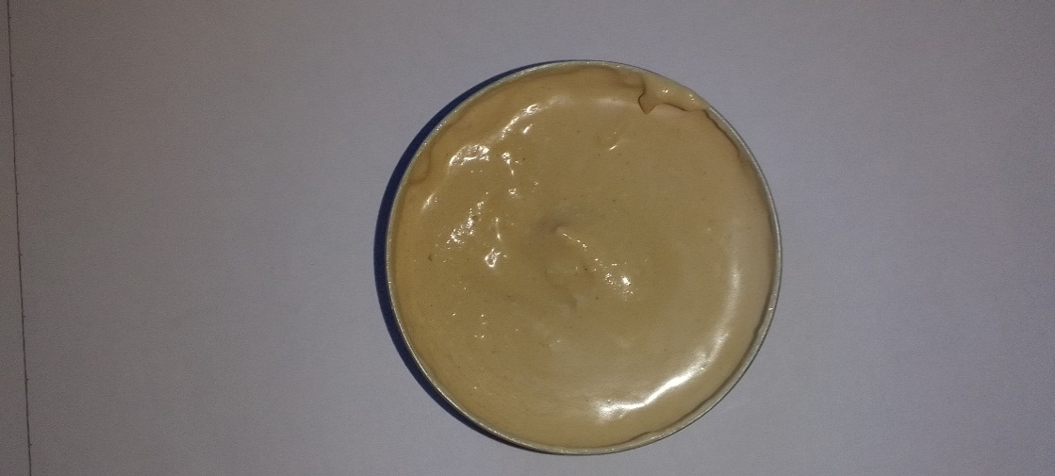

**Fig.1**

Turmeric powder ,aloe vera and vitamin E capsule was added in the beaker. While still hot add the phase 1 into the phase 2 are heated at same temperature i.e. 70°c continue this process for 5 minutes, stir all the time then remove from the heat and stir until it cools down and a semi solid mass was obtain .

|  |  |  |
| --- | --- | --- |
| **Sr. No.** | **Ingredients** | **Quantity** |
| 1 | Neem oil | **46 ml** |
| 2 | Turmeric powder | 1 gm |
| 3 | Aloe vera | 2 ml |
| 4 | Sesame oil | 2 ml |
| 5 | Borax | 1 ml |
| 6 | Beeswax | 20 gm |
| 7 | Rose water | 26 ml |
|  | Net Weight | 98 gm |

Table no.1. : Formulation table for herbal cold cream (for 98 gm

**EVALUATION OF HERBAL COLD CREAM**

Evaluation of the herbal cold cream involved following:-

● **Physical** **properties**: The cream was observed for the color, odor and appearance.

● **Determination** **of pH** : The pH meter was calibrated with the help of standard buffer solution. Weigh 0.5 gm of cream dissolved it in 50.0ml of distilled water and its pH was measured with the help of digital pH meter.

● **Determination** **of homogeneity** : Homogeneity was tested via visual appearance and test.

● **Determination** **of** **spread** **ability** **test** : The cream sample was applied between the tow glass slides and was compressed between the two-glass slide to uniform thickness by placing 1gm of weight for 5 minutes then weight was added to the weighting pan. The time in which the upper glass slide moved over the lower slide was taken as a measure of spread ability.

S = m × L / T

Where ,

S = Spread ability

M = weight tight to upper slide

L = length moved on the glass slide

T = time take

● **Patch test :** About 1-3 of material to be tested was placed on a piece of fabric of funnel and applied to the sensitive part of the skin behind ears, the cosmetic to be tested was applied to an area of 1sq.m.of the skin control patches were also applied. The side of patch is inspected after 24 hrs.

● **Dye** **test** : The scarlet red dye is mixed with the cream. Place a drop of the cream on a microscopic slide then covers it with a cover slip, and examines it under a microscopic. If the disperse globules appear red the ground colorless. The cream is o/w type. The reverse condition occurs in w/o type cream i.e. the disperse globules appear colorless.

**Result and discussion**

**● Physical** **properties**:-

|  |  |  |
| --- | --- | --- |
| Sr. No. | Properties | Result |
| 1 | Color | Yellow |
| 2 | Odor | Pleasant |
| 3 | Appearance | Semi-solid |

Table no.2. : physical properties of formulated herbal cold cream

**● PH** **of** **the** **cream** : The pH of the cream was found to be in range of 5.6 to 6.8 which is good for skin pH .The herbal formulation was shown pH nearer to skin required i.e pH 6.8.

**● Homogeneity** : The homogeneity of the formulated cream was judged by the visual appearance and touch .The appearance and touch of the were good.

**● Dye** **test** : The scarlet red dye is mixed with the cream. Place a drop of the cream on a microscopic slide covers it with a cover slip and examines it under a microscopic. The disperse globules appear colorless in the red ground i.e. w/o type cream

**Conclusion:** From the above results it is concluded that the formulated cream showed good consistency and spread ability , homogeneity , pH , non - greasy and there is no phase separation during study period of research . From the above study it can be concluded that the polyherbal cold cream is safe to use as it is developed from herbal extract . Natural remedies are more acceptable in the belief that they are safer with fewer side effects than the synthetic ones . So , the values of herbs in the cosmeceutical has been extensively improved in personal care system and there is a great demand for the herbal cosmetics nowadays . An herbal cream which is non - toxic , safe , effective and improves patient compliance by the utilization of herbal extracts would be highly acceptable than synthetic ones .

**Refrence** :

1. N. Shah, B.M.Methal, (2006) A Handbook of Cosmetic, Vallabh Prakashan.
2. Saraf, S., & Kaur, C. D. (2010). Phytoconstituents as photoprotective novel cosmetic formulations. Pharmacognosy reviews, 4(7).
3. Jadhav Ravindra T. Patil Pratibha R. Patil Payal H. Formulation and evaluation of semisolid preparation (ointment, gel & cream) of thiocolchicoside, Journal of pharmaceutical and biomedical sciences, Volume 08. issue 08. JPBMS 2011, 1-6.
4. Panda, H. (2000). Herbal Cosmetics Hand Book. National Institute of Industrial Re.