Water Level Estimation and Automation of Reservoir Gates Using IOT

Aditya Engineering College, Surampalem, A.P, India

Dr. A. Vanathi, M.E.; Ph.D.; Associate Professor,

[hod_cse@aec.edu.in](mailto:hod_cse@aec.edu.in)

|  |  |  |
| --- | --- | --- |
| Seeli Stella Rani1, | Kalla Mani Shankar2, | Guggilapu Eswar Abhishek3, |
| Department of CSE, | Department of CSE, | Department of CSE, |
| [19a91a0551@aec.edu.in](mailto:19a91a0551@aec.edu.in) | [19a91a0522@aec.edu.in](mailto:19a91a0522@aec.edu.in) | [19a91a0516@aec.edu.in](mailto:19a91a0516@aec.edu.in) |

# *Abstract*- On earth, water is a very vital necessity. For the sake of the next generation, it is our duty as humans to conserve water. Rainwater is wasted frequently these days. A further waste of water from dams damages gates internally and sends ripples across the surrounding villages. Our suggested methodology for calculating water level and automating dam/reservoir gates utilizing relays aids in automating dam gates and sending notifications to registered mobile numbers and neighbouring dams over GSM Module in order to avoid all these negative effects. In order to avert future effects, rain drop sensors are also employed to identify significant rainfall in the past. Dams nearby are therefore informed as well.

# *Keywords*: *IOT, Relays, GSM Module.*

# 1.INTRODUCTION

In order to avoid problems, a dam's water level must be effectively maintained. Since this is typically done manually, more people must be employed to provide full-time supervision. A man is unable to correctly regulate the gates with no knowledge of the accurate water level and rate of input since the amount of water

provided is usually erroneous, resulting in water loss. comprehension of the precise water level and input rate. This system's sensors are connected to an Arduino board. The water level was examined using the sensors.

Officials can use their mobile devices to view information about the water level in the dam. A wide range of concerns, including dynamic responses to prior warnings of dangerous situations and the stage of the current water level, are brought about by human-based opposition to flood management techniques. Numerous sectors have given the Internet of Things (IOT) a great deal of attention.

The project's objective is to create an application system that utilises the Internet of Things to safeguard public safety by alerting the public in advance if projected floods are caused by rising water levels in dams and reservoirs. A cloud database approach is used to achieve the aim, using local knowledge and data from routine water level monitoring. When the sensor data is collected, the rise in water level is noted. Consequently, the public is automatically made aware of the earlier stages of the water level rise. Finally, it was shown that this technique boosts the degree of accuracy when compared to the traditional monitoring and alerting system.

Relays and motor drivers are used in this project to open and close the dam gates. GSM modules have been used to send alerts to mobile devices and nearby dams.

**2. LITERATURE SURVEY**

**1.International Conference on Information Technology and Digital Applications, May 2018, "Iot Based Water Supply Monitoring and Controlling System"**

Water is a essential necessity for all living things. The water must be preserved by everybody. Water regularly spills when monitoring is insufficient. Tanks may overflow due to this considerable water waste. In addition, pipeline damage from overflow at increased pressure is a possibility. Leak detection is another problem. These problems are brought on by a lack of supervision, manual work, and personnel. A survey was conducted for this study. The city of Aurangabad and field research were carried out in order to investigate water supply distribution and related systemic difficulties. They conducted a study and found that everything is done manually and that better technology is needed to disseminate things effectively.

**2.** **International Journal of Scientific & Engineering Research, April-2016. Using GSM Technology for Gate Control Automation and Water Level Reservoir**

A dam is a structure that prevents water from flowing. A dam retains water, but floodgates and other obstacles keep it from flowing into In. In certain geographical locations. When the level of water in the dam exceeds to certain threshold, the dam gate collapses. To avoid this, levels in dam has to be checked on a regular basis. Because water is a limited resource, it must be safeguarded and maintained in excellent shape. Water-related metrics should be regularly monitored and reviewed. Two of the most important indications of water pollution are temperature and pH. In this proposal, the pic16f877a microcontroller was used, which assists in continuously monitoring the water level in dams and providing flood warnings.

**3. International Conference on Intelligent Computing, Communication and Convergence,2015, Wireless Disaster Monitoring and Management System for Dams**

This study's proposed system would monitor a high density, and then interact in real time. Given the recent developments in June 2013, a devastating scenario has emerged as a result of strong rain and cloud bursting in a variety of regions. Many people were ignorant of many features of the flow and discharge from surrounding dams that had previously been influenced due to inadequate communication across these dams. There was a considerable loss of life and property as a result of this.

**4.** **Monitoring and controlling the level of the dam gate, International Journal of Innovative Trends in Engineering (IJITE), June 2020**

The primary goal of this research is to regulate the level of water in a dam that was linked to the IOT. As a consequence, the scheduled monitoring system was designed, implemented, and controlled. The project's genesis is based on the Internet of Things (IOT). To get the best results, Proteus is used as the working platform, while the basic principle of the automation of variety of settings and prospective situations, the gate control setup is subjected to dry running.

**5.** **International Journal of Innovations in Engineering and Science's 2017 article, "Raspberry Pi Based Automatic Dam Monitoring and Alert System,"**

The automated control of a dam river system is the subject of this essay. Due to the different outputs provided by intermediate measurement locations dispersed along the river, the system is a single input-single output (siso) cascade. systems and may be conceived of as a single input-multiple output (simo) system. For internal model-based controllers, a comprehensive resilient design synthesis based on the design of an internal model controller (imc) created. Because of the system's nonlinear dynamics, the resilience is calculated using a multiplicative uncertainty constraint that takes model mistakes into account.

The river's nonlinear model is used in the simulations. Since its inception, the sector has concentrated on developing and adjusting relatively simple controlling and automation technologies that allow for the manufacture and modification of relatively simple automation and control systems for any severe process. The design and implementation of a control system using microcomputers and data transmission networks is presented in this study. To check the fundamental functioning of the controlling scheme that will be discussed, a tiny pcb system is used to test the automated dam model.

**6.** **Lake Water Level Monitoring System Using IoT, International Journal of Lakes and Rivers, May 2019**

In this work, they had introduced the idealogy of the water levels keeping an eye on and the management of lake water storage sources for towns. They exhibited the Raspberry Pi as a controller for monitoring and controlling water levels in both wired and wireless contexts.

It might also represent the amount of available water in the lake. This system makes use of GSM technology. Recently, cell phones with reasonable processing power and high-quality graphical user interfaces become accessible. From the standpoint of the user, it is critical to reuse such a precious resource in a mobile application. Finally, the paper proposes a monitoring service method based on the web and cellular technology to track lake water availability.

**3. METHODOLOGY**

The ultrasonic sensor is linked to an Arduino board in the proposed system, and an LCD screen displays the results. An SMS will be sent to the authorities along with the LED alarm and the values of the ultrasonic sensor are continually updated and shown on an LCD. The dc motor, which serves as the dam gate, may also be operated.

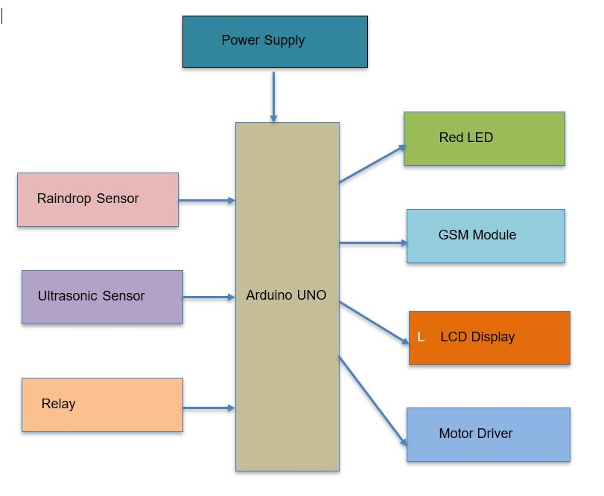

**Hardware requirements:**

Arduino UNO

Raindrop Sensor

Ultrasonic Sensor

LED

GSM Module

LCD Display

Relays

Motor Driver

**Software requirements:**

Arduino IDE

**4. SENSORS USED**

**Ultrasonic Sensor:**

Ultrasonic Sensor is used to measure the distance of the object. In our Proposed Methodology, the ultrasonic sensor is used to calculate amount of water in the reservoir/dam.

When water level reaches to certain extent, ultrasonic sensor detects it. LED glows at that time indicating water level has been increased. Due to this, dams can be automatically controlled using relays and motor drivers.

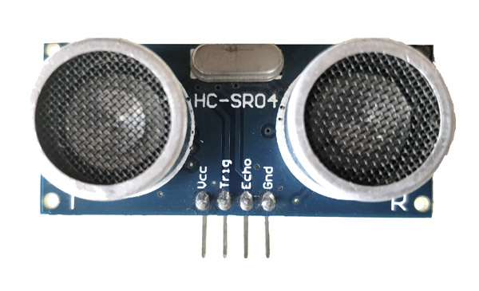

**Rain Drop Sensor:**

Raindrop sensor is used to detect the amount of rainfall. Whenever heavy rainfall is detected, raindrop sensor detects it and led glows automatically. This helps in automation of Dam gates in prior to any consequences that occur.

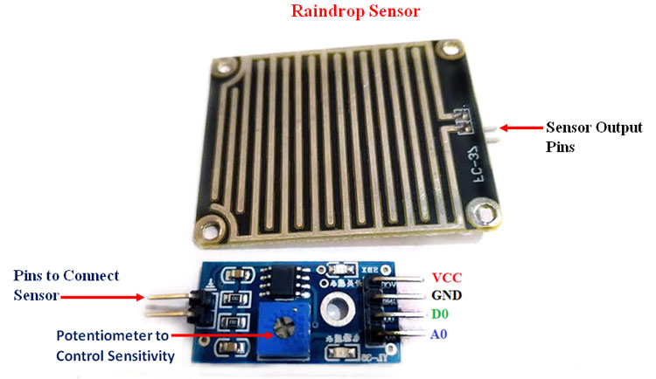

**5. EXPERIMENTAL RESULTS**

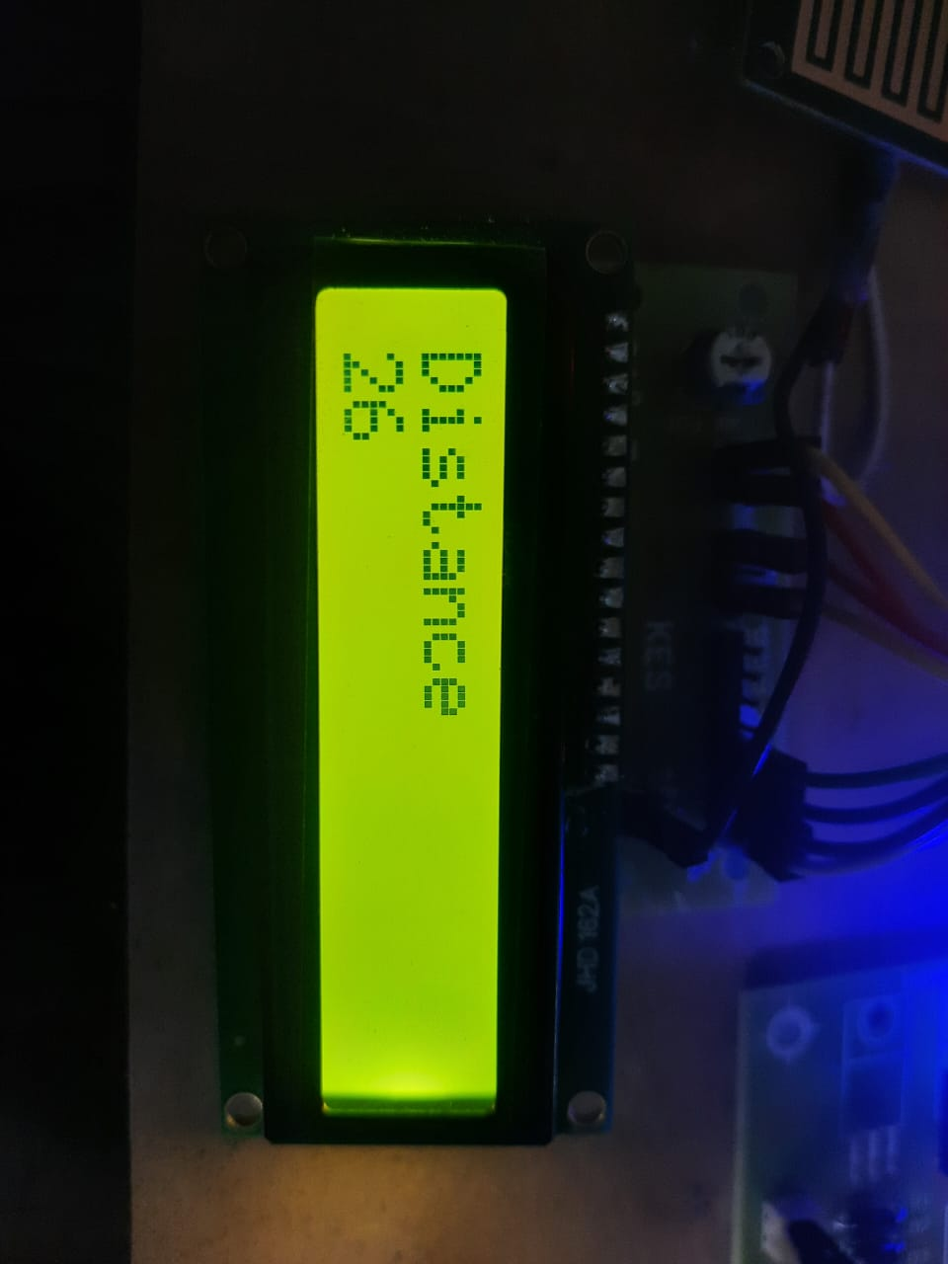

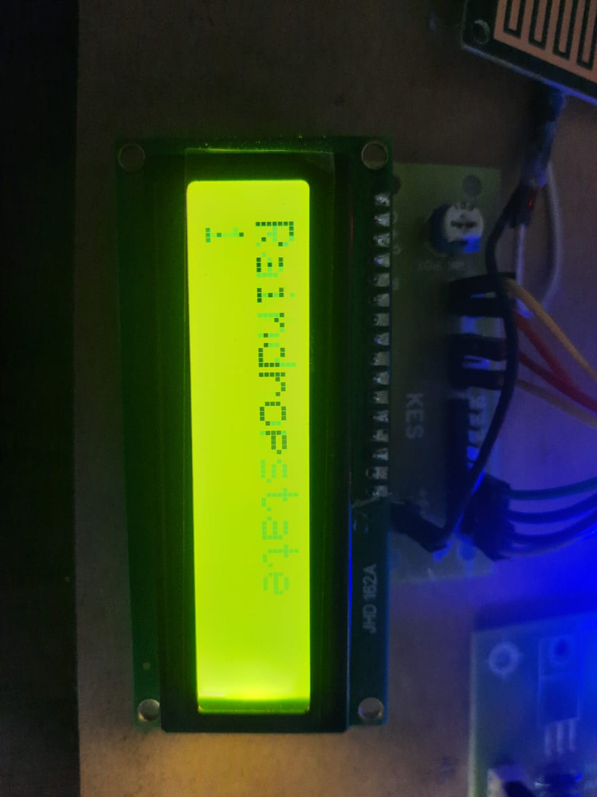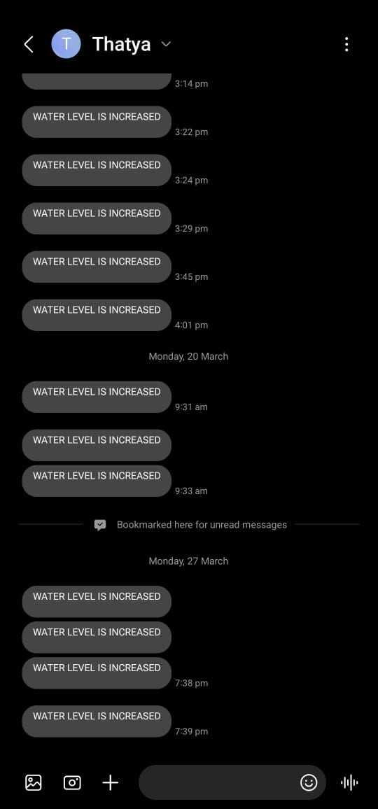

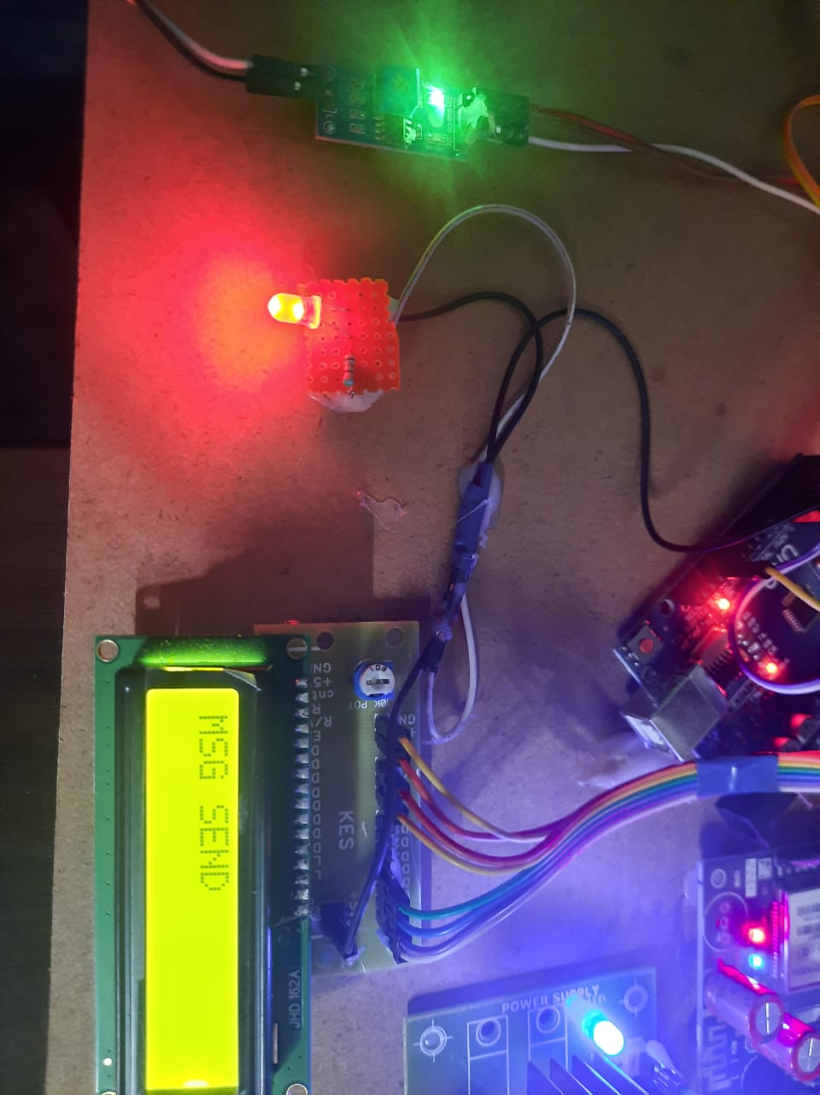

**6.DATA FLOW DIAGRAM**

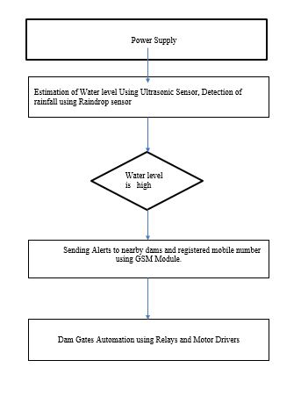

**7. ADVANTAGES**

* Automates Dam
* Low cost
* Efficient
* Estimates Water level Accurately
* No Manual Power Required

**8. CONCLUSION**

As a result, the IOT-enabled technology assists us in precisely measuring the water level in the dam. With the use of this sensor data, relays can automatically open dam gates, and motor drivers can automatically close gates when the water level drops. More sensors might be used to expand and modify the system. Using sensors and hardware components, we can conserve water.

Reduce unnecessary water use while also conserving energy. To save energy, an alert message about the water level is delivered to the user's mobile device. Furthermore, this program is useful for small-scale enterprises and families. Finally, the inclusion of project-based, uncomplicated components makes it efficient and cost-effective. As a consequence, this project provides users with a reliable solution.

**9. FUTURE SCOPE**

This initiative will assist large dam systems in regulating water overflow. We can control the dam gates from anywhere in the planet. A pH sensor may also be used to measure filthy water. This device sends every change in water level to a web server over the internet, allowing nearby neighbours to be warned in real time. Many lives are saved as a result, and horrible occurrences are avoided. Real-world prototyping of this module in a river utilising float sensors to monitor and adjust water level and make suitable judgements from any location is possible.

This can be improved further.

**10. REFERENCES**

1. IOT Based Water Supply Monitoring and Controlling System, The International Conference on Information Technology and Digital Applications, May 2018
2. Automatic Gate Control and Water Level Reservoir Using GSM Technology, International Journal of Scientific & Engineering Research, April-2016
3. Wireless Disaster Monitoring and Management System for Dams, International Conference on Intelligent Computing, Communication & Convergence, 2015
4. Dam gate level monitoring and control, International Journal of Innovative Trends in Engineering (IJITE), June 2020
5. Raspberry Pi Based Automatic Dam Monitoring and Alert System, International Journal of Innovations in Engineering And Science, 2017
6. IOT Based Water Level Monitoring System for Lake, International Journal of Lakes and Rivers, May 2019
7. Thinagaran Perumal1 published "Internet of Things (IoT) Enabled Water Monitoring System" in the 2015 IEEE 4th Global Conference on Consumer Electronics (GCCE).
8. In July 2014, Daniel Wu, Fakhreddine Karray, and Insop Song published "Water level control by fuzzy logic and neural networks" in the IEEE magazine.
9. Maarten Breckpot "Flood control with model predictive control for river systems with water reservoirs," Journal of Irrigation and Drainage Engineering/ASCE, July 2013.
10. In July 2014, Daniel Wu published "Water level control by fuzzy logic and neural networks" in IEEE magazine.
11. Ramli Adnan, Fazlina Ruslan, Samad, and Zainazlan Md Zain, "Artificial Neural Network Modelling and Flood Water Level Prediction Using Extented Kalman Filter," Department of Surveying Science and Geomatics, 2012 IEEE conference on control system and computing engineering.
12. Zhang Ji and Qi Anwen, "Applications of Internet of Things in China's Emergency Management System," IEEE 2010.