DONATIONS USING ANDROID APPLICATION

 | Authors:
B.Yaswanth | T.Y.PhaniKumar | P.Sai Srinivas
(19A91A0502), | (19A91A0556), CSE, | (19A91A0540), CSE,
CSE, B.Tech, | B.Tech, | B.Tech,
Aditya Engineering College, | Aditya Engineering College, | Aditya Engineering College,
Surampalem | Surampalem | Surampalem

Guide: Dr. K. Vydehi, M.Tech

Senior Assistant Professor
Aditya Engineering College

ABSTRACT: The main objective of the Donation project is to develop an android application for the orphanage and old age home to analyze the current requirement and to schedule the donors.

In highly populated countries like India, food, cloth and books wastage is a disturbing issue. The streets, garbage bins, and landfills have ample proof to prove it. Marriages, canteens, restaurants, social and family get-togethers and functions expel so much food. Food wastage is not only an indication of hunger but also of many economic problems. The high standard of living has resulted in the wastage of food, clothes, etc. Because of quick changes in habits and lifestyle. Instead of wasting these things we can put them in use by donating them to various organizations such as orphanages, old age homes, etc.

The sharp increase in the amount of wastage in terms of food, clothes, books, etc. makes the need for charity in terms of donation. This project presents a new internet-based application that provides a platform for donating old stuff and leftover food to all needy people/organizations. It provides

information about the motivation to come up with such an application, thereby describing the existing donation system and how the proposed product works for the betterment of society. The product is shown to be an effective means of donating things to organizations, etc. over the internet. It shows the potential for avoiding the wastage of food, clothes, books and other stuff.

1. INTRODUCTION

This idea comes under. Now a days world is running around technologies, So we make use of technology in order to overcome the difficulties faced by the orphanage's for the donations. Here we make use of Android Development technology and designed an app such that donor is able to donate with at most satisfaction. The purpose of this project is to use Android Development to identify where the orphanage is and what it requires to make the donors contact the nearby orphanage easily. Most of the children in orphanages suffer from malnutrition because they are fed with less amount or unhealthy food. Due to low caring and unwillingness to take

care of children by their parents, the number of children in orphanages had increased linearly. Although the count of children is increasing, the charity provided for the orphanages is lesser in ratio. With the help of our OHS site this problem can be easily resolved or reduced. This donation app is developed in order to increase or ease the charity provided for the orphanages and old age homes. This application can be used to develop with ease. This application provides hundreds of readymade offers great customization options to design your layouts for the app from scratch level.

2. LITERATURE REVIEW

As we know, the pandemic has been tough on a lot of people. According to the International Labour Organization, the coronavirus crisis is having a devastating effect on orphanages & old age homes worldwide, with more orphanage homes and old age homes at risk to have good meals and clothes and they unable to find the donors due to the situation of pandemic. Charities are losing their donors, thus seeing plummeting revenue and disruptions to their services. Some old age homes struggle to meet their basic needs such as food, clothing, and even a mask but are unable to receive help from any sources. More than 4 in 10 orphanage homes and old age homes face serious financial problems amid this pandemic. On the other end of the spectrum, we have some potential donors who are either clueless about how and where they can help, or maybe they are shy about the fact that they can only afford little.

We thought, why not make the donation process easier so that one can donate as little as a rupee, any moment they want, within just a few clicks. We all love using apps that make our life easier on a day to

day basis, and that's what we did with the donation app. We made an app. Anyone can enter the app and donate some pre-built care packages (a care-package contains some necessary items specific individuals need daily) or any amount of money they want within seconds.

3.METHODOLOGY

•In our proposed system we try to create an interface between Orphanages and Old age Homes which are in need of charity and people/Donors who are willing to help these people.

•Most of the people would like to help the orphanage/old age home but the major problem is that they have no idea on how to approach these orphanage/old age home.

•Need for each orphanage/old age home varies in different categories such as food, money, clothes, medicine. Through our proposed system the donors can actually select the category in which they like to help.

•This application is built with React Native, Nodejs, MongoDB in it. It consists of two modules namely Orphanage Maintainer and Donor. Orphanage Maintainer can manage and update the requirements and can chat with the donor. The donor will be able to login and check the requirement's and can be able to contact using chat window or call.

•As map is provided in the application in order to locate the orphanages nearby and get the directions to it which makes the donation easy. This application is very interactive and user-friendly, it can also accept more traffic and can load pages fast. Each module of the application is highly secured.

•Through the offered chat box on this application, donors can speak with the orphanages directly.

•By including a chat box in the application, we can ensure that donations made by donors are genuine.The given map can be used by the donors to find the closest orphanages or the orphanages they'd want to support easily.

Hardware requirements:

- Processor – I5 , Rygen 5000 series or above

- SSD – 128 GB

- RAM - 8GB or Above

- GPU - optional

Software requirements:

- Famework – Express, Flutter

- Database - Mongo

- Language – Javascript , Dart

- Editor – VS Code, Android SDK

  - EXPERIMENTAL RESULTS
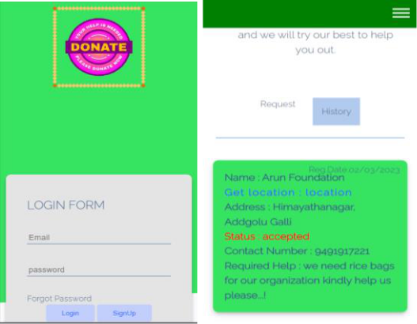
5. TECHNOLOGIES USED

Firebase Auth :-Firebase Auth is a service that can authenticate users using only client-side code. It supports social login providers Facebook, GitHub, Twitter and Google (and Google Play Games). Additionally, it includes a user management system whereby developers can enable user authentication with email and password login stored with Firebase

MongoDB:-MongoDB is an open-source document database and leading NoSQL database. MongoDB is written in C++. This tutorial will give you great understanding on MongoDB concepts needed to create and deploy a highly scalable and performance-oriented database.

Android Studio:-Android Studio is the official integrated development environment (IDE) for Google's Android operating system, built on JetBrains' IntelliJ IDEA software and designed specifically for Android development.Android Studio was announced on May 16, 2013 at the Google I/O conference. It was in early access preview stage starting from version 0.1 in May 2013.The current stable version is 3.1 released in March 2018.

Flutter:-Flutter is a free and open-source UI software development kit from Google that allows developers to build cross-platform mobile apps with ease.

Express:-Express is a node js web application framework that provides broad features for building web and mobile applications.
6. FLOWCHART
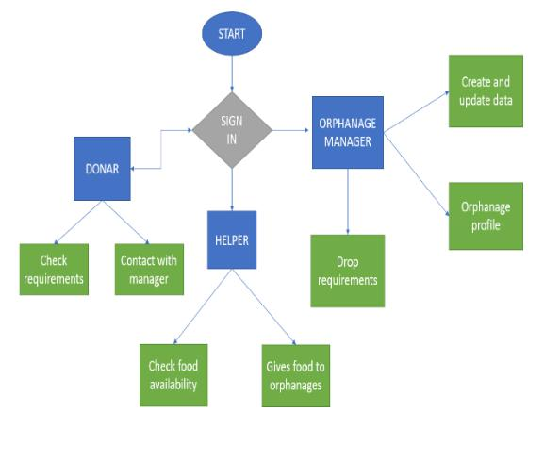

7. ADVANTAGES

•In this application the donors can directly contact the orphanages by using the chat box provided.

•By introducing the chat box in the application we can assure the donor's fraud free donation.

•The donors can use the map provided to get easy access to the nearby or their desired orphanages with the shortest directions to it.

8. CONCLUSION

A study by an International Children’s Charity for orphaned and abandoned children has found that 4% (20 million) of India’s child population are orphans. Most children and senior old citizens in orphanages and old age homes have been abandoned by their parents and families of senior citizens. In fact, the estimates state that only 0.3% of these orphans are children whose parents have actually died. Each of them can’t be afforded by the orphanages, so people should come forward to make a difference in their lives. Each penny counts. And coming to the senior

citizens they abandoned by their child’s they need house support with these.

9. FUTURE SCOPE

Some of the future enhancement ideas of OH & OAH are:

•All Orphanages and Old age Homes across India can be included with real time data.

•Education and medical details of the children can be added to the Orphanage details.

•Notifications via SMS can be sent for donation and necessary needs required to Orphanages & Old Age Homes.

  - REFERENCES

- Chen, H., Chiang, Y. Chang, F., H. Wang, H.

(2010). Toward Real-Time Precise Point Positioning: Differential GPS Based on IGS Ultra Rapid Product,SICE Annual Conference, The Grand Hotel, Taipei, Taiwan August 18-21.

- Asaad M. J. Al-Hindawi, Ibraheem Talib,

“Experimentally Evaluation of GPS/GSM Based System Design”, Journal of Electronic Systems Volume 2 Number 2 June 2012

[3] Chen Peijiang, Jiang Xuehua, “Design and Implementation of Remote monitoring system based on GSM,” vol.42, pp.167-175. 2008.

- V.Ramya, B. Palaniappan, K. Karthick,

“Embedded Controller for Vehicle In-Front Obstacle Detection and Cabin Safety Alert System”, International Journal of Computer Science & Information Technology (IJCSIT) Vol 4, No 2, April 2012.

